***"Organic farming enriches your life"***

The Agricultural Commodity and Service Cooperative (ACSC) Bio Farmer was created in Jalalabad province in 2007 with support of Helvetas Swiss Intercooperation. Bio Farmer was the first cooperative in Kyrgyzstan that received an IMO certificate for organic production and in 2008 it was the first cooperative to be Fairtrade certified by FLO-CERT Germany in whole Central Asia.



Beginning of 2016, Bio Farmer has 1394 farmer-members and covers a total area of 2950 hectares. The cooperative works almost exclusively with smallholder producers (98%) who own an area of less than 2 hectares and 19,15 % of its organic farmer-members are women.

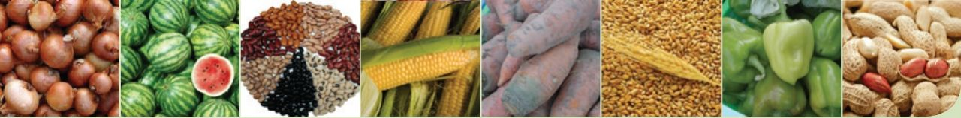

**Structure of ACSC "Bio Farmer"**

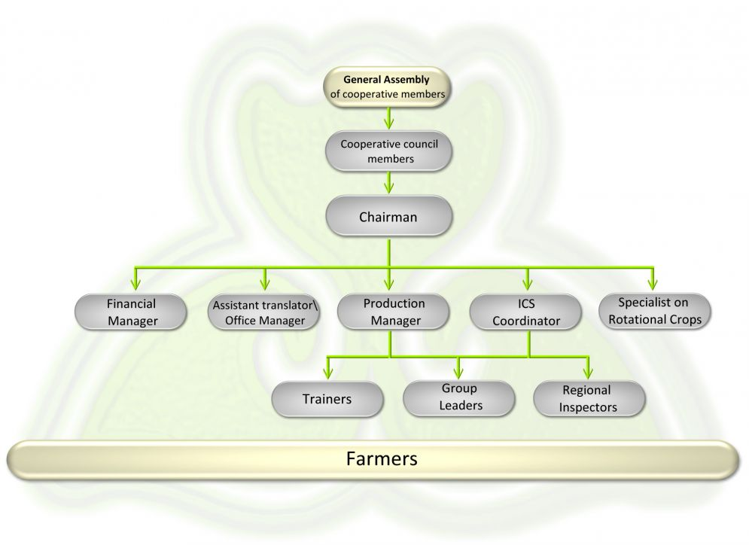

**Donors**

Since its foundation Bio Farmer has been supported by Helvetas Swiss Intercooperation, HIVOS and ICCO. During 2014-2016 Bio Farmer is receiving programme support from Helvetas and the Swiss State Secretariat of Economic Affairs (SECO).

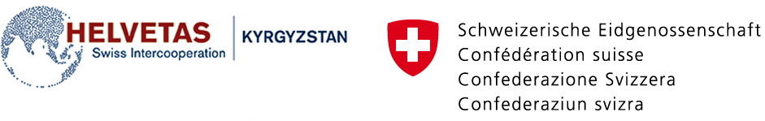

**Organic and Fairtrade Cotton**

"Bio Farmer" as an agricultural cooperative produces since 2008 certified organic and Fairtrade cotton and it is successfully exporting it to Germany. The cooperative has international certifications for EU Organic standards (IMO Turkey) and international Fairtrade (FLO-CERT, Germany).

