COMP 4981

server.c | server

User Guide

Wilson Sue & Roy Xavier Pimentel

A01266055 & A00697839

Feb 4th, 2024

**Purpose 3**

**Installing 3**

Obtaining from repo 3

OR Building from pax file 3

Commands for running the server 3

**Features 4**

Built-in Commands 5

**Limitations 6**

**Demonstrations 7**

Start Server 7

GET request from Browser 7

GET from curl 8

GET from wget 8

POST with curl 8

POST with wget 8

HEAD with curl and wget 8

Quitting Server or Client 9

# Purpose

The server.c program’s purpose is to allow you to communicate between a server and clients. Also, this program helps us to understand the flow of TCP traffic. Utilizing Wireshark, we can see the traffic flow of the communication within the program and between different operating systems or browsers.

# Installing

## Obtaining from repo

git clone <https://github.com/WilsonSue/COMP4537A1>

cd ./COMP4537A1

sudo chmod u+x *

./generate-flags.sh

./generate-cmakelists.sh

./change-compiler.sh -c <gcc or clang or clang-16>

./build.sh

## OR Building from pax file

mkdir ./COMP4537A1

cd ./COMP4537A1

./generate-flags.sh

./generate-cmakelists.sh

./change-compiler.sh -c <gcc or clang or clang-16>

./build.sh

## Commands for running the server

./server //this is of defaulting to localhost:8080

./server <server_IP> <PORT>

# 

# Features

* The server can be started and then accept any amount of client requests
* The server has a webroot directory that can store more additional static HTML pages
* Ctrl-c closes the server connection
* Can keep the connection on for clients
  + It can also detect when a client disconnects
* Webroot has a 404 not found redirected for GET that doesn't find the requested file
  + 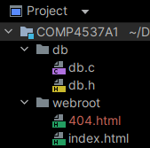
* GET and HEAD can be run from these browsers
  + Chrome
  + Chrome mobile(android)
  + Brave
  + Opera
  + Chromium
  + Edge
  + Edge mobile(android/ios)
* POST can
  + Take a string to server
  + Store it in database
  + Override the current data stored
  + Read it back
  + Send it back to the client as a response

## 

## Built-in Commands

| **Command** | **Purpose** |
| --- | --- |
| START SERVER | |
| ip a | grep "scope global" | grep -Po '(?<=inet )[\d.]+' | Retrieve IP for servers local machine |
| ./server | This defaults to localhost:8080 |
| ./server <server_IP> <PORT> | Initializes and starts server to specified IP and PORT |
| GET request from Browser | |
| FROM BROWSER:  <server_IP>:<PORT> | To handle a GET request input which redirects to index.html |
| <server_IP>:<PORT>/index.html | To handle a GET request to reach the homepage |
| <server_IP>:<PORT> / <HTMLfile> | To handle a GET request and access an explicit HTML added to webroot |
| 127.0.0.1:8080 OR http://localhost:8080/ | Input url on browser if default ./server was run |
| GET from curl | |
| curl -0 http://localhost:8080 | Runs a POST request from terminal for localhost |
| curl -0 <server_IP> : <PORT> | Runs a POST request from terminal for server_IP |
| GET from wget | |
| wget <server_IP>:<PORT> | Get command to go to homepage |
| POST with curl | |
| curl -X POST localhost:8080/submit -d "String"  OR  curl -X POST 127.0.0.1:8080/submit -d "String" | POST request with localhost |
| curl -X POST <server_IP>:<PORT>/submit -d "String" | POST request with server_IP |
| POST with wget | |
| wget --post-data "String" localhost:8080/submit  OR  wget --post-data "String" 127.0.0.1:8080/submit | POST request with localhost |
| wget --post-data "String" <server_IP>:<PORT>/submit | Post request with server_IP |
| HEAD with curl and wget | |
| curl -I <server_IP>:<PORT>/index.html | HEAD Request with curl |
| wget --spider --server-response <server_IP>:<PORT>/index.html | HEAD Request with wget |
| Quitting Server or client | |
| ctrl-c | Quit from either any Client or Server connection |

## Limitations

* The program must have an IP address and port if you wish to have requests across local network
* The server must first establish a connection, then the client can connect.
* Server must be on to handle requests

The following browsers are not supported for GET

* Chrome mobile(ios)
* Safari mobile (ios)
* Firefox

# 

# Demonstrations

### Start Server



### GET request from Browser

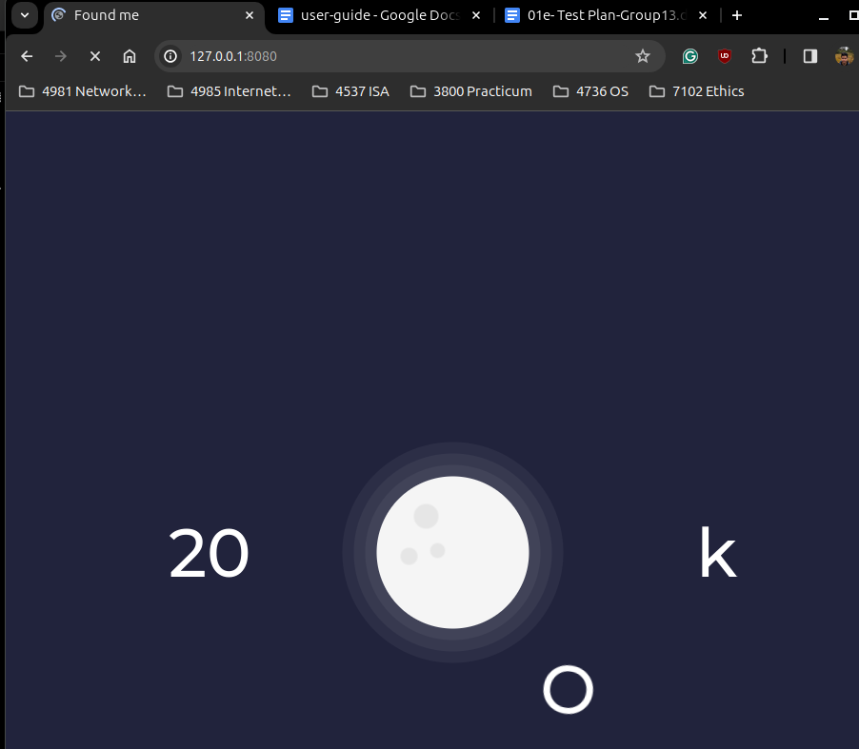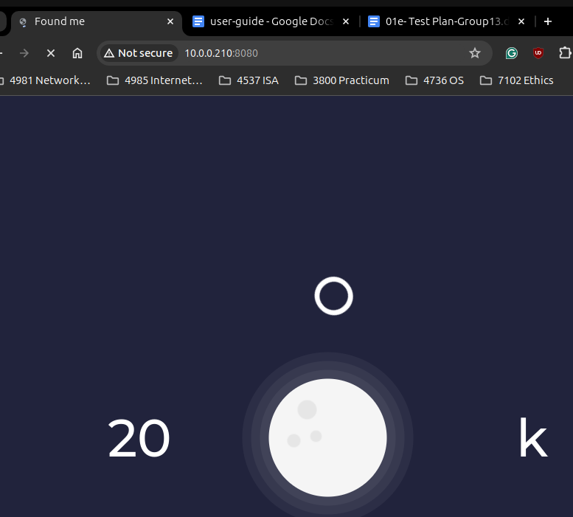

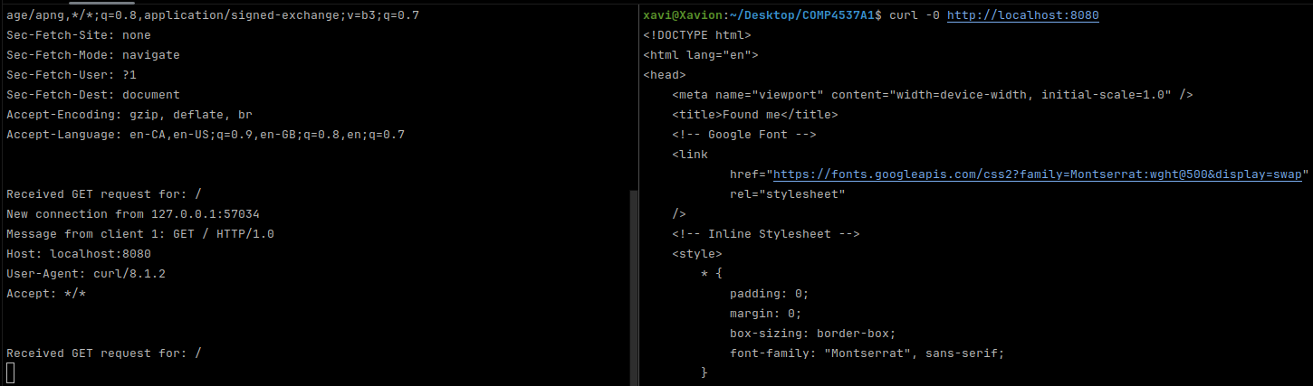

### GET from curl

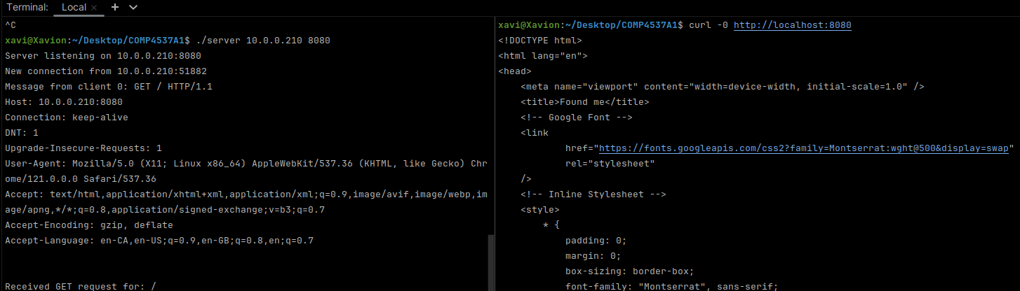

### GET from wget

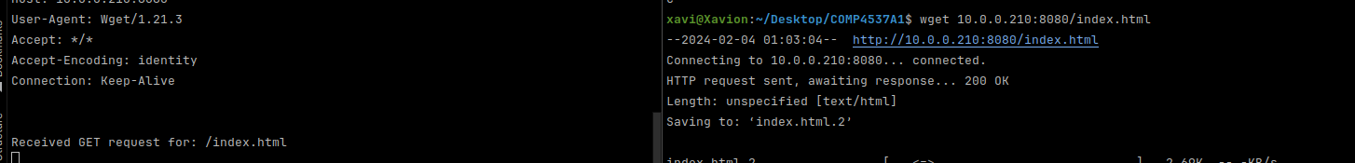

### POST with curl

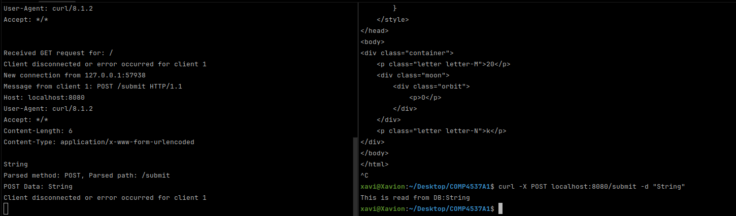

### POST with wget

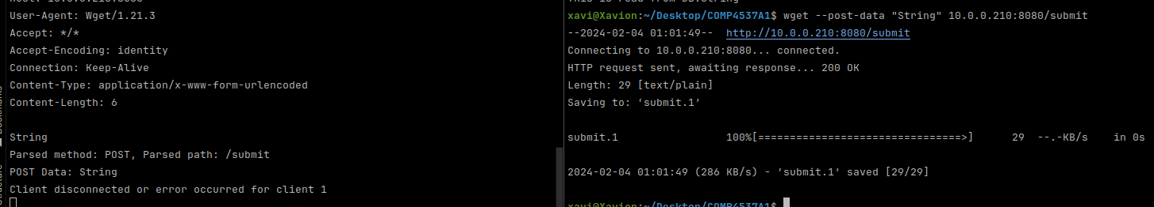

### HEAD with curl and wget



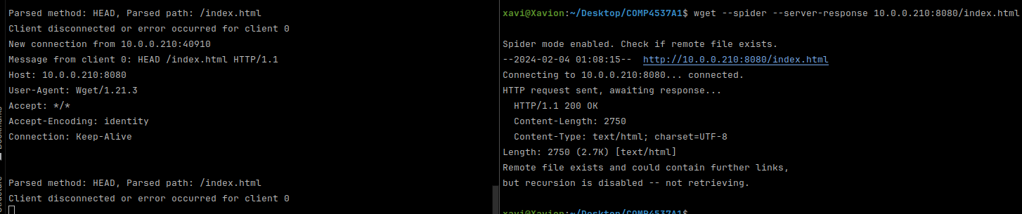

### Quitting Server or Client

