SVGBanner

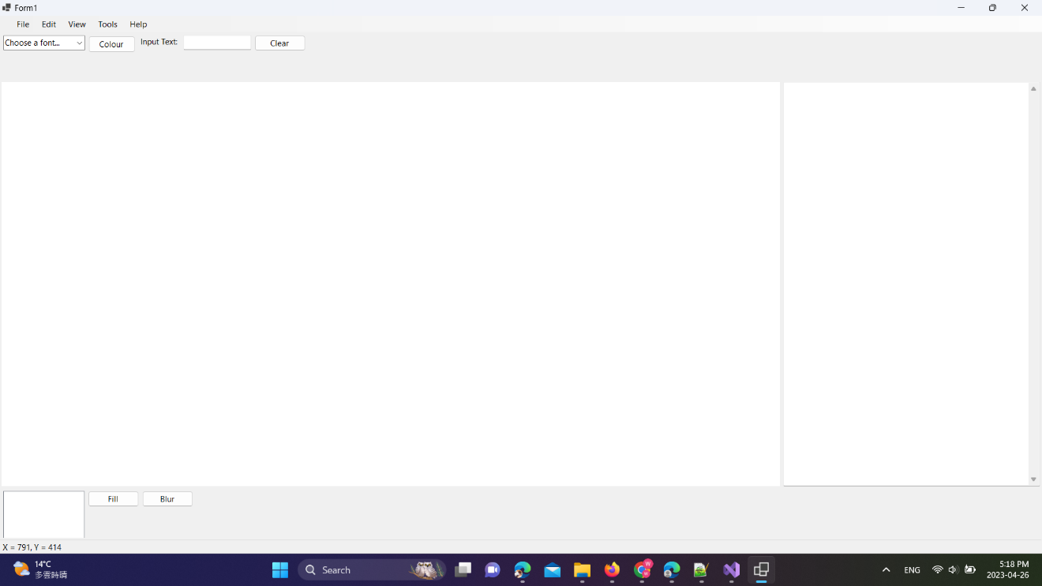

1. Enter Text and ENTER
2. Choose a colour
3. Choose a font

Basic operation

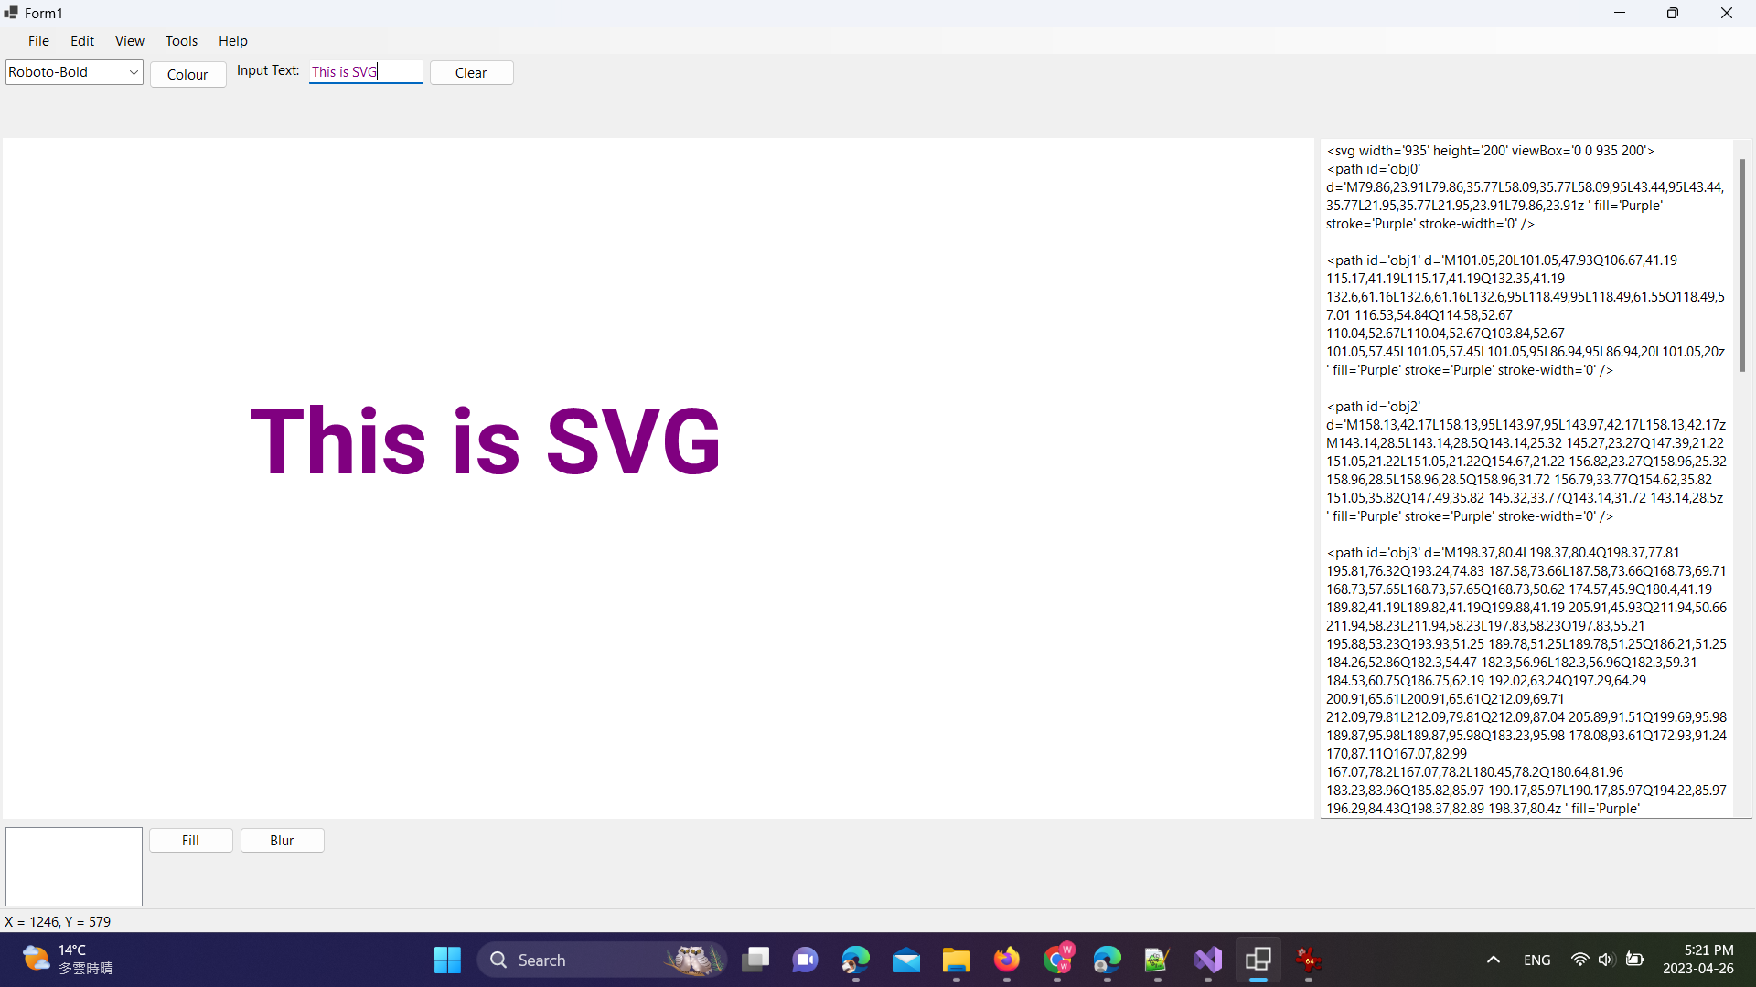

Your Text

SVG paths

Fill

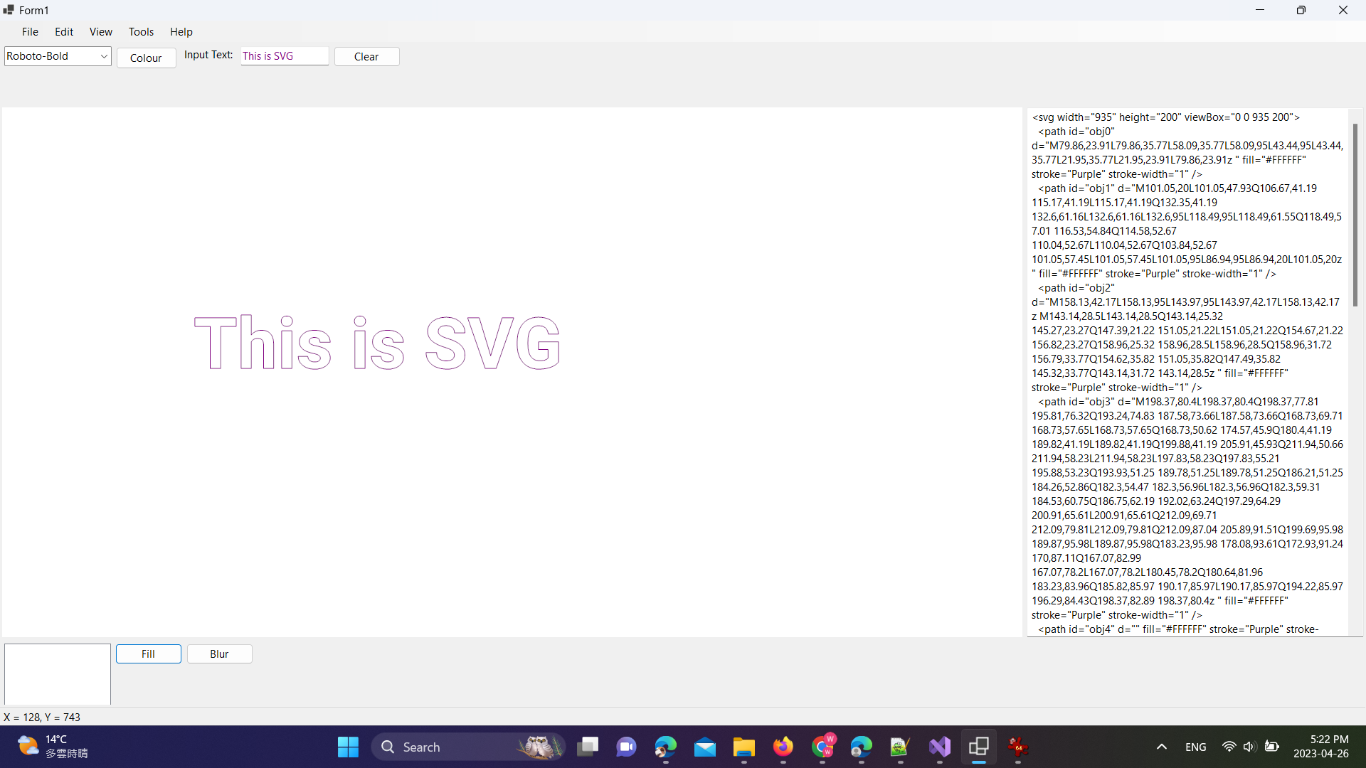

Updated SVG path

Blur

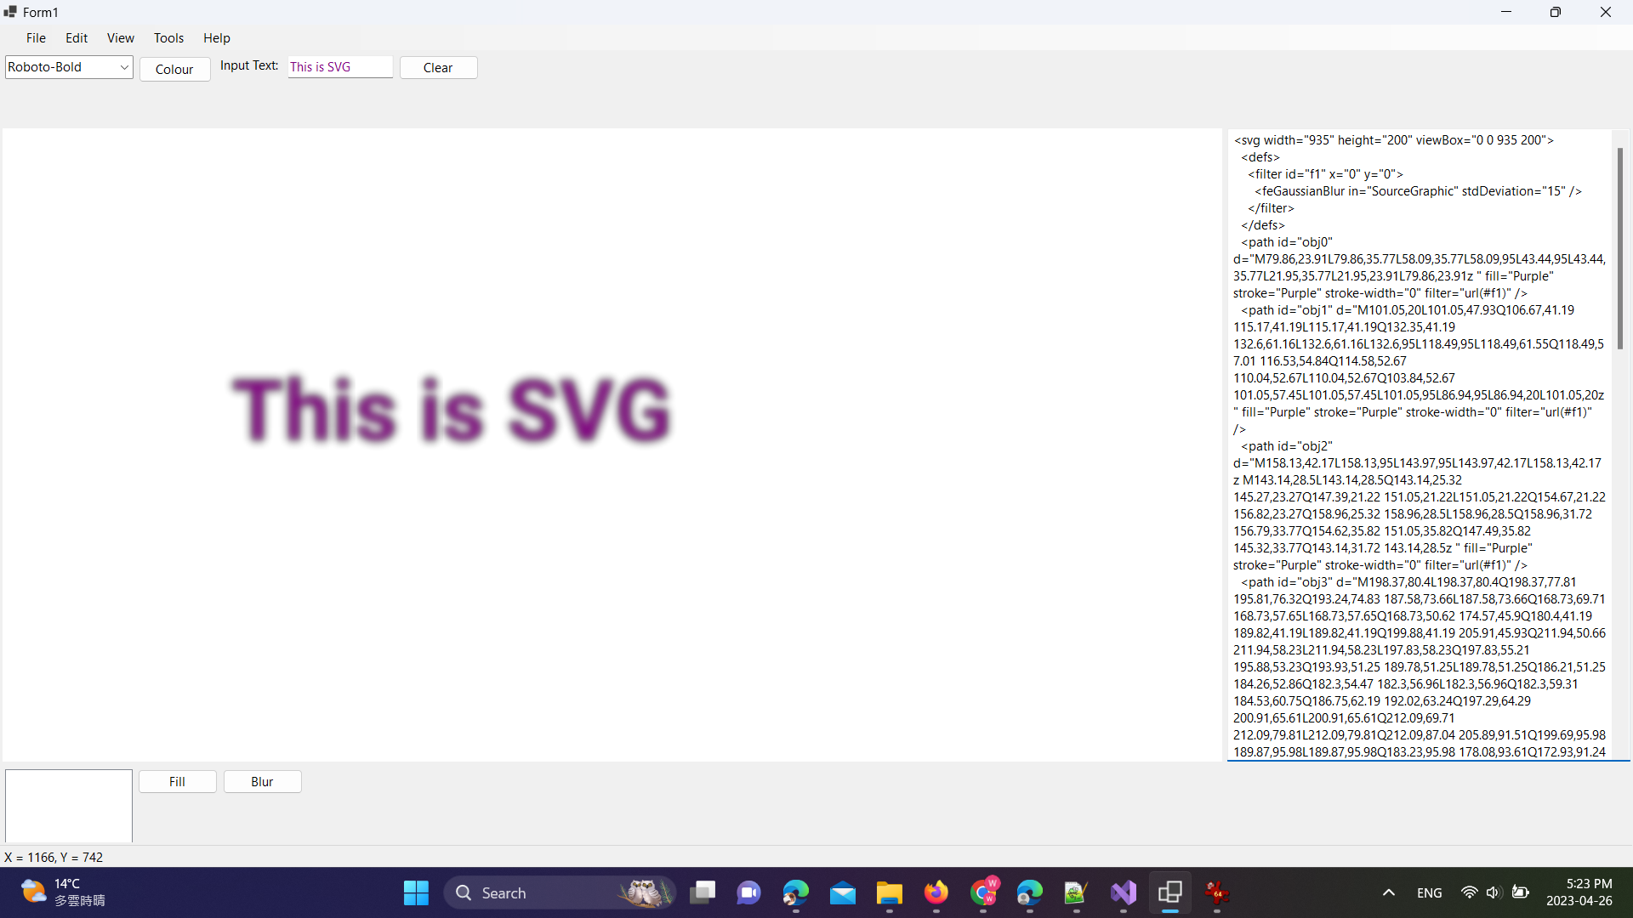

Updated SVG path

Credits:

1. Prof. Diggins demo program
2. WaterTrans/Glyphloaders
3. SVG-net/SVG

Known issues:

1. Buttons work only one way