Capstone: Next Steps and Roadmap
Date: 1 June 2026
This document summarises what the project has delivered so far and sets out the next
steps, both for the current software-demonstration milestone and for the capstone as a
whole. Under the revised schedule, all development (Objectives 1 to 3) is completed by
26 June 2026, and the final capstone report is submitted by 10 July 2026.

1. Where the project stands
- The proposal was approved by the supervisor on 28 May 2026, which opened the
implementation phase.
- An initial software demonstration is built and deployed: a classical machine-learning
classifier that sorts a short message into phishing, mobile-money fraud, advance-fee
fraud, or not-a-scam. It uses TF-IDF features with Logistic Regression and Random Forest,
and scores a test macro-F1 of 0.94 (held-out set, n = 664).
- It is served as a REST API (FastAPI, on Render) and a web app (on Vercel), with an
executed model notebook and a clean repository.
- A working corpus has been pooled from public sources: 8,536 unique messages after
de-duplication. The initial demonstration model is trained on a 4,422-row labelled
subset, using each source's own labels.

2. A note on the labels
The demonstration model is an initial baseline. Its labels come from the source datasets
(provenance labels), not from a human adjudication process. The numbers are therefore
slightly optimistic, because the model partly learns which dataset a message resembles.
The final dissertation evaluation will run on a human, inter-rater-verified corpus, which
is the work described in Objective 1 below.

3. Immediate next steps (this week, demonstration milestone)
Task | Owner | Status
Record the 5 to 10 minute demo video (notebook, then the live app) | Student | Pending
Add the video link to the repository README | Student | Pending
Submit the repository zip and the repo link | Student | Pending
Revoke the deployment tokens used during setup (Vercel, Render) | Student | Pending
Optionally lock the API CORS setting to the web-app domain | Student | Optional

4. Objective 1: the verified corpus (internal target ~14 June)
This is the next major deliverable. The acceptance criterion is a labelled corpus of at
least 500 balanced items with Cohen's kappa of 0.7 or higher on a 100-item audit.
Steps:
1. Run the assisted labelling pass to produce at least 500 human-confirmed labels across
the in-scope categories, prioritising a balanced set rather than the natural skew.
2. Recruit a second rater. Draw the 100-item blinded audit sample, have the second rater
label it independently, and compute kappa.
3. If kappa is below 0.7, adjudicate the disagreements, refine the labelling guide, and
re-rate the disputed items until the threshold is met.
4. Lock the corpus and produce the stratified 70/15/15 train/dev/test split. The test set
is touched only once, at final evaluation.
Scope decision to confirm with the supervisor: three categories (phishing, mobile-money
fraud, advance-fee fraud) have enough real message data to train and evaluate. Romance,
identity-theft, and synthetic-media fraud do not, so they move to future work with a
documented sourcing rationale. The classifier ships as a three-category model plus a
not-a-scam class.

5. Objective 2: the platform (complete by 26 June)
The demonstration API and web app are the seed for the platform. Next steps:
1. Harden the API: input validation, a batch endpoint, model versioning, and request
logging.
2. Improve the web front-end and connect it to the intended mobile delivery channel.
3. Containerise the service and move to stable hosting, with a simple retrain-and-deploy
routine.

6. Objective 3: the comparative evaluation (complete by 26 June)
1. Retrain TF-IDF with Logistic Regression and TF-IDF with Random Forest on the verified
corpus from Objective 1.
2. Report per-category precision, recall, and F1, plus macro-F1 and confusion matrices, on
the held-out test set.
3. Run an error analysis and a language breakdown (for example English against Portuguese).
4. Compare the verified-corpus results against the initial source-labelled baseline to show
the effect of proper labelling.

7. Data gaps and future work
- The thin categories (romance, identity-theft, synthetic-media) need data the public web
does not provide as text. Options: Kaggle-token corpora, a data collaboration with the
CMU-Africa smishing honeynet, or targeted collection. Synthetic-media (deepfake) fraud is
audio and video, so it sits outside a text classifier and stays as future work.
- Language coverage leans English, with Portuguese mobile-money smishing as the main
non-English slice. French and Pidgin coverage is thin and is a future-work item.
- Scraping regional news produced little usable signal, because articles report about fraud
rather than being scam messages. Future collection should favour message datasets and
institutional collaborations over news scraping.

8. Risks and mitigations
Risk | Mitigation
Kappa below 0.7 on the first audit | Adjudicate and re-rate; the audit and kappa tooling already exists
Second-rater availability | Recruit a peer or colleague early in the labelling week
Source-label leakage inflates demo metrics | Report final numbers only from the verified corpus
Free-tier hosting cold starts | Acceptable for the demo; upgrade the plan if a live pilot is run
Category imbalance in the corpus | Cap per class or apply class weighting; report macro-F1

9. Timeline
Under the revised schedule, all development finishes by 26 June and the final report is
submitted by 10 July. Objectives 1, 2, and 3 overlap so the development work fits inside
the 26 June freeze; report writing then runs to the 10 July submission.
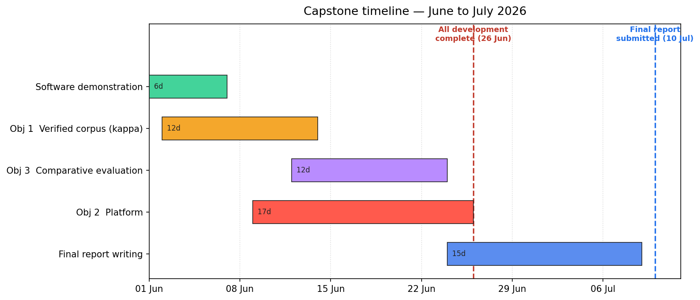
Phase | Deliverable | Target date
Software demonstration | MVP plus video | Early June (this week)
Objective 1 | Verified corpus (kappa >= 0.7) | ~14 June (internal)
Objective 3 | Comparative evaluation | ~24 June (internal)
Objective 2 | Platform | 26 June
Development freeze | All development complete | 26 June 2026
Final report | Capstone report submitted | 10 July 2026

