AI-Powered Mobile Application for Cybercrime Reporting and Scam Detection in West Africa
Pre-Capstone Research Proposal
Wilsons Navid Wado Tiwa
African Leadership University
Pre-Capstone Project
Supervisor: TBD
2026

Declaration
I, Wilsons Navid Wado Tiwa, hereby declare that this research proposal titled "AI-Powered Mobile Application for Cybercrime Reporting and Scam Detection in West Africa" is my original work and has not been submitted for any other academic award at any institution. All sources of information used in this proposal have been duly acknowledged through proper referencing.

Signature: WILSONS NAVID WADO TIWA

Date: 3/15/2026

Table of Contents
Declaration
Table of Contents
List of Tables
List of Figures
List of Acronyms/Abbreviations

CHAPTER ONE: INTRODUCTION
1.1 Introduction and Background
1.2 Problem Statement
1.3 Project's Main Objective
1.3.1 Specific Objectives
1.4 Research Questions
1.5 Project Scope
1.6 Significance and Justification

CHAPTER TWO: LITERATURE REVIEW
2.1 Introduction
2.2 Related Literature
2.3 Research Gap
2.4 Conceptual Framework
2.5 Conclusion

CHAPTER THREE: RESEARCH METHODOLOGY
3.1 Introduction
3.2 Research Design
3.3 Population and Sampling Strategy
3.4 Data Collection and Analysis
3.5 System Development and Design
3.5.1 Development Model
3.5.2 System Analysis
3.5.3 Description of the Proposed System
3.5.4 Functional and Non-Functional Requirements
3.5.5 System Architecture
3.5.6 System Design (UML Diagrams)
3.5.7 Development Tools
3.6 Ethical Considerations

References

List of Tables
Table 1: Comparison of Existing Cybercrime Reporting Solutions
Table 2: Functional Requirements of the Proposed System
Table 3: Non-Functional Requirements of the Proposed System
Table 4: Development Tools and Technologies
Table 5: Scam Classification Categories and Descriptions

List of Figures
Figure 1: Agile Development Model Adapted for the Project
Figure 2: System Architecture Diagram
Figure 3: Entity Relationship Diagram (ERD)
Figure 4: Class Diagram
Figure 5: Use Case Diagram
Figure 6: Convergent Parallel Mixed-Methods Design

List of Acronyms/Abbreviations
Acronym | Full Form
AI | Artificial Intelligence
ANTIC | Agence Nationale des Technologies de l'Information et de la Communication
API | Application Programming Interface
APA | American Psychological Association
APWG | Anti-Phishing Working Group
AU | African Union
BEC | Business Email Compromise
CNN | Convolutional Neural Network
EFCC | Economic and Financial Crimes Commission
ERD | Entity Relationship Diagram
GPS | Global Positioning System
GSM | Global System for Mobile Communications
IoT | Internet of Things
ITU | International Telecommunication Union
LSTM | Long Short-Term Memory
ML | Machine Learning
NCC | Nigerian Communications Commission
ngCERT | Nigeria Computer Emergency Response Team
NLP | Natural Language Processing
SDK | Software Development Kit
SIM | Subscriber Identity Module
SMS | Short Message Service
SUS | System Usability Scale
SVM | Support Vector Machine
TAM | Technology Acceptance Model
UI | User Interface
UML | Unified Modeling Language
URL | Uniform Resource Locator

CHAPTER ONE: INTRODUCTION
1.1 Introduction and Background
Cybercrime is one of the most serious security threats of this era. As digital connectivity has spread across the globe, so have criminal activities that rely on electronic networks, and the growth in both scale and sophistication has been steep. The International Telecommunication Union (ITU) estimated that global cybercrime damages reached about $8.4 trillion in 2022, with projections exceeding $10.5 trillion per year by 2025 (Morgan, 2022). Phishing, online fraud, identity theft, romance scams, and financial exploitation now affect every continent and demographic.
Africa has experienced a particularly sharp rise in cybercrime over the past decade. The continent is going through a rapid digital transition, fueled by growing mobile phone adoption and wider internet access. While this shift has opened up economic opportunities, it has also exposed millions of new users to cyber threats that many of them do not fully recognize. The African Union's Cybersecurity Report estimated the annual cost of cybercrime to African economies at roughly $4 billion, a figure that drags on socioeconomic development (African Union, 2022). West Africa has become a global hotspot for cybercriminal activity, with Nigeria and Cameroon ranking among the worst-affected countries (INTERPOL, 2021).
Nigeria is at the center of this crisis. It is the continent's largest economy and most populous nation, with over 220 million people and more than 100 million internet users, making it the biggest online population in Africa (Internet World Stats, 2023). The country has long been associated with advance-fee fraud, commonly called "419 scams" after the relevant section of the Nigerian Criminal Code. But cybercriminals based in Nigeria have moved well beyond that. Business email compromise (BEC), romance scams, phishing, and cryptocurrency fraud are now widespread. The Economic and Financial Crimes Commission (EFCC) put cybercrime-related losses in Nigeria at over $500 million in 2022, with thousands of citizens victimized each year (EFCC, 2023). Even those numbers probably understate reality. The Nigeria Computer Emergency Response Team (ngCERT) has noted that the vast majority of incidents go unreported because of stigma, confusion about where to seek help, and a lack of accessible reporting platforms (ngCERT, 2022).
Cameroon faces a similar problem, though its situation has distinct characteristics. The country has about 15 million internet users, and its mobile money ecosystem is growing fast. That growth has brought a wave of cybercrime, especially mobile money fraud, SIM swap attacks, and social media scams (Ndifon & Achou, 2023). Cameroon's bilingual makeup, split between French-speaking and English-speaking communities, makes public awareness campaigns harder to run effectively. The National Agency for Information and Communication Technologies (ANTIC) has recorded a steady increase in online fraud complaints, but Cameroon still does not have a centralized digital platform where citizens can report cybercrime or receive immediate assistance (ANTIC, 2022). The country's cybercrime legislation also remains incomplete, which leaves victims with few legal avenues.
The reasons cybercrime thrives in West Africa go deeper than technology. Rapid urbanization, high youth unemployment, and limited digital literacy have created an environment where cybercrime flourishes, both as a way to exploit others and, troublingly, as something some young people view as a legitimate path to income (Warner, 2011). Many victims, particularly in lower-income communities, lack the knowledge to recognize scam tactics and the financial resilience to absorb losses. Women, elderly individuals, and first-time internet users are disproportionately targeted, and they are also the groups least likely to report incidents (Akanle et al., 2020).
Mobile applications have been used across multiple sectors to facilitate incident reporting, share information, and engage communities. In public safety, mobile-based reporting systems have shown real results in speeding up responses and improving data collection for law enforcement (Bott & Young, 2012). But when it comes to cybercrime victim reporting in West Africa, almost nothing exists.
Artificial Intelligence and Machine Learning have real potential to help with cybercrime detection and prevention. AI systems can process large amounts of data, identify patterns linked to fraud, classify scam types, and generate real-time risk assessments (Buczak & Guven, 2016). In developed countries, machine learning is already used in email filtering, financial fraud detection, and phishing website identification. The problem is that very little of this work has been adapted for mobile platforms built for the West African context, where mobile money fraud and locally tailored scam schemes are the dominant threats (Tade, 2022).
Cross-platform frameworks like Flutter now make it practical to build applications that run on both Android and iOS from a single codebase, which matters in markets where Android dominates. Combined with real-time database solutions like Firebase, developers have the tools to create responsive apps that handle dynamic data, secure authentication, and instant notifications (Google Developers, 2023). These technologies provide the foundation needed for an accessible cybercrime reporting tool aimed at West African users.
There is an ethical dimension to this work as well. Combating cybercrime connects directly to the Millennium Project's Global Challenge 12: How can transnational organized crime networks be stopped from becoming more powerful and sophisticated? Cybercrime is transnational by nature. Perpetrators in West Africa target victims across Europe, North America, and other parts of Africa, while also preying on local populations. Addressing this challenge requires innovative, technology-driven approaches that give citizens the power to report incidents, access protective resources, and break the cycle of victimization (Glenn & Gordon, 2009).
This project sets out to develop an AI-powered mobile application that enables cybercrime victims in Nigeria and Cameroon to report scams, receive instant risk assessments, and access educational resources. The app will use machine learning for scam pattern detection, Flutter for cross-platform development, and Firebase for real-time data management. The aim is to fill a gap in cybercrime victim support across West Africa and contribute to the broader effort of combating cybercrime on the continent.
1.2 Problem Statement
Even as cybercrime escalates across West Africa, victims face serious barriers when trying to report scams or seek help. In Nigeria, the main channels for reporting are the EFCC and the Nigeria Police Force Cybercrime Unit. Both require in-person visits or formal written complaints, which are slow, intimidating, and out of reach for many citizens, especially those in rural areas (Adeniran, 2008). In Cameroon, ANTIC is the designated national cybersecurity body, but it has no public-facing digital reporting platform, and most citizens are unaware of its existence (ANTIC, 2022). The result: INTERPOL's African Cyberthreat Assessment (2021) found that fewer than 20% of cybercrime incidents in Africa get formally reported. In countries with limited digital reporting infrastructure, the real figure is almost certainly lower.
Two existing solutions have tried to address parts of this problem. ScamAdviser (www.scamadviser.com) is an online tool that lets users check the trustworthiness of websites and online vendors before engaging with them. It works for website verification, but it is primarily web-based, lacks a dedicated mobile reporting function, and was never designed around the scam patterns common in West African markets, things like mobile money fraud, advance-fee schemes, SIM swap attacks, and phishing campaigns run through WhatsApp and SMS (ScamAdviser, 2023). Trend Micro's Fraud Buster application uses AI to scan messages and URLs for potential threats. It is effective at threat detection but does not support victim reporting or provide recovery resources. It also does not draw on region-specific scam data from West Africa and lacks support for local languages like Pidgin English, Yoruba, Igbo, or French (Trend Micro, 2023).
Both solutions fall short in three ways. First, neither provides an integrated platform that combines scam reporting, AI-driven risk assessment, and victim resources in a single mobile application. Second, neither was designed for the West African user, meaning they do not account for low-bandwidth connectivity, multilingual populations, mobile money fraud patterns, or the need to connect with local law enforcement. Third, neither uses machine learning models trained on West African cybercrime data, which is necessary for detecting the region-specific scam patterns that make up most incidents in Nigeria and Cameroon.
The gap this project targets is straightforward: there is no AI-powered, mobile-first platform that lets cybercrime victims in Nigeria and Cameroon report incidents, receive intelligent scam analysis, and access targeted support in one place. This underreporting problem feeds directly into the growing power of transnational organized crime networks, as described in Global Challenge 12. When cybercriminals can operate with near-total impunity and law enforcement is starved of the data it needs to identify patterns, disrupt networks, and build cases, the problem only worsens.
1.3 Project's Main Objective
This project aims to develop an AI-powered mobile application that enables cybercrime victims in Nigeria and Cameroon to report scams, receive instant risk assessments, and access educational and support resources. The goal is to improve cybercrime reporting rates and strengthen victim support infrastructure across West Africa.
1.3.1 Specific Objectives
1. To design and build a cross-platform mobile application using Flutter that gives cybercrime victims in Nigeria and Cameroon an intuitive, multilingual interface for reporting scam incidents, with a target development cycle of three months.
2. To train a machine learning model on West African cybercrime datasets that can classify reported scams into five categories (advance-fee fraud, mobile money fraud, phishing, romance scams, and identity theft) with at least 85% accuracy.
3. To integrate a real-time risk assessment feature, powered by Firebase, that provides users with instant feedback on the threat level of their reported incident within 30 seconds of submission.
4. To build an educational resource module within the app containing at least 20 articles, guides, and videos on scam identification and prevention, available in English, French, and Pidgin English.
5. To evaluate the app's usability and effectiveness through pilot testing with at least 50 users in Lagos, Nigeria, and Douala, Cameroon, collecting feedback to refine the system over a two-month testing period.
1.4 Research Questions
1. How can a mobile application be designed to offer an accessible, user-friendly platform for cybercrime victims in Nigeria and Cameroon to report scam incidents?
2. How accurately can machine learning algorithms detect and classify scam patterns specific to the West African context, including advance-fee fraud and mobile money scams?
3. How effective is a real-time, AI-powered risk assessment feature in helping users understand the severity and nature of reported cybercrime incidents?
4. Which educational resources and support mechanisms are most effective in helping cybercrime victims in West Africa recover from scams and avoid future victimization?
5. How do pilot users in Lagos, Nigeria, and Douala, Cameroon, perceive the usability and usefulness of the application?
1.5 Project Scope
Geographically, this project focuses on two pilot locations: Lagos, Nigeria, and Douala, Cameroon. Lagos was chosen because it is Nigeria's commercial capital and largest city, with over 20 million residents and the highest concentration of internet users in the country. It is also where cybercrime victimization rates are highest in the region (NCC, 2023). Douala, Cameroon's economic hub with about 4 million residents, was selected for its rapidly growing mobile money ecosystem, rising rates of digital fraud, and the perspective it offers on the Francophone West African context (ANTIC, 2022). Testing in both cities allows the study to capture insights from Anglophone and Francophone populations.
The pilot testing population will consist of 50 to 100 adults (aged 18 and older) across both cities. These participants will be active mobile phone users who have either experienced cybercrime or face elevated risk of victimization. In Lagos, recruitment will take place in the Ikeja and Victoria Island areas through community technology hubs, the University of Lagos, Yaba College of Technology, and local NGOs focused on digital literacy. In Douala, participants will be recruited from the Akwa and Bonaberi neighborhoods through the University of Douala, cybercafe networks, and community organizations.
On the technical side, the application will be built with Flutter for cross-platform compatibility across Android and iOS, Firebase for real-time database management and user authentication, and Python-based machine learning libraries (TensorFlow and Scikit-learn) for the scam detection model. The model covers five primary scam categories: advance-fee fraud (419 scams), mobile money fraud, phishing, romance scams, and identity theft. Training data will come from publicly available cybercrime datasets, supplemented with records from Nigerian and Cameroonian cybercrime reports, EFCC case files, and ANTIC incident logs.
The project is planned to run over six months: three months for application development and machine learning model training, followed by three months of pilot testing, evaluation, and iteration. The app will support English, French, and Pidgin English to ensure accessibility for both target populations. Direct integration with law enforcement databases is not included at this stage, but the architecture is modular, designed so that future iterations could connect to EFCC, ANTIC, or INTERPOL systems.
1.6 Significance and Justification
If this application works as intended, it will give citizens in Nigeria and Cameroon a practical tool for reporting scam incidents and receiving immediate, intelligent feedback. That matters because the underreporting problem is severe. INTERPOL (2021) estimated that fewer than 20% of cybercrime cases in Africa are formally reported. A mobile-first, multilingual approach that reduces the friction around reporting could increase both the volume and quality of cybercrime data available to agencies like the EFCC and ANTIC, data they need to investigate and prosecute offenders.
The project also speaks to the Millennium Project's Global Challenge 12 on transnational organized crime. West African cybercriminal networks run operations that span multiple countries and target victims worldwide (Tade, 2022). A platform that detects scam patterns and aggregates structured incident data could become a useful intelligence tool for mapping cybercrime trends, identifying criminal networks, and supporting coordinated law enforcement action across national and regional boundaries (African Union, 2022).
Beyond enforcement, the app's educational module will give vulnerable populations, including women, elderly users, and first-time internet adopters, the knowledge to recognize and avoid scams, building digital resilience over time. The project has implications for multiple stakeholders: victims gain an accessible reporting channel and recovery resources; law enforcement agencies gain structured, analyzable incident data; researchers gain access to cybercrime trend datasets; and policymakers gain evidence they can use to push for stronger cybersecurity legislation in both Nigeria and Cameroon.

CHAPTER TWO: LITERATURE REVIEW
2.1 Introduction
This chapter reviews existing literature relevant to the development of an AI-powered mobile application for cybercrime reporting and scam detection in West Africa, with a focus on Nigeria and Cameroon. The project sits within the Millennium Project's Global Challenge 12, which asks: "How can transnational organized crime networks be stopped from becoming more powerful and sophisticated?" (Glenn & Gordon, 2009). Cybercrime in West Africa has moved well beyond isolated fraud schemes. It is now a transnational enterprise generating billions of dollars annually, with the African Union (2022) estimating the cost to African economies at about $4 billion per year. Fewer than 20% of cybercrime incidents in Africa are formally reported (INTERPOL, 2021), which creates a data vacuum that allows criminal networks to operate with little accountability.
The literature is organized across seven thematic areas: (1) the cybercrime landscape in West Africa, (2) artificial intelligence and machine learning for cybercrime detection, (3) mobile applications for crime reporting, (4) digital literacy and cybersecurity awareness, (5) transnational organized crime and Global Challenge 12, (6) mobile technology and cross-platform development, and (7) cybersecurity policy and legislation. Each theme synthesizes key findings, identifies strengths and limitations in the existing research, and connects the literature to the project's objectives.
2.2 Related Literature
2.2.1 Cybercrime landscape in West Africa
Understanding the scope of cybercrime in West Africa is a necessary starting point for any intervention aimed at supporting victims in the region. What the literature makes clear is that cybercrime here is not simply a technical problem. It is a deeply embedded social phenomenon driven by poverty, limited digital literacy, and inadequate reporting infrastructure.
Adeniran (2008) traces the emergence of the "Yahoo-boys" subculture in Nigeria, arguing that economic deprivation and the social glorification of fraudulent wealth have normalized cybercriminal behavior among young Nigerians. Akanle et al. (2020) build on that work through a sociological analysis of the "Yahoo Yahoo" phenomenon, showing that cybercrime is a symptom of systemic failures in governance and economic opportunity. They also highlight that vulnerable populations, particularly women, the elderly, and first-time internet users, are disproportionately targeted. This directly supports the case for a victim-centered reporting platform designed to be accessible to those most at risk.
In Cameroon, Ndifon and Achou (2023) document the rise of mobile money fraud, SIM swap attacks, and social media scams, noting the absence of a centralized digital reporting platform and the difficulties posed by the country's bilingual population. Their work is one of the few peer-reviewed analyses focused specifically on Cameroonian cybercrime, and it supports the rationale for including Douala as a pilot location with multilingual support. Tade (2022) extends the picture by examining how Nigerian cybercrime has evolved from advance-fee schemes to business email compromise and cryptocurrency fraud, with severe underreporting due to victim stigma and inaccessible reporting mechanisms. His findings are consistent with Akanle et al. (2020) and ngCERT (2022), and they describe exactly the problem the proposed application is designed to address.
2.2.2 Artificial intelligence and machine learning for cybercrime detection
The second body of literature addresses whether AI and machine learning can actually work for cybercrime detection. Buczak and Guven (2016), in a widely cited survey published in IEEE Communications Surveys and Tutorials, compare decision trees, support vector machines, neural networks, and ensemble methods for cybersecurity intrusion detection. Their algorithmic comparisons remain useful and inform the choice of classification techniques for the proposed scam detection model.
Salloum et al. (2022) systematically review NLP techniques for phishing email detection and find that NLP-based approaches consistently outperform rule-based methods. Hajomer and Yunus (2023) propose a phishing detection model using NLP and deep learning that achieves high accuracy on over 50,000 web pages through word embeddings and recurrent neural networks. Both studies demonstrate that NLP has real power for scam detection, but they share a limitation: their training data is overwhelmingly English-language and Western-centric. That raises questions about direct applicability to the multilingual West African context, where SMS and WhatsApp-based campaigns are the main attack vectors, not email (Ndifon & Achou, 2023).
Chieloka and Ugwu (2021) provide the most directly relevant precedent. They evaluate Random Forest, Gradient Boosting, and Neural Networks on Nigerian cybercrime data from law enforcement records and find that ensemble methods achieve the highest accuracy for classifying advance-fee fraud and romance scams, which corroborates Buczak and Guven (2016) in a regional setting. Their dataset is small, though, which underscores how hard it is to get labeled cybercrime data in West Africa. This is a challenge the proposed project will need to address through supplementary data collection during pilot testing.
2.2.3 Mobile applications for crime reporting and public safety
A third strand of literature examines mobile platforms for crime reporting in developing countries. Bott and Young (2012) look at how crowdsourcing technologies, including platforms like Kenya's Ushahidi, can improve governance and public safety by giving communities tools to report incidents and providing authorities with real-time data. Agushaka et al. (2021) build on this by designing an intelligent crime management system that integrates mobile reporting and data analytics for Nigerian law enforcement. They found significant reductions in reporting time compared to paper-based methods, though their system was designed around law enforcement workflows rather than victim needs. That leaves an opening for the proposed application to add AI-driven classification and victim-centered resources.
Mwiya and Phiri (2020) propose a GSM and GIS-based crime reporting system for Zambia that works over basic mobile networks, addressing the challenge of limited internet connectivity. Their positive user acceptance testing results reinforce the importance of designing for low-bandwidth environments. Taken together, these studies show that mobile crime reporting is viable in Sub-Saharan Africa, but none of the existing platforms combine AI-powered scam detection, victim reporting, and educational resources in a single cybercrime-focused application.
2.2.4 Digital literacy and cybersecurity awareness
The literature on digital literacy points to severe awareness gaps that any cybercrime reporting platform will need to account for. Kshetri (2019) analyzes Africa's cybersecurity vulnerabilities, including rapid digitization without matching security investment and a shortage of about 100,000 cybersecurity professionals across the continent. This provides important context for the challenges in Nigeria and Cameroon specifically.
Okuku et al. (2015) find that even Kenyan university students, who are regular internet users, have significant gaps in knowledge about phishing, password security, and social engineering. If university students cannot identify common scam techniques, awareness among elderly and rural populations targeted by scams is likely much lower (Akanle et al., 2020). These findings make a clear case for multilingual educational content within the proposed application. Ogbanufe and Gerhart (2020) add a design insight by showing that strong identity relationships with technology lead to sustained engagement. For this project, that means the application needs to become something users trust and return to regularly, not just a tool they use once.
2.2.5 Transnational organized crime and Global Challenge 12
The Millennium Project's foundational document (Glenn & Gordon, 2009) identifies 15 Global Challenges, including Challenge 12 on stopping transnational organized crime. It estimates that transnational organized crime generates 3% to 7% of global GDP annually and notes the convergence between cybercrime and traditional organized crime. INTERPOL's African Cyberthreat Assessment (2021) provides the most authoritative data on the scale of the problem on the continent, finding that fewer than 20% of cybercrime incidents in Africa are formally reported. Nigeria and Cameroon are among the hardest-hit nations.
The African Union (2022) adds to this by documenting that only 11 of 55 member states had enacted comprehensive cybersecurity legislation, estimating cybercrime costs at $4 billion annually, and recommending investments in digital literacy and stronger national CERTs. These sources place the proposed application within the global effort to combat organized criminal networks and show that underreporting directly enables those networks to grow.
2.2.6 Mobile technology and cross-platform development
The technical feasibility of the proposed application is supported by a growing body of work on cross-platform mobile development. Google Developers (2023) documents Flutter as an open-source SDK for building natively compiled cross-platform applications from a single codebase. This matters in markets where Android dominates but iOS users cannot be ignored. Flutter's widget-based architecture and Dart language offer performance advantages over hybrid alternatives like React Native, though as official documentation it does not address low-bandwidth deployment challenges that Mwiya and Phiri (2020) identified as important in Sub-Saharan African contexts.
Iliescu and Olariu (2021) validate the integration of Firebase's real-time database, authentication, and cloud messaging within a Flutter tourism application, showing that the stack can handle dynamic data and user authentication. Their tourism use case has less demanding security requirements than cybercrime reporting, though, and they do not discuss data sovereignty concerns around storing sensitive victim data on Google's cloud infrastructure, an issue that the African Union (2022) has flagged in its emphasis on building domestic digital capacity.
Mamoun et al. (2021) address this gap more directly by developing a Flutter-based healthcare application that handles sensitive personal data, with positive usability testing results. Their work in healthcare, where data security requirements are similar to cybercrime reporting, is the closest precedent for the proposed application. There is a tension in this literature between the convenience of cloud-based solutions like Firebase and the data localization preferences expressed by African cybersecurity bodies (ANTIC, 2022; ngCERT, 2022). The proposed application navigates this by using Firebase's encryption and security rules while keeping the architecture modular enough for future migration to locally hosted infrastructure if regulatory requirements demand it.
2.2.7 Cybersecurity policy and legislation in Africa
The final theme looks at the institutional and policy context in Nigeria and Cameroon. The policy landscape in both countries reveals a significant gap between the recognition of cybercrime as a national security threat and the institutional capacity to deal with it. ANTIC (2022) documents rising online fraud complaints in Cameroon, particularly mobile money fraud and social media scams, while acknowledging that there is no public-facing digital reporting platform. Cameroon's cybercrime legislation remains incomplete, leaving victims with limited legal recourse even when they do report. As a government self-assessment, the report may understate systemic shortcomings.
ngCERT (2022) paints a parallel picture in Nigeria, acknowledging that the vast majority of cyber incidents go unreported due to victim stigma and the absence of user-friendly reporting platforms. This echoes Tade (2022), Akanle et al. (2020), and INTERPOL (2021), creating a consistent evidence base across both academic and institutional sources. There is, however, an unresolved question in the policy literature: while both ANTIC and ngCERT call for improved reporting mechanisms, neither specifies how those mechanisms should be designed, funded, or governed. The African Union (2022) documented that only 11 of 55 member states had enacted comprehensive cybersecurity legislation, which suggests this institutional gap is continental, not just country-specific.
One pattern across these policy sources is that they emphasize state-level responses, calling for stronger legislation, greater institutional capacity, and cross-border cooperation, while giving less attention to grassroots, technology-driven interventions. Academic sources like Akanle et al. (2020) and Adeniran (2008) take the opposite approach, foregrounding socioeconomic dimensions and the need for community-based solutions. Few sources bridge these two perspectives, which is the space the proposed application aims to occupy: a technology platform that empowers individual citizens while also generating structured data that strengthens institutional capacity. The government reports from both countries confirm that there is institutional recognition of the need for better reporting infrastructure, which gives the research a degree of legitimacy while also highlighting the room for innovation that official channels have not yet filled.
2.3 Research Gap
Despite the breadth of the reviewed literature, several gaps stand out. First, there is a geographic imbalance: while cybercrime in Nigeria has received considerable scholarly attention, Cameroon remains severely understudied. Ndifon and Achou (2023) are one of the few peer-reviewed analyses focused on Cameroonian cybercrime, and the broader Francophone West African context is largely absent from the English-language academic literature. Including Douala, Cameroon, as a pilot location is a deliberate attempt to address this.
Second, the AI and machine learning literature on cybercrime detection is overwhelmingly Western-centric. The NLP models reviewed by Salloum et al. (2022) and Hajomer and Yunus (2023) were trained on English-language datasets from North American and European sources. There is almost no published research on training scam detection models using West African cybercrime data, multilingual text in English, French, and Pidgin English, or scam typologies specific to the region such as mobile money fraud and SIM swap attacks. Chieloka and Ugwu (2021) are a notable exception, but their small dataset underscores the difficulty of obtaining labeled cybercrime data in West Africa.
Third, there is a tension in the literature between institutional and grassroots perspectives on combating cybercrime. Government and institutional sources frame the problem through a law enforcement and policy lens, while academic sources emphasize socioeconomic roots and the need for community-based interventions. Few sources consider how technology-driven platforms can complement both, which is what the proposed application aims to do.
Fourth, the mobile crime reporting literature shows proof of concept for citizen reporting systems in developing countries but does not address the specific requirements of cybercrime reporting: handling sensitive digital evidence, classifying scam types, or providing real-time AI-driven risk assessments. While the constituent elements of the proposed solution have each been validated independently in the literature, no existing study or platform combines AI-based scam detection, mobile crime reporting, and cybersecurity education into a single, mobile-first application tailored for the West African context.
2.4 Conceptual Framework
Two theoretical frameworks inform the design and evaluation of the proposed application. The first is the Technology Acceptance Model (TAM), originally proposed by Davis (1989), which explains how perceived usefulness and perceived ease of use influence whether people adopt new technologies. Ogbanufe and Gerhart (2020) extend this by showing that technology identity mediates deeper engagement, which suggests the application needs to be designed so that users see it as a trusted part of their digital safety routine, not just a functional tool. This matters especially in contexts where Kshetri (2019) and Okuku et al. (2015) have documented low levels of digital trust and cybersecurity awareness.
The second framework is Routine Activity Theory (Cohen & Felson, 1979), which holds that crime occurs when a motivated offender, a suitable target, and the absence of a capable guardian converge. In the West African context, the "motivated offenders" are well-documented by Adeniran (2008) and Tade (2022). The "suitable targets" are the digitally vulnerable populations identified by Akanle et al. (2020) and Kshetri (2019). The "absence of a capable guardian" is exactly the institutional gap described by INTERPOL (2021), ANTIC (2022), and ngCERT (2022). The proposed application is intended to function as a form of digital guardianship, giving users the ability to recognize, report, and respond to cybercrime threats.
The reviewed literature draws on diverse methodologies: qualitative and mixed-methods research in the cybercrime landscape studies, quantitative experimental approaches in the AI and machine learning studies, and design science research in the mobile application studies. This methodological diversity strengthens the evidence base by triangulating insights from social science, computer science, and information systems research.
2.5 Conclusion
This literature review shows that the proposed AI-powered mobile application addresses a clearly documented gap in West Africa's cybersecurity infrastructure. The reviewed sources establish that West Africa faces a severe and growing cybercrime problem characterized by diverse scam types, disproportionate victimization of vulnerable populations, and a persistent underreporting crisis. AI and machine learning techniques can detect and classify cybercrime patterns effectively, though region-specific training data remains a challenge. Mobile crime reporting platforms have shown viability in Sub-Saharan Africa, and the Flutter-Firebase technical stack can meet the security and usability requirements of the proposed application.
The central finding from this review is that while each component of the proposed solution has been validated independently in the literature, no existing study or platform combines AI-based scam detection, mobile crime reporting, and cybersecurity education into a single application designed for the West African context. This integration is the project's primary contribution. The project will also help close the data gap by collecting and labeling cybercrime incident reports from Nigerian and Cameroonian users, generating empirical evidence on mobile cybercrime reporting in both Anglophone and Francophone West African contexts, and testing whether combining detection and prevention in a single platform can improve cybercrime resilience among vulnerable populations.

CHAPTER THREE: RESEARCH METHODOLOGY
3.1 Introduction
This chapter lays out the research methodology for the AI-powered mobile application for cybercrime reporting and scam detection in West Africa. It covers the research design, population and sampling strategy, data collection and analysis methods, system development and design (including the development model, system analysis, architecture, and UML diagrams), development tools, and ethical considerations. The study uses a mixed-methods design that pairs quantitative evaluation of the machine learning scam detection model and app usability with qualitative exploration of user experiences through interviews and open-ended survey questions.
3.2 Research Design
This study uses a mixed-methods research design, combining quantitative and qualitative approaches. A mixed-methods approach makes sense here because the project has two distinct but connected sides: building and evaluating an AI-powered mobile application, which requires quantitative measurement; and understanding how users actually perceive and interact with the app, which calls for qualitative exploration (Creswell & Creswell, 2018).
The quantitative side combines an experimental component with a descriptive survey. The experimental part involves training and testing machine learning models on West African cybercrime data to classify scam reports into five categories: advance-fee fraud, mobile money fraud, phishing, romance scams, and identity theft. Model performance will be measured by accuracy, precision, recall, and F1-score, with a target accuracy of at least 85%. The survey component uses the System Usability Scale (SUS), a 10-item questionnaire that produces a numerical usability score (Brooke, 1996).
The qualitative side uses semi-structured interviews and open-ended survey questions to collect detailed feedback from users. Topics include how intuitive the reporting process feels, whether the AI-generated risk assessments make sense, how relevant the educational resources are, and what users would change. This qualitative data adds context to the numbers and helps explain why users rate certain features the way they do.
The study follows a convergent parallel design, meaning quantitative and qualitative data will be collected at the same time during pilot testing and then brought together during analysis (Creswell & Plano Clark, 2017). The idea is to check whether what users say in interviews lines up with how they score the app on the SUS. Where the two data sources diverge is usually where the most useful insights come from.
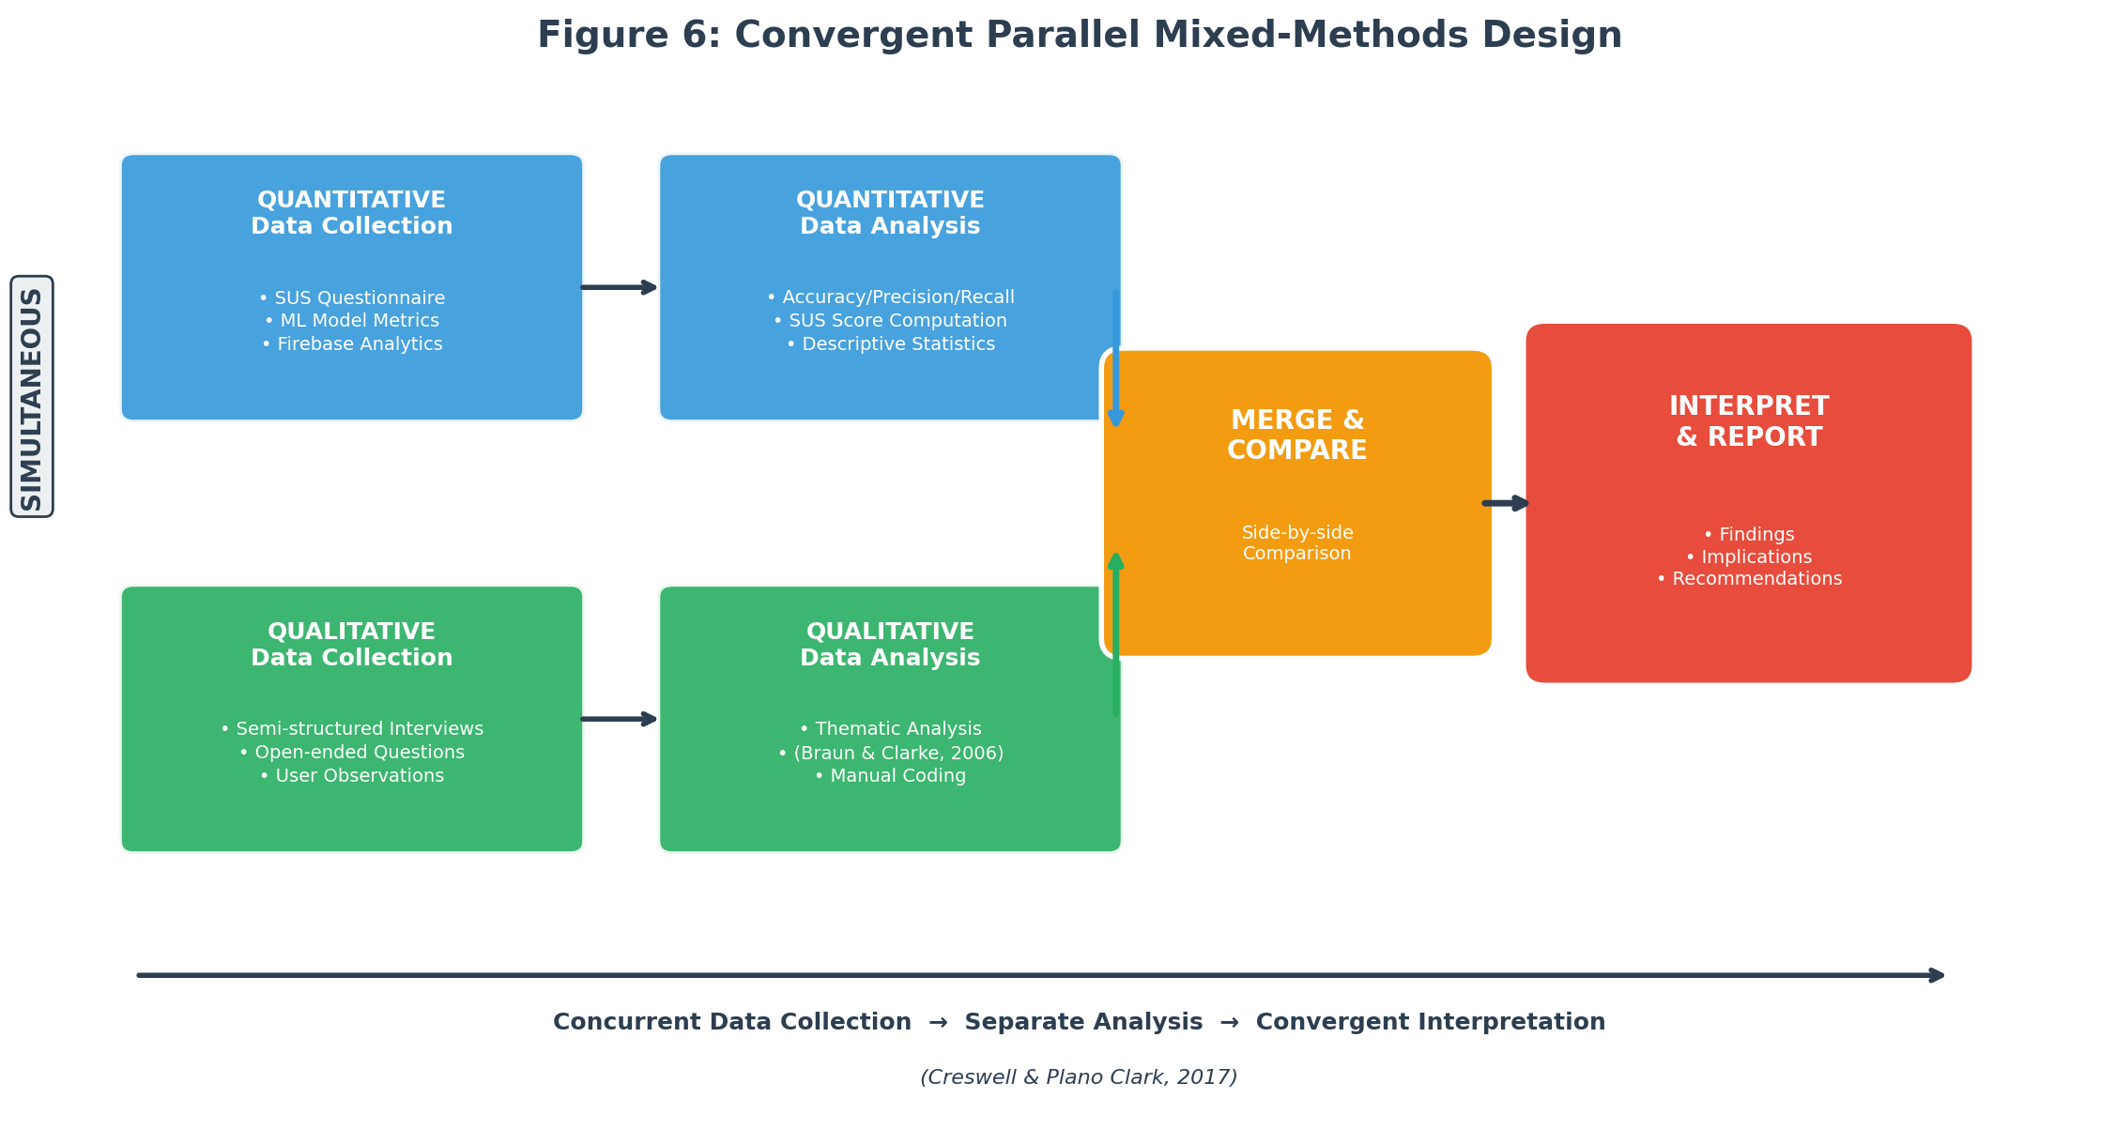
Figure 6: Convergent Parallel Mixed-Methods Design (Creswell & Plano Clark, 2017)
3.3 Population and Sampling Strategy
The study targets adult mobile phone users (18 and older) in Lagos, Nigeria, and Douala, Cameroon, who have either been victims of cybercrime or face a high risk of it. Lagos is Nigeria's commercial capital, with over 20 million residents and the country's highest concentration of internet users, and it has the highest rates of cybercrime victimization in the region (NCC, 2023). Douala is Cameroon's economic centre with roughly 4 million people, chosen because its mobile money market is expanding fast, digital fraud is rising, and it offers a Francophone perspective (ANTIC, 2022).
The pilot will recruit 50 to 100 participants across both cities: roughly 30 to 50 from Lagos and 20 to 50 from Douala. Nielsen (2000) found that as few as 5 to 15 users can uncover most usability issues, but samples of 30 or more are needed for statistically meaningful SUS scores. Participants will be recruited through a combination of purposive and snowball sampling. Purposive sampling is the primary method because the study needs people who use mobile phones and have some exposure to cybercrime, making random sampling impractical (Etikan et al., 2016). Snowball sampling will supplement this, especially in Douala, where early participants will refer others from their networks. This is particularly useful for reaching cybercrime victims, who are often reluctant to come forward on their own (Goodman, 1961).
To participate, individuals must be at least 18 years old, own and actively use a smartphone (Android or iOS), live in Lagos or Douala, and have either experienced a cybercrime incident or face elevated risk because of frequent online transactions, heavy mobile money use, or limited digital literacy. They must also speak English, French, or Pidgin English. Anyone under 18, without a smartphone, living outside the two pilot cities, or unable to give informed consent will be excluded.
3.4 Data Collection and Analysis
3.4.1 Data Collection Methods
Data collection draws on both primary and secondary sources. Four primary data collection methods will be used during the pilot:
First, surveys and questionnaires. After using the app for at least two weeks, every pilot participant will complete a questionnaire built around the System Usability Scale (SUS). The SUS is a 10-item Likert scale that yields a usability score from 0 to 100 (Brooke, 1996). Beyond the SUS items, the questionnaire will ask about demographics (age, gender, education, self-rated digital literacy), prior cybercrime experience, how useful participants found the risk assessment feature, how satisfied they were with the educational content, and whether they would use the app to report future incidents.
Second, semi-structured interviews. Between 10 and 15 participants (5 to 8 from Lagos, 5 to 7 from Douala) will sit for one-on-one interviews lasting 20 to 30 minutes. The interviews will explore how easy or difficult the reporting process was, whether the AI risk assessments made sense, how relevant the educational materials felt, what barriers came up during use, and what participants would improve. Each interview will be conducted in the participant's preferred language and audio-recorded with consent, then transcribed.
Third, app usage analytics. Firebase Analytics will be embedded in the app to track behavioral data during the pilot: the number of scam reports submitted, how long it takes to complete a report, how often users access educational resources, whether risk assessments come back within the 30-second target, session length, and retention rates. These numbers provide an objective counterpart to what users self-report in surveys and interviews.
Fourth, machine learning model testing. The scam detection model will be evaluated on a labeled test set of West African cybercrime records. Classification performance will be measured for each of the five scam categories using accuracy, precision, recall, and F1-score. During the pilot, real-world accuracy will also be checked by having an expert manually review a random sample of user-submitted reports and comparing those labels to the model's predictions.
Secondary data will come from three sources: the literature review completed earlier in this proposal; publicly available cybercrime datasets from the Anti-Phishing Working Group (APWG), the UCI Machine Learning Repository, and Kaggle fraud detection collections, supplemented with region-specific records from EFCC annual reports, ANTIC cybercrime logs, and ngCERT advisories; and institutional and policy documents from INTERPOL, the African Union, the World Bank, and national cybersecurity bodies.
3.4.2 Data Collection Instruments
Five instruments will be used: (1) the System Usability Scale (SUS) questionnaire, a 10-item questionnaire scored on a 5-point Likert scale with strong reliability at a Cronbach's alpha of 0.91 (Bangor et al., 2008); (2) a custom demographic and experience questionnaire capturing participant demographics, prior cybercrime experience, digital literacy, and opinions on specific app features; (3) a semi-structured interview guide with open-ended questions grouped by theme; (4) a Firebase Analytics dashboard that automatically tracks report submissions, feature usage, session length, and risk assessment response times; and (5) a machine learning evaluation framework using Python, Scikit-learn, and TensorFlow to compute accuracy, precision, recall, F1-score, and confusion matrices.
The SUS has been used and tested extensively in human-computer interaction research and needs no additional validation (Brooke, 1996). The custom questionnaire will be reviewed by the project supervisor for content validity and pre-tested with 5 to 10 people who will not be part of the main pilot. The interview guide will also be reviewed by the supervisor and piloted with 2 to 3 individuals. A French translation will be prepared for Douala participants and checked by a bilingual colleague. For the machine learning evaluation, stratified 5-fold cross-validation will produce robust performance estimates across all five scam categories (Kohavi, 1995).
3.4.3 Data Analysis Methods
Analysis will follow the mixed-methods design, with separate quantitative and qualitative tracks that converge during interpretation. On the quantitative side, accuracy, precision, recall, and F1-score will be calculated for each scam category and for the model overall. A confusion matrix will show where misclassifications happen, with a benchmark of 85% overall accuracy. Each participant's SUS score will be calculated using Brooke's (1996) standard method, and a mean SUS score above 68 is generally considered above-average usability (Sauro, 2011). Descriptive statistics will also summarize the Likert-scale items on perceived usefulness and satisfaction. Firebase Analytics data will be summarized with descriptive statistics: total reports submitted, average time to finish a report, how often educational resources were accessed, and what percentage of risk assessments were delivered within the 30-second window.
On the qualitative side, interview transcripts and open-ended survey responses will be analyzed through thematic analysis, following Braun and Clarke's (2006) six phases: familiarization with the data, generating initial codes, searching for themes, reviewing themes, defining and naming themes, and producing the report. Coding will be done manually, and the supervisor will review the codes and themes to reduce bias. During interpretation, qualitative themes will be placed alongside quantitative results in a side-by-side comparison (Creswell & Plano Clark, 2017).
3.5 System Development and Design
3.5.1 Development Model
The application will be developed using an Agile methodology, specifically the Scrum framework adapted for a single-developer research project. Agile was chosen because the project requires iterative development with continuous user feedback, flexibility to adapt features based on pilot testing results, and the ability to deliver working increments at regular intervals (Schwaber & Sutherland, 2020).
The development process is organized into six two-week sprints over the three-month development phase. Sprint 1 focuses on setting up the Flutter project structure, Firebase backend configuration, and user authentication module. Sprint 2 covers the scam reporting interface and form validation. Sprint 3 involves training and integrating the machine learning scam classification model. Sprint 4 develops the real-time risk assessment feature and push notification system. Sprint 5 builds the educational resource module with multilingual content. Sprint 6 is dedicated to integration testing, performance optimization, and preparation for pilot deployment. Each sprint concludes with a review against the research objectives and adjustments to the product backlog based on testing outcomes.
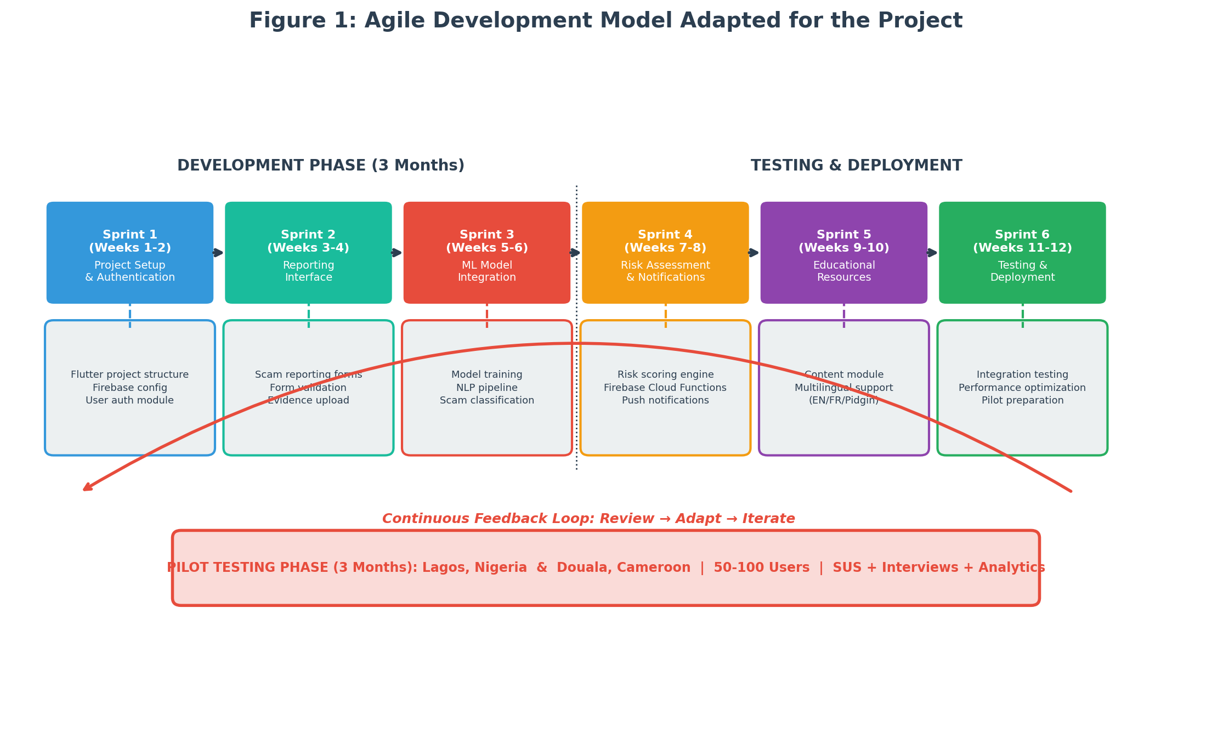
Figure 1: Agile Development Model Adapted for the Project
3.5.2 System Analysis
A review of existing cybercrime reporting and scam detection solutions shows significant limitations that the proposed system aims to address. Two systems are analyzed below.
ScamAdviser is a web-based platform that lets users check the trustworthiness of websites and online vendors by analyzing domain age, hosting location, and user reviews. It has a large database and a straightforward interface. However, it is primarily web-based with no dedicated mobile reporting function, does not support victim incident reporting, was not designed for West African scam patterns such as mobile money fraud and SIM swap attacks, lacks multilingual support for African languages, and does not provide AI-driven risk assessments or educational resources (ScamAdviser, 2023).
Trend Micro Fraud Buster is a mobile application that uses AI to scan messages and URLs for potential phishing and fraud threats. It has real-time threat detection and integrates with messaging platforms. However, it does not support victim reporting or connect users to recovery resources, does not draw on region-specific scam data from West Africa, lacks support for local languages such as Pidgin English, Yoruba, Igbo, or French, and focuses only on threat detection without educational or community-building features (Trend Micro, 2023).
Table 1: Comparison of Existing Cybercrime Reporting Solutions
Feature | ScamAdviser | Trend Micro Fraud Buster | Proposed System
Mobile-first design | No (web-based) | Yes | Yes (Flutter cross-platform)
Victim incident reporting | No | No | Yes
AI scam classification | No | Partial (URL/message scan) | Yes (5-category ML model)
Real-time risk assessment | No | Yes (threat detection) | Yes (within 30 seconds)
West African scam data | No | No | Yes (region-specific training)
Multilingual support | Limited | No | Yes (English, French, Pidgin)
Educational resources | No | No | Yes (20+ articles/guides/videos)

3.5.3 Description of the Proposed System
The proposed system is an AI-powered mobile application called CyberGuard West Africa, designed specifically for cybercrime victims in Nigeria and Cameroon. It consists of five core modules:
• Scam Reporting Module: Allows users to submit detailed incident reports including scam type, description, evidence (screenshots, messages), date, and financial impact. The reporting form supports English, French, and Pidgin English and is designed for completion in under five minutes.
• AI Scam Classification Engine: A machine learning backend that automatically classifies submitted reports into one of five categories (advance-fee fraud, mobile money fraud, phishing, romance scams, identity theft) using NLP and ensemble classification methods trained on West African cybercrime datasets.
• Real-Time Risk Assessment Module: Powered by Firebase Cloud Functions, this module analyzes submitted reports and returns a risk assessment (Low, Medium, High, Critical) within 30 seconds, with a plain-language explanation of the threat and recommended next steps.
• Educational Resource Hub: A curated library of at least 20 articles, guides, and videos on scam identification, prevention strategies, and recovery steps, available in English, French, and Pidgin English. Content is organized by scam type and updated regularly.
• User Dashboard and Analytics: Gives users a history of their submitted reports, risk assessment results, and personalized safety recommendations. Aggregated anonymized data feeds into a backend dashboard for researchers and law enforcement.
The system is configured for deployment on both Android and iOS through Flutter's single-codebase architecture. The backend uses Firebase Authentication for secure user login, Cloud Firestore for real-time data storage, Firebase Cloud Functions for serverless ML model inference, and Firebase Cloud Messaging for push notifications.
3.5.4 Functional and Non-Functional Requirements
Table 2: Functional Requirements of the Proposed System
ID | Requirement | Description
FR-01 | User Registration and Login | Users can register using email or phone number and authenticate via Firebase Authentication with email verification or OTP.
FR-02 | Scam Incident Reporting | Users can submit scam reports with category selection, free-text description, file attachments (screenshots, messages), date, and estimated financial loss.
FR-03 | AI Scam Classification | The system automatically classifies submitted reports into one of five scam categories using the trained ML model.
FR-04 | Real-Time Risk Assessment | Upon report submission, the system returns a risk level (Low/Medium/High/Critical) with a plain-language explanation within 30 seconds.
FR-05 | Multilingual Support | The app interface and educational content are available in English, French, and Pidgin English.
FR-06 | Educational Resource Access | Users can browse, search, and filter educational articles, guides, and videos organized by scam type.
FR-07 | Report History and Dashboard | Users can view their submitted reports, risk assessment results, and personalized safety tips.
FR-08 | Push Notifications | The system sends alerts about emerging scam trends, safety tips, and report status updates via Firebase Cloud Messaging.

Table 3: Non-Functional Requirements of the Proposed System
ID | Requirement | Description
NFR-01 | Performance | Risk assessment results must be returned within 30 seconds of report submission. App screens must load within 3 seconds on a 3G connection.
NFR-02 | Security | All user data must be encrypted in transit (TLS 1.2+) and at rest. Firebase security rules must prevent unauthorized data access.
NFR-03 | Scalability | The Firebase backend must support at least 500 concurrent users during pilot testing without performance degradation.
NFR-04 | Usability | The app must achieve a mean System Usability Scale score of 68 or above, indicating above-average usability.
NFR-05 | Availability | The system must maintain 99% uptime during the pilot testing period, excluding scheduled maintenance.
NFR-06 | Compatibility | The app must run on Android 8.0+ and iOS 13.0+ devices, covering over 90% of smartphones in the target markets.

3.5.5 System Architecture
The system follows a three-tier client-server architecture: a presentation layer, an application logic layer, and a data layer. This separation allows independent development and testing of each tier while supporting horizontal scaling of backend services.
The presentation layer is the Flutter mobile application running on Android and iOS. It handles user interaction, form input validation, and display of risk assessments and educational content. The application communicates with the backend through RESTful API calls and real-time Firestore listeners.
The application logic layer consists of Firebase Cloud Functions that handle business logic, including routing scam reports to the ML classification engine, computing risk assessments, managing push notifications, and serving educational content. The ML model is deployed as a TensorFlow Lite model accessible via a Cloud Function endpoint, enabling serverless inference without dedicated ML infrastructure.
The data layer uses Cloud Firestore as the primary database for storing user profiles, scam reports, risk assessments, and educational content metadata. Firebase Storage holds uploaded evidence files (screenshots, message logs). Firebase Authentication manages user identity and access control. All data is encrypted at rest and in transit, and Firestore security rules enforce role-based access control.
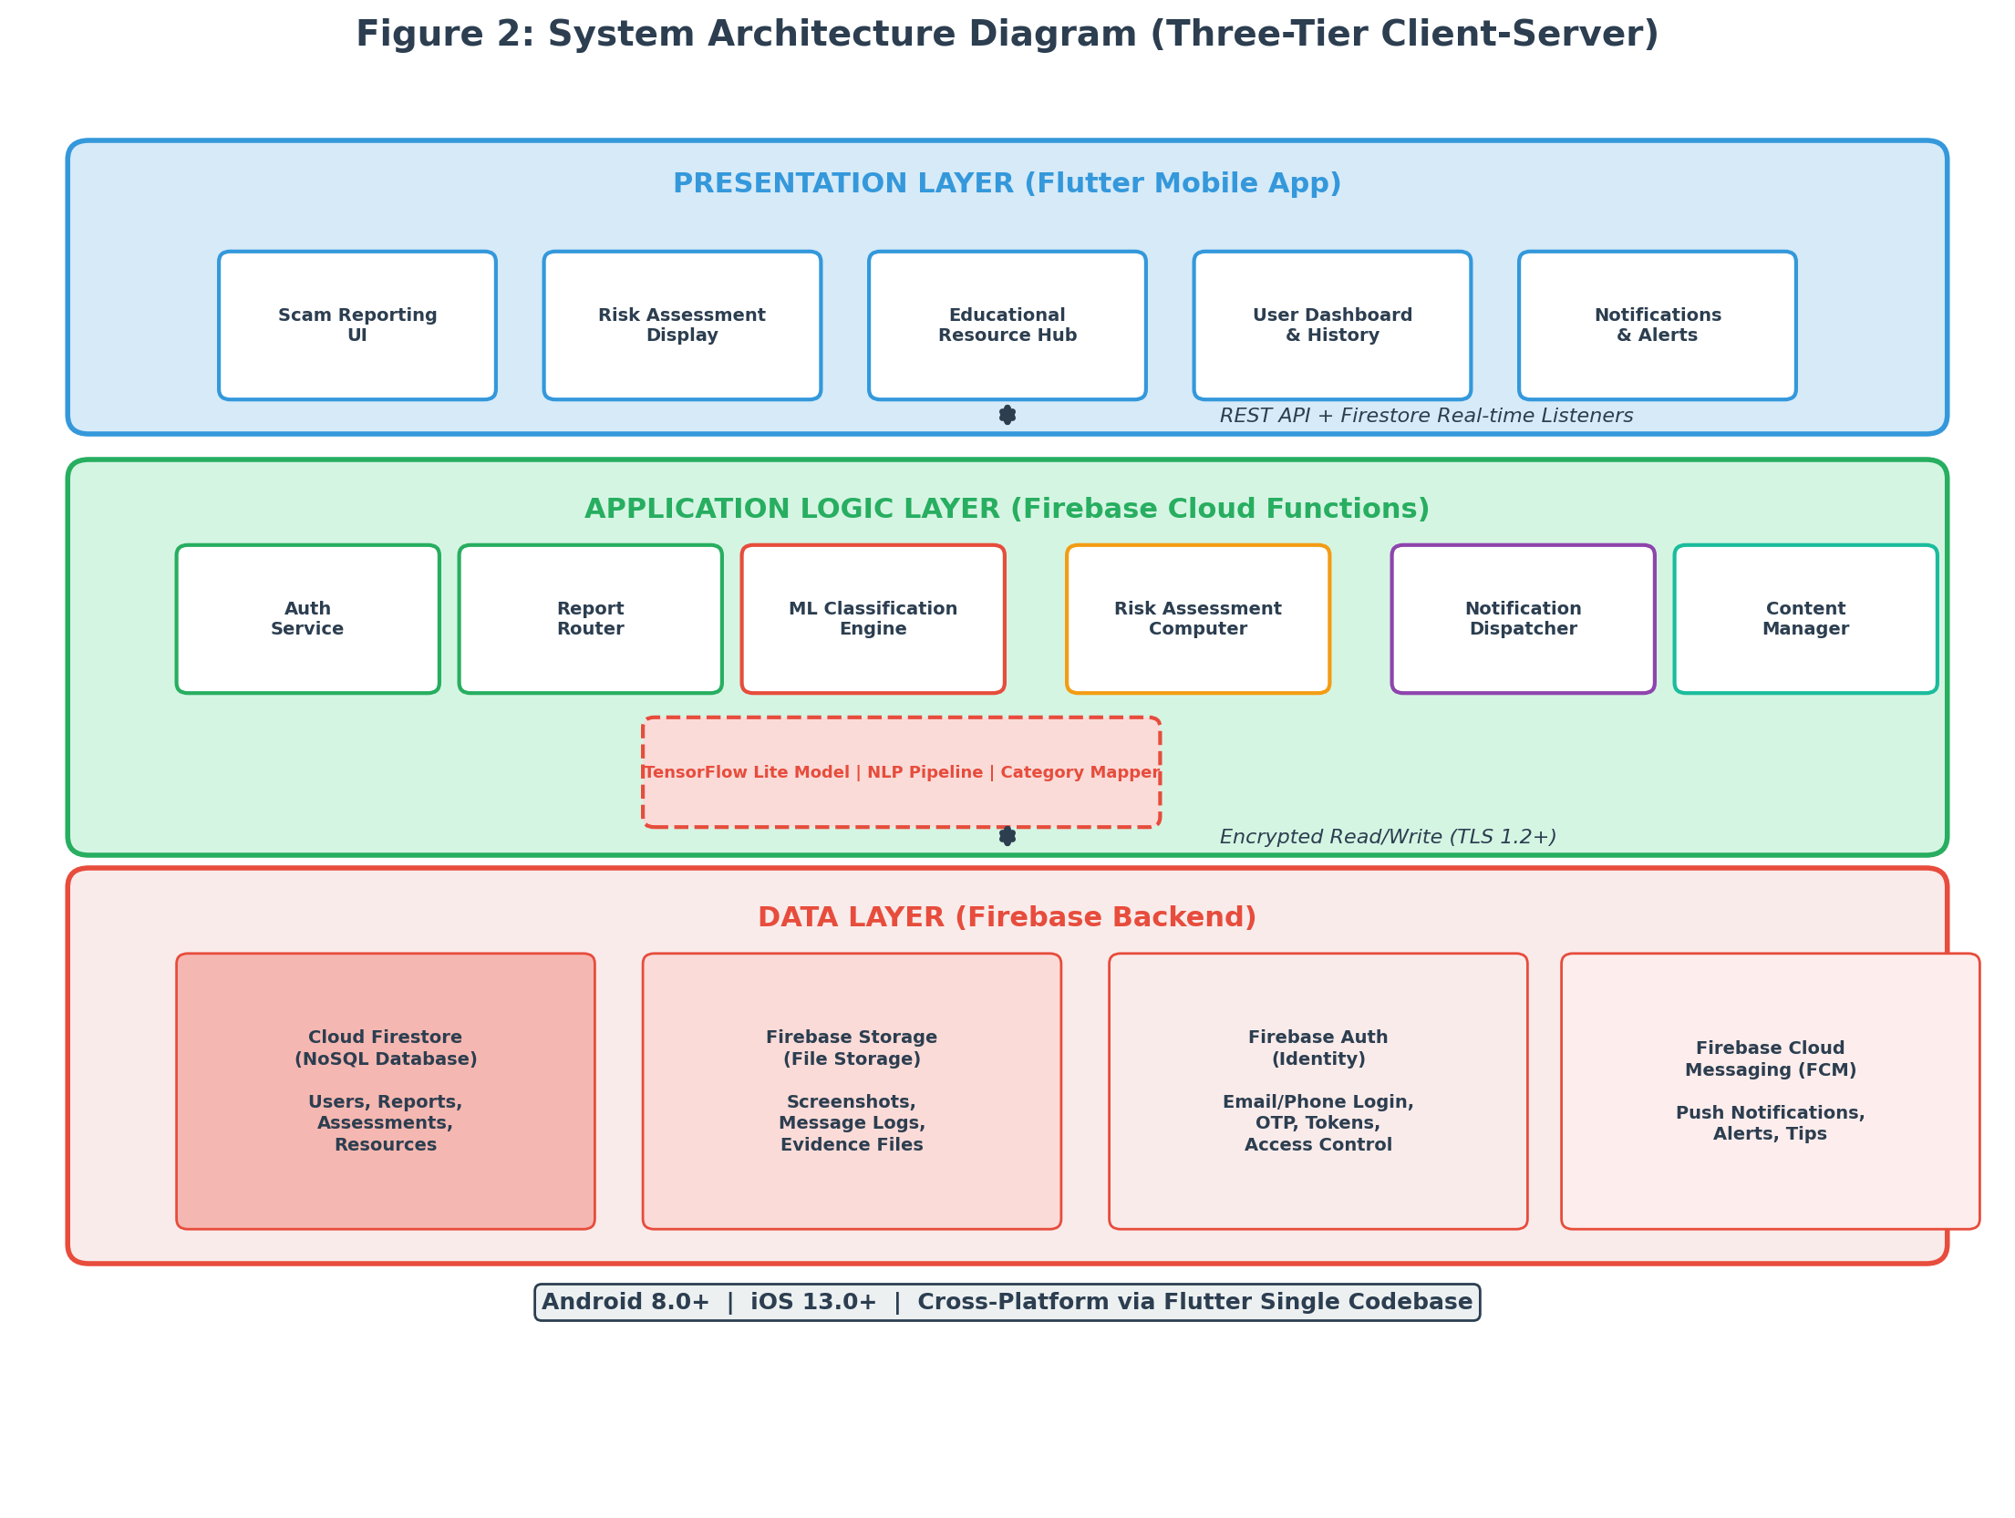
Figure 2: System Architecture Diagram (Three-Tier Client-Server)
3.5.6 System Design
This section presents the UML design diagrams for the proposed system. Three mandatory diagrams are provided: the Entity Relationship Diagram (ERD), the Class Diagram, and the Use Case Diagram.
Entity Relationship Diagram (ERD)
The ERD models the data structure and relationships between key entities. The primary entities are:
• User: Stores user profile information including user_id (PK), name, email, phone, language_preference, city, digital_literacy_level, and registration_date.
• ScamReport: Contains report_id (PK), user_id (FK), scam_category, description, evidence_url, date_of_incident, financial_loss, submission_date, and status.
• RiskAssessment: Stores assessment_id (PK), report_id (FK), risk_level (Low/Medium/High/Critical), confidence_score, explanation, and assessment_date.
• EducationalResource: Contains resource_id (PK), title, content_type (article/guide/video), scam_category, language, url, and publication_date.
• Notification: Stores notification_id (PK), user_id (FK), message, type (alert/tip/status_update), sent_date, and read_status.
Key relationships: A User can submit many ScamReports (one-to-many). Each ScamReport generates exactly one RiskAssessment (one-to-one). EducationalResources are associated with scam categories but are independent of specific users. Notifications are sent to Users based on their report activity and scam trends (one-to-many).
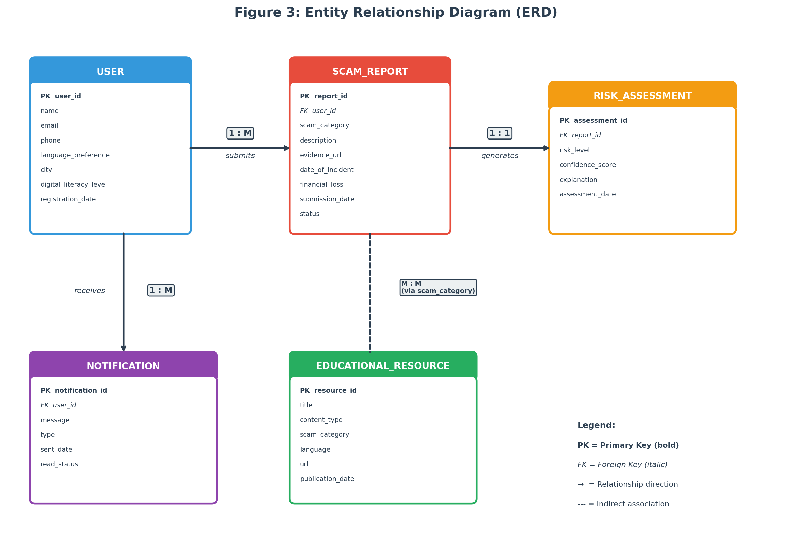
Figure 3: Entity Relationship Diagram (ERD)
Class Diagram
The class diagram models the object-oriented structure of the application's codebase. The main classes are:
• UserService: Handles user registration, authentication, and profile management. Methods include registerUser(), loginUser(), updateProfile(), and getLanguagePreference().
• ReportService: Manages the scam reporting workflow. Methods include createReport(), uploadEvidence(), getReportHistory(), and updateReportStatus().
• ClassificationEngine: Interfaces with the ML model for scam classification. Methods include classifyReport(), loadModel(), preprocessText(), and getConfidenceScore().
• RiskAssessmentService: Computes and delivers risk assessments. Methods include generateAssessment(), calculateRiskLevel(), and formatExplanation().
• EducationService: Manages educational content retrieval and filtering. Methods include getResources(), filterByCategory(), filterByLanguage(), and searchResources().
• NotificationService: Handles push notification logic. Methods include sendAlert(), sendTip(), sendStatusUpdate(), and scheduleNotification().
The ClassificationEngine depends on a ScamModel class that wraps the TensorFlow Lite model, a TextPreprocessor class for NLP pipeline operations, and a CategoryMapper class that maps model outputs to human-readable scam categories.
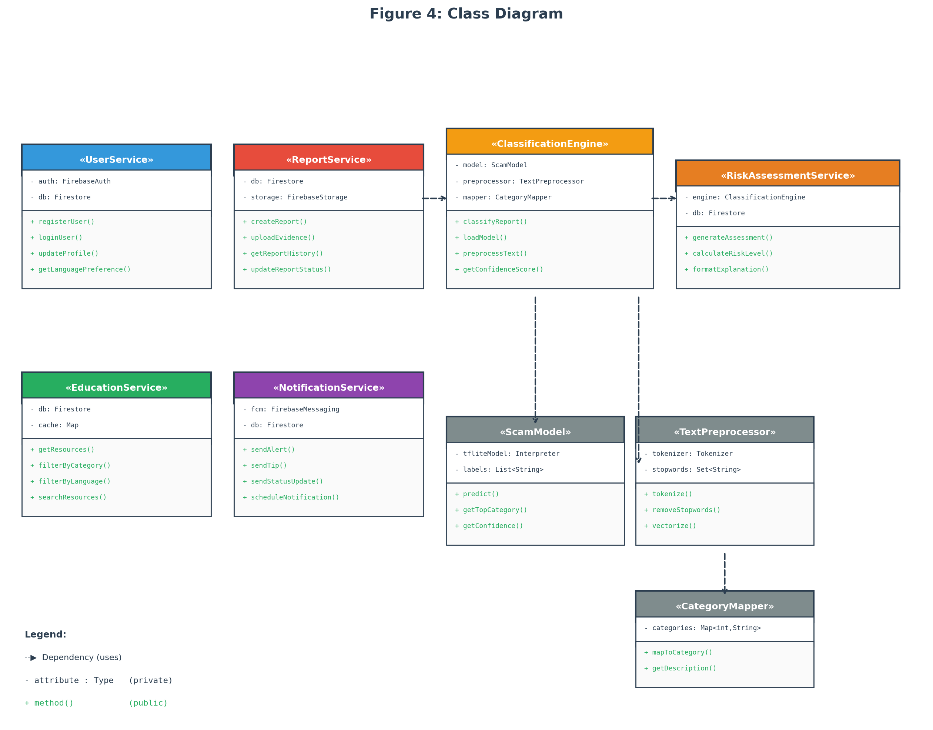
Figure 4: Class Diagram
Use Case Diagram
The use case diagram identifies the system's actors and their interactions with the application. Three actors are identified:
• Victim/User: The primary actor who registers, submits scam reports, views risk assessments, accesses educational resources, manages their report history, and receives push notifications.
• ML Classification System: An internal system actor that receives scam reports, performs NLP preprocessing, classifies reports into scam categories, and returns confidence scores to the Risk Assessment module.
• Administrator/Researcher: A secondary actor who accesses the backend dashboard, reviews aggregated anonymized data, monitors system performance, and manages educational content.
The primary use cases for the Victim/User actor are: Register/Login, Submit Scam Report, View Risk Assessment, Browse Educational Resources, View Report History, Update Language Preference, and Receive Notifications. The Submit Scam Report use case includes the Classify Scam (performed by the ML system) and Generate Risk Assessment sub-use cases. The Browse Educational Resources use case extends to Filter by Scam Category and Filter by Language.
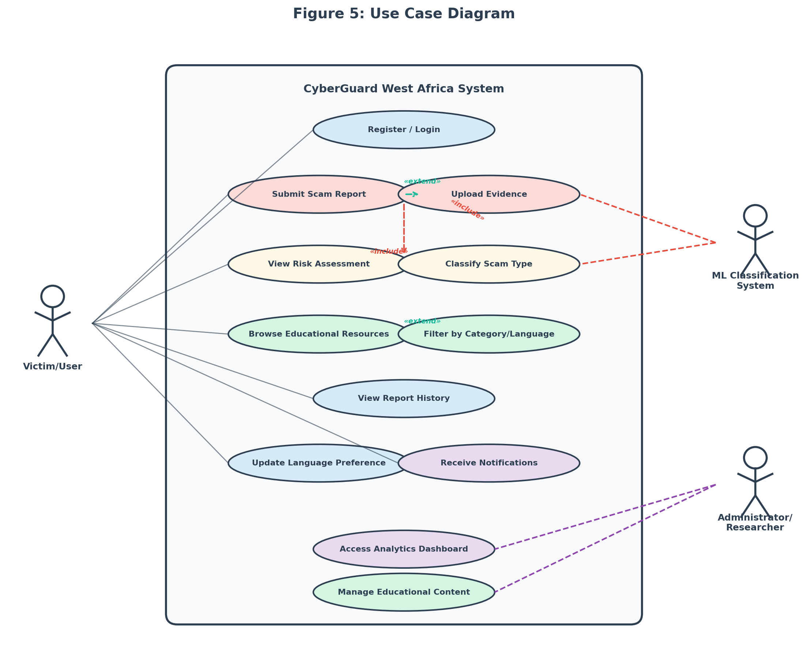
Figure 5: Use Case Diagram
3.5.7 Development Tools
The following tools and technologies will be used:
Table 4: Development Tools and Technologies
Tool/Technology | Purpose | Justification
Flutter (Dart) | Cross-platform mobile app development | Single codebase for Android and iOS; high performance; growing community (Google Developers, 2023)
Firebase Authentication | User registration and login | Supports email, phone (OTP), and social login; integrates natively with Flutter
Cloud Firestore | Real-time NoSQL database | Real-time data synchronization; offline support; scalable serverless architecture
Firebase Cloud Functions | Serverless backend logic | Handles ML inference, risk assessment computation, and notification dispatch without dedicated servers
Firebase Cloud Storage | File storage for evidence uploads | Secure storage for screenshots and message logs with fine-grained access control
Firebase Cloud Messaging | Push notifications | Reliable cross-platform notification delivery for scam alerts and safety tips
TensorFlow / TensorFlow Lite | ML model training and deployment | Industry-standard ML framework; TFLite enables on-device or cloud inference for scam classification
Scikit-learn | ML model evaluation and preprocessing | Standard library for classification metrics, cross-validation, and data preprocessing (Kohavi, 1995)
Visual Studio Code | Integrated development environment | Lightweight IDE with excellent Flutter, Dart, and Python extension support

3.6 Ethical Considerations
The study follows the Belmont Report's principles of respect for persons, beneficence, and justice (National Commission for the Protection of Human Subjects, 1979).
Institutional approval will be obtained from the African Leadership University's Institutional Review Board (or its equivalent) before any pilot testing begins. No data involving human participants will be collected until that approval has been granted. Informed consent will be obtained from every participant through a consent form that explains the purpose of the study, what participation involves, what data will be collected, how it will be stored and used, and their right to withdraw at any point without consequences. In Douala, the informed consent form will be available in both English and French. Written informed consent is required before any data collection starts.
All participant data will be kept confidential. Names and other personal identifiers will be stripped from datasets and replaced with codes during analysis and reporting. Surveys, interview transcripts, and app usage logs will be stored in encrypted files accessible only to the researcher and supervisor. On the app side, Firebase Authentication and Firestore security rules will prevent unauthorized access. Participants will be told exactly what data the app collects and how it is processed.
Some participants may find it uncomfortable to discuss their cybercrime experiences. Participation is voluntary, and participants can skip any question or leave the study at any time. Where appropriate, information about local victim support services will be provided. The study does not involve any intervention that could cause physical or psychological harm; the app is a support tool, and using it during the pilot carries no risks beyond those of normal smartphone use.
Research data will be kept for two years after the study ends in case verification or follow-up analysis is needed. After that, digital files will be permanently deleted and physical consent forms will be shredded. Participants will be recruited fairly through community technology hubs, universities, cybercafe networks, and local NGOs, without excluding anyone on the basis of gender, ethnicity, socioeconomic status, or language. The app itself supports English, French, and Pidgin English to keep access as broad as possible.

References
Adeniran, A. I. (2008). The internet and emergence of Yahoo-boys sub-culture in Nigeria. International Journal of Cyber Criminology, 2(2), 368-381.
African Union. (2022). African Union cybersecurity report: The state of cybersecurity in Africa. African Union Commission.
Agushaka, J. O., Oyefolahan, I. O., Abisoye, O. A., & Umar, M. B. (2021). An intelligent crime management system for reporting, investigation, and detection. Fudma Journal of Sciences, 5(2), 47-56.
Akanle, O., Adesina, J. O., & Akarah, E. P. (2020). Towards human dignity and the internet: The cybercrime (Yahoo Yahoo) phenomenon in Nigeria. African Journal of Science, Technology, Innovation and Development, 12(6), 683-691. https://doi.org/10.1080/20421338.2019.1694993
ANTIC. (2022). Rapport annuel sur la cybercriminalité au Cameroun 2021-2022. Agence Nationale des Technologies de l'Information et de la Communication.
Bangor, A., Kortum, P. T., & Miller, J. T. (2008). An empirical evaluation of the System Usability Scale. International Journal of Human-Computer Interaction, 24(6), 574-594. https://doi.org/10.1080/10447310802205776
Bott, M., & Young, G. (2012). The role of crowdsourcing for better governance in international development. PRAXIS: The Fletcher Journal of Human Security, 27, 47-70.
Braun, V., & Clarke, V. (2006). Using thematic analysis in psychology. Qualitative Research in Psychology, 3(2), 77-101. https://doi.org/10.1191/1478088706qp063oa
Brooke, J. (1996). SUS: A "quick and dirty" usability scale. In P. W. Jordan, B. Thomas, B. A. Weerdmeester, & I. L. McClelland (Eds.), Usability evaluation in industry (pp. 189-194). Taylor & Francis.
Buczak, A. L., & Guven, E. (2016). A survey of data mining and machine learning methods for cyber security intrusion detection. IEEE Communications Surveys & Tutorials, 18(2), 1153-1176. https://doi.org/10.1109/COMST.2015.2494502
Chieloka, O. E., & Ugwu, C. (2021). Application of machine learning in cybercrime detection in Nigeria. Journal of Computer Science and Its Application, 28(1), 14-27.
Cohen, L. E., & Felson, M. (1979). Social change and crime rate trends: A routine activity approach. American Sociological Review, 44(4), 588-608.
Creswell, J. W., & Creswell, J. D. (2018). Research design: Qualitative, quantitative, and mixed methods approaches (5th ed.). SAGE Publications.
Creswell, J. W., & Plano Clark, V. L. (2017). Designing and conducting mixed methods research (3rd ed.). SAGE Publications.
Davis, F. D. (1989). Perceived usefulness, perceived ease of use, and user acceptance of information technology. MIS Quarterly, 13(3), 319-340. https://doi.org/10.2307/249008
EFCC. (2023). Economic and Financial Crimes Commission annual report 2022. Federal Republic of Nigeria.
Etikan, I., Musa, S. A., & Alkassim, R. S. (2016). Comparison of convenience sampling and purposive sampling. American Journal of Theoretical and Applied Statistics, 5(1), 1-4. https://doi.org/10.11648/j.ajtas.20160501.11
Glenn, J. C., & Gordon, T. J. (2009). Futures research methodology version 3.0. The Millennium Project.
Goodman, L. A. (1961). Snowball sampling. The Annals of Mathematical Statistics, 32(1), 148-170.
Google Developers. (2023). Flutter documentation: Build apps for any screen. https://flutter.dev/docs
Hajomer, A. A. E., & Yunus, F. (2023). A phishing-attack-detection model using natural language processing and deep learning. Applied Sciences, 13(9), 5275. https://doi.org/10.3390/app13095275
Iliescu, D., & Olariu, C. (2021). Improving the tourists' experiences: Application of Firebase and Flutter technologies in mobile applications development process. In Proceedings of the 2021 International Conference on Engineering Technologies and Computer Science (pp. 45-51). IEEE. https://doi.org/10.1109/EnT52731.2021.9623025
Internet World Stats. (2023). Africa internet users, 2023 population and Facebook statistics. https://www.internetworldstats.com/stats1.htm
INTERPOL. (2021). African cyberthreat assessment report 2021. INTERPOL.
Kohavi, R. (1995). A study of cross-validation and bootstrap for accuracy estimation and model selection. Proceedings of the 14th International Joint Conference on Artificial Intelligence, 2, 1137-1143.
Kshetri, N. (2019). Cybercrime and cybersecurity in Africa. Journal of Global Information Technology Management, 22(2), 77-81. https://doi.org/10.1080/1097198X.2019.1603527
Mamoun, R., Alqudah, S., & Jaradat, A. (2021). Design and development of a mobile healthcare application prototype using Flutter. International Journal of Interactive Mobile Technologies, 15(17), 4-20.
Morgan, S. (2022). Cybercrime to cost the world $10.5 trillion annually by 2025. Cybersecurity Ventures. https://cybersecurityventures.com/cybercrime-damage-costs-10-trillion-by-2025/
Mwiya, B., & Phiri, J. (2020). Public crime reporting and monitoring system model using GSM and GIS technologies: A case of Zambia Police Service. International Journal of Advanced Computer Science and Applications, 11(4), 356-363.
National Commission for the Protection of Human Subjects. (1979). The Belmont Report: Ethical principles and guidelines for the protection of human subjects of research. U.S. Department of Health and Human Services.
NCC. (2023). Subscriber statistics: Annual report 2022. Nigerian Communications Commission.
Ndifon, R. A., & Achou, B. F. (2023). Cybercrime and mobile money fraud in Cameroon: Trends, challenges, and policy implications. African Journal of Criminology and Justice Studies, 16(1), 45-63.
ngCERT. (2022). Nigeria Computer Emergency Response Team annual report 2021-2022. Federal Republic of Nigeria.
Nielsen, J. (2000). Why you only need to test with 5 users. Nielsen Norman Group. https://www.nngroup.com/articles/why-you-only-need-to-test-with-5-users/
Ogbanufe, O., & Gerhart, N. (2020). The mediating influence of smartwatch identity on deep use and innovative individual use. Information Systems Frontiers, 22(4), 897-912. https://doi.org/10.1007/s10796-019-09910-w
Okuku, A., Renaud, K., & Vasileiou, I. (2015). Cybersecurity awareness in developing nations: A study of university students in Kenya. In Proceedings of the 2015 Information Security for South Africa Conference (pp. 1-7). IEEE.
Salloum, S., Gaber, T., Vadera, S., & Shaalan, K. (2022). A systematic literature review on phishing email detection using natural language processing techniques. IEEE Access, 10, 65703-65727.
Sauro, J. (2011). A practical guide to the System Usability Scale: Background, benchmarks, and best practices. Measuring Usability LLC.
ScamAdviser. (2023). About ScamAdviser. https://www.scamadviser.com/about
Schwaber, K., & Sutherland, J. (2020). The Scrum guide: The definitive guide to Scrum: The rules of the game. Scrum.org.
Tade, O. (2022). Internet fraud and the challenges of cybercrime in Nigeria. In Handbook of Research on Cybercrime and Information Technology (pp. 112-130). IGI Global.
Trend Micro. (2023). Trend Micro Fraud Buster. https://www.trendmicro.com/en_us/forHome/products/fraud-buster.html
Warner, J. (2011). Understanding cyber-crime in Ghana: A view from below. International Journal of Cyber Criminology, 5(1), 736-749.

