**CHAPTER 1**

**INTRODUCTION**

1. **Background Study**

Industry game is one of the biggest industries in this era. There are a lot of platform in Game industry such as WebGL, android, IOS, PC and etc. but mobile phone is the most and biggest device use in game industry. There are two major platform in mobile phone there is android and IOS.

In this modern era, online games are no longer foreign to the ears of teenagers. In the last 10 years, electronic games or what we often call online games have mushroomed everywhere. This is supported by the number of game centers in the surrounding environment, which offer affordable prices for teenagers. The game center itself is not like internet cafes, they have more regular customers than internet cafes. This is what makes game centers almost always crowded, not only game centers that are popular. However, gadgets / smartphones are also increasingly sophisticated and offer so many games, both offline and online games.

For today Game is not a really bad thing that every individual should avoid it. there is a lot of Educational game. But still need under parents’ control to avoid unwanted case that child doesn’t understand about. Even in covid-19 pandemic situation other than online study, interactive education game is one of the alternatives for school to increase student study.

Apart from this extreme thinking, the influence of online games on social life is seen at least at three levels of the individual, between individuals and communities.

Online game is an electronic and visual based game that utilizes electronic visual media technology and is played on a LAN or internet network. Furthermore, most of these "multiplayer games," here meaning games with more than two players, are "free-for-alls," meaning that each player is trying to win for him or herself as opposed to being on a team.

It is different from traditional games which tend to rely on the strength of the body muscles. Online games more often use the brain's ability to think and body agility on the fingers of the hand in pressing the buttons on the game control stick.

In Indonesia, the development of online games has become very rapid with the emergence of game centres that offer a variety of games at affordable prices and are easily accessible to school children or teenagers. There is around 270 million people in Indonesia. This is one of the biggest markets around the world.

In Esport industry, Indonesia is ready to support with the new regulation that make it simpler and more reliable. Indonesia ministry communication and information technology said that they will reducing the government's role as regulator and increasing its role as facilitator and accelerator. Former minister communication and information technology, Rudiantara (2014-2019) in IDBYTE ESPORT 2019 di ICE BSD, Tangerang, Banten.

*"Esports opens opportunities for millennials to become game developers. In the context of developing games, it is part of the growth of the digital economy in Indonesia,"*

Game can increase focus on what is happening around them, the players of this game are also able to master several things at the same time or multitasking. The learning process through games is also absorbed more quickly by someone. In other words, data games help train people who have problems in concentrating. In essence, the players of this game can be more focused and can concentrate more on something. In addition, games also have other benefits, namely games can train improvements in visual skills or vision. Various kinds of missions in the game

Dr. Rachel Kowert, whose study of the effects of video games and other mediated interaction said “game-rooted friendships “are as real as any offline friendships, “and they shouldn’t be discredited just because they’re mediated through technology.”

Era of technology is very wide and fast. There are a lot of smartphone user in world. Even in Indonesia there are 80% of android user. Android app is very affordable and easy to install. User not only can install from store; they can also install from APK.

UNITY is a game engine for a lot of platform. It can create 2D and 3D android game, video and VR. Unity have an easy to use UI (User Interface), easy to build and a lot plugin support. Developer of the unity is easier to find and have a big community base. There are a lot of android game that make using unity.

1. **Problem identification**

- Still new, in IT&B game programming is new, with a very large game industry in Indonesia is not grow equally with the grow of developer and the game programming education. Game programming has some different experience in the development step, game programming can give us more have fun in coding because everybody can express their idea on the game make it.

- Students often play games for many reasons. First, because the game has its own appeal to play. With various types of games that exist in this era, games can attract the attention of many people, especially students. Games have an extraordinary sensation, namely that they can provide entertainment and fun for students. This student age is an age where we get bored quickly with something. An example is with too many tasks to be done. Now, playing this game might make students get rid of the fatigue between them doing their assignments. By playing games, students' minds may be refreshed and can be used to think clearly again. Another reason student play game is to entertain themselves.

1. **The Scope of study**

* The study focusses on Game Development using Unity
* The game is only for education use, its mean that can only use by IT&B Campus environment.

1. **Objectives**

The objective of this study is to provide an entertainment media for student in IT&B Campus. The research also aims to increase or improve game development in IT&B campus. Moreover, it provides a source of information on the latest market developments and trends that can be useful for a number of individuals and organizations, including school and university.

1. **Benefit**

* Student
  + The ranking system in this game will increase interaction and collaboration among the student with each student. schools can also provide weekly, monthly or semester rewards based on the student rank in the game. Rewards can be any object as long as it can increase students' intentions in the game.
* Hopefully this game will increase the interest of computer students at the IT&B campus to learn game development.
* The example, source code and asset can be used to improve the knowledge and understanding in Unity Development.
* Teacher
  + The game source code can be use as an example for subject on unity lesson

**Chapter 2**

**Theoretical background**

1. **DEFINITION OF UNITY**

Unity is a cross-platform game engine developed by Unity Technologies, first announced and released in June 2005 at Apple Inc.'s Worldwide Developers Conference as a Mac OS X-exclusive game engine. As of 2018, the engine had been extended to support more than 25 platforms. The engine can be used to create three-dimensional, two-dimensional, virtual reality, and augmented reality games, as well as simulations and other experiences. The engine has been adopted by industries outside video gaming, such as film, automotive, architecture, engineering and construction.

Also, Unity 3D offers a free version so developers can release games made with Unity Personal without paying for the software, so long as they make less than $100,000 from games made with Unity. Unity 3D comes loaded with a ton of professional tools for both programmers and artists. Unity provides a workspace that combines artist-friendly tools with a component-driven design that makes game development pretty darn intuitive. Both 2D and 3D development is possible in Unity, with 2D physics handled by the popular Box2D engine. Unity uses a component-based approach to game dev revolving around prefabs. With prefabs, game designers can build objects and environments more efficiently and scale faster. With powerful shaders, physics-based materials, post-processing, and high-resolution lighting systems, Unity can deliver impressive graphics across the board.

**2.1.1 Scene view**

The scene view is one of the most used views as this is where all the game objects are placed and scenes for the game are built. Is the example of scene view of this game been built, in specific “MainMenu” Scene. This view allows the programmer to move through the entire world the game is built in. To help position objects, Unity can snap to specific increments when dragging. To use snapping, hold down Command (Mac) or Control (PC) when using the Translate tool (W) to move objects in the Sceneview.”

**2.1.2 Game View**

The game view is what user will see when the game is started. There are several options for this window. Across the top of the window there are several button/drop down menus which can change things from the perspective, full screen, and gizmos shown in the game view. And for android resolution unity prepare a lot of resolution start from landscape and portrait, even we can customize the resolution with 2 option , aspect ratio and fixed resolution.

This is very helpful for the programmer to set the resolution and positioning the object in the game with live view , rather then build and run in android device

**2.1.3 Hierarchy View**

The hierarchy view is where all the objects in the game can be created, accessed, grouped and manipulated to make the game. When the project is saved, the objects are saved in a scene file. Is the hierarchy view where are all the objects that make up the game. Any entry which has an arrow next to it can be expanded to show more objects; the arrow indicates a group of objects. This hierarchy view is extremely helpful when there are many objects in a scene and just one of them needs to be found in the scene. The object can be double clicked in this view and it will be selected and zoomed in on the scene view. We can also search, sort, categorize the GameObject.

**2.1.4 Project View**

The project view is where all the scripts and scenes are accessible from. This view is exactly like the file explorer on Windows or Mac and allows creating files and folders to help organize the projects assets. Same as the hierarchy concept, where the arrow side of the folder mean there is a subfolder or item. Is very important for us to always organize the item and folder

**2.1.5 Inspector View**

The inspector view is where all the physics and properties of the objects are stored and accessed from. Every game object has a transform; this is what holds properties of the object such as rotation, position and scale. Other properties are the physics affecting the object, textures to load on the object and sound. This also where our script can interact to the GameObject and Game.

1. **PlayerPrefs**

Stores and accesses player preferences between game sessions. Data can be Integer, string, float. It very helpful for small game and small data size kind of playername, playerpoint, player position.

On Android data is stored (persisted) on the device. The data is saved in Shared Preferences. C#/JavaScript, Android Java and Native code can all access the PlayerPrefs data. The PlayerPrefs data is physically stored in /data/data/pkg-name/shared_prefs/pkg-name.xml.

On Windows, PlayerPrefs are stored in the registry under HKCU\Software\[company name]\[product name] key, where company and product names are the names set up in Project Settings.On iOS, PlayerPrefs are stored in /Library/Preferences/[bundle identifier].plist.

1. **Visual Studio (IDE)**

Visual Studio, also known as Microsoft Visual Studio and VS, is an integrated development environment for Microsoft Windows. It is a tool for writing computer programs, websites, web apps, and web services. It includes a code editor, debugger, GUI design tool, and database schema designer, and supports most major revision control systems. It is available in both a free "Community" edition and a paid commercial version.

Visual studio is also one of the most popular IDE for unity follow by visual Studio Code and MonoDevelop.

1. **C# (Programing language)**

C# (pronounced see sharp, like the musical note C♯, but written with the number sign) is a general-purpose, multi-paradigm programming language encompassing strong typing, lexically scoped, imperative, declarative, functional, generic, object-oriented (class-based), and component-oriented programming disciplines.[16] It was developed around 2000 by Microsoft as part of its .NET initiative, and later approved as an international standard by Ecma (ECMA-334) and ISO (ISO/IEC 23270:2018). Mono is the name of the free and open-source project to develop a compiler and runtime for the language. C# is one of the programming languages designed for the Common Language Infrastructure (CLI).

C# is widely-used to create games using the Unity game engine, which is the most popular game engine today. More than a third of top games are made with Unity, and there are approximately 770 million active users of games created using the Unity engine. Unity is also used for VR, with 90% of all Samsung Gear and 53% of all Oculus Rift VR games developed using Unity.

C# is a very popular tool for creating these applications, and so makes a great choice for any programmer hoping to break into the game development industry.

1. **PHP (Scripting Language)**

PHP is a server-side scripting language. that is used to develop Static websites or Dynamic websites or Web applications. PHP stands for Hypertext Pre-processor, that earlier stood for Personal Home Pages. PHP scripts can only be interpreted on a server that has PHP installed. The client computers accessing the PHP scripts require a web browser only.

Scripting language is a set of programming instructions that is interpreted at runtime. A scripting language is a language that interprets scripts at runtime. Scripts are usually embedded into other software environments. The purpose of the scripts is usually to enhance the performance or perform routine tasks for an application.

Server-side scripts are interpreted on the server while client-side scripts are interpreted by the client application. PHP is a server-side script that is interpreted on the server while JavaScript is an example of a client-side script that is interpreted by the client browser. Both PHP and JavaScript can be embedded into HTML pages.

1. **Web Hosting (000WebHost)**

Web hosting is a service that allows organizations and individuals to post a website or web page onto the Internet. A web host, or web hosting service provider, is a business that provides the technologies and services needed for the website or webpage to be viewed in the Internet. Websites are hosted, or stored, on special computers called servers. When Internet users want to view your website, all they need to do is type your website address or domain into their browser. Their computer will then connect to your server and your webpages will be delivered to them through the browser.

Free web hosting tends to be so limited in capabilities and features that users must pay to get what they need.

However, 000webhost is a free website hosting solution that provides an array of valuable features, including a website builder, WordPress support, and no ads. Users can upgrade to a paid plan to get even more features and support, but based on our reviews, 000webhost is the best free web hosting solution for those who are truly on a tight budget. One of the most impressive features of 000webhost is that you can run PHP and MySQL from a free account.

This enables you to use a content management system (CMS) like WordPress, which is a great platform for users who don't have much tech experience. 000webhost's custom control panel makes it easy to manage your websites, files, databases, email, backups, and FTP accounts. This is also where you can view traffic levels and see how much space your site is using.

1. **JSON**

JSON can be defined as a Java Script Object Notation file format, that is used for sending, receiving and storing the data from same or different systems in a network. It is generally used in the REST request and response application program interface (API) services, as JSON is uncomplicated and in readable format. Unlike the traditionally used Extensible Markup Language (XML), it enables faster accessibility, memory optimization, shorter and simpler in nature, and does not contain complicated syntax & tags.

{“Name”: “Alex”,  
“Occupation”: “Teacher”,  
“Places visited”: [“San Francisco”, “California”, “Houston”] }

In the above examples, ‘Name’, ‘Occupation’, ‘Places visited’ are the keys and ‘’Alex’, ‘Teacher’ and the array [“San Francisco”, “California”, “Houston”] are the values of the respective keys and the whole data enclosed in the flower brackets constitutes an JavaScript Object Notation Object. The values can be a string, another object, a Boolean, null, a number.

Use the [JsonUtility](https://docs.unity3d.com/ScriptReference/JsonUtility.html) class to convert Unity objects to and from the [JSON](http://www.json.org/) format. For example, you can use JSON Serialization to interact with web services, or to easily pack and unpack data to a text-based format.

JSON Serialization uses a notion of “structured” JSON: you create a class or structure to describe what variables you want to store in your JSON data. For example:

[Serializable]

public class MyClass

{

public int level;

public float timeElapsed;

public string playerName;

}

Benchmark tests indicate that [JsonUtility](https://docs.unity3d.com/ScriptReference/JsonUtility.html) is significantly faster than popular .NET JSON solutions, even though this class provides fewer features in some cases.

Memory usage for garbage collection (GC) is at a minimum:

* [ToJson](https://docs.unity3d.com/ScriptReference/JsonUtility.ToJson.html) allocates GC memory only for the returned string.
* [FromJson](https://docs.unity3d.com/ScriptReference/JsonUtility.FromJson.html) allocates GC memory only for the returned object, as well as any subobjects needed (for example, if you deserialize an object that contains an array, then Unity allocates GC memory for the array).
* [FromJsonOverwrite](https://docs.unity3d.com/ScriptReference/JsonUtility.FromJsonOverwrite.html) allocates GC memory only as necessary for written fields (for example, strings and arrays). This means that Unity does not allocate any GC memory at all if all the fields being overwritten by the JSON are value-typed.

You can use the JsonUtility API from a background thread. However, as with any multithreaded code, be careful not to access or alter an object on one thread while another thread is serializing or deserializing it.

1. **Unity Asset Store**

The Unity Asset Store is home to a growing library of free and commercial assets created both by Unity Technologies and also members of the Community. A wide variety of assets is available, covering everything from textures, models and animations to whole Project examples, tutorials and Extension Assets.

The assets are accessed from a simple interface built into the Unity Editor and are downloaded and imported directly into your project. People use the Asset Store as the content helps them to improve their game or application and reduce the workload needed to create models or tools.

1. **Network**

A network consists of multiple devices that communicate with one another. It can be as small as two computers or as large as billions of devices. While a traditional network is comprised of desktop computers, modern networks may include laptops, tablets, smartphones, televisions, gaming consoles, smart appliances, and other electronics.

1. Local Area Network (LAN)

A local area network is limited to a specific area, such as a home, office, or campus. A home network may have a single router that offers both wired and wireless connections. For example, a computer may connect to the router via Ethernet, while smartphones and tablets connect to the router via Wi-Fi. All devices connected to the router share the same network and often the same Internet connection.

A larger network, such as the network of an educational institution, may be comprised of many switches, hubs, and Ethernet cables. It may also include multiple wireless access points and wireless repeaters that provide wireless access to the network. While this type of network is much more complex than a home network, it is still considered a LAN since it is limited to a specific location.

1. Wide Area Network (WAN)

A wide area network is not limited to a single area, but spans multiple locations. WANs are often comprised of multiple LANs that are connected over the Internet. A company WAN, for example, may extend from the headquarters to other offices around the world. Access to WANs may be limited using authentication, firewalls, and other security measures. The Internet itself is the largest WAN since it encompasses all locations connected to the Internet.

1. **Database**

A database is an organized collection of structured information, or data, typically stored electronically in a computer system. A database is usually controlled by a database management system (DBMS). Together, the data and the DBMS, along with the applications that are associated with them, are referred to as a database system, often shortened to just database.

Data within the most common types of databases in operation today is typically modeled in rows and columns in a series of tables to make processing and data querying efficient. The data can then be easily accessed, managed, modified, updated, controlled, and organized. Most databases use structured query language (SQL) for writing and querying data.

1. **MySql**

MySQL is a Relational Database Management System (RDBMS) used as SaaS (Software as a Service). MySQL was released in 1995 and is now developed by Oracle Corporation. MySQL is the most popular database management system for hosting service providers such as Rackspace, GoDaddy, Bluehost, and WHM. In addition, Facebook, Twitter, Yahoo, Wikipedia, YouTube use MySQL. Here are some of the advantages of MySQL :

1) MySQL can be used in various operating systems such as Windows, Linux, FreeBSD, Mac Os X Server, Solaris, Amiga, and many more.

2) MySQL is open source.

3) MySQL can be used by multiple users at the same time without any problems or conflicts.

4) MySQL has amazing speed in handling simple queries, in other words it can process more SQL per unit of time.

5) MySQL has very complex column types, such as signed/unsigned integer, float, double, char, text, date, timestamp, etc.

6) MySQL has full operators and functions and supports Select and Where commands in commands (queries).

7) MySQL is capable of handling databases at scale, with more than 50 million records and 60 thousand tables and 5 billion rows. 8) MySQL has an interface to various applications and programming languages using API (Application Programming Interface) function

**Chapter 3**

**Research Methodology**

1. Research Object
   * Unity Game, research does research of unity coding C# fundamental, intermediate and some unity plugin and source to review and complete the Game project.
   * Web host, research how to operate 000webhost for the web hosting, the reason is free and suitable for this game project that didn’t need a very big traffic of use and data.
   * PhpMyAdmin, the database to store user data and information that provide by the phpMyAdmin web host. Researcher found how to make a connection between the database and the unity game coding. and researcher also learn and look for some coding material for understanding the php.
2. Location

* IT&B Campus, Mahoni Street, Medan North Sumatera Researcher does research in IT&B campus, the main object and purpose in this research is to provide game as entertainment for student in IT&B Campus.

1. Data Analysis

Data analysis typically requires appropriate statistical techniques to be applied to the collected data. There are two forms of research, Primary and secondary. Primary research is defined as a methodology used by researchers to collect data directly, rather than depending on data collected from previously done research. Technically, they “own” the data.

Secondary is published information available from the other sources that has already been gathered. This information is relevant to the problem at hand. Either internal or external to an organization. One of the most popular ways of collecting secondary data is using the internet.

In this research, researcher mostly using the secondary method to finish the research. Most of coding is using the reference and solution over internet and previous done research.

1. Data Analyzing Method

The writer used the following methods for research in order to complete this research, as follow:

1. Quantitative data is information about quantities, and therefore numbers

The data can be using the mathematical and statistical solution to solve and provide an information about the research.

In quantitative method, researcher first need to know how interest the potential user in the game to get the prediction quantity of the user. This also can give the researcher to prepare the game and the user database to support the game.

1. *“Qualitative research is multimethod in focus, involving an interpretive, naturalistic approach to its subject matter. This means that qualitative researchers study things in their natural settings, attempting to make sense of, or interpret, phenomena in terms of the meanings people bring to them.” (Denzin and Lincoln (1994, p. 2)).*

A good example of a qualitative research method would be unstructured interviews which generate qualitative data through the use of open questions.  This allows the respondent to talk in some depth, choosing their own words.  This helps the researcher develop a real sense of a person’s understanding of a situation. student, parent and school. This will generate a data and information for researcher

**Chapter 4**

**RESULT & DESIGN**

1. **Result**
2. **System Diagram**

**Figure 4.1** Flowchart Beginning Game



In this scene first we checking the internet connection, if the internet connection is not found or offline, then error message will show then user have choice to retry or quit the application.

Then if there have an internet connection, the scene will continue checking if android ID have the same with the server android ID, then check the PlayerPrefs data. if PlayerPrefs not empty it will continue to “MainMenuScene” else “LogInScene”.

**Figure 4.2** Flowchart Login Scene



Login scene is where the information about the user is set. First user input their user ID and user password. Then the server will check the validation of the user ID and user Password in database. if not valid error message will show else will continue to Main Menu.

In this process , also will reassign User Android Id in database , this mean that every last user login using the same user ID , the first user will been log Out from the app. So the better choice for secure the User id is change the user password .

**Figure 4.3** Flowchart Main Menu



Main Menu scene is the main scene for the entire game, user detail and game will be in this scene. When the first load of scene, the app will assign user detail base on the user information where the app got from the server. Then when the user wants to play the game. They can select the game on the scene, it will show the leaderboard for each game. Only to 10 users will show on the leaderboard.

When the user presses the start game Button, first the app will check the internet connection of the device. If the connection is null or no connection message pop Up will shown and will give 2 buttons of retry and quit application. Else if the connection is available the app will make sure that there are no more than 1 device using an account. By checking and compare the device ID from the smartphone and server. If there are different device Id it means possible another device is using the same account. So the first user that using the account will been log out.

**Figure 4.4** Flowchart Game Scene



In Game scene is same flow for each Game, it only updates the user score if the score is greater than the previous high score. For the first load of the game scene. It will take no action of internet connection, because the game can be play offline, only when the user lose and the game need to update the score is where the internet connection will needed. The high score will only update if the score in game is higher or greater than the score in server.

1. **Design**

**Figure 4.5** Loading Scene



Loading scene, or beginning scene in flowchart. The design in the scene use TextMeshPro from unity assetstore, similar with UnityEngine.Ui.Text that show text for the user, but using the textmeshpro we can have more editable text and HD look in the on the editor and very helpful for developer.

For the loading bar , it using the unity slider and by change the asset and control the value in the slider, we can get a loading bar design.

**Figure 4.6** Log In scene



Login Scene design, using input field from unity UI for the user ID and User Password by changing the asset sprite of the input field we can get a better look of input field rather than the default input field. Similar for the button Log In , by changing the asset sprite also will get a better look design.

**Figure 4.7** Event

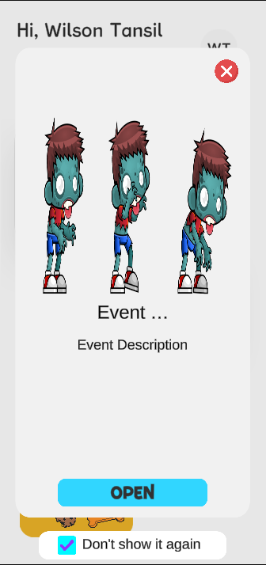

Event, is a pop Up message that show on the beginning of the main menu scene. This function is use for IT&B campus to announcement and event. This event is get from the server database. It provide image and text. User can check the “Don’t show it again” to prevent PopUp every load the Menu.

**Figure 4.8** Menu

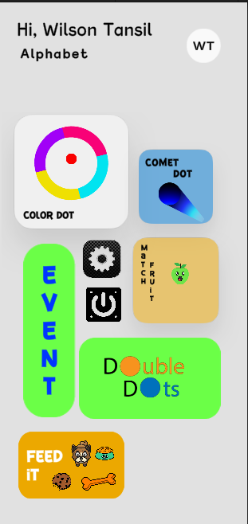

Main menu design, the developer tries to make a simple User interface and clean. On the main menu, there are only User Name, User class as the information and for the Circle on the right top is a button for detailed user information.

**Figure 4.9** User Information Detail

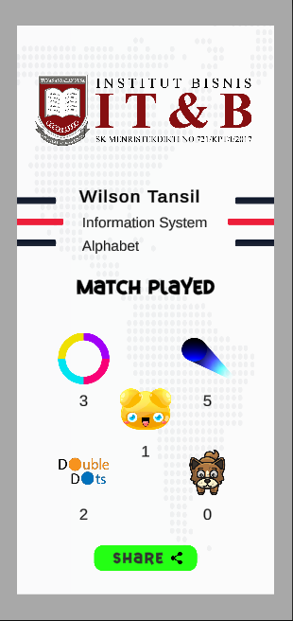

The panel will show out if the user presses the top right corner button. Is contain user information such as name, majors, class, favorite Game, played game. User can also share the user information card through media social.

This also will help promotion along IT&B campus program.

**Figure 4.10** Setting

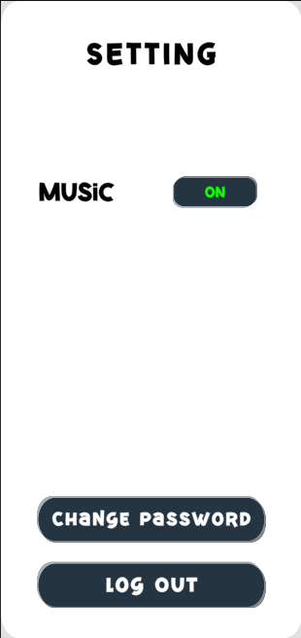

Setting panel, the panel that contain Music, BGM, Change Password, Log out button. User can choose to mute or unmute music and BGM.

**Figure 4.11** Leaderboard

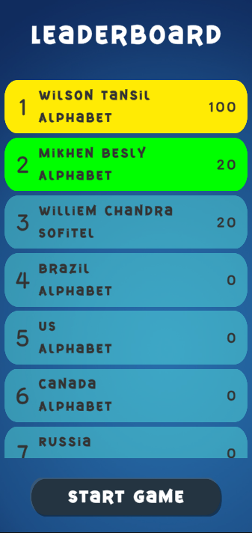

Ranking system can enhance playing group experience. When player overlap the ranking of the other player. The player that has been overlap will continue play to beat the upper rank. Some case this condition can be continue until one of the players give up.

**Figure 4.12** Check Connection



In flow chart main menu, we can find that there is a decision checking connection. This the design of checking connection before starting game.

If the connection is ready. It will continue checking the Device ID by compare user device ID and device ID from server that previous update after User Login to the game.

**Figure 4.13** Warning User Login

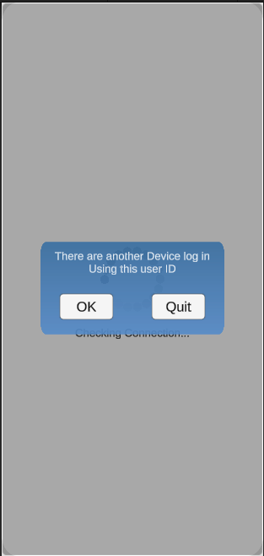

If there is different between Device ID and Device ID from the server. A Popup message will show. And told the user that there is another device already login using the user ID. There are two choice for the user. “OK” button will take user back login scene. And “Quit” button will take user Quit from the app.

This message also give a warning to user to always change the password.

**Figure 4.14** Chat Room

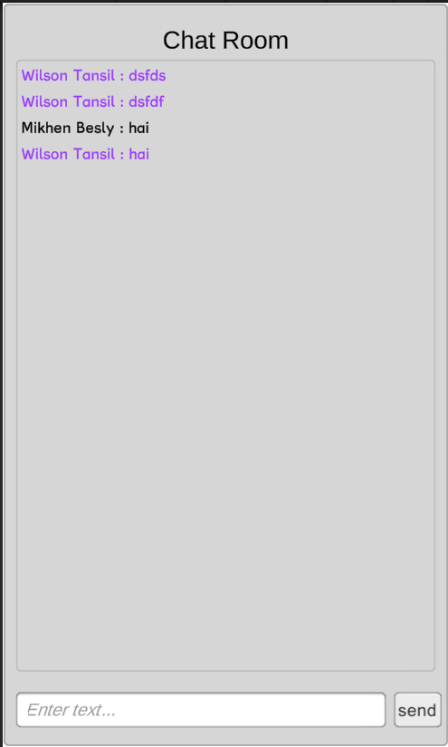

Chat room, is a feature that base on the title of research “to increase interaction between IT&B Student”. This is an open chat room, mean that every user can chat in this chat room and seen by every user. User or student can share their experience and information here.

**Figure 4.15** Game



Game scene, one example of this GameHub Game project. Every game will have a similar point and logic game such as high score.

**Figure 4.16** High score

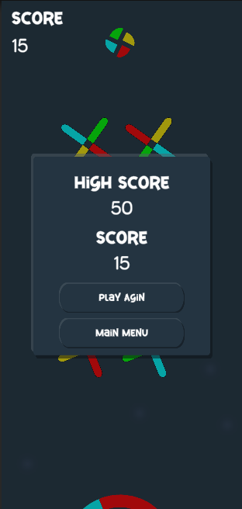

High score, show the user High score for the game. And also, in this session the will update the user game match.

1. **Analysis and Discussion**
2. **Analysis**

Analysis is can be used to identify a problem for a system requirement. The result used to help analysis user needs and system requirement.

The purpose of propose this project is the writer want to introduce is game programming, and give an entertainment for all student and staff.

1. **Discussion**

Application testing is done by testing functionality and testing to users. Functionality testing is done to find out errors when using the application. Meanwhile, user testing is carried out to determine the suitability of the application to the needs of users in the field.

The functionality that writer testing is:

1. Checking Internet connection, this functionality is to make sure user device is ready to start the game, because the Game hub need Internet connection to connect and grab data from the server.
2. Login User, every student has their own user ID and user password use to identify every user.
3. Event system, to get information about event in IT&B campus.
4. Chat room, for every user to chat and share information.
5. Leader board system, information about high score for every ga

**Chapter 5**

**CONCLUSION & SUGGESTION**

1. **Conclusion**

After finishing the research about the game programming and the potential. Writer can conclude that game programming is one of the most successful carrier field in information technology. With a lot of potential talent such as programmer, graphic design, back-end server, UI and UX. All is including in the game programming,

1. **Suggestion**

Based on the conclusion above, the writer would like to give a few suggestions for IT&B Campus:

1. Team work in game programming is very important, every individual have their own talent. To gather every talent into one group base on the requirement in conclusion will increase their ability.
2. Learning Game programming is new step for IT&B campus, but the market of game programming is very big , a lot of competitor and a lot of requirement to be success in this field.

Citation

Petty, J. (2019, March 14). *What is Unity 3D & What is it Used For?* Concept Art Empire. <https://conceptartempire.com/what-is-unity/>

*Player Interaction in Multiplayer Games | Board Game Snob*. (n.d.). BoardGameGeek. Retrieved August 5, 2021, from https://www.boardgamegeek.com/blogpost/61919/player-interaction-multiplayer-games

‌ *Pemerintah Siap Dukung Esport di Indonesia*. (2019, September 14). Merdeka.com. <https://www.merdeka.com/teknologi/pemerintah-siap-dukung-esport-di-indonesia.html>

*Jason Dansie Game Development in Unity Game Production, Game Mechanics and the Effects of Gaming*. (2013). <https://www.theseus.fi/bitstream/handle/10024/68068/Dansie_Jason.pdf?sequence=1&isAllowed=y>

*000webhost Reviews 2021*. (n.d.). Digital.com. Retrieved August 5, 2021, from <https://www.whoishostingthis.com/hosting-reviews/000webhost/>

*What is PHP? Write your first PHP Program*. (2019, May 29). Guru99.com. <https://www.guru99.com/what-is-php-first-php-program.html>

*What is JSON? | How It Works | Advantages & Disadvantages | Examples*. (2019, May 8). EDUCBA. <https://www.educba.com/what-is-json/>

Technologies, U. (n.d.). *Unity - Manual: JSON Serialization*. Docs.unity3d.com. <https://docs.unity3d.com/Manual/JSONSerialization.html>

*Network Definition*. (2018). Techterms.com. <https://techterms.com/definition/network>

Oracle. (2021). *What is a database?* Www.oracle.com. https://www.oracle.com/database/what-is-database/

‌ Catheline(09020008). (n.d.). *UNO NETWORKING GAMES* [BOOK *UNO NETWORKING GAMES*].

‌

‌

‌

‌

‌

‌

‌

‌

https://conceptartempire.com/what-is-unity/

<https://www.boardgamegeek.com/blogpost/61919/player-interaction-multiplayer-games>

https://www.merdeka.com/teknologi/pemerintah-siap-dukung-esport-di-indonesia.html

UNO NETWORKING GAMES, Catheline, 09020008 ,2013

<https://www.theseus.fi/bitstream/handle/10024/68068/Dansie_Jason.pdf?sequence=1&isAllowed=y>

<https://www.whoishostingthis.com/hosting-reviews/000webhost/>

<https://www.guru99.com/what-is-php-first-php-program.html>

<https://www.educba.com/what-is-json/>

credit

**Music by Joystick -** <https://www.joystock.org>

**= Aura,popcicle (DOubleDot)**

**= funky beach (mainMenu)**

<https://mixkit.co>

https://docs.unity3d.com/Manual/JSONSerialization.html

<https://techterms.com/definition/network>

https://www.oracle.com/database/what-is-database/