IT&B CAMPUS IT FINAL YEAR PROJECT

Unity GameHub with Leaderboard System to Increase Interaction between student in IT&B campus

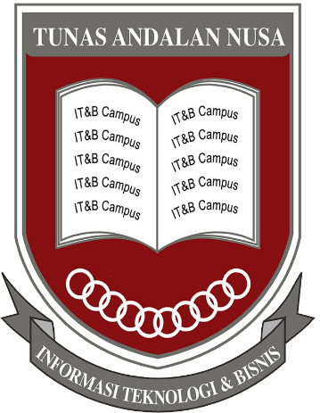

By

Wilson Tansil

17020014

Information System- IT&B CAMPUS

MEDAN

2021

IT&B CAMPUS IT FINAL YEAR PROJECT

Unity GameHub with Leaderboard System to Increase Interaction between student in IT&B campus

This final year project is Done as one of the requirements to complete the Diploma Degree for Information System Program Study



By

Wilson Tansil

17020014

Information System- IT&B CAMPUS

MEDAN

2021

PREFACE

With the grace and blessing of the Almighty God, the writer has completed the final year project entitled “Unity GameHub with Leaderboard System to Increase Interaction between student in IT&B campus”.

This project is written for partial fulfillment of the requirements for the degree on the study program of information system., IT&B Campus, Medan, North Sumatra, Indonesia.

In completing the writing, the author would like to express the sincere thank you, assistance, and advice to the following people:

1. Mr. Thamrin Kwan, BSc(Hons), as Information Technology Head of IT Department and as final year project advisor who had guided me and given me instructions for the completion this project.

Lastly, the writer has admit that there may still be some imperfections and mistake in this final year project. Therefore, constructive comments as well as criticism from the readers aimed at the improvement of the thesis content are welcomed and highly appreciated.

Medan

The author

Wilson Tansil

(17020014)

Abstract

Unity is one of the most popular game engine for beginner or to learn Game programming. The title has a main point, it is “Game Hub” actually the meaning of Hub is a group of some content. in this case a group of game in one Apps.

In leaderboard system, the writer using database to store the value and it’s using an internet connection to play the game. The type of game is a hyper-Casual game, it simple to play and fast to finish.

Another main point of this final year project is the writer hope this game can be develop more in the future. As we can see the market of game development is bigger and bigger through the time. also the technology that the game engine use to make development easier and faster.