**BIRLA INSTITUTE OF TECHNOLOGY AND SCIENCE, PILANI**

**SECOND SEMESTER 2021-2022**

**SESAP ZG629T PROJECT WORK**

**Project Work Outline**

**BITS ID No.** 2021SP93008 **Name of Student:** Wilton Santhosh D Souza

**E-mail ID of the student:** [2021SP93008@wilp.bits-pilani.ac.in](mailto:2021SP93008@wilp.bits-pilani.ac.in)

**Name of Supervisor:** Gowthami Konakanchi

**Designation of Supervisor**: Developer

**Qualification and Experience:** B. E. with 8 years of experience at SAP Labs, India

**E- mail ID of Supervisor**: g.konakanchi@sap.com

**Title of Project Work**: Customer Dissatisfaction and Commitment Projections using Linear Discriminant

Analysis, Support Vector Machines and Decision Trees

**Name of Examiner:** Abhishek Kumar

**Designation of First Examiner**: Developer

**Qualification and Experience:** B.Tech. with 10 years of experience at SAP Labs, India

**E- mail ID of First Examiner:** abhishek.kumar11@sap.com

**Supervisor’s rating of the Technical Quality of this Project Work Outline**

EXCELLENT / GOOD / FAIR/ POOR (Please specify): Excellent

**Supervisor’s suggestions and remarks about the outline:** Ok and Approved





Wilton Santhosh D Souza Gowthami Konakanchi

(Signature of Student) (Signature of Supervisor)

Date: 10.02.2023 Date: 10.02.2023

**Problem Statement**

The most valuable asset of any business is its customers and keeping those customers happy can increase revenue and foster meaningful long-term relationships with them. Additionally, getting a new customer is five times more expensive than keeping an existing one. One of the most well-known issues in business is customer attrition or loss, which occurs when customers or subscribers cease using a product or a company. They should ideally no longer be a paying customer.

This problem affects companies in various industries frequently. You need to make an investment in gaining new customers if you want your business to expand. Every time a customer goes, a sizable investment is lost. It is necessary to put time and effort into finding replacements. A company can save a ton of money if it can foresee when a client is most likely to depart and give them incentives to stay.

Understanding what keeps customers engaged is therefore very important information since it may help you create retention strategies and implement operational procedures meant to prevent customers from leaving.

**Proposed Solution**

The solution proposed is Customer Dissatisfaction and Commitment Projections. It is predicting which customers are most likely to leave your business or end a subscription to a service.

In the proposal approach, we will be using three algorithms that is Linear Discriminant Analysis (LDA), Support Vector Machines and Decision Trees. Based on the models developed from these algorithms using unbalanced and balanced data and the best data will be chosen out of it. All of the issues raised above can be effectively resolved with this information. The user is given access to a dashboard that displays all the insights obtained through the algorithms and enables him to take swift action on the insights. The activity comprises delivering a feedback form, offering additional discounts to customers who are purchasing frequently and notifying them of loyalty discounts. It also includes sending new product and related product alerts through email or SMS to customers who are valued and frequent buyers.

The proposed solution has the following advantages:

* Identification of at-risk clients,
* Identification of pain points
* Identification of implementable strategies
* Increased revenue
* Optimization of products and services

**Broad area of work**

Customer dissatisfaction measures how frequently customers decide not to buy more of a company's products or services. An approach to calculating this rate is through customer attrition analysis. Attrition analysis essentially shows you what proportion of your consumers don't make a return purchase compared to the proportion that do repeat business. You might be able to see trends that can prevent failure or propel an already successful product or service to the next level by delving further into these numbers. The financial effects of consumers leaving are also measured by high-performing businesses, who then compare those results to key performance indicators (KPIs) important to the profitability of the company. This KPI can be calculated over different timeframes and its results can be trended.

Linear Discriminant Analysis (LDA) is a dimensionality reduction technique. By splitting groups into two or more classes, it is used to illustrate how groups differ from one another. This technique divides the two groups as clearly as possible between the two groups using data from the dataset (in our case, the two groups are customers who stay and customers who leave).

Support Vector Machines is used to uncover hidden trends in the dataset. It is a supervised learning technique that finds the most effective hyperplanes for dividing samples of different classes using mathematical equations to describe a given collection of variables in a high-dimensional environment. In the same high-dimensional space, new samples are represented and assigned a class based on how close they are to the hyperplane. When used to predict customer attrition, this model works remarkably well.

Decision Tree models produce a tree-like structure and represents a set of decision values. Each class label's probability is estimated. Internal, branch, and leaf nodes are the three main types of nodes found in decision trees. It is one of the most often used attrition prediction models since it can predict both continuous and categorical data.

**Objective**

The main objective of the project is to develop a dashboard that will aid the primary user by training machine learning models and understanding the hidden patterns in the extensive customer database that can accurately predict which customers will leave a business, allowing the owner to make better marketing decisions.

**Benefit to the organization**

Every business aspires to have a deeper understanding of its client so that it may base strategic decisions on that understanding. With the aid of this service, businesses can utilise the client data at their disposal to enhance sales and build enduring operations. These days, it's necessary to provide the application intelligence in addition to integrating it with other systems. The B2C market is the focus of this solution area. The company will really profit from this, and competitors will adopt it more widely and gain market share.

**Scope of Work**

* Pre-processing the customer dataset to avoid outliers in the data
* Applying Linear Discriminant Analysis, Support Vectors Machines and Decision Trees to train the machine learning models
* Providing the customer, a dashboard with a full analysis so they can take appropriate action. The activity includes sending an email or SMS with a feedback form, providing discount notifications to churning out customer, providing the client a dashboard with a full analysis so they can take appropriate action, proposing related products and new ones, and offering loyal customers discounts.

**Detailed Plan of Work**

|  |  |  |  |  |
| --- | --- | --- | --- | --- |
| **Serial Number of Task** | **Tasks or subtasks to be done (be precise and specific)** | **Start Date-End Date** | **Planned duration in weeks** | **Specific Deliverable in terms of the project** |
| 1 | Literature Survey - Problem comprehension, application cases, and relevant research |  | 2 weeks | Document |
| 2 | Finalizing the tech stack, components, and system design |  | 1 week | System Design |
| 3 | Data visualization and pre-processing |  | 3 weeks | Final Dataset |
| 4 | Decision Trees and Support Vector Machines models development with training |  | 2 weeks | Prepared models |
| 5 | Linear Discriminant Analysis model development with training |  | 1 week | Prepared model |
| 6 | Admin Dashboard – To maintain the models with updated datasets |  | 2 weeks | Admin Dashboard |
| 7 | UI design for the User dashboard and development - ReactJS |  | 2 weeks | UI Dashboard Design |
| 8 | Integration UI and models |  | 1 week | UI Dashboard with pickle version of models |
| 9 | Testing and Bug Fixes |  | 1 week | Testing |
| 10 | Project Documentation |  | 1 week | Documentation |

**Particulars of the Supervisor and Examiner**

|  |  |  |
| --- | --- | --- |
|  | **Supervisor** | **Additional Examiner** |
| **Name** | Gowthami Konakanchi | Abhishek Kumar |
| **Qualification** | B.E. | B.Tech. |
| **Designation** | Developer | Developer |
| **Employing Organization and Location** | SAP Labs, India  Bangalore | SAP Labs, India  Bangalore |
| **Phone No. (with STD Code)** | +919611133588 | +918971809978 |
| **Email Address** | g.konakanchi@sap.com | abhishek.kumar11@sap.com |

**Remarks of the Supervisor**

|  |  |  |
| --- | --- | --- |
|  |  |  |
| Signature of Student | Signature of Supervisor | Signature of Additional Examiner |
| **Name: Wilton Santhosh D Souza** | **Name: Gowthami Konakanchi** | **Name: Abhishek Kumar** |

**Email Approval from Supervisor**

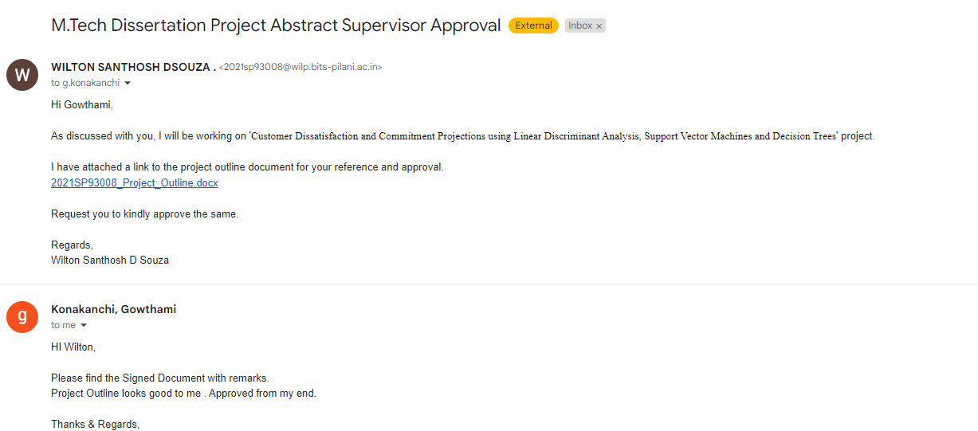

**Email Approval from Additional Examiner**

