Indien er geen SSH key meer aanwezig is in GitHub. Je kan er een aanmaken met prompt command (best admin) :

ssh-keygen

Er zal een file gemaakt worden in de c:\users\gebruiker/.ssh map

Een bestaande key kan je vinden in die map onder de naam .pub (openen met kladblok) en kopiëren naar GitHub:

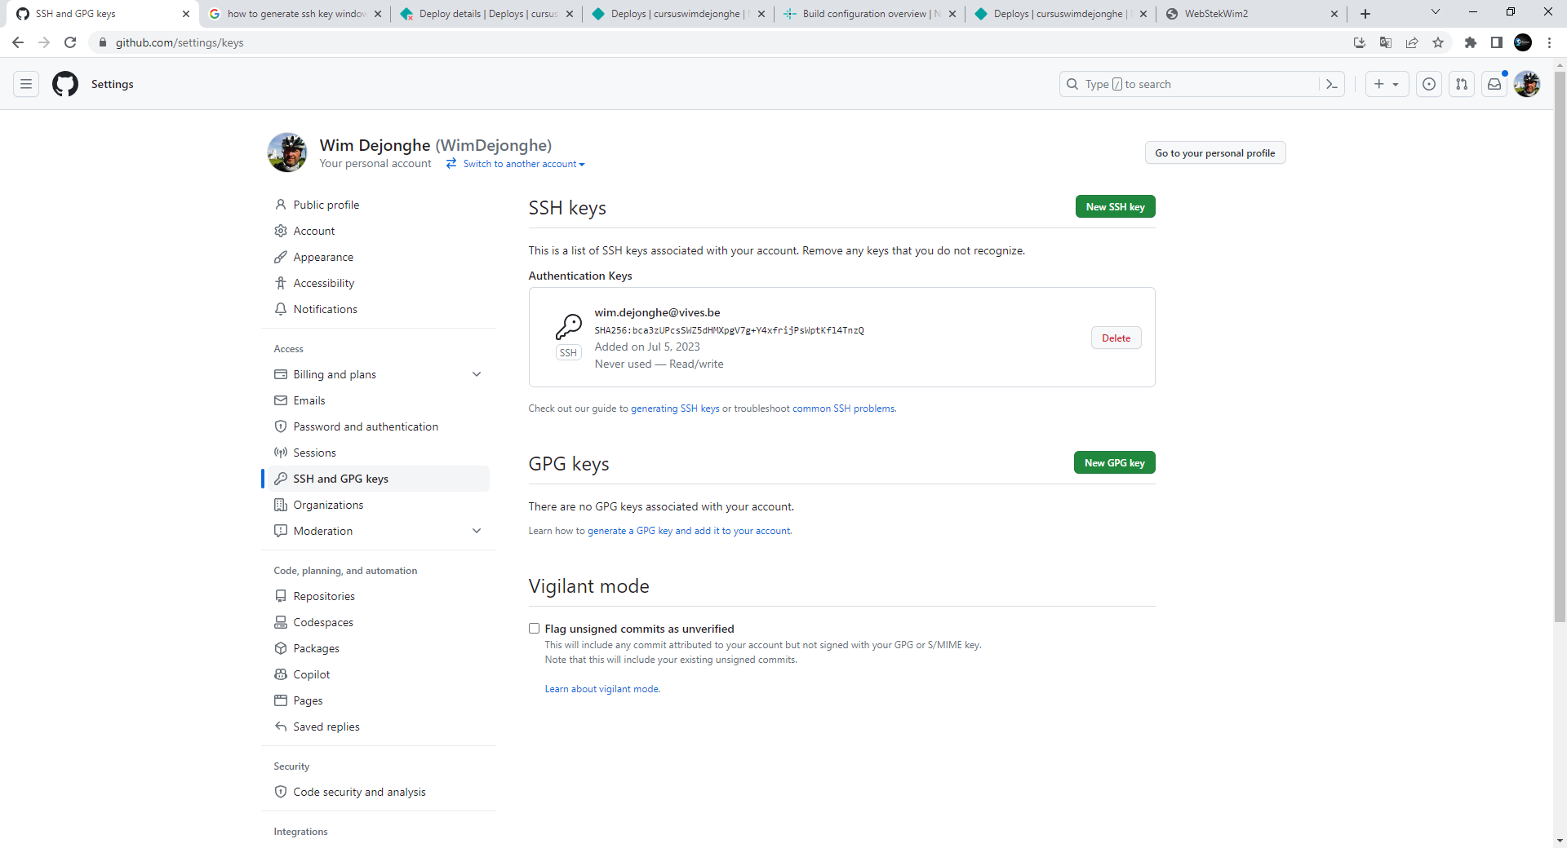

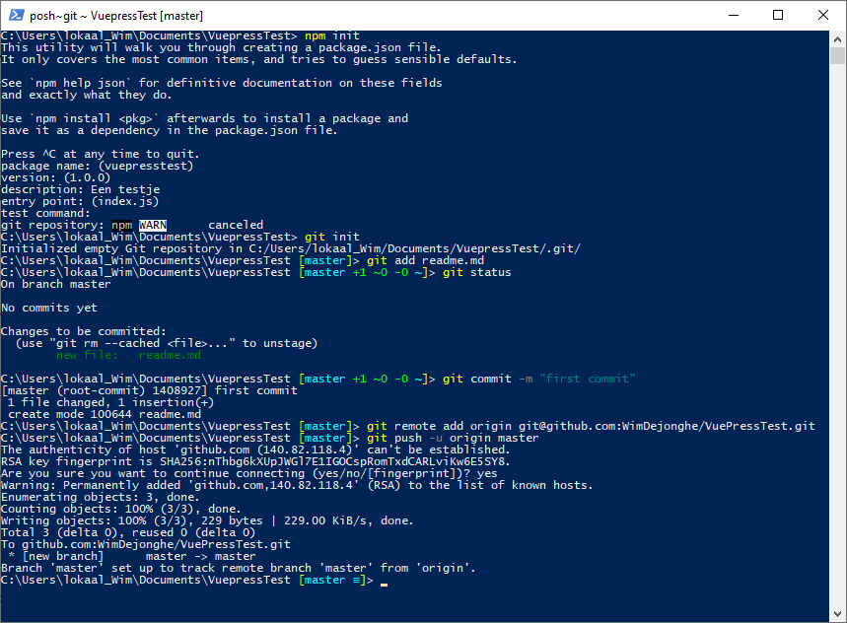

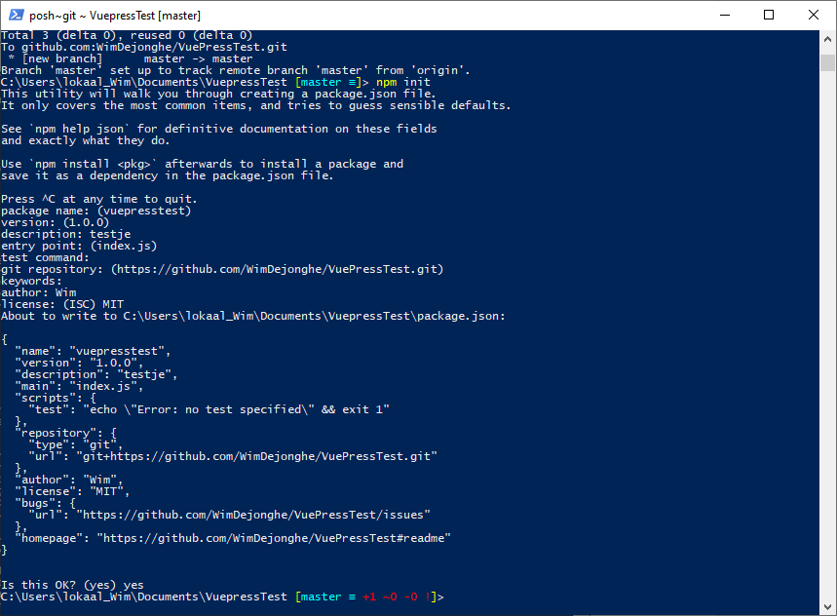

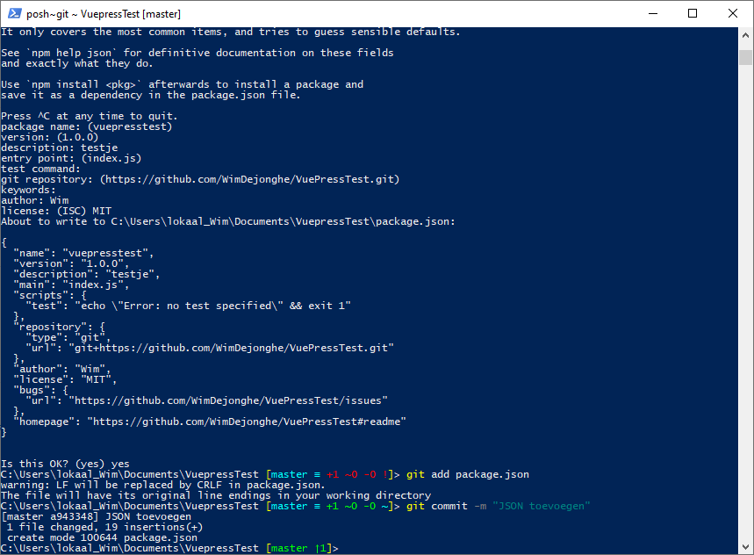

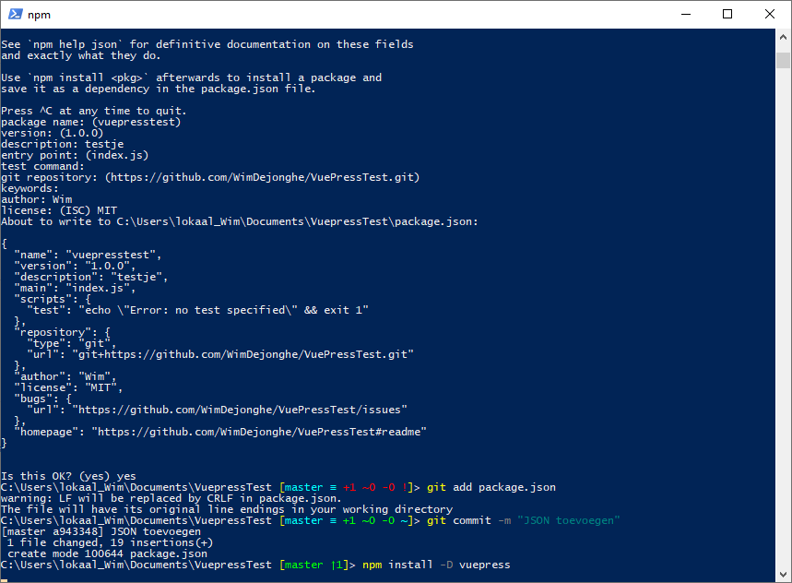

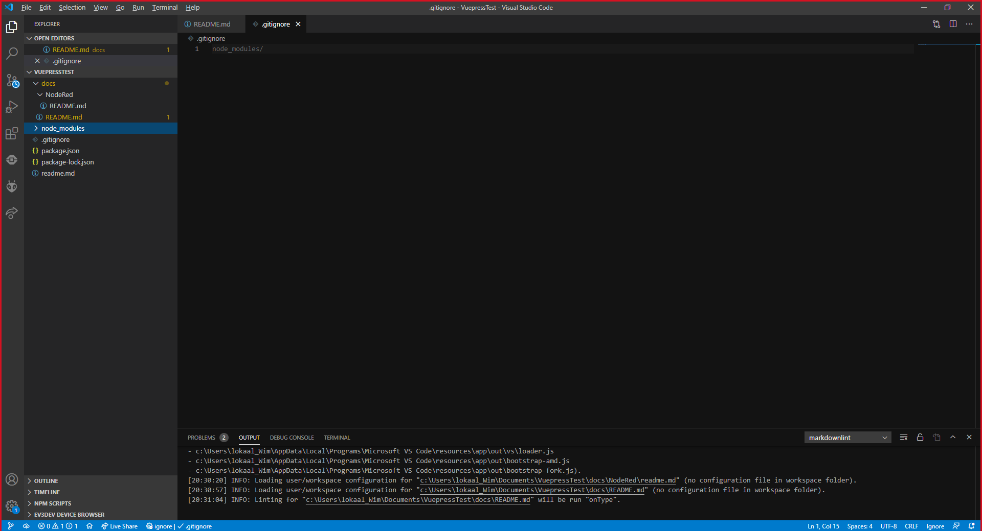

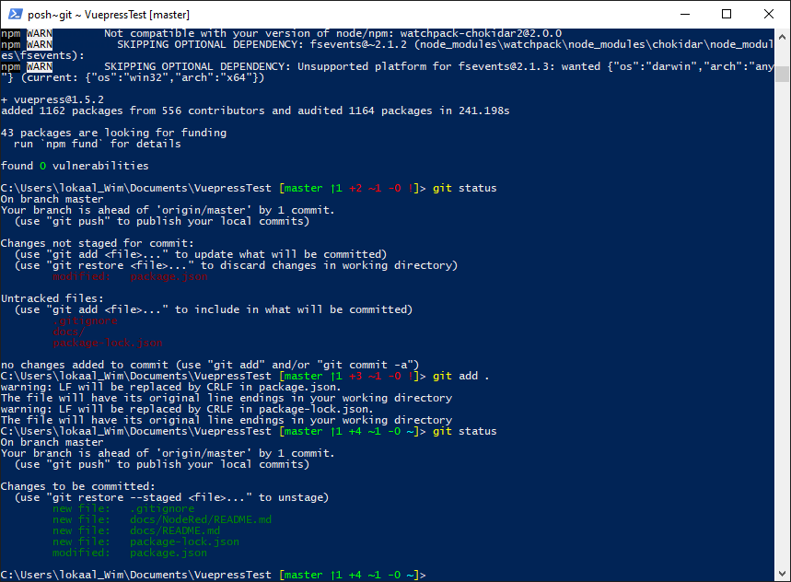

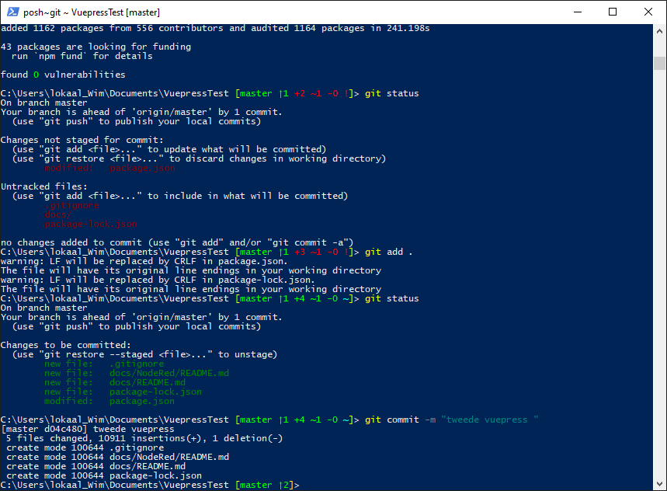

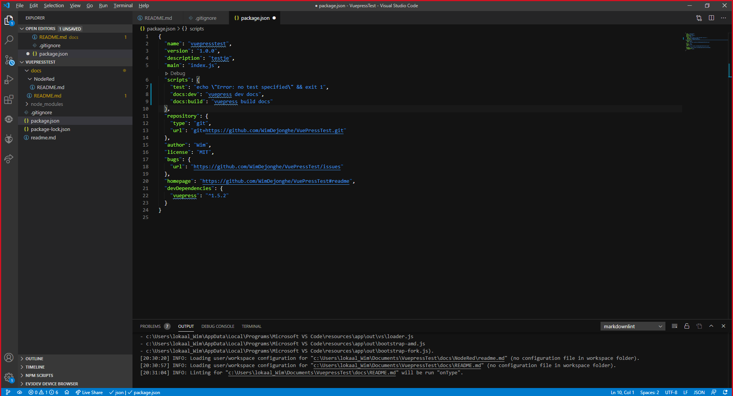

"docs:dev": "vuepress dev docs",

    "docs:build": "vuepress build docs"

npm run docs:dev

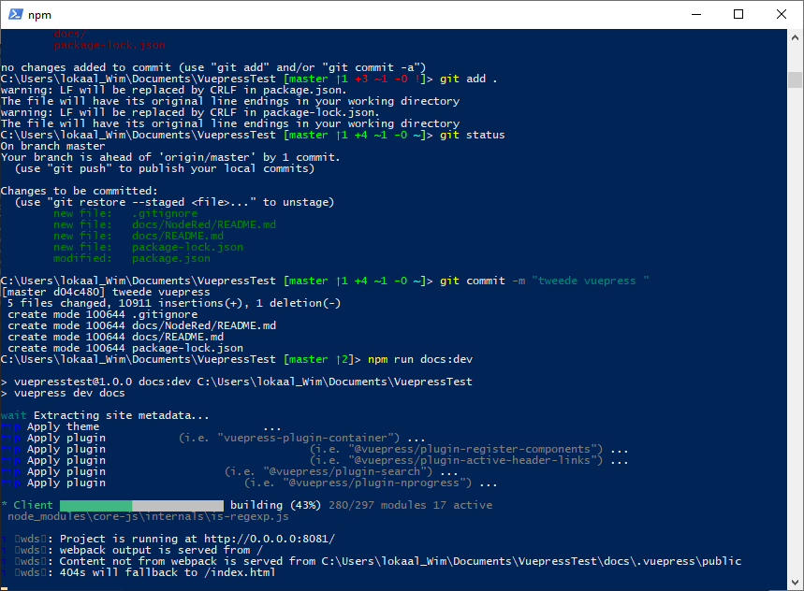

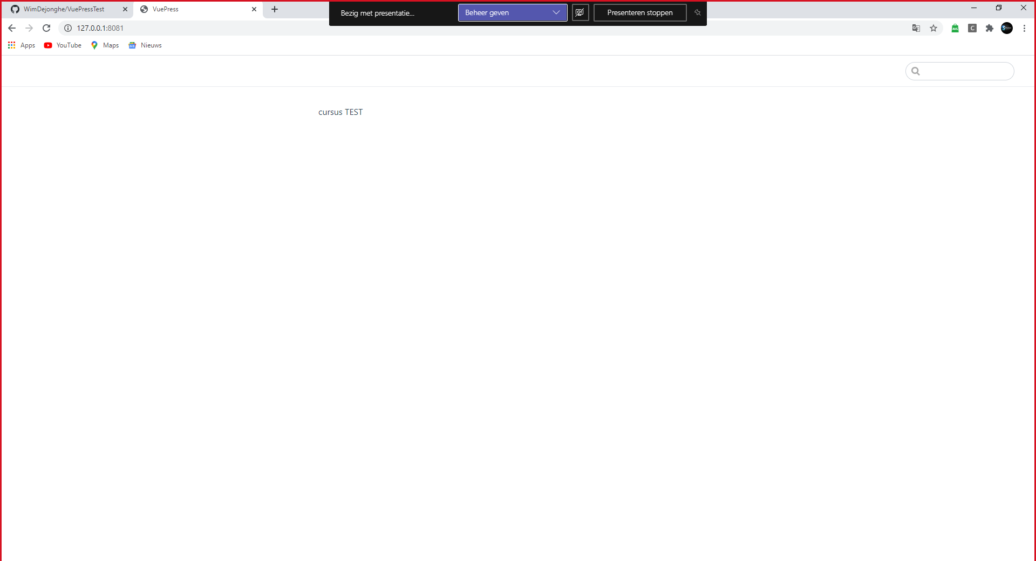

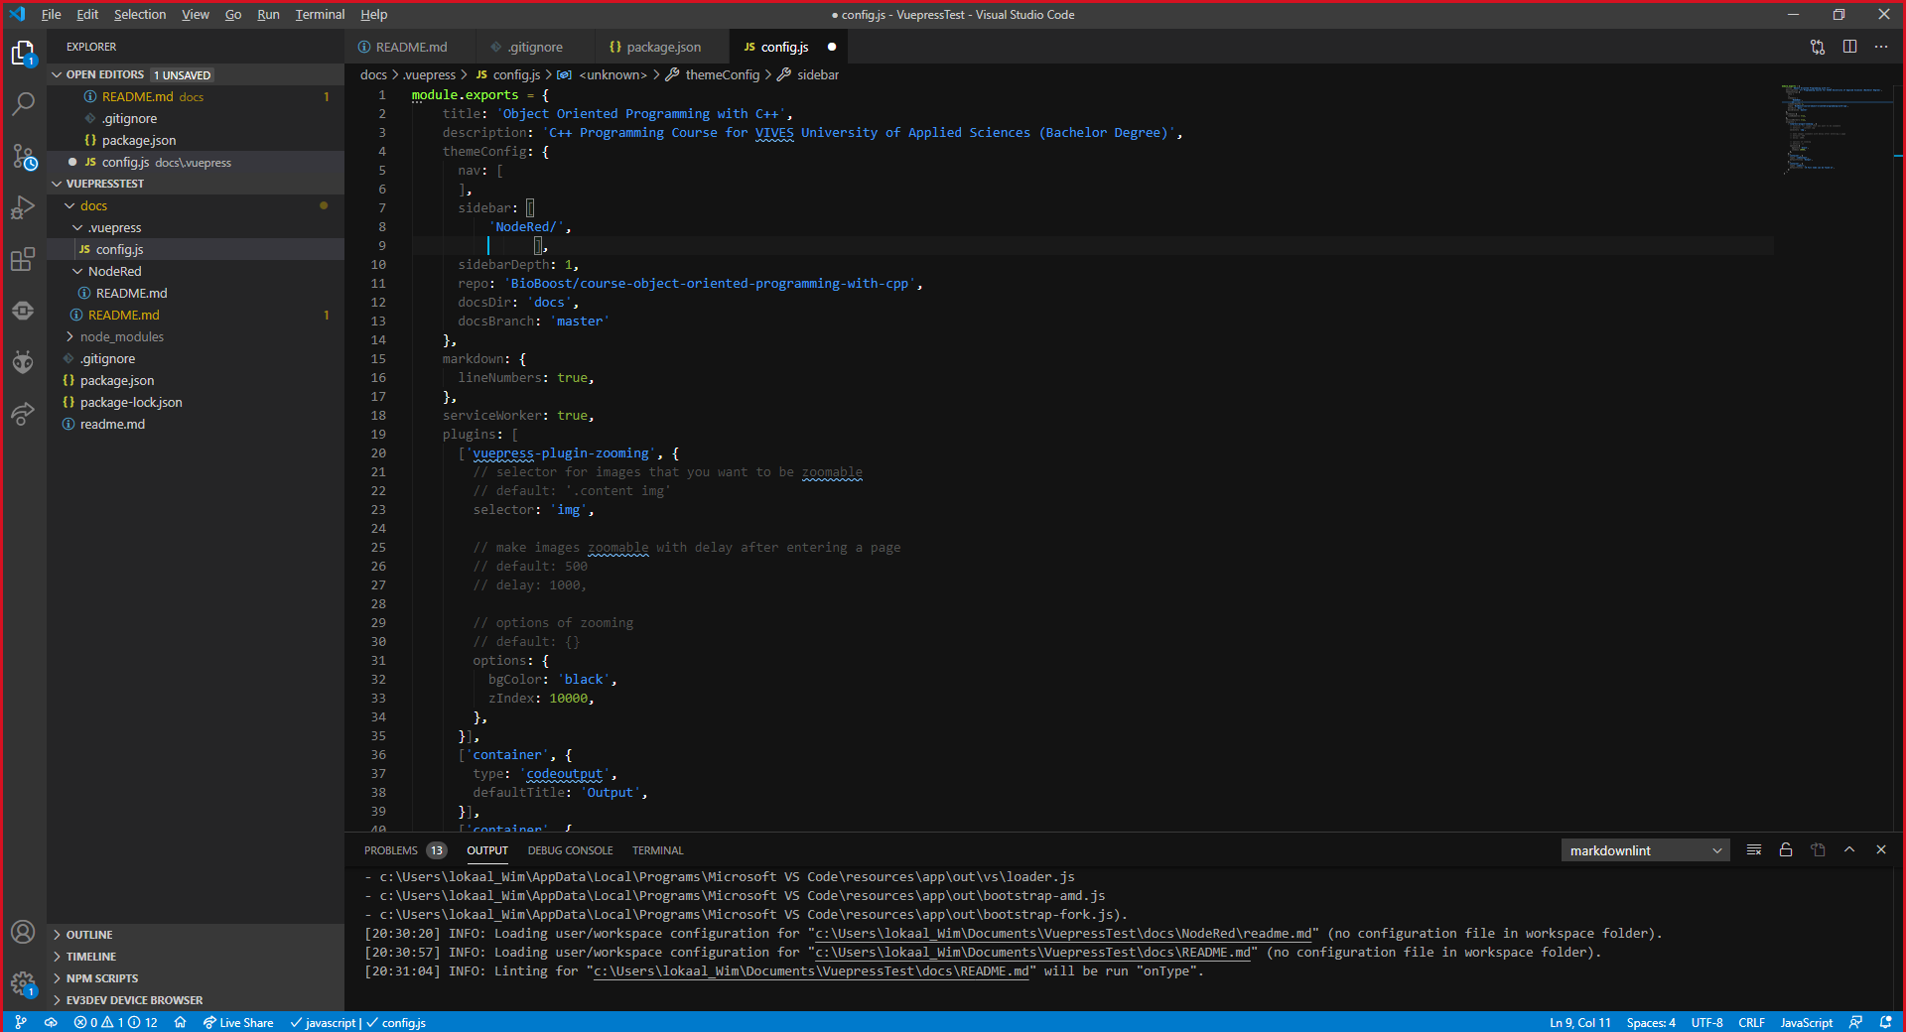

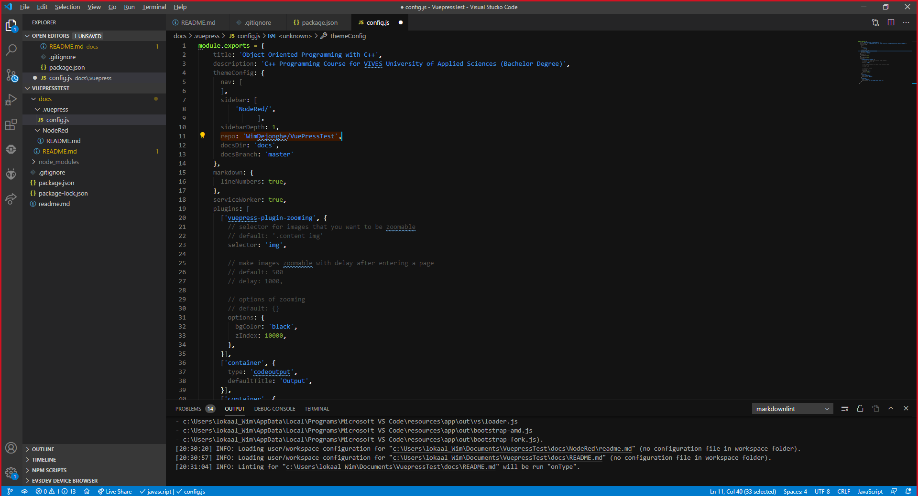

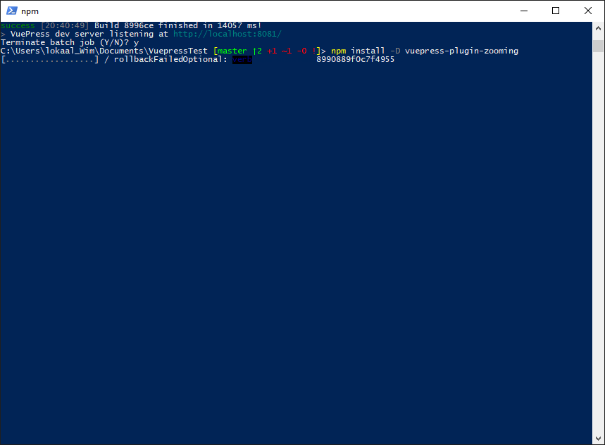

npm run docs:dev

Try the new cross-platform PowerShell https://aka.ms/pscore6

Loading personal and system profiles took 1270ms.

C:\Users\lokaal_Wim\Documents\VuepressTest [master ↑2 +2 ~3 -0 !]> git add .

warning: LF will be replaced by CRLF in package-lock.json.

The file will have its original line endings in your working directory

The file will have its original line endings in your working directory

C:\Users\lokaal_Wim\Documents\VuepressTest [master ↑2 +2 ~3 -0 ~]> git commit -m "derde probeer"

[master 4536fec] derde probeer

5 files changed, 60 insertions(+), 3 deletions(-)

create mode 100644 docs/.vuepress/config.js

create mode 100644 docs/NodeRed/images/node-red.png

C:\Users\lokaal_Wim\Documents\VuepressTest [master ↑3]> git push origin master

Enumerating objects: 24, done.

Counting objects: 100% (24/24), done.

Delta compression using up to 8 threads

Compressing objects: 100% (18/18), done.

Writing objects: 100% (23/23), 124.24 KiB | 2.48 MiB/s, done.

Total 23 (delta 4), reused 0 (delta 0)

remote: Resolving deltas: 100% (4/4), done.

To github.com:WimDejonghe/VuePressTest.git

1408927..4536fec master -> master

C:\Users\lokaal_Wim\Documents\VuepressTest [master ≡]>

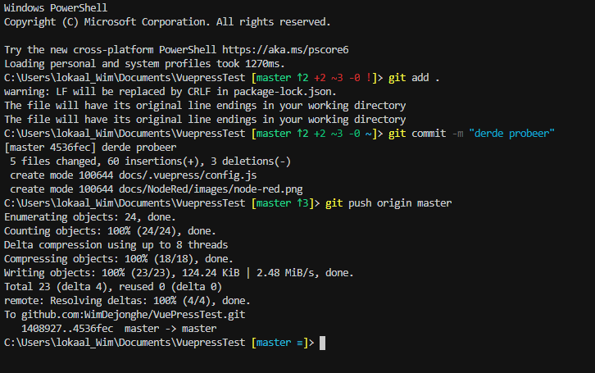

<https://devbit-git-course.netlify.app/>

<https://github.com/BioBoost/course-object-oriented-programming-with-cpp>

<https://raw.githubusercontent.com/BioBoost/course-object-oriented-programming-with-cpp/master/docs/.vuepress/config.js>

<https://vuepress.vuejs.org/theme/default-theme-config.html>

<https://vuepress.vuejs.org/guide/markdown.html#custom-containers>

Ga in <https://app.netlify.com/>

Verwijs naar Github en laat de site maken