Kedok, Acoustic rifle scope for the visually impaired.

Instructions:
Before use, the receiver must be adjusted.
This can be done manually or automatically.

Automatic:
Press the "Right" key for 3 seconds, the screen will show "Auto adjust" and the shooter will hear two beeps through headphones.
One gets 20 seconds to get set. The measurments start after the following beep, the shooter must try to aim in such a matter he get the highest pitch, after about 20 seconds. the shooter will hear three beep tones.
The weapon is now set automatically. The shooter does not have to fire during this session.

Manual:
The best way is to read the sensor value during a shooting session.
Minimum value can be entered via the menu [MIN], enter a minimum value about 20 lower than the lowest value read ([Low] value in the display).
The maximum value can be entered via the menu. [MAX]
Pitch will be in within these values ​through headphones.
The better you set these values, the better the results will be shot.
With [Gain] allows you to make the pitch more progressive.
This means that the closer you come to the center, the more change in pitch is observed. A good value to start with is a Gain of 0.
The pitch can also be set with the menu options [LowTone] and [HighTone] "low tone" is the lowest tone when you're on the outside of the card and "high tone" the highest tone in the center.
If you want configure the unit for the first time, set the minimum value to 100 and the maximum value to 800.
During a shooting session you can read the lowest value on the display.
Then go to the menu and set this value minus 20 for [MIN] and set [MAX] 200 higher than the minimum value.

Example:
During a shooting session you will read that the lowest measured is 380. Then, enter 360 in the menu [Min] and 560 to [Max]. Set gain to a value that the shooter observe the best details.

If the shooter hear three beeps while aiming, then the minimum value is exceeded.
Lower the [MIN] value in the menu. The shooter can also do this during a shooting session.
With the UP and DOWN buttons the shooter's can increase or decrease the operating window with 10.
By this a shooter does not have to stop a serie with an incorrect setting. He presses the DOWN button and can continue his series.

Note: All cables must be connected before the unit is turned on.
Always follow safety guidelines for armed subjects.
Example effect of Gain. (Set of 4)

Battery charging is via the mini USB port on the side. Charging the battery takes about one hour.
With a single charge you can shoot a minimum of eight hours.

If the device has been set, you can turn the display off. This can be done with the [LEFT] key. (disable screen)
This value can also be set in the menu under the [Display] set it to "None". This increases the speed in which the sensor is read out.
All settings are stored in the unit, under normal circumstances, does not longer have to be set.

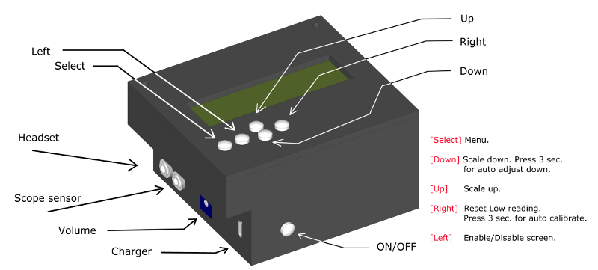
Recommended lamp for illuminating the card is a Philips Master Line ES 18 142 45W 8°

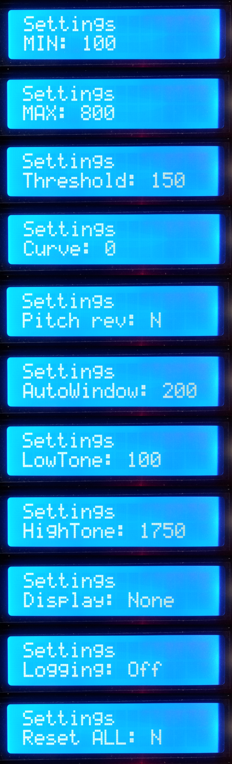
With this setting you can get the lowest measured
value. (Card Centre)

Maximum value. (Outer rim target card)

Window Size in which there is a solid tone is heard outside the target card.
This makes it easier to find the card. (0 to 190)

Sound curve. (0 to 5)

Reversing pitch, from high to low or vice versa.

Window Size of automatic detection during automatic set.

Lowest tone through headphones in Hz.

Highest tone through headphones in Hz.

Display output. (None, bar chart or value)

Debug recording option for shooting motions.
For use by software developers only.

Reset all settings to factory defaults.

Kedok, open source acoustic aiming device for visually impaired shooters.

Web site: http://acoustic-shooting.blogspot.nl
Software updates can be found at: https://github.com/WimHager/Kedok

