Kedok, -Acoustic rifle scope for the visually impaired.

Instructions:
Before use, the receiver must be adjusted.
This can be done manually or automatically.
Automatic:
Press the “Right” key for 3 seconds. The screen will show “Auto adjust” and the shooter will hear 2 beeps through the headphones

It takes about 20 seconds to get set. The measurements start after the second beep. The shooter must try to aim so that he gets the highest pitch. After about 20 seconds the shooter will hear three beep tones.
The weapon is now set automatically. The shooter does not have to fire during this session.
Manual:
The best approach is to read the sensor value during a shooting session.
The minimum value can be entered via the menu [MIN]. Enter a minimum value about 20 lower than the lowest value read ([Low] value in the display).
The maximum value can be entered via the menu [MAX].
The pitch, heard through headphones, will be within these values.
The better you set these values, the better the shooting results.
With [Gain] you can make the pitch more progressive.
This means that the closer you come to the centre, the more change in pitch is heard. A good value to start with is a gain of 0.
The pitch can also be set with the menu options [LowTone] and [HighTone]. “low tone” is the lowest tone when you are outside the card and “high tone” is the highest tone when you are in the centre.
If you are configuring the unit for the first time, set the minimum value to 100 and the maximum value to 800.
During a shooting session, you can read the lowest value on the display.
Then go to the menu and set this lowest value minus 20 for [MIN] and set [MAX] 200 higher than the minimum value.
Example:
During a shooting session, you read the lowest value as 380. Then enter 360 in the [MIN] menu and 560 in the [MAX] menu. Set gain to the value at which the shooter observes the best details.

If the shooter hears 3 beeps while aiming, then the minimum value is exceeded.
Lower the [MIN] value in the menu. The shooter can also do this during a shooting session.
With the UP and DOWN buttons, the shooter can increase or decrease the amount in the operating window by 10. With this, the shooter doesn’t have to stop a series due to an incorrect setting. He can press the DOWN button and continue his series.

Note: All cables must be connected before the unit is turned on.
Always follow safety guidelines for armed subjects.
Example effect of Gain. (Set of 4)

Battery charging is via the mini USB port on the side. Charging the battery takes about an hour. With a single charge, you can shoot for a minimum of 8 hours.
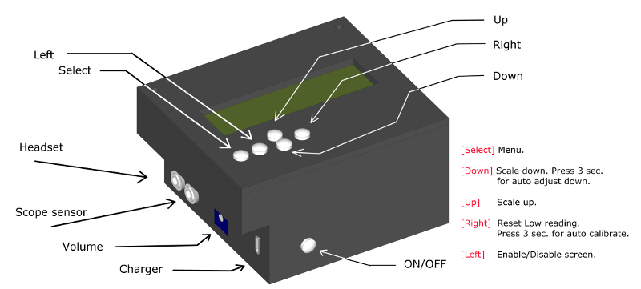
If the device has been set, you can turn the display off. This can be done with the [LEFT] key (disable
screen). This value can also be in the menu under [Display] by setting it to “None”.This increases the speed at which the sensor is read out.
All settings are stored in the unit and, under normal circumstances, it does not have to be set again.
Recommended lamp for illuminating the card is Phillips Master Line ES 18 142 45W 8o

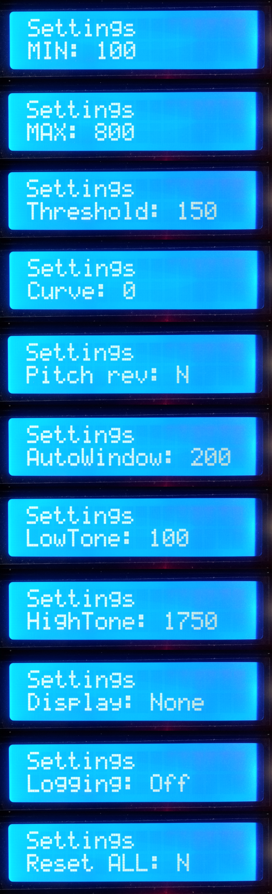
With this setting you can set the lowest measured
value. (Card center)

Maximum value. (Outer rim target card)

Window size in which there is a solid tone is heard outside the target card.
This makes it easier to find the card. (0 to 190)

Sound curve. (0 to 5)

Reversing pitch, from high to low or vice versa.

Window size of automatic detection during automatic set.

Lowest tone through the headphones in Hz.

Highest tone through the headphones in Hz.

Display output. (None, bar chart or value)

Debug recording option for shooting motions.
For use by software developers only.

Reset all settings to factory defaults.

Kedok, open source acoustic aiming device for visually impaired shooters.

Web site: http://acoustic-shooting.blogspot.nl
Software updates can be found at: https://github.com/WimHager/Kedok

