Gesture-Speech Physics in Fluent Speech and Rhythmic Upper Limb Movements

|  |
| --- |
| Wim Pouw1,2,3, Lisette de Jonge-Hoekstra1,4, Steven J. Harrison1, Alex Paxton1, & James A. Dixon1 |
| 1 Center for the Ecological Study of Perception and Action, University of Connecicut |
| 2 Donders Institute for Brain, Cognition and Behaviour, Radboud University Nijmegen |
| 3 Institute for Psycholinguistics, Max Planck Nijmegen |
| 4 University of Groningen |
|  |

# Author note

Correspondence concerning this article should be addressed to Wim Pouw, Donders Institute for Brain, Cognition and Behaviour, Heyendaalseweg 135, 6525 AJ Nijmegen. E-mail: [w.pouw@psych.ru.nl](mailto:w.pouw@psych.ru.nl)

Abstract

Communicative hand gestures are often temporally coordinated with prosodic aspects of speech – salient moments of gestural movement (e.g., quick changes in speed) often co-occur with salient moments in speech (e.g., near peaks in fundamental frequency and intensity). This temporal coordinative feat has been invariably rendered as a purely neural-cognitive achievement emerging in late stages of cognitive development. However, recently a potential biomechanical gesture-speech coupling has been proposed and tested in rudimentary vocalizations. Forces produced during gesturing are absorped by a tensioned body leading to changes in respiratory-related activity and thereby affecting vocalization F0 and intensity during steady-state vocalization and mono-syllable utterances. In the current experiment (N = 34) we show that gesture-speech physics is relevant for fluent speech too. We find that when participants are rhythmically moving their upper limbs vs. not moving, that F0 and amplitude envelope of fluid speech is heightened, and such effects are more pronounced for higher-impetus arm versus lower-impetus wrist movement. We confirm that effects on acoustics arise especially during moments of peak-impetus (i.e, the beat) of the movement, namely around a deceleration phases of the movement. Finally, higher deceleration rates were related to higher peaks in acoustics, confirming a role for force-transmissions of gesture onto the tensioned body, affecting speech. The current study serves as an important confirmation that gesture can biomechanically constrain fluent speech. These results further support a radically embodied account of cognitive, ontogenetic, and phylogenetic origins of human gesture.

*Keywords:* hand gesture, speech production, speech acoustics, biomechanics, entrainment

Word count: X

Gesture-Speech Physics in Fluent Speech and Rhythmic Upper Limb Movements

Communicative hand gestures are ubiquitous in human culture. Gestures aid communication by seamlessly interweaving relevant pragmatic, iconic and symbolic expressions in the hands together with speech (Feyereisen, 2017; Holler & Levinson, 2019; Streeck, 2008). For such multi-articulatory utterances to do their communicative work, gesture and speech must be tightly temporally coupled to form a sensible speech-gesture whole. And in fact, gestures’ salient moments are often timed with emphatic stress made in speech, no matter what the hands depict (Shattuck-Hufnagel & Prieto, 2019; Wagner, Malisz, & Kopp, 2014). For such exquisite gesture-speech coordination to get of the ground, the system must functionally constrain its degrees of freedom (Turvey, 1990), and in doing so it will have to utilize (or otherwise account for) intrinsic dynamics arising from the bio-physics of speaking and moving at the same time.  
In this report we provide evidence that movement of the upper limbs constrain fluent self-generated speech acoustics through biomechanics. This replicates and extends results obtained with rudimentary steady-state vocalization and mono-syllable utterances showing that physical impulses generated by upper limb movements reach the respiratory system, affecting vocalization acoustics (Pouw et al., 2019a, 2019b; Pouw, Paxton, Harrison, & Dixon, 2020). We thereby show that there is a further complexity to the human voice in that it is inhabited by gestural movement, which we believe provide means for simplifying gesture-speech coordination.

## The gesture-speech prosody link

The tight coordination of prosodic aspects of speech with the kinematics of gesture has been long appreciated and is classically referred to as the beat-like quality of co-speech gesture (McNeill, 1992). This phenomenon has been studied in sevaral ways. Human coders have been trained to identify salient moments called the apex in gestures, together with prosodically meaningful moments in fluent speech. In that research tradition it has been found that gestures’ gesture apices often align with *pitch accents* in speech - accents which are acoustically predominataly defined by positive excursions in the fundemantal frequency (F0), lowering of the second formant, longer vowel duration and increased intensity (Loehr, 2012; McClave, 1998; Mendoza-Denton & Jannedy, 2011). There also pitch accents that are acoustically differently defined, such as a sudden *lowering* of F0, but it has been shown that gestures do not seem allign with those events quite as much (Im & Baumann, 2020).  
In more recent motion-tracking studies these gesture-speech prosody correlations have been obtained as well, showing for example that gesture’s peak velocity often co-occur near peaks in F0, even when such gestures are depicting something (Danner, Barbosa, & Goldstein, 2018; Krivokapić, 2014; Leonard & Cummins, 2011; Pouw & Dixon, 2019a, 2019b). In pointing gestures it has been found that stressed syllables align neatly with the maximum extension of the pointing movement, such that the hand movement terminates at the first syllable utterance in strong-weak stressed “PApa”, and terminates later during the second syllable utterance in the weak-strong “paPA” (Esteve-Gibert & Prieto, 2013; Rochet-Capellan, Laboissière, Galván, & Jean-Luc, 2008). During finger-tapping and mono-syllable utterances, when participants are instructed to alternate prominence in their uterrances (“pa, PA, pa, PA”) the tapping action will automatically follow and will consist of a larger movement during stressed syllables (Parrell, Goldstein, Lee, & Byrd, 2014). Conversely, if participants are instructed to alternate stress in finger tapping (STRONG weak STRONG weak tapping), speech will follow, with larger oral-labial appertures for stressed vs. unstressed tapping movements.  
Indeed it has been found that even when people do not intend to change the stress patterning of an uttered sentence, gesturing will concurrently affect speech acoustics in a way that make it seem intendedly stressed, where gestures induce increases in vocalization duration, and lowering of the second formant of co-occurent speech (Krahmer & Swerts, 2007). It has further has been shown that gesture and speech cycle rates seem to be attracted towards particular (polyrhythmic) stabilities, where in-phase speech-tapping is preferred over anti-phase coordination, or where 2:1 speech:tapping ratios are preferred over more complex integer ratios such as 2:5 (Kelso & Tuller, 1984; Stoltmann & Fuchs, 2017; Treffner & Peter, 2002; Zelic, Kim, & Davis, 2015). All these previous studies results indicate that gesture and speech naturally couple their activity, raising questions about origins of its pervasiveness.

## Gesture-speech physics as a possibly radically embodied revision of cognitive, ontogenetic, and phylogenetic accounts of gesture

There is a common thread in current understanding of the gesture-prosody link. Cognitively, it is judged to be solved by purely neural-cognitive resources (Iverson & Thelen, 2005; Ruiter, 2000). After all, when an event in gesture is timed together with an event in speech, and there are no clear environmental constraints, there must be a centralized mechanism that couples both subsystems in synchrony. Ontogenetically, the gesture-speech prosody link in the form of beat-like gestures is held to be dependent on neural development occurring in relatively late stages of maturation - after more than 16 months of age (Iverson & Thelen, 2005). Phylogenetically, beat-like gestures are assumed to emerge later in the history of anatomically modern humans than the invention of depictive gestures (Fröhlich, Sievers, Townsend, Gruber, & Schaik, 2019), although often the gesture-prosody link is simply not mentioned at all in a plausible story how multimodal language might have arisen in humans (Kendon, 2017; Levinson & Holler, 2014; Prieur, Barbu, Blois-Heulin, & Lemasson, 2019). The available evidence for the fundamental gesture-prosody link together with recent findings on a possible biomechanical gesture-prosody link could however revise some current assumptions.  
Recently it has been shown that hand gesturing physically impacts steady-state vocalizations and mono-syllable consonant-vowel utterances (Pouw et al., 2019a, 2019b, 2019d, 2020). Specifically, hand and arm movements can transfer a force (a physical impulse) onto the musco-skeletal system, thereby modulating respiration-related muscle activity, leading to changes in vocalization’s intensity. If gesture-induced impulses are not accommodated for by vocal fold adjustments, the Fundamental Frequency (F0) of vocalizations is affected as well. It has been found that higher-impulse arm- versus wrist movements, or dual- versus one handed movements, will induce more pronounced effects on F0 and intensity. This is because the mass of the “object” in motion is higher for arm(s) versus wrist movements thereby changing the momentum of the effector, everything else - such as effector speed - being equal (as momentum effector = effctor mass x effector velocity). The change in momentum is the physical impulse, and the moment where physical impulse is highest, is when the change in velocity (i.e., acceleration) is highest, everything else - such as effector mass - being constant.  
The way in which physical impulses are absorped by the respiratory system is likely complex and not a simple linear funciton (Levin, 2006). However, a complete understanding will involve an appreciation of the body as pre-stressed system (Bernstein, 1967; Profeta & Turvey, 2018), forming an interconnected tensioned network of compressive (e,g., bones) and tensile elements (e.g., fascia, muscles) through which forces may reverbarate non-linearly (Silva, Moreno, Mancini, Fonseca, & Turvey, 2007; Turvey & Fonseca, 2014). Specifically, the upper limb movements are controlled by stabilizing musco-skeletal actions of the scapula and shoulder joint, which directly implicate accessory expiratory muscles that also stabilize scapula and shoulder joint actions (e.g., the Serratus Anterior Inferior; see Pouw et al., 2019a for an overview). Furthermore, there is a role to play for more peripheral actions as well, as performing an upper limb recruits a whole kinetic chain of muscle activity around the trunk (e.g., Rector Abdominus) that is needed to maintain posture (Hodges & Richardson, 1997). Indeed, when people are standing vs. sitting for example, it has been found that the effects of peak impetus of gestures are more pronounced [pouwGesturespeechPhysicsBiomechanical2019]. We reasoned that this is because standing involves more forceful anticipatory postural counter adjustments (Cordo & Nashner, 1982). Namely, the force-transmission of peripherical upper limb movements onto more distal activity in the body is possible as posturally stable . Recently, more direct evidence has been found for the gesture-respiratory-speech link, where it was shown that respiratory related activity (measured with a respiratory belt) was enhanced during moments of peak-impetus of gesture as opposed to other phases in the gesture movement, and this respiratory related activity itself was related to gesture-related intensity modulations of mono-syllable utterances (Pouw et al., 2019a). The deeper implication of said gesture-speech physics is that there is a morphological driver for gesture and speech to synchronize on the level of prosody. Cognitively, this will imply that the supposed timing mechanism that is held to be neurally instantiated can be simplified, as F0 and intensity levels can emerge and draw from bio-morphological information contained in the dynamics the body. Note though, that any biophysical effect of gesture on speech may be counteracted, not exploited, or further intensified given the intentional prosodic targets the speaker may have in mind. Indeed, while speech is by necessity constrained by gesture physics (when gesturing and vocalizing), speech can act differently in relation to these constraints for reaching sensorimotor solutions to prosodic goals. Thus, to be very clear, gesture-speech physics is not something that *controls* the speaker.  
With regards to ontogeny: An account of gesture-speech physics does not imply that intentional control over gesture-speech dynamics is something that newborns lack. It may indeed be fully instantiated only after 16 months of age (Iverson & Thelen, 2005). Gesture-speech physics does entail however that constrains of upper limb movement on vocalization are present at birth. It is well known that infants produce concurrent vocal motor babblings, and improvement of rhythmiticity or increased frequency of motor babbling predicts speech-like maturation of vocalization (Ejiri, 1998; Ejiri & Masataka, 2001). Gesture-speech physics revises current accounts such that, rather than a primarily neural development that instantiates gesture-speech synchrony (Iverson & Thelen, 2005), it is the discovery of gesture-speech physics during random-like vocal-motor babblings that provides the basis for infants to develop stable sensorimotor solutions such as a synchronized pointing gesture with a vocalization. It is likley that such sensorimotor solutions are of course solicited and practiced through support of caretakers, yet without the biomorphological background gesture-speech synchrony would not get of the ground ontogenetically.  
Finally, gesture-speech physics has promise for a revision of our understanding for the emergence of communicative gesture in anatomically modern humans. Namely, instead of forefronting the depiction and referential function of gesture as the driver for its modern day instantiation (Fröhlich et al., 2019; Kendon, 2017; Tomasello, 2008), it should be considered that peripheral body movements may have served as a control parameter of an under-evolved vocal system. It has already been proposed that vocal system may have been evolutionarily exapted from rhythmic abilities in the loco-motor domain (Larsson, Richter, & Ravignani, 2019; Ravignani et al., 2019), and upper limb movements as having constrained the vocal systems evolution fits neatly in such views. Specifically, when our species became bipedal it has been argued that the respiratory system was thereby liberated from upper-limb locomotary perturbations. Namely, we know that breathing (and vocalization) cycles often rigidly couple 1:1 with locomotion cycles in quadrupeds (Carrier et al., 1984), rigidly limiting what can be done (communicated) in one breath. For example. vocalization acoustics of flying bats are synchronized with their wing beats (Lancaster, Henson, & Keating, 1995). Bipedalism, however, did only free respiration from locomotion, it freed the upper limbs too, allowing these highly skilled articulators to modulate a possibly less killed respiratory-vocal system. Gestures may then have played a role in the complexification of the respiratory system in our species which has been attributed to have occured to serve speech evolution (MacLarnon & Hewitt, 1999).  
Gesture-speech physics thus is not in principle culture specific, animals such as bats can do it too. Orangutangs deepen their vocalizations by cupping their hands in front of their mouth (Hardus, Lameira, Schaik, & Wich, 2009). Animals have been found to be sensitive to body-related information in sound in that body size and strength can be detected from vocalizations alone (Ghazanfar et al., 2007; Pisanski et al., 2016a), and humans are able to do this with some accuracy as well (Pisanski, Fraccaro, Tigue, O’Connor, & Feinberg, 2014), even when they are blind from birth (Pisanski et al., 2016b). In a recent experiment we have found that listeners are exquisitly sensitive to gesture-moduled acoustics as listeners can synchronize their own upper limb movement by listening to a vocalizer producing a steady-state vocalization while rhythmically moving her wrist or arm (pouwAcousticInformationUpper2020a; Pouw et al., 2019d). To conclude, gesture-speech physics opens up the possibility that gesture may have initially evolved as control parameter on vocal actions, which would mean a radically embodied revision of the origin gesture.  
The evidence reviewed so far have been based on experiments on continuous vocalizations or mono-syllabic utterances. Such results cannot directly generalize to fluent, self-generated, full-sentenced speech. There are promising indications, however, that gesture-speech physics does generalize to fluent speech. In a recent study it was found that encouraging participants to gesture during cartoon-narration versus giving no instructions lead to 22Hz increase in observation of max F0, and lead to greater F0 ranges of speech and intensity (Cravotta, Busà, & Prieto, 2019). Furthermore, computational modelers have reported on interesting successes of synthesizing gesture kinematics based on speech acoustics alone (Ginosar et al., 2019; Kucherenko, Hasegawa, Henter, Kaneko, & Kjellström, 2019), indicating that information about body movements inhabits the speech signal. Although promising, such results do not necessitate a role for biomechanics, but only suggests a strong connection between gesture and speech.

## Current experiment

The current experiment was conducted as a simple test of the constraints of upper limb movement on fluent speech speech acoustics. Participants were asked to retell a cartoon scene that they had just watched, while either not moving, vertically moving their wrist, or vertically moving their arm at a tempo of 80 beats per minute (1.33Hz). Participants were asked to give a stress or beat in the downward motion with a sudden stop at maximum extension (i.e., sudden deceleration). Participants were asked to not allow movements to affect their speaking performance in any way. Similar to previous experiments (e.g., Pouw et al., 2019c), we assessed the following to conclude that gesture-speech physics is present: * 1) Does rhythmic co-speech movement change acoustic markers of prosody (F0 and amplitude envelope)?  
* 2) At what moments of co-speech movement is change in acoustics observed?  
* 3) Does degree of physical impulse (as measured by changes in speed, or effector mass), predict acoustic variation?

# Method

## Participants & Design

We have tested a total of 37 participants (*M* age = 18.76, *SD* age = 0.95, %cis-gender female = 67.57, %cis-gender male = 32.43, %right-handed = 94.59), drawn from an undergraduate participant pool at the University of Connecticut. There were 6 non-native English speaking Asian-undergraduates in the current sample.  
The current design was fully-within subject, with a three-level Movement condition (Passive Vs. Wrist Vs. Arm condition). We also have added another artificial condition to our analysis which we will refer to as “Passive (Falsely Paired)”. For this surrogate condition speech of a Passive condition trial was randomly paired with motion-tracking data from a movement condition for that participant (wihout scrambling the order). This surrogate condition will allow use to exclude the possibility that any effects of movement are due to chance coupling inherent to the structure of speech and movement. We will only use this surrogate control condition as a contrast when we are performing analysis on the temporal relation between speech and movement. Participants performed 419 trials in total lasting about 40 seconds with Movement condition randomly assigned per trial. The study design was approved by the IRB committee of the University of Connecticut (#H18-227).

## Material & Equipment

### Cartoon scenes

Twelve cartoon scenes were created from the “Canary Row” and “Snow Business” Tweety and Sylvester cartoons, *M* duration scenes = 59.42seconds (*SD* = 32.11). These cartoons are often used in gesture research (McNeill, 1992). Readers can access the videos here: <https://osf.io/rfj5x/>.

### Audio and Motion Tracking

A cardioid condenser microphone headset MicroMic C520 (AKG, Inc.) was used to record audio. A Polhemus Liberty motion tracking system (Polhemus, Inc.) was used to record the position of participant’s index finger of the dominant hand, sampling with one 6D sensor at 240Hz. We applied a first order Butterworth filter at 30Hz for the vertical position (z) traces and its derivatives.

## Procedure

Upon arrival participants were briefed that this 30-minute experiments entailed retelling cartoon scenes while standing and performing upper limb movements. A motion sensor was attached to the tip of the index finger of the dominant hand, and a microphone headset was put on. Participants were asked to stand upright and were introduced to three movement conditions (see Figure 1). In the Passive Condition, participants did not move and kept their arm resting alongside the body. In the Wrist Movement Condition participants were asked to continuously vertically move the hand at the wrist joint while keeping the elbow joint in 90 degrees. In the Arm Movement Condition, participants moved their arm at the elbow joint, without wrist movement. Similar to previous studies [e.g., pouwAcousticInformationUpper2020a], participants were asked to give emphasis in the downward motion of the movement with a sudden halt, in other words a beat, at the maximum extension of their movement.  
After introduction of the movement condition, participants were told they were to move at a particular tempo which was indicated by visual feedback system which showed a horizontal bar that adjusted real time to the participants movement speed of the previous movement cycle. The participant were to keep the horizontal bar between two low and higher boundaries (a 20% region, [72-88]BPM) of the target tempo which was set at 1.33Hz (i.e., 80 BPM). Participants briefly practiced moving at the target rate before starting the experiment. Thus importantly, the participants were not exposed to an external rhythmic signal, like a visual metronome. Subsequently, participants were instructed that they would watch cartoon clips which they would retell after having watched it, while at the same time making one of the instructed movements (or making no movements). Participants were asked to keep their speech as normal as possible while making the movements (or no movement). When moving while speaking, participants were to keep their movement tempo within the target range.  
Twelve cartoon scenes were readied to be shown before each trial, but if the total experiment time exceeded 30 minutes the experiment would be terminated wihout all scenes being retold. To ensure that all Movement conditions would be performed at least once within that time we set the maximum time per trial at 1 minute, such that when participants were still retelling after 60 seconds the experimenter would terminate the trial and move to the next trial. Mean retelling time was however generally well below one minute, *M* = 26.00 seconds, *SD* = 7.06.

Figure 1. Graphical overview of movement conditions 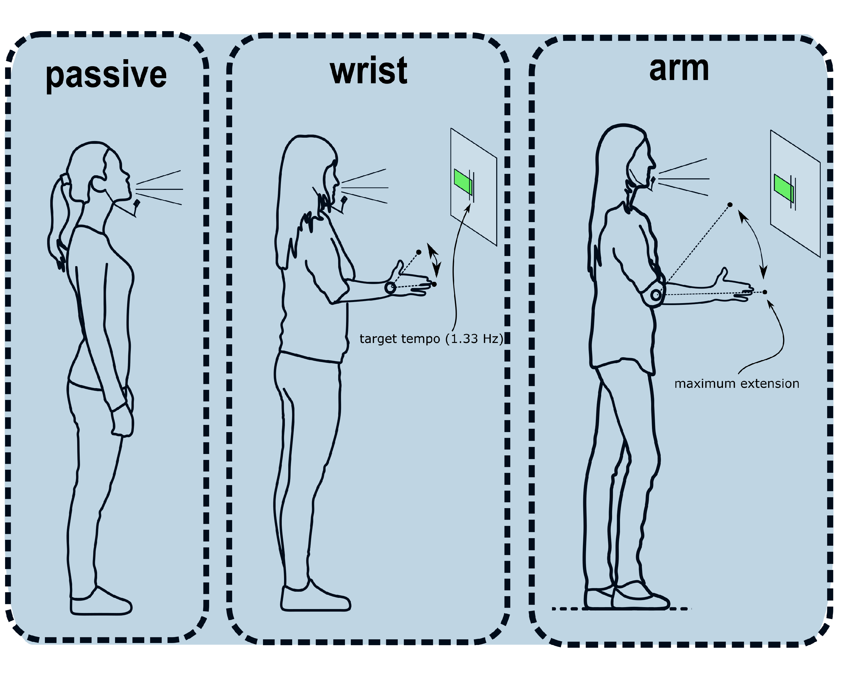 *Note*. Movement conditions are shown. Each participant performed all conditions (i.e., within-subjects). To ensure that movement tempo remained relatively constant participants were shown a moving green bar which indicated whether they moved too fast or too slow relative to a 20% target region of 1.33Hz. Participants were instructed to have a emphasis in the downbeat with a abrupt stop (i.e., beat) at the maximum extension.

## Preprocessing

### Speech acoustics

The Fundamental Frequency was extracted with gender-appropriate preset ranges (male = 50-400Hz, female = 80-640Hz). We used a previously written (Pouw & Trujillo, 2019) R-script (<https://osf.io/m43qy/>) utilizing R-package ‘wrassp’ (Winkelmann, Bombien, & Scheffers, 2018) which applies a K. Schaefer-Vincent algorithm. We also extracted a smoothed (5Hz hanning window) amplitude envelope using a previously written custom-written R script (<https://osf.io/uvkj6/>, which reimplements in R a procedure from He & Dellwo (2017).

### Data and Exclusions

Due to a c++ coding error the precise timing data for the motion-tracking was lost for a smaller portion of the data. This coding error caused an incorrect memory allocation for a 7- instead of 8-digit vector in the c++ experiment code. This resulted in losing track of the tracking system’s time above 1.000.000 milliseconds (16 min and 40 seconds). Thus the motion tracking data after 16m40s had to be excluded. Interpolation of missing time points for the remaining data was considered, but this will inevitably lead to temporal innacuracies as sampling rate of the recording system is never perfectly constant at 240Hz (as such a continuous time-keeping is needed). Thus if we only look at speech we will have access to all data, meaning 189.70 minutes of continous data (Passive = 63.45, Wrist Movement = 63.56, Arm Movement = 62.69). For analysis including kinematics, we have access to 124.49 minutes of continuous speech data (Passive = 40.08, Wrist Movement = 42.32, Arm Movement = 42.10).

## Manipulation Checks

The following measures we computed so as to check whether our movement manipulation was successful, and whether speech rates were comparable for conditions. Figure 2 shows a summary of the results for key manipulation check measures.

### Movement Frequency

To ascertain if participants were indeed moving their limbs within the target range of 1.33Hz we performed a wavelet-based analysis with R-package ‘WaveletComp’ (Rosch & Schmidbauer, 2014), whereby we assessed for each time step which frequency had the highest estimated power (please see our processing script on OSF for further details). Figure 3. shows an example of the wavelet analysis, whereby faster oscillations indeed show higher frequency estimates for that moment during the trial. It can be seen from Figure 2 that wrist movements were slightly performed at faster rates, *M* = 1.44 Hz, *SD* = 0.24, than arm movements, *M* = 1.36 Hz, *SD* = 0.19, but in both cases the movements were distributed over the range 1.33Hz. This confirms that our movement manipulation was succesful. Note further that for our surrogate control condition Passive (Falsely Paired) the mean frequency of the false movement time series was in between both Arm and Wrist movement frequency distributions, *M* = 1.41 Hz, *SD* = 0.22.

### Speech Rate

we have calculated two measures to provide an indication of speech rate (see Figure 2 for examples), namely vocalization duration and vocalization interval. Figure 3 shows relatively uniform distributions for speech measures, and thus no clear one-to-one frequency couplings of movement and vocalization duration/vocalization interval, or any other clear signs of polyrhythmic coupling of movement and speech as has been observed in basic tapping paradigms (Zelic et al., 2015). Thus we restrict ourselves for the current report to speech vocalization acoustics, instead of focusing on possible temporal changes of speech rate produced under rhythmic movement (e.g., Stoltmann & Fuchs, 2017).  
So as to compare vocalization rates to movement, we have computed the average vocalization duration for each trail by tracking the time of uninterrupted runs of F0 observations, and converted the time in milliseconds to Hz (cycles per second). For the Passive condition the average vocalization duration was *M* = 6.24 Hz (i.e., 250ms), *SD* = 6.03. For the Wrist condition the vocalization duration was *M* = Hz (i.e., 1000/3.99 = 250ms), *SD* = NA, and for the Arm condition *M* = 5.99 Hz (i.e., 250ms), *SD* = 5.83.  
The average vocalization interval for the Passive condition was *M* = 5.17 Hz (i.e., 250ms), *SD* = 6.94. For the Wrist condition the vocalization interval was *M* = 5.02 Hz, *SD* = 6.86, and for the Arm condition *M* = 4.86 Hz, *SD* = 5.76.

Figure 2. Example movement-, amplitude envelope-, F0- time series, and time-dependent movement frequency estimates 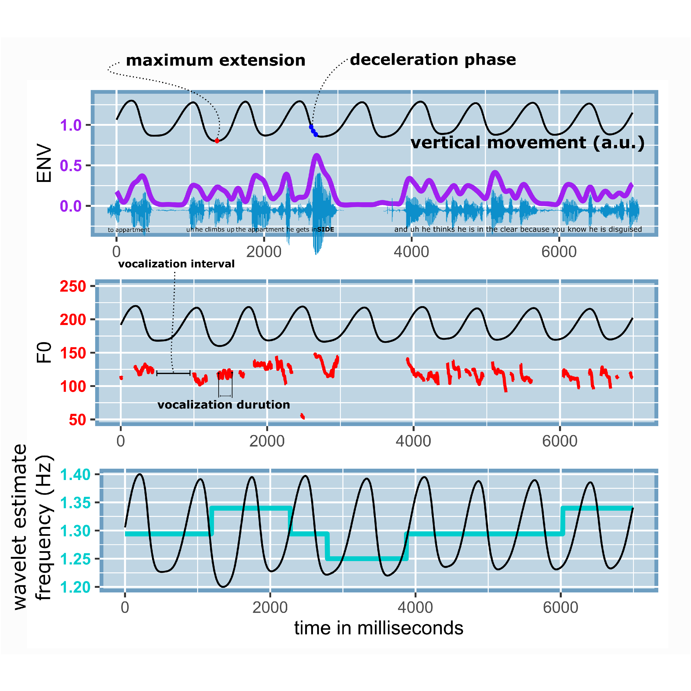

*Note figure 2.* A sample of data of about 10 seconds is shown. With the participant’s permission the speech sample is available at <https://osf.io/2qbc6/>. The smoothed amplitude envelope in purple traces the waveform maxima’s. The F0 traces show the concomitant vocalizations in Hz, with an example of vocalization interval and vocalization duration (which was calculated for all vocalizations). The bottom panel shows the continuously estimated movement frequency in cyan, which hovers around 1.33 Hz. In all these panels the co-occurring movement is plotted in arbitrary units (a.u.) so as see the temporal relation of movement phases and the amplitude envelope, F0, and the movement frequency estimate. Note that in our upcoming analysis we refer to the maximum extension and deceleration phases as relevant moments for speech modulations. In this example there is a particularly dramatic acoustic excursion during a moment of deceleration of the arm movement, possibly an example of gesture-speech physics.

Figure 3. Summary of movement-frequency, vocalization duration and vocalization interval  
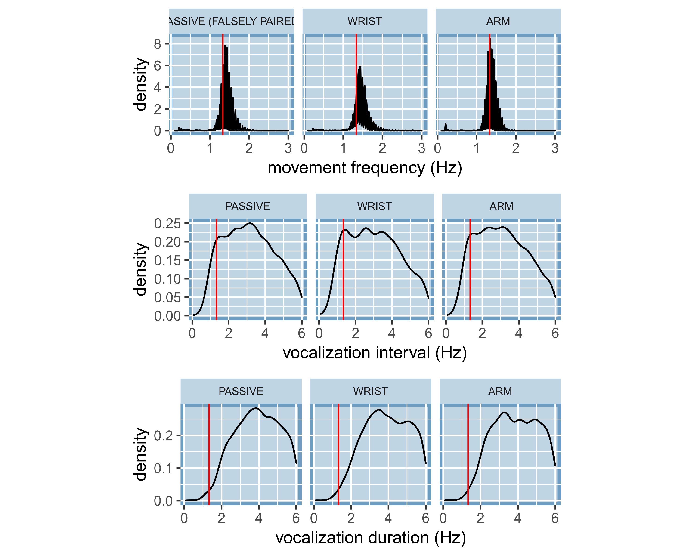

*Note Figure 3*. Density distributions of movement frequencies, vocalization interval, and vocalization duration are shown. Note, that for the Passive condition there was no movement, but we have in this case falsely paired movement time series for the Passive (Falsely Paired) condition for which frequency information is shown. The red vertical line indicates the target movement frequency at 1.3Hz.

# Results

## Overview analysis

We will report three main analysis to show that gesture-speech physics is present in fluent speech. Firstly, we will assess whether there are overall effects on movement condition on vocalization acoustics (F0 and the amplitude envelope), which would confirm that (especially high impulse) upper limb movement constrains fluent speech acoustics. Secondly, we assess whether vocalization acoustic modulations are observed at particular phases of the movement cycle, which should occur at moments of peaks in deceleration if gesture-speech physics is true. Thirdly, we assess whether a continous estimate of upper limb physical impulse through deceleration rate predicts vocalization acoustic peaks, which would confirm that physical impulses are transfered onto the vocalization system.  
The following generally applies to all analyses: For hypothesis testing we performed mixed linear regression models with R-package ‘nlme’ (Pinheiro, Bates, DebRoy, Sarkar, & R Team, 2019), or non-linear generalized additive modeling (GAM) with R-package ‘gam’ (Hastie, 2019) with random intercept for participants. If random slopes for any of the analysis converged as well we wil report so.

## Acousic correlates of movement condition

Figure 4 shows the average F0 and Amplitude Envelope (z-scaled for participants) per trial per condition. The Passive condition had generally lower levels of F0 and Amplitude Envelope as compared to the movement conditions. Furthermore, the higher-impulse Arm movement condition generally had higher levels of F0 and Amplitude envelope as compared to lower-impulse Wrist movement condition.  
Table 1 shows the results of mixed linear regression analysis. For the amplitude envelope,Passive condition had a lower average amplitude envelope as compared to the the Wrist condition (*p* < .05), as well as the Arm condition (*p* < .0001). We further obtain that after accounting for differences in F0 for gender (males had generally 73Hz lower F0), Wrist Movement condition has about 1.4 Hz increase in average (*p* < .05) as compared to Passive condition. Further, the Arm movement condition had 3.2 Hz increase in F0 over the Passive Condition (*p* < .0001).

Figure 4. Average F0 and Amplitude Envelope per trial per condition.

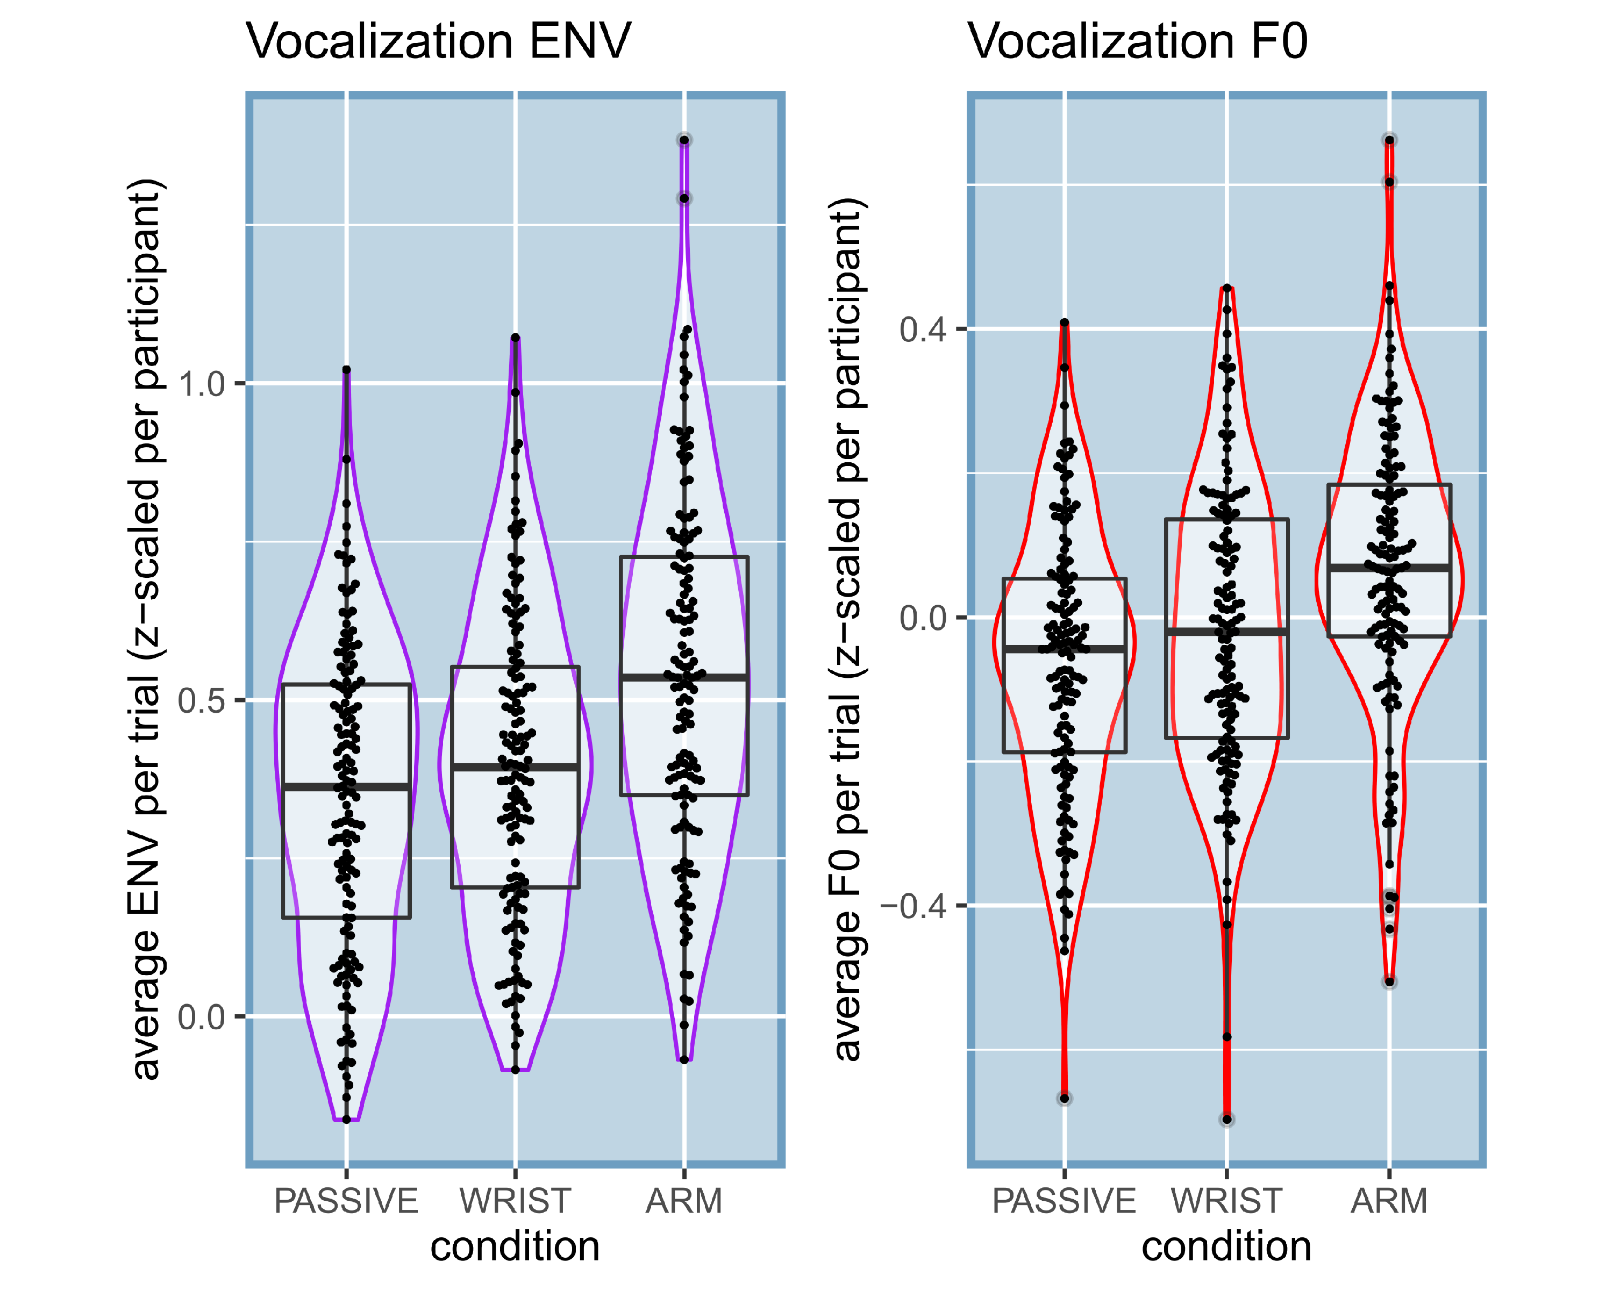

*Note Figure 4*. Violin and box plots are shown for average F0 (Hz) and amplitude envelope (z-scaled) per trial (jitters show observation).

Table 1. Linear mixed effects for effects of condition on F0 and Amplitude envelope

|  |  |  |  |  |  |
| --- | --- | --- | --- | --- | --- |
|  | contrast | b | SE | df | p |
| ENV (z-scaled) | intercept | 0.347 | 0.033 | 382 | < .0001 |
|  | Wrist vs. Passive | 0.048 | 0.022 | 382 | 0.0287 |
|  | Arm vs. Passive | 0.189 | 0.022 | 382 | < .0001 |

F0 (Hz) intercept 186.916 3.25 382 < .0001 Male vs. Female -73.049 5.511 33 < .0001 Wrist vs. Passive 1.419 0.673 382 0.0357  
Arm vs. Passive 3.208 0.674 382 < .0001

## Coupling of vocalization duration and movement

Having ascertained in the previous analysis that there is some kind of acoustic modulation for movement versus no movement, we further need to confirm that such modulations occur at particular moments in the movement cycle. Figure 5 show the main results for all data. It can be seen that just before the moment of maximum extension that there is a clear peak in the observed amplitude envelope, most dramatically for Arm condition, but also present for the Wrist condition. For falsely paired movement and passive condition speech this was not the case, excluding mere chance occurences. For F0 more inconclusive patterns are shown, but still with positive peaks just before the maximum extension. These findings replicate our earlier work on steady-state vocalization and mono-syllable utterances, showing that at moments of peak deceleration there are observed peaks in acoustics (Pouw et al., 2019b, 2019c).  
To formally test that trajectories are indeed non-linear and are reliably different from the passive condition, we performed GAM, a type of non-linear mixed effects procedure. We assessed the average trajectory of acoustics around 800 milliseconds of the maximum extension of the mvoement. We chose 800 milliseconds (-400, 400) as this is about the time for a 1.33Hz cycle (1000/1.33Hz = 752 ms) with an added margin of error of about 50ms. The model results with random slopes and intercept for participant are shown in table 2. Firstly, for all models tests for non-linearity of the trajectories were statistically reliable (*p*’s < .0001), meaning that there are peaks or valleys in acoustics over the movement cycle (Figure 6). As shown in Table 2 our results replicate the general finding that Wrist movements lead to reliably different non-linear peaks in acoustics as compared to the passive condition (*p* < .0001), and this effect relative to the passive condition is even more extreme for the Arm movement condition (*p* < .0001). Figure 6 provides the fitted trajectories for the GAM models.  
For readers interested in individual differences in trajectories, we have uploaded an interactive graph where each participant’s average Amplitude Envelope trajectories can be inspected (<https://osf.io/a423h/>), as well for F0 trajectories (<https://osf.io/fdzwj/>).  
 Figure 5. Average observed vocalization acoustics relative to the moment of maximum extension  
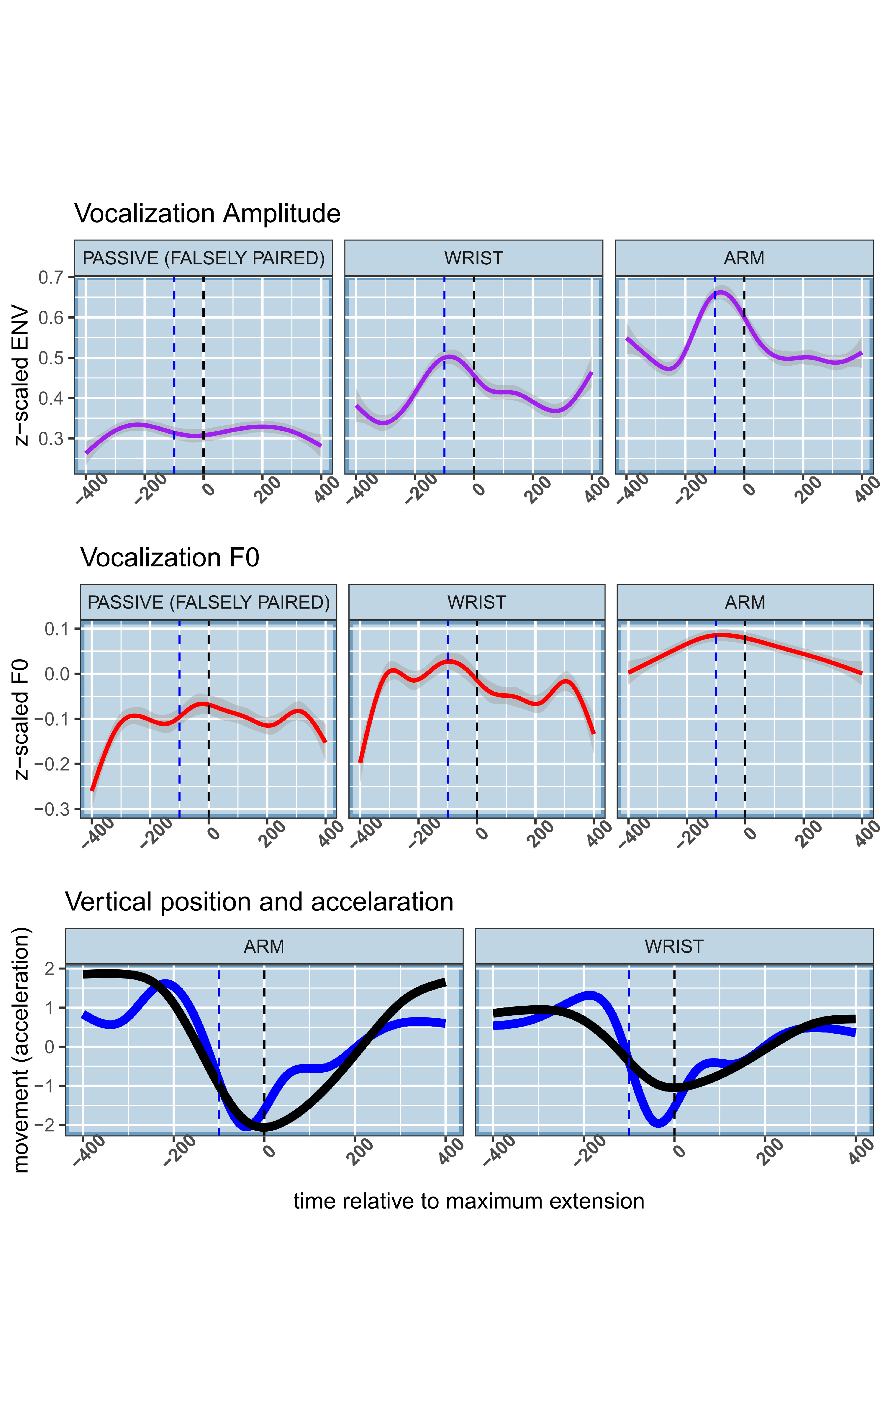

*Note Figure 5*. For the upper two panels the average acoustic trajectory is shown around the moment of maximum extension (*t* = 0, dashed line). In the lower panel we have plotted the z-scaled average vertical displacement of the hand, and the z-scaled acceleration trace. We have marked with the blue dashed vertical line the moment where the deceleration phase starts, which aligns with peaks in acoustics.

Figure 6. Fitted trajectories GAM 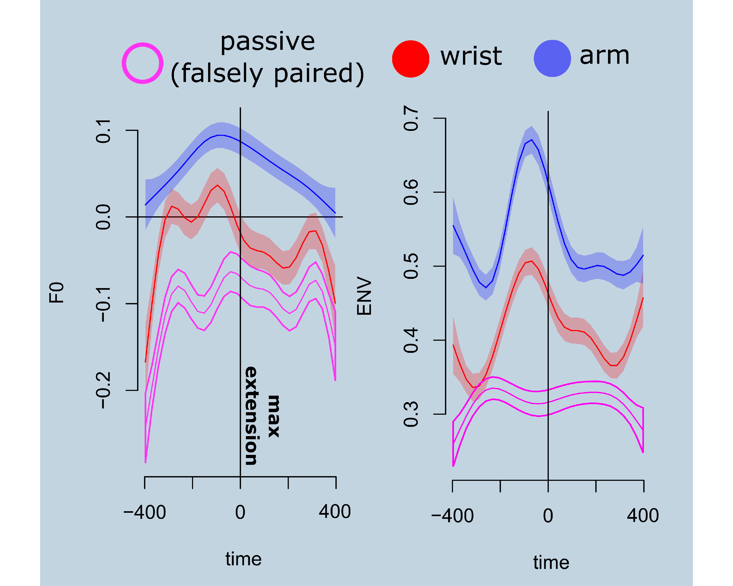

Table 2. Model results for GAM analysis

|  |  |  |  |  |  |
| --- | --- | --- | --- | --- | --- |
|  | contrast | b | SE | df | p |
| ENV (z-scaled) | intercept | 0.237 | 0.006 | 36.923 | < .0001 |
|  | Wrist vs. Passive | 0.096 | 0.009 | 10.579 | < .0001 |
|  | Arm vs. Passive | 0.152 | 0.009 | 16.862 | < .0001 |

F0 (Hz) intercept -0.061 0.006 -8.351 < .0001 Male vs. Female -0.019 0.009 -4.29 < .0001 Wrist vs. Passive 0.101 0.009 10.222 < .0001 Arm vs. Passive 0.094 0.103 9.546 < .0001

*Note*. Model results are shown for the ampltiude envelope (z-scaled) and F0 (Hz). For F0 we accounted for differences of gender when estimating independent effects of condition.

## Degree of physical impetus and acoustic peaks

We have confirmed that speech acoustics is modulated around moments of the deceleration phase, about 0-200 ms before the maximum extension. However a further support of gesture-speech physics would entail a demonstration that forces produced by the upper limb movement predict acoustic peaks. Therefore we assessed for all vocalizations that occurred between 200 to 0ms before the maximum extension whether its acoustic peak (maximum F0 or maximum amplitude envelope) was predicted by the maximum deceleration value (i.e, minimum acceleration observation) observed in that 200 millisecond window. In previous research we obtained that higher deceleration were related to higher amplitude envelope observations, but not F0 (Pouw et al., 2019a).  
Figure 7 shows the general pattern of the results for the Wrist and Arm condition, wherebe we averaged per trial the maximum deceleration v value, max F0, and Max ENV, for each vocalization event. Table 3 shows the model results of linear mixed effects model with random intercept and slopes for participants, where we regressed the trial-averaged max observed deceleration against the co-occuring trial-averaged vocalization acoustic peaks, for amplitude envelope and F0 seperately. We observed that higher deceleration was indeed predicting higher amplitude envelope and F0, for both Wrist and Arm movements (*p* < .001). Similar to previous research, for F0 this effect is more weakly present, and only for the Arm movement condition, as indicated by a statistically reliable interaction between condition and max deceleration effect (*p* < .001). An added interaction effect of acceleration and arm movement was also found amplitude envelope, which confirms that both acceleration and mass of the effector are producing a physical impulse.

Figure 7. Relation max deceleration and height acoustic peak 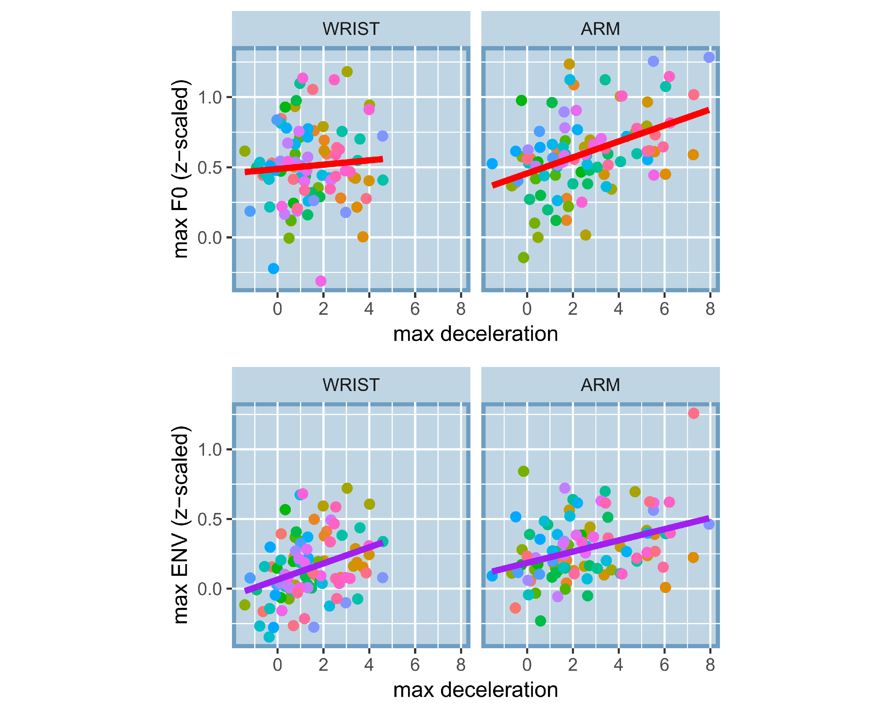

*Note Figure 7*. On the x-axis the average maximum deceleration is shown per trial is shown (absolutized negative acceleration value), where 0 indicates no deceleration and positive values indicate higher deceleration rates in cm/seconds squared. It can be seen that deceleration rates are more extreme for the Arm versus the Wrist condition. On the y-axis we have the average maximum observed amplitude envelope (lower panel) and F0 (upper panel) for those moments of deceleration. There is a general trend that higher decelerations are co-occur with higher peaks in acoustics, especially for the amplitude envelope, and especially for the Arm condition.

Table 4. Linear mixed effects of deceleration and acoustic peaks

|  |  |  |  |  |  |
| --- | --- | --- | --- | --- | --- |
|  | contrast | b | SE | df | p |
| ENV (z-scaled) | Intercept | 0.104 | 0.037 | 342042 | 0.0051 |
|  | Arm vs. Wrist | 0.037 | 0.001 | 342042 | < .0001 |
|  | Max Deceleration | 0.093 | 0.02 | 342042 | < .0001 |
|  | Arm x Max Deceleration | -0.008 | 0.001 | 342042 | < .0001 |

F0 (z-scaled) intercept 0.543 0.062 342042 < .0001 Arm vs. Wrist 0.007 0.001 342042 < .0001 Max Deceleration -0.02 0.032 342042 0.5352  
Arm x Max Deceleration 0.025 0.001 342042 < .0001

*Note*. We included interaction terms if they were found to be statistically reliable.

# Discussion

In the current study we demonstrated biomechanical effects of gesture onto speech, by replicating effects obtained in steady-state vocalization and mono-syllable utterances in fluent speech. We showd that rhythmically moving the wrist or arm, affects vocalization acoustics by heightening F0 and amplitude envelope of speech vocalizations, as compared to a passive control condition. We further show that acoustic modulations of speech vocalizations are especially found around moments of the high-impetus beat, i.e., where the movement abruptly decelerates, thereby producing a physical impetus on the body. We finally show that higher deceleration rates of the movement materialize into more extreme acoustic peaks, demonstrating a role for physcial impulse from gesture onto speech. Further, there was an interaction between the mass of the effector and the rate of deceleration, thus confirming that both mass of the effector and decceleration determine the physical impulse that materializes in vocalization. Indeed, in all analysis we observe that higher-mass arm versus wrist movements affects speech more dramatically.  
The current study is still limited in a number of ways. For example it is not known when biomechanics is counteracted or exploited depending the speakers intentions and information structure of the utterances. Indeed, it should be noted that gesture-speech physics has only been tested in situations where participants are instructed to keep their vocalizations or speech as stable as possible. Although a recent study did show that encouraging participants to gesture, without any instruction about how to speak, did lead to modulation of acoustics similar to the current findings (Cravotta et al., 2019). In the current study, however, participants are likely to counteract effects of the movements, although they are not able to as the results suggest. Future research should therefore focus on how prosodic goals might recruit these biomechanical resources. Indeed, although the movements may have been experienced as a nuisance for participants in the current experiment, we would maintain that gesture-speech physics is a *resource* that can be recruited by an embodied speaker. Prosodic goals, such as producing a pitch accent, can thereby be in part performed by a ‘morphological computation’ (Zhang & Ghazanfar, 2018), i.e., producing a physical impulse via gesturing conducive of reaching prosodic goals.  
Specifically, biomechanics such as these are providing behavioral stabilities that can be allowed by the speaker to arise, and which would be more complicated to perform by some other sensorimotor solution (Perrier & Fuchs, 2015). We have argued in this respect that cognitively, the biomehechanical coupling of gesture and speech provides a ‘smart’ mechanism for ‘timing’ acoustic and movement expressions. With regards to ontogenesis of gesture-speech coupling, we think gesture-speech physics explains how an infant learns to produce multimodal utterances, through the natural discovery of morphological computations during kinesthetic exploration in the form of vocal-motor babbling (Ejiri, 1998). Phylogenetically, gesture-speech physics may have shaped the evolution of the vocal system. What makes this particular thesis exciting we think, is that all theories on multimodal language evolution have been preoccupied with showing how representational functions of gesture are the primary reason for multimodal language to exist. Such arguments piggyback on arguably still hotly debated grounds that such representational gestural capacities are also present in some suffcient proto-form in non-human homonids to explain its current day instantiation (Corballis, 2002; Fröhlich et al., 2019; Kendon, 2017; Levinson & Holler, 2014; Prieur et al., 2019; Tomasello, 2008). In contrast, gesture-speech physics provides a more solid phylogenetic basis for a evolution of multimodal behavior, whereby peripheral bodily tensioning naturally formed coalitions with sound-producing organs that were still very much under development.

# References

Bernstein, N. (1967). *The Co-ordination and Regulations of Movements* ([1st English ed.] edition.). Pergamon Press.

Carrier, D. R., Kapoor, A. K., Kimura, T., Nickels, M. K., Satwanti, Scott, E. C., … Trinkaus, E. (1984). The Energetic Paradox of Human Running and Hominid Evolution [and Comments and Reply]. *Current Anthropology*, *25*(4), 483–495. Retrieved from <https://www.jstor.org/stable/2742907>

Corballis, M. C. (2002). *From hand to mouth: The origins of language*. Princeton, NJ.: Princeton University Press.

Cordo, P. J., & Nashner, L. M. (1982). Properties of postural adjustments associated with rapid arm movements. *Journal of Neurophysiology*, *47*(2), 287–302. doi:[10.1152/jn.1982.47.2.287](https://doi.org/10.1152/jn.1982.47.2.287)

Cravotta, A., Busà, M. G., & Prieto, P. (2019). Effects of Encouraging the Use of Gestures on Speech. *Journal of Speech, Language, and Hearing Research*. doi:[10.21437/SpeechProsody.2018-42](https://doi.org/10.21437/SpeechProsody.2018-42)

Danner, S. G., Barbosa, A. V., & Goldstein, L. (2018). Quantitative analysis of multimodal speech data. *Journal of Phonetics*, *71*, 268–283. doi:[10.1016/j.wocn.2018.09.007](https://doi.org/10.1016/j.wocn.2018.09.007)

Ejiri, K. (1998). Relationship between Rhythmic Behavior and Canonical Babbling in Infant Vocal Development. *Phonetica*, *55*(4), 226–237. doi:[10.1159/000028434](https://doi.org/10.1159/000028434)

Ejiri, K., & Masataka, N. (2001). Co-occurences of preverbal vocal behavior and motor action in early infancy. *Developmental Science*, *4*(1), 40–48. doi:[10.1111/1467-7687.00147](https://doi.org/10.1111/1467-7687.00147)

Esteve-Gibert, N., & Prieto, P. (2013). Prosodic structure shapes the temporal Realization of intonation and manual gesture movements. *Journal of Speech, Language, and Hearing Research*, *56*(3), 850–864. doi:[10.1044/1092-4388(2012/12-0049)](https://doi.org/10.1044/1092-4388(2012/12-0049))

Feyereisen, P. (2017). *The Cognitive Psychology of Speech-Related Gesture*. New York: Routledge. Retrieved from <http://books.google.com?id=nJguDwAAQBAJ>

Fröhlich, M., Sievers, C., Townsend, S. W., Gruber, T., & Schaik, C. P. van. (2019). Multimodal communication and language origins: Integrating gestures and vocalizations. *Biological Reviews*, *94*(5), 1809–1829. doi:[10.1111/brv.12535](https://doi.org/10.1111/brv.12535)

Ghazanfar, A. A., Turesson, H. K., Maier, J. X., van Dinther, R., Patterson, R. D., & Logothetis, N. K. (2007). Vocal-tract resonances as indexical cues in rhesus monkeys. *Current Biology*, *17*(5-2), 425–430. doi:[10.1016/j.cub.2007.01.029](https://doi.org/10.1016/j.cub.2007.01.029)

Ginosar, S., Bar, A., Kohavi, G., Chan, C., Owens, A., & Malik, J. (2019). Learning individual styles of conversational gesture. In *Proceedings of the IEEE Conference on Computer Vision and Pattern Recognition* (pp. 3497–3506). Retrieved from <https://arxiv.org/abs/1906.04160>

Hardus, M. E., Lameira, A. R., Schaik, C. S., & Wich, S. A. (2009). Tool use in wild orang-utans modifies sound production: A functionally deceptive innovation? *Proceedings of the Royal Society B: Biological Sciences*, *276*(1673), 3689–3694. doi:[10.1098/rspb.2009.1027](https://doi.org/10.1098/rspb.2009.1027)

Hastie, T. (2019). Gam: Generalized Additive Models (Version 1.16.1). Retrieved from <https://CRAN.R-project.org/package=gam>

He, L., & Dellwo, V. (2017). Amplitude envelope kinematics of speech: Parameter extraction and applications. *The Journal of the Acoustical Society of America*, *141*(5), 3582–3582. doi:[10.1121/1.4987638](https://doi.org/10.1121/1.4987638)

Hodges, P. W., & Richardson, C. A. (1997). Feedforward contraction of transversus abdominis is not influenced by the direction of arm movement. *Experimental Brain Research*, *114*(2), 362–370. doi:[10.1007/pl00005644](https://doi.org/10.1007/pl00005644)

Holler, J., & Levinson, S. C. (2019). Multimodal language processing in human communication. *Trends in Cognitive Sciences*, *23*(8), 639–652. doi:[10.1016/j.tics.2019.05.006](https://doi.org/10.1016/j.tics.2019.05.006)

Im, S., & Baumann, S. (2020). Probabilistic relation between co-speech gestures, pitch accents and information status. *Proceedings of the Linguistic Society of America*, *5*(1, 1), 685–697. doi:[10.3765/plsa.v5i1.4755](https://doi.org/10.3765/plsa.v5i1.4755)

Iverson, J. M., & Thelen, E. (2005). Hand, mouth and brain: The dynamic emergence of speech and gesture. *Journal of Consciousness Studies*, 22.

Kelso, J. A., & Tuller, B. (1984). Converging evidence in support of common dynamical principles for speech and movement coordination. *The American Journal of Physiology*, *246*(6 Pt 2), R928–935. doi:[10.1152/ajpregu.1984.246.6.R928](https://doi.org/10.1152/ajpregu.1984.246.6.R928)

Kendon, A. (2017). Reflections on the “gesture-first” hypothesis of language origins. *Psychonomic Bulletin & Review*, *24*(1), 163–170. doi:[10.3758/s13423-016-1117-3](https://doi.org/10.3758/s13423-016-1117-3)

Krahmer, E., & Swerts, M. (2007). The effects of visual beats on prosodic prominence: Acoustic analyses, auditory perception and visual perception. *Journal of Memory and Language*, *57*(3), 396–414. doi:[10.1016/j.jml.2007.06.005](https://doi.org/10.1016/j.jml.2007.06.005)

Krivokapić, J. (2014). Gestural coordination at prosodic boundaries and its role for prosodic structure and speech planning processes. *Philosophical Transactions of the Royal Society B: Biological Sciences*, *369*(1658). doi:[10.1098/rstb.2013.0397](https://doi.org/10.1098/rstb.2013.0397)

Kucherenko, T., Hasegawa, D., Henter, G. E., Kaneko, N., & Kjellström, H. (2019). Analyzing Input and Output Representations for Speech-Driven Gesture Generation. In *Proceedings of the 19th ACM International Conference on Intelligent Virtual Agents - IVA ’19* (pp. 97–104). Paris, France: ACM Press. doi:[10.1145/3308532.3329472](https://doi.org/10.1145/3308532.3329472)

Lancaster, W. C., Henson, O. W., & Keating, A. W. (1995). Respiratory muscle activity in relation to vocalization in flying bats. *Journal of Experimental Biology*, *198*(1), 175–191. Retrieved from <https://jeb.biologists.org/content/198/1/175>

Larsson, M., Richter, J., & Ravignani, A. (2019). Bipedal Steps in the Development of Rhythmic Behavior in Humans. *Music & Science*, *2*, 2059204319892617. doi:[10.1177/2059204319892617](https://doi.org/10.1177/2059204319892617)

Leonard, T., & Cummins, F. (2011). The temporal relation between beat gestures and speech. *Language and Cognitive Processes*, *26*(10), 1457–1471. doi:[10.1080/01690965.2010.500218](https://doi.org/10.1080/01690965.2010.500218)

Levin, S. M. (2006). Tensegrity: The new biomechanics. In M. Hutson & R. Ellis (Eds.), *Textbook of muscularskeletal medicine* (pp. 69–80). Oxford, England: Oxford University Press.

Levinson, S. C., & Holler, J. (2014). The origin of human multi-modal communication. *Philosophical Transactions of the Royal Society B: Biological Sciences*, *369*(1651). doi:[10.1098/rstb.2013.0302](https://doi.org/10.1098/rstb.2013.0302)

Loehr, D. P. (2012). Temporal, structural, and pragmatic synchrony between intonation and gesture. *Laboratory Phonology*, *3*(1), 71–89. doi:[10.1515/lp-2012-0006](https://doi.org/10.1515/lp-2012-0006)

MacLarnon, A. M., & Hewitt, G. P. (1999). The evolution of human speech: The role of enhanced breathing control. *American Journal of Physical Anthropology*, *109*(3), 341–363. doi:[10.1002/(SICI)1096-8644(199907)109:3<341::AID-AJPA5>3.0.CO;2-2](https://doi.org/10.1002/(SICI)1096-8644(199907)109:3%3C341::AID-AJPA5%3E3.0.CO;2-2)

McClave, E. (1998). Pitch and Manual Gestures. *Journal of Psycholinguistic Research*, *27*(2), 69–89. doi:[https://doi.org/10.1023/A:1023274823974](https://doi.org/https://doi.org/10.1023/A:1023274823974)

McNeill, D. (1992). *Hand and Mind: What Gestures Reveal about Thought*. Chicago: University Of Chicago Press.

Mendoza-Denton, N., & Jannedy, S. (2011). Semiotic Layering through Gesture and Intonation: A Case Study of Complementary and Supplementary Multimodality in Political Speech. *Journal of English Linguistics*, *39*(3), 265–299. doi:[10.1177/0075424211405941](https://doi.org/10.1177/0075424211405941)

Parrell, B., Goldstein, L., Lee, S., & Byrd, D. (2014). Spatiotemporal coupling between speech and manual motor actions. *Journal of Phonetics*, *42*, 1–11. doi:[10.1016/j.wocn.2013.11.002](https://doi.org/10.1016/j.wocn.2013.11.002)

Perrier, P., & Fuchs, S. (2015). Motor Equivalence in Speech Production. In *The Handbook of Speech Production* (pp. 223–247). John Wiley & Sons, Ltd. doi:[10.1002/9781118584156.ch11](https://doi.org/10.1002/9781118584156.ch11)

Pinheiro, J., Bates, D., DebRoy, S., Sarkar, D., & R Team, R. C. (2019). *Nlme: Linear and nonlinear mixed effects models*.

Pisanski, K., Cartei, V., McGettigan, C., Raine, J., & Reby, D. (2016a). Voice modulation: A window into the origins of guman vocal control? *Trends in Cognitive Sciences*, *20*(4), 304–318. doi:[10.1016/j.tics.2016.01.002](https://doi.org/10.1016/j.tics.2016.01.002)

Pisanski, K., Fraccaro, P. J., Tigue, C. C., O’Connor, J. J. M., & Feinberg, D. R. (2014). Return to Oz: Voice pitch facilitates assessments of men’s body size. *Journal of Experimental Psychology. Human Perception and Performance*, *40*(4), 1316–1331. doi:[10.1037/a0036956](https://doi.org/10.1037/a0036956)

Pisanski, K., Oleszkiewicz, A., & Sorokowska, A. (2016b). Can blind persons accurately assess body size from the voice? *Biology Letters*, *12*(4), 20160063. doi:[10.1098/rsbl.2016.0063](https://doi.org/10.1098/rsbl.2016.0063)

Pouw, W., & Dixon, J. A. (2019a). Entrainment and modulation of gesture–speech synchrony under delayed auditory feedback. *Cognitive Science*, *43*(3), e12721. doi:[10.1111/cogs.12721](https://doi.org/10.1111/cogs.12721)

Pouw, W., & Dixon, J. A. (2019b). Quantifying gesture-speech synchrony. In *Proceedings of the 6th meeting of Gesture and Speech in Interaction* (pp. 68–74). Paderborn: Universitaetsbibliothek Paderborn. doi:[10.17619/UNIPB/1-812](https://doi.org/10.17619/UNIPB/1-812)

Pouw, W., Esteve-Gibert, N., Harrison, S. H., & Dixon, J. A. (2019a). *Energy flows in gesture-speech physics: The respiratory-vocal system and its coupling with hand gestures*. Retrieved from <https://psyarxiv.com/rnpav>

Pouw, W., Harrison, S. H., & Dixon, J. A. (2019b). Gesture-speech physics: The biomechanical basis of the emergence of gesture-speech synchrony. *Journal of Experimental Psychology: General*. doi:[10.1037/xge0000646](https://doi.org/10.1037/xge0000646)

Pouw, W., Harrison, S. J., Esteve-Gibert, N., & Dixon, J. A. (2019c). Energy flows in gesture-speech physics: Exploratory findings and pre-registration of confirmatory analysis. doi:[10.31234/osf.io/c7456](https://doi.org/10.31234/osf.io/c7456)

Pouw, W., Paxton, A., Harrison, S. J., & Dixon, J. A. (2019d). Acoustic specification of upper limb movement in voicing. In *Proceedings of the 6th meeting of Gesture and Speech in Interaction* (pp. 75–80). Paderborn, Germany: Universitaetsbibliothek Paderborn. doi:[10.17619/UNIPB/1-812](https://doi.org/10.17619/UNIPB/1-812)

Pouw, W., Paxton, A., Harrison, S. J., & Dixon, J. A. (2020). Acoustic information about upper limb movement in voicing. *Proceedings of the National Academy of Sciences*. doi:[10.1073/pnas.2004163117](https://doi.org/10.1073/pnas.2004163117)

Pouw, W., & Trujillo, J. P. (2019). *Materials Tutorial Gespin2019 - Using video-based motion tracking to quantify speech-gesture synchrony*. Retrieved from <10.17605/OSF.IO/RXB8J>

Prieur, J., Barbu, S., Blois-Heulin, C., & Lemasson, A. (2019). The origins of gestures and language: History, current advances and proposed theories. *Biological Reviews of the Cambridge Philosophical Society*. doi:[10.1111/brv.12576](https://doi.org/10.1111/brv.12576)

Profeta, V. L. S., & Turvey, M. T. (2018). Bernstein’s levels of movement construction: A contemporary perspective. *Human Movement Science*, *57*, 111–133. doi:[10.1016/j.humov.2017.11.013](https://doi.org/10.1016/j.humov.2017.11.013)

Ravignani, A., Dalla Bella, S., Falk, S., Kello, C. T., Noriega, F., & Kotz, S. (2019). Rhythm in speech and animal vocalizations: A cross‐species perspective. *Annals of the New York Academy of Sciences*. doi:[10.1111/nyas.14166](https://doi.org/10.1111/nyas.14166)

Rochet-Capellan, A., Laboissière, R., Galván, A., & Jean-Luc, S. (2008). The speech focus position effect on jaw–finger coordination in a pointing task. *Journal of Speech, Language, and Hearing Research*, *51*(6), 1507–1521. doi:[10.1044/1092-4388(2008/07-0173)](https://doi.org/10.1044/1092-4388(2008/07-0173))

Rosch, A., & Schmidbauer, H. (2014). WaveletComp 1.1: A guided tour through the R package, 59.

Ruiter, J. P. de. (2000, August). *The production of gesture and speech*. *Language and Gesture*. doi:[10.1017/CBO9780511620850.018](https://doi.org/10.1017/CBO9780511620850.018)

Shattuck-Hufnagel, S., & Prieto, P. (2019). Dimensionalizing co-speech gestures. In *Proceedings of the International Congress of Phonetic Sciences 2019* (p. 5). Melbourne, Australia.

Silva, P., Moreno, M., Mancini, M., Fonseca, S., & Turvey, M. T. (2007). Steady-state stress at one hand magnifies the amplitude, stiffness, and non-linearity of oscillatory behavior at the other hand. *Neuroscience Letters*, *429*(1), 64–68. doi:[10.1016/j.neulet.2007.09.066](https://doi.org/10.1016/j.neulet.2007.09.066)

Stoltmann, K., & Fuchs, S. (2017). Syllable-pointing gesture coordination in Polish counting out rhymes: The effect of speech rate. *Journal of Multimodal Communication Studies*, *4*(1-2), 63–68.

Streeck, J. (2008). Depicting by gesture. *Gesture*, *8*(3), 285–301. doi:[10.1075/gest.8.3.02str](https://doi.org/10.1075/gest.8.3.02str)

Tomasello, M. (2008). *The origins of human communication*. Cambdride, MA: MIT press.

Treffner, P., & Peter, M. (2002). Intentional and attentional dynamics of speech–hand coordination. *Human Movement Science*, *21*(5-6), 641–697. doi:[10.1016/S0167-9457(02)00178-1](https://doi.org/10.1016/S0167-9457(02)00178-1)

Turvey, M. T. (1990). Coordination. *American Psychologist*, *45*(8), 938–953. doi:[10.1037/0003-066X.45.8.938](https://doi.org/10.1037/0003-066X.45.8.938)

Turvey, M. T., & Fonseca, S. T. (2014). The Medium of Haptic Perception: A Tensegrity Hypothesis. *Journal of Motor Behavior*, *46*(3), 143–187. doi:[10.1080/00222895.2013.798252](https://doi.org/10.1080/00222895.2013.798252)

Wagner, P., Malisz, Z., & Kopp, S. (2014). Gesture and speech in interaction: An overview. *Speech Communication*, *57*, 209–232. doi:[10.1016/j.specom.2013.09.008](https://doi.org/10.1016/j.specom.2013.09.008)

Winkelmann, R., Bombien, L., & Scheffers, M. (2018). Wrassp: Interface to the ’ASSP’ Library (Version 0.1.8). Retrieved from <https://CRAN.R-project.org/package=wrassp>

Zelic, G., Kim, J., & Davis, C. (2015). Articulatory constraints on spontaneous entrainment between speech and manual gesture. *Human Movement Science*, *42*, 232–245. doi:[10.1016/j.humov.2015.05.009](https://doi.org/10.1016/j.humov.2015.05.009)

Zhang, Y. S., & Ghazanfar, A. A. (2018). Vocal development through morphological computation. *PLOS Biology*, *16*(2), e2003933. doi:[10.1371/journal.pbio.2003933](https://doi.org/10.1371/journal.pbio.2003933)

Bernstein, N. (1967). *The Co-ordination and Regulations of Movements* ([1st English ed.] edition.). Pergamon Press.

Carrier, D. R., Kapoor, A. K., Kimura, T., Nickels, M. K., Satwanti, Scott, E. C., … Trinkaus, E. (1984). The Energetic Paradox of Human Running and Hominid Evolution [and Comments and Reply]. *Current Anthropology*, *25*(4), 483–495. Retrieved from <https://www.jstor.org/stable/2742907>

Corballis, M. C. (2002). *From hand to mouth: The origins of language*. Princeton, NJ.: Princeton University Press.

Cordo, P. J., & Nashner, L. M. (1982). Properties of postural adjustments associated with rapid arm movements. *Journal of Neurophysiology*, *47*(2), 287–302. doi:[10.1152/jn.1982.47.2.287](https://doi.org/10.1152/jn.1982.47.2.287)

Cravotta, A., Busà, M. G., & Prieto, P. (2019). Effects of Encouraging the Use of Gestures on Speech. *Journal of Speech, Language, and Hearing Research*. doi:[10.21437/SpeechProsody.2018-42](https://doi.org/10.21437/SpeechProsody.2018-42)

Danner, S. G., Barbosa, A. V., & Goldstein, L. (2018). Quantitative analysis of multimodal speech data. *Journal of Phonetics*, *71*, 268–283. doi:[10.1016/j.wocn.2018.09.007](https://doi.org/10.1016/j.wocn.2018.09.007)

Ejiri, K. (1998). Relationship between Rhythmic Behavior and Canonical Babbling in Infant Vocal Development. *Phonetica*, *55*(4), 226–237. doi:[10.1159/000028434](https://doi.org/10.1159/000028434)

Ejiri, K., & Masataka, N. (2001). Co-occurences of preverbal vocal behavior and motor action in early infancy. *Developmental Science*, *4*(1), 40–48. doi:[10.1111/1467-7687.00147](https://doi.org/10.1111/1467-7687.00147)

Esteve-Gibert, N., & Prieto, P. (2013). Prosodic structure shapes the temporal Realization of intonation and manual gesture movements. *Journal of Speech, Language, and Hearing Research*, *56*(3), 850–864. doi:[10.1044/1092-4388(2012/12-0049)](https://doi.org/10.1044/1092-4388(2012/12-0049))

Feyereisen, P. (2017). *The Cognitive Psychology of Speech-Related Gesture*. New York: Routledge. Retrieved from <http://books.google.com?id=nJguDwAAQBAJ>

Fröhlich, M., Sievers, C., Townsend, S. W., Gruber, T., & Schaik, C. P. van. (2019). Multimodal communication and language origins: Integrating gestures and vocalizations. *Biological Reviews*, *94*(5), 1809–1829. doi:[10.1111/brv.12535](https://doi.org/10.1111/brv.12535)

Ghazanfar, A. A., Turesson, H. K., Maier, J. X., van Dinther, R., Patterson, R. D., & Logothetis, N. K. (2007). Vocal-tract resonances as indexical cues in rhesus monkeys. *Current Biology*, *17*(5-2), 425–430. doi:[10.1016/j.cub.2007.01.029](https://doi.org/10.1016/j.cub.2007.01.029)

Ginosar, S., Bar, A., Kohavi, G., Chan, C., Owens, A., & Malik, J. (2019). Learning individual styles of conversational gesture. In *Proceedings of the IEEE Conference on Computer Vision and Pattern Recognition* (pp. 3497–3506). Retrieved from <https://arxiv.org/abs/1906.04160>

Hardus, M. E., Lameira, A. R., Schaik, C. S., & Wich, S. A. (2009). Tool use in wild orang-utans modifies sound production: A functionally deceptive innovation? *Proceedings of the Royal Society B: Biological Sciences*, *276*(1673), 3689–3694. doi:[10.1098/rspb.2009.1027](https://doi.org/10.1098/rspb.2009.1027)

Hastie, T. (2019). Gam: Generalized Additive Models (Version 1.16.1). Retrieved from <https://CRAN.R-project.org/package=gam>

He, L., & Dellwo, V. (2017). Amplitude envelope kinematics of speech: Parameter extraction and applications. *The Journal of the Acoustical Society of America*, *141*(5), 3582–3582. doi:[10.1121/1.4987638](https://doi.org/10.1121/1.4987638)

Hodges, P. W., & Richardson, C. A. (1997). Feedforward contraction of transversus abdominis is not influenced by the direction of arm movement. *Experimental Brain Research*, *114*(2), 362–370. doi:[10.1007/pl00005644](https://doi.org/10.1007/pl00005644)

Holler, J., & Levinson, S. C. (2019). Multimodal language processing in human communication. *Trends in Cognitive Sciences*, *23*(8), 639–652. doi:[10.1016/j.tics.2019.05.006](https://doi.org/10.1016/j.tics.2019.05.006)

Im, S., & Baumann, S. (2020). Probabilistic relation between co-speech gestures, pitch accents and information status. *Proceedings of the Linguistic Society of America*, *5*(1, 1), 685–697. doi:[10.3765/plsa.v5i1.4755](https://doi.org/10.3765/plsa.v5i1.4755)

Iverson, J. M., & Thelen, E. (2005). Hand, mouth and brain: The dynamic emergence of speech and gesture. *Journal of Consciousness Studies*, 22.

Kelso, J. A., & Tuller, B. (1984). Converging evidence in support of common dynamical principles for speech and movement coordination. *The American Journal of Physiology*, *246*(6 Pt 2), R928–935. doi:[10.1152/ajpregu.1984.246.6.R928](https://doi.org/10.1152/ajpregu.1984.246.6.R928)

Kendon, A. (2017). Reflections on the “gesture-first” hypothesis of language origins. *Psychonomic Bulletin & Review*, *24*(1), 163–170. doi:[10.3758/s13423-016-1117-3](https://doi.org/10.3758/s13423-016-1117-3)

Krahmer, E., & Swerts, M. (2007). The effects of visual beats on prosodic prominence: Acoustic analyses, auditory perception and visual perception. *Journal of Memory and Language*, *57*(3), 396–414. doi:[10.1016/j.jml.2007.06.005](https://doi.org/10.1016/j.jml.2007.06.005)

Krivokapić, J. (2014). Gestural coordination at prosodic boundaries and its role for prosodic structure and speech planning processes. *Philosophical Transactions of the Royal Society B: Biological Sciences*, *369*(1658). doi:[10.1098/rstb.2013.0397](https://doi.org/10.1098/rstb.2013.0397)

Kucherenko, T., Hasegawa, D., Henter, G. E., Kaneko, N., & Kjellström, H. (2019). Analyzing Input and Output Representations for Speech-Driven Gesture Generation. In *Proceedings of the 19th ACM International Conference on Intelligent Virtual Agents - IVA ’19* (pp. 97–104). Paris, France: ACM Press. doi:[10.1145/3308532.3329472](https://doi.org/10.1145/3308532.3329472)

Lancaster, W. C., Henson, O. W., & Keating, A. W. (1995). Respiratory muscle activity in relation to vocalization in flying bats. *Journal of Experimental Biology*, *198*(1), 175–191. Retrieved from <https://jeb.biologists.org/content/198/1/175>

Larsson, M., Richter, J., & Ravignani, A. (2019). Bipedal Steps in the Development of Rhythmic Behavior in Humans. *Music & Science*, *2*, 2059204319892617. doi:[10.1177/2059204319892617](https://doi.org/10.1177/2059204319892617)

Leonard, T., & Cummins, F. (2011). The temporal relation between beat gestures and speech. *Language and Cognitive Processes*, *26*(10), 1457–1471. doi:[10.1080/01690965.2010.500218](https://doi.org/10.1080/01690965.2010.500218)

Levin, S. M. (2006). Tensegrity: The new biomechanics. In M. Hutson & R. Ellis (Eds.), *Textbook of muscularskeletal medicine* (pp. 69–80). Oxford, England: Oxford University Press.

Levinson, S. C., & Holler, J. (2014). The origin of human multi-modal communication. *Philosophical Transactions of the Royal Society B: Biological Sciences*, *369*(1651). doi:[10.1098/rstb.2013.0302](https://doi.org/10.1098/rstb.2013.0302)

Loehr, D. P. (2012). Temporal, structural, and pragmatic synchrony between intonation and gesture. *Laboratory Phonology*, *3*(1), 71–89. doi:[10.1515/lp-2012-0006](https://doi.org/10.1515/lp-2012-0006)

MacLarnon, A. M., & Hewitt, G. P. (1999). The evolution of human speech: The role of enhanced breathing control. *American Journal of Physical Anthropology*, *109*(3), 341–363. doi:[10.1002/(SICI)1096-8644(199907)109:3<341::AID-AJPA5>3.0.CO;2-2](https://doi.org/10.1002/(SICI)1096-8644(199907)109:3%3C341::AID-AJPA5%3E3.0.CO;2-2)

McClave, E. (1998). Pitch and Manual Gestures. *Journal of Psycholinguistic Research*, *27*(2), 69–89. doi:[https://doi.org/10.1023/A:1023274823974](https://doi.org/https://doi.org/10.1023/A:1023274823974)

McNeill, D. (1992). *Hand and Mind: What Gestures Reveal about Thought*. Chicago: University Of Chicago Press.

Mendoza-Denton, N., & Jannedy, S. (2011). Semiotic Layering through Gesture and Intonation: A Case Study of Complementary and Supplementary Multimodality in Political Speech. *Journal of English Linguistics*, *39*(3), 265–299. doi:[10.1177/0075424211405941](https://doi.org/10.1177/0075424211405941)

Parrell, B., Goldstein, L., Lee, S., & Byrd, D. (2014). Spatiotemporal coupling between speech and manual motor actions. *Journal of Phonetics*, *42*, 1–11. doi:[10.1016/j.wocn.2013.11.002](https://doi.org/10.1016/j.wocn.2013.11.002)

Perrier, P., & Fuchs, S. (2015). Motor Equivalence in Speech Production. In *The Handbook of Speech Production* (pp. 223–247). John Wiley & Sons, Ltd. doi:[10.1002/9781118584156.ch11](https://doi.org/10.1002/9781118584156.ch11)

Pinheiro, J., Bates, D., DebRoy, S., Sarkar, D., & R Team, R. C. (2019). *Nlme: Linear and nonlinear mixed effects models*.

Pisanski, K., Cartei, V., McGettigan, C., Raine, J., & Reby, D. (2016a). Voice modulation: A window into the origins of guman vocal control? *Trends in Cognitive Sciences*, *20*(4), 304–318. doi:[10.1016/j.tics.2016.01.002](https://doi.org/10.1016/j.tics.2016.01.002)

Pisanski, K., Fraccaro, P. J., Tigue, C. C., O’Connor, J. J. M., & Feinberg, D. R. (2014). Return to Oz: Voice pitch facilitates assessments of men’s body size. *Journal of Experimental Psychology. Human Perception and Performance*, *40*(4), 1316–1331. doi:[10.1037/a0036956](https://doi.org/10.1037/a0036956)

Pisanski, K., Oleszkiewicz, A., & Sorokowska, A. (2016b). Can blind persons accurately assess body size from the voice? *Biology Letters*, *12*(4), 20160063. doi:[10.1098/rsbl.2016.0063](https://doi.org/10.1098/rsbl.2016.0063)

Pouw, W., & Dixon, J. A. (2019a). Entrainment and modulation of gesture–speech synchrony under delayed auditory feedback. *Cognitive Science*, *43*(3), e12721. doi:[10.1111/cogs.12721](https://doi.org/10.1111/cogs.12721)

Pouw, W., & Dixon, J. A. (2019b). Quantifying gesture-speech synchrony. In *Proceedings of the 6th meeting of Gesture and Speech in Interaction* (pp. 68–74). Paderborn: Universitaetsbibliothek Paderborn. doi:[10.17619/UNIPB/1-812](https://doi.org/10.17619/UNIPB/1-812)

Pouw, W., Esteve-Gibert, N., Harrison, S. H., & Dixon, J. A. (2019a). *Energy flows in gesture-speech physics: The respiratory-vocal system and its coupling with hand gestures*. Retrieved from <https://psyarxiv.com/rnpav>

Pouw, W., Harrison, S. H., & Dixon, J. A. (2019b). Gesture-speech physics: The biomechanical basis of the emergence of gesture-speech synchrony. *Journal of Experimental Psychology: General*. doi:[10.1037/xge0000646](https://doi.org/10.1037/xge0000646)

Pouw, W., Harrison, S. J., Esteve-Gibert, N., & Dixon, J. A. (2019c). Energy flows in gesture-speech physics: Exploratory findings and pre-registration of confirmatory analysis. doi:[10.31234/osf.io/c7456](https://doi.org/10.31234/osf.io/c7456)

Pouw, W., Paxton, A., Harrison, S. J., & Dixon, J. A. (2019d). Acoustic specification of upper limb movement in voicing. In *Proceedings of the 6th meeting of Gesture and Speech in Interaction* (pp. 75–80). Paderborn, Germany: Universitaetsbibliothek Paderborn. doi:[10.17619/UNIPB/1-812](https://doi.org/10.17619/UNIPB/1-812)

Pouw, W., Paxton, A., Harrison, S. J., & Dixon, J. A. (2020). Acoustic information about upper limb movement in voicing. *Proceedings of the National Academy of Sciences*. doi:[10.1073/pnas.2004163117](https://doi.org/10.1073/pnas.2004163117)

Pouw, W., & Trujillo, J. P. (2019). *Materials Tutorial Gespin2019 - Using video-based motion tracking to quantify speech-gesture synchrony*. Retrieved from <10.17605/OSF.IO/RXB8J>

Prieur, J., Barbu, S., Blois-Heulin, C., & Lemasson, A. (2019). The origins of gestures and language: History, current advances and proposed theories. *Biological Reviews of the Cambridge Philosophical Society*. doi:[10.1111/brv.12576](https://doi.org/10.1111/brv.12576)

Profeta, V. L. S., & Turvey, M. T. (2018). Bernstein’s levels of movement construction: A contemporary perspective. *Human Movement Science*, *57*, 111–133. doi:[10.1016/j.humov.2017.11.013](https://doi.org/10.1016/j.humov.2017.11.013)

Ravignani, A., Dalla Bella, S., Falk, S., Kello, C. T., Noriega, F., & Kotz, S. (2019). Rhythm in speech and animal vocalizations: A cross‐species perspective. *Annals of the New York Academy of Sciences*. doi:[10.1111/nyas.14166](https://doi.org/10.1111/nyas.14166)

Rochet-Capellan, A., Laboissière, R., Galván, A., & Jean-Luc, S. (2008). The speech focus position effect on jaw–finger coordination in a pointing task. *Journal of Speech, Language, and Hearing Research*, *51*(6), 1507–1521. doi:[10.1044/1092-4388(2008/07-0173)](https://doi.org/10.1044/1092-4388(2008/07-0173))

Rosch, A., & Schmidbauer, H. (2014). WaveletComp 1.1: A guided tour through the R package, 59.

Ruiter, J. P. de. (2000, August). *The production of gesture and speech*. *Language and Gesture*. doi:[10.1017/CBO9780511620850.018](https://doi.org/10.1017/CBO9780511620850.018)

Shattuck-Hufnagel, S., & Prieto, P. (2019). Dimensionalizing co-speech gestures. In *Proceedings of the International Congress of Phonetic Sciences 2019* (p. 5). Melbourne, Australia.

Silva, P., Moreno, M., Mancini, M., Fonseca, S., & Turvey, M. T. (2007). Steady-state stress at one hand magnifies the amplitude, stiffness, and non-linearity of oscillatory behavior at the other hand. *Neuroscience Letters*, *429*(1), 64–68. doi:[10.1016/j.neulet.2007.09.066](https://doi.org/10.1016/j.neulet.2007.09.066)

Stoltmann, K., & Fuchs, S. (2017). Syllable-pointing gesture coordination in Polish counting out rhymes: The effect of speech rate. *Journal of Multimodal Communication Studies*, *4*(1-2), 63–68.

Streeck, J. (2008). Depicting by gesture. *Gesture*, *8*(3), 285–301. doi:[10.1075/gest.8.3.02str](https://doi.org/10.1075/gest.8.3.02str)

Tomasello, M. (2008). *The origins of human communication*. Cambdride, MA: MIT press.

Treffner, P., & Peter, M. (2002). Intentional and attentional dynamics of speech–hand coordination. *Human Movement Science*, *21*(5-6), 641–697. doi:[10.1016/S0167-9457(02)00178-1](https://doi.org/10.1016/S0167-9457(02)00178-1)

Turvey, M. T. (1990). Coordination. *American Psychologist*, *45*(8), 938–953. doi:[10.1037/0003-066X.45.8.938](https://doi.org/10.1037/0003-066X.45.8.938)

Turvey, M. T., & Fonseca, S. T. (2014). The Medium of Haptic Perception: A Tensegrity Hypothesis. *Journal of Motor Behavior*, *46*(3), 143–187. doi:[10.1080/00222895.2013.798252](https://doi.org/10.1080/00222895.2013.798252)

Wagner, P., Malisz, Z., & Kopp, S. (2014). Gesture and speech in interaction: An overview. *Speech Communication*, *57*, 209–232. doi:[10.1016/j.specom.2013.09.008](https://doi.org/10.1016/j.specom.2013.09.008)

Winkelmann, R., Bombien, L., & Scheffers, M. (2018). Wrassp: Interface to the ’ASSP’ Library (Version 0.1.8). Retrieved from <https://CRAN.R-project.org/package=wrassp>

Zelic, G., Kim, J., & Davis, C. (2015). Articulatory constraints on spontaneous entrainment between speech and manual gesture. *Human Movement Science*, *42*, 232–245. doi:[10.1016/j.humov.2015.05.009](https://doi.org/10.1016/j.humov.2015.05.009)

Zhang, Y. S., & Ghazanfar, A. A. (2018). Vocal development through morphological computation. *PLOS Biology*, *16*(2), e2003933. doi:[10.1371/journal.pbio.2003933](https://doi.org/10.1371/journal.pbio.2003933)