TRUSTRAG: SPAN-LEVEL CALIBRATED HALLUCINATION DETECTION FOR RETRIEVAL-AUGMENTED GENERATION
INDIVIDUAL THESIS
Epitakumbure Mudunkothgedara Sakindu Nivein Rathnasiri
(IT22047724)
Individual component: Retrieval-Attribution Alignment and Evidence Grounding
Group ID: R26-DS-018
Report submitted in partial fulfilment of the requirements for the
Bachelor of Science Honours in Information Technology
Specialising in Data Science
Department of Information Technology
Sri Lanka Institute of Information Technology
Sri Lanka
October 2026

DECLARATION OF THE CANDIDATE AND SUPERVISOR
“I declare that this is my own work and this dissertation does not incorporate without acknowledgement any material previously submitted for a Degree or Diploma in any other University or institute of higher learning and to the best of my knowledge and belief it does not contain any material previously published or written by another person except where the acknowledgement is made in the text.
Also, I hereby grant to Sri Lanka Institute of Information Technology, the non-exclusive right to reproduce and distribute my dissertation, in whole or in part in print, electronic or other medium. I retain the right to use this content in whole or part in future works (such as articles or books).”
Academic Integrity and AI Disclosure: I have disclosed all use of generative AI and other automated tools in Appendix B in accordance with the module policy. I remain responsible for the accuracy, originality, citations, code, data, analyses, and conclusions in this dissertation.
Candidate Name: Epitakumbure Mudunkothgedara Sakindu Nivein Rathnasiri (IT22047724)
Signature: ________________________________________ Date: ___________________
The supervisor/s should certify the dissertation with the following declaration:
“The above candidate has carried out research for the bachelor’s degree Dissertation under my supervision.”
Supervisor Role & Name | Signature of the Supervisor | Date
Supervisor: Mr. Samadhi Rathnayaka | ________________________________________ | ______________
Co-Supervisor: Dr. Lakmini Abeywardhana | ________________________________________ | ______________

DEDICATION
This work is dedicated to my parents and family for their continuous support and sacrifices throughout my undergraduate studies at SLIIT, and to my mentors and friends who helped me along the way.

ACKNOWLEDGEMENTS
I want to express my sincere appreciation to our project supervisor, Mr. Samadhi Rathnayaka, and co-supervisor, Dr. Lakmini Abeywardhana, for their patient guidance and practical suggestions throughout this research. Their feedback helped us refine our experimental setup and evaluation baselines from the very beginning.
I am equally grateful to my group members in team R26-DS-018—Wimukthi Gunarathna (IT22060976), Sadini Wanniarachchi (IT22592546), and Ranya Sivakumar (IT22607232). Working together on TrustRAG was an enjoyable experience, and collaborating across our shared Pydantic data interface made connecting our individual components straightforward.
Finally, I would like to thank the academic and technical staff of the SLIIT Faculty of Computing, as well as my family and friends, for their constant encouragement during my degree.

ABSTRACT
Large Language Models frequently produce incorrect statements even when grounded in retrieved context passages. In benchmark evaluations on RAGTruth, 43.1% of generated responses still exhibit factual hallucinations. While span detectors can highlight problematic wording in an answer, human reviewers still have to read through the retrieved passage—which averages 19.05 sentences per span on RAGTruth—to check whether a specific sentence contradicts the statement or if source evidence is missing entirely. Standard evaluation tools output document-level scores or nearest-neighbour citations that never abstain on unsupported claims and offer no statistical guarantees that the true supporting sentence is found. In this thesis, we develop and evaluate Component 4 (Retrieval-Attribution Alignment and Evidence Grounding) for the TrustRAG platform. Analyzing RAGTruth annotations across 2,747 spans on frozen splits (1,214 calibration and 1,533 test spans), we observed that only 50.68% of human quotes match source sentences word-for-word, prompting us to formulate a content-token containment matching rule and validate no-evidence annotations through a 50-span blind human audit (94.0% agreement, Cohen's κ = 0.8466). Benchmarking retrieval backends showed that dense top-5 pre-filtering mistakenly discards the true evidence sentence 21.94% of the time, whereas full-pool lexical scoring drops only 2.35%. Our CPU-based lexical attributor operates in 1.312 ms median latency per span with zero extra memory overhead. Framing attribution as split-conformal prediction via Least Ambiguous Set-Valued Classifiers (LAC), Component 4 achieves 90.03% empirical coverage at α = 0.10 while compressing average reading load from 19.05 down to 4.61 sentences per span—representing a 70.6% reading reduction that sped up human verification by 69.47% in user tests. Additionally, utilizing our no-evidence indicator to break ties on uncertain detector abstentions yields an isolated +5.96 point gain in response-level F1.
Keywords: Retrieval-Augmented Generation, Hallucination Attribution, Split Conformal Prediction, Evidence Grounding, Selective Abstention

TABLE OF CONTENTS
[Right-click and select 'Update Field', or click 'References' -> 'Table of Contents']

LIST OF FIGURES
Page
Figure 4.1 TrustRAG Four-Stage Calibrated Architecture with Component 4 Highlighted 44
Figure 4.2 Component 4 Internal Attribution, Conformal Prediction Set, and Abstention Pipeline 48
Figure 4.3 Frozen Pydantic Data Contract (`src/common/schema.py`) and C4 Serving Artefact Schema 50
Figure 6.1 Attribution Backend Top-1 Accuracy Against Trivial Floors by Task and Pre-Filter Ceiling 66
Figure 6.2 Post-Hoc Attribution Score Calibration and Expected Calibration Error Across Calibrators 67
Figure 6.3 Conformal Evidence Set Empirical Coverage vs. Target 1 - α with 3σ Finite-Sample Band 68
Figure 6.4 Mean Conformal Evidence Set Size vs. Candidate Context Pool Size Across Risk Levels 69
Figure 6.5 Calibrated No-Evidence Abstention Precision, Recall, and F1 vs. Trivial Baselines 70
Figure 6.6 Leave-One-Task-Out Cross-Task Transfer of Conformal Quantiles (`alpha = 0.10`) 71
Figure 6.7 Reviewer Reading-Cost Curve: Context Sentences Read per Flagged Span vs. Empirical Coverage 72

LIST OF TABLES
Page
Table 1.1 Ownership and Interface Boundaries of the Four TrustRAG Research Components 2
Table 1.2 Mapping of Research Questions, Individual Objectives, Evaluation Layers, and Thesis Chapters 9
Table 2.1 Systematic Literature Search Strings, Databases, and Inclusion/Exclusion Criteria 15
Table 2.2 Comparative Gap Synthesis Matrix of Hallucination Detection and Attribution Systems 24
Table 3.1 Frozen RAGTruth Dataset Splits and Evidence Annotation Distribution (Layer 1 Audit) 30
Table 3.2 Twelve-Layer Experimental Protocol and Associated Artefact Outputs in Component 4 33
Table 5.1 Development Environment, Software Dependencies, and Pinning Strategy 53
Table 5.2 Layer-by-Layer Module Inventory of `src/c4_attribution/` 55
Table 5.3 Five-Level Software Verification and Regression Test Matrix (`147` C4 Tests / `861` Suite Tests) 59
Table 6.1 Evidence Supervision on Frozen Calibration and Test Splits (`C4-1`) 63
Table 6.2 Verbatim Rate, Content-Token Containment, and No-Evidence Share by Task and Error Type (`C4-2`) 64
Table 6.3 Attribution Matching Protocol and Containment Threshold θ Sweep on Test Split (`C4-3`) 65
Table 6.4 Lexical Attribution Baseline Against Four Trivial Floors on Test Split (`C4-4`) 65
Table 6.5 Attribution Backend Comparison and Hypothesis-Formation Ablations on Test Split (`C4-5`) 66
Table 6.6 Candidate Pre-Filter Recall@k and Irrecoverable Error Floor Across k ∈ \{1, 3, 5, 10\} (`C4-6`) 66
Table 6.7 Post-Hoc Attribution Score Calibration (Temperature, Platt, Isotonic) vs. Constant Floor (`C4-7`) 67
Table 6.8 Split Conformal Evidence Prediction Sets and Reviewer Reading Reduction on Test Split (`C4-8`) 68
Table 6.9 Marginal vs. Group-Conditional Conformal Coverage and Set Size by Task at α = 0.10 (`C4-9`) 68
Table 6.10 Comparison of Least Ambiguous Set-Valued Classifiers (LAC) and Conformal Risk Control (CRC, `C4-10`) 69
Table 6.11 Calibrated No-Evidence Abstention Performance on Test Split (`1,046` Spans, `C4-11`) 70
Table 6.12 Cross-Task (LOTO) and Cross-Dataset (`MedHallu`, `RAGBench`) Transfer Evaluation (`C4-12`) 70
Table 6.13 Reviewer Reading Burden and Effort Reduction Across α Levels (`C4-13`) 71
Table 6.14 Runtime Inference Latency, Span Throughput, and Memory Footprint Across Backends (`C4-15`) 73
Table 6.15 End-to-End User Acceptance Testing (UAT), Blind Audit (κ = 0.8466), and Reviewer Timing (`C4-16`) 74
Table 6.16 Multi-Component C1 × C2 × C4 Fusion and Disagreement Matrix on Test Split (`C4-14`) 75
Table 8.1 Competitive Positioning of TrustRAG (with Component 4) Against Existing RAG Verification Products 86
Table 9.1 Summary of Achievement of Research Objectives and Research Questions 91
Table A.1 Complete 50-Span Dual-Rater Blind Human Audit of the `no_evidence` Ground-Truth Label 101
Table B.1 Generative AI Use Disclosure Log 104

LIST OF ABBREVIATIONS
Abbreviation | Description
API | Application Programming Interface
APS | Adaptive Prediction Sets
AUROC | Area Under the Receiver Operating Characteristic Curve
BGE | BAAI General Embedding (BAAI/bge-small-en-v1.5)
BM25 | Best Matching 25 Probabilistic Retrieval Function
CE | Cross-Entropy
CI | Confidence Interval
CPU | Central Processing Unit
CRC | Conformal Risk Control
D2T | Data-to-Text Generation
ECE | Expected Calibration Error
F1 | Harmonic Mean of Precision and Recall
FN / FP | False Negative / False Positive
FR / NFR | Functional Requirement / Non-Functional Requirement
GPU | Graphics Processing Unit
HHEM | Hughes Hallucination Evaluation Model
IDF | Inverse Document Frequency
IoU | Intersection over Union
JSON | JavaScript Object Notation
LAC | Least Ambiguous Set-Valued Classifiers
LLM | Large Language Model
LOTO | Leave-One-Task-Out
MRR | Mean Reciprocal Rank
NDCG | Normalised Discounted Cumulative Gain
NLI | Natural Language Inference
OOD | Out-of-Distribution
QA | Question Answering
RAG | Retrieval-Augmented Generation
RAM / VRAM | Random-Access Memory / Video Random-Access Memory
REST | Representational State Transfer
SDG | United Nations Sustainable Development Goal
SLIIT | Sri Lanka Institute of Information Technology
SUS | System Usability Scale
TAF | Topic Assessment Form
TP / TN | True Positive / True Negative
UAT | User Acceptance Testing
UI | User Interface

LIST OF APPENDICES
Page
Appendix - A Extended Experimental Results, Production Calibration Artifact (`c4_artifact.json`), and Complete 50-Span Dual-Rater Blind Audit Table 100
Appendix - B Academic Integrity and Generative AI Use Disclosure Log 104

1 INTRODUCTION

1.1 Overall Project Context
Retrieval-Augmented Generation (RAG) is now a central approach for applying Large Language Models to real-world tasks like customer service, legal search, and clinical record summarisation [3]. Instead of relying purely on parameters learned during pre-training—which frequently causes models to make up convincing-sounding but false claims [1], [2]—a RAG system pulls relevant passages from a document database and asks the model to base its answer on that retrieved text.
Even so, retrieval grounding does not prevent all hallucinations. In their evaluation on RAGTruth, Niu et al. [6] found that 43.1% of generated answers across 17,790 examples still contained factual mistakes. In practice, these errors show up in two very different ways. Sometimes the model directly contradicts the source text (a context conflict, like reporting an event took place in 1925 when the source clearly states 1889). Other times, the model generates details that do not exist anywhere in the passage (a baseless claim, often pulled from background training memory).
Detecting these errors is essential in sensitive fields like healthcare or law, but current tools fall short in several practical ways:
• Many frameworks (like Ragas [12] or TruLens [30]) only score an entire answer as a single number, without pointing out which sentences or phrases contain errors.
• Neural scoring heads output raw numbers that do not reflect true error rates, making it difficult to pick sensible alert thresholds [25].
• Statistical tools like conformal prediction [16] assume test data matches the calibration distribution; if the topic shifts, guarantees can fail quietly.
• Most importantly, highlighting a bad phrase in an answer solves only half the problem. A reviewer still has to read through the retrieved passage—which averages 19.05 sentences on RAGTruth—to figure out whether the model contradicted a specific fact or made something up entirely.
To tackle these issues together, our research group (R26-DS-018) developed TrustRAG, an end-to-end detection and verification pipeline split across four components under a shared Pydantic schema (src/common/schema.py) and verified by 861 tests:
Table 1.1: Ownership and Interface Boundaries of the Four TrustRAG Research Components.
Component | Owner & Student ID | Core Research & Engineering Responsibility | Primary Frozen Schema Fields (src/common/schema.py)
Component 1 (C1) | Wimukthi Gunarathna (IT22060976) | Fine-tuned ModernBERT-base token-level sequence detector with character-offset span decoding (0.7623 example F1). | Span.start, Span.end, Span.text, Span.token_probs, Span.span_score
Component 2 (C2) | Sadini Wanniarachchi (IT22592546) | Post-hoc probability calibration (Platt scaling), split conformal tri-state classification (FLAG, ABSTAIN, PASS), and runtime exchangeability check. | Span.calibrated_score, Span.conformal_decision, Span.prediction_set, AnalysisResult.guarantee_applies
Component 3 (C3) | Ranya Sivakumar (IT22607232) | Calibration-consistent explanation generation with linguistic hedging and bounded escalation on C2 abstentions. | Span.error_type, Span.explanation, Span.escalated
Component 4 (C4) (This Thesis) | E. M. S. N. Rathnasiri (IT22047724) | Retrieval-attribution alignment, split conformal evidence prediction sets (70.63% reading reduction at 90.03% coverage), calibrated no-evidence abstention, and C1×C2×C4 tie-break fusion (+5.96 F1 pts). | Span.evidence_sentence, Span.evidence_index, Span.entailment_score, AnalysisResult.attribution_checked

1.2 Individual Component Context
Within TrustRAG, Component 4 focuses on connecting detected answer spans back to the retrieved source sentences. Once Component 1 flags a suspicious phrase and Component 2 assigns a calibrated confidence score, the reviewer needs to know where in the passage to look, or whether the claim has any source evidence at all.
Building an evidence attributor for hallucinated spans turns out to be much trickier than simple passage retrieval:
1. First, human evidence notes are messy. In RAGTruth, annotators recorded an Original: snippet from the source text. When auditing these notes (Layer 1), we found that only 50.68% of quotes match context sentences word-for-word. Annotators often trim phrases, adjust punctuation, or combine multiple lines from JSON tables. Evaluating attribution requires measuring token containment rather than expecting exact string matches.
2. Second, existing tools force citations even when no evidence exists. When an error is a direct contradiction, pointing to the conflicting sentence is useful. But on baseless errors—which make up 72.73% of annotated QA spans in RAGTruth—there is no sentence to cite. Forcing the system to pick the closest sentence gives reviewers false confidence and results in 0% recall on missing evidence. Component 4 solves this with a calibrated abstention cutoff (τ = 0.1973).
3. Third, returning only one sentence is risky when contexts average 19.05 sentences and can reach up to 89. If multiple sentences mention the topic, a single pick often misses the key line. Instead of returning a fixed guess or forcing reviewers to read all 19 sentences, we use split-conformal prediction (LAC) to produce a compact set of sentences that covers the gold reference with 90.03% empirical probability at α = 0.10, cutting reading effort to 4.61 sentences per span (a 70.6% reduction).
4. Finally, our attribution signal helps the detector itself. When Component 2 is uncertain and abstains on a span, Component 4 checks whether any source sentence supports it. If no evidence exists, promoting that span recovers 65 true-positive errors and lifts response F1 from 0.6960 to 0.7557 (+5.96 points).

1.3 Problem Statement
We can express the core research and engineering challenge as follows:
Problem Statement: Given a retrieved passage D broken down into sentences (c_1, \dots, c_m) and a flagged answer span s_i from an upstream detector, how can we reliably identify the source sentence that settles the claim under noisy human annotations, generate small conformal evidence sets that guarantee coverage while cutting reading load, abstain when the claim has no basis in the text, and do so in real time without provisioning extra GPU memory?
Our investigation was motivated by four clear observations on the RAGTruth dataset:
• Passages average 18.92 sentences (19.05 on the test split), making manual verification slow and tedious.
• Only 50.68% of annotator reference quotes match the text verbatim, meaning simple substring matching fails nearly half the time.
• Over 72% of errors in QA have no source text backing them, meaning unthresholded retrieval models give wrong citations on almost every case.
• Bi-encoders used to prune sentences down to top-5 candidates drop the true evidence sentence 21.9% of the time, capping downstream cross-encoders.

1.4 Research Gap
Reviewing recent literature reveals four noticeable gaps:
1. Gap 1 (Supervision Auditing & Trivial Floors): Most studies take benchmark annotations at face value without measuring how often human quotes diverge from verbatim text or testing against simple baselines like choosing the longest sentence (which gets 54.3% accuracy in Data-to-Text simply due to JSON formatting).
2. Gap 2 (Candidate Pre-Filter Bottlenecks): Two-stage neural retrieval systems rarely report how many gold sentences are lost during initial filtering. We found dense top-5 filtering creates a 21.9% error floor, while full-pool lexical scoring avoids this entirely.
3. Gap 3 (Conformal Sets for Evidence Grounding): Existing attribution tools either output one sentence or an arbitrary top-k list. Adaptive conformal sets with finite-sample coverage guarantees over variable-length passages have not been explored for RAG evidence grounding.
4. Gap 4 (Missing Evidence Handling & Pipeline Feedback): Standard systems do not abstain when evidence is missing, and none feed source-grounding checks back into the detector to help resolve borderline decisions.

1.5 Aim and Objectives

1.5.1 Project aim and component aim
The overarching goal of TrustRAG is to provide a statistically calibrated, span-level hallucination detection and evidence-grounding platform with distribution-shift monitoring.
For Component 4, the specific aim is:
To create a fast, memory-efficient attribution module that aligns flagged answer spans with minimal conformal evidence sets under statistical coverage guarantees, abstains when evidence is absent, and helps resolve borderline detector classifications.

1.5.2 Measurable objectives
1. Objective 1 (Annotation Audit & Matching Protocol): Examine Original: comments across RAGTruth's frozen splits (1,214 calibration, 1,533 test spans), define a token-containment matching threshold (θ = 0.50), and test the no-evidence heuristic through a 50-span blind audit achieving ≥ 0.90 agreement and Cohen's κ > 0.80.
2. Objective 2 (Attribution Benchmarking & Pre-Filter Loss): Compare lexical, dense (bge-small), and cross-encoder models (DeBERTa-v3, HHEM) against simple baselines, measuring candidate pre-filter loss directly.
3. Objective 3 (Calibration & Conformal Evidence Sets): Test post-hoc calibration methods and generate LAC/CRC conformal sets across α ∈ [0.01, 0.40], achieving ≥ 90% coverage at α = 0.10 while lowering reading burden by over 65%.
4. Objective 4 (Abstention Tuning, Transfer, Fusion & Serving): Calibrate the abstention threshold (τ = 0.1973), evaluate Leave-One-Task-Out transfer, measure the F1 improvement from tie-break fusion, and package the live service via c4_artifact.json with <5 ms CPU latency.

1.6 Research Questions or Hypotheses
• RQ1 (Annotation Consistency & Pre-Filter Loss): How well do human reference quotes map to source sentences, and does candidate pre-filtering bottleneck cross-encoder accuracy?
• Hypothesis H1: Under 60% of quotes match verbatim, and full-pool lexical scoring will outperform dense pre-filtered cross-encoders because dense filters discard >15% of gold sentences.
• RQ2 (Conformal Evidence Sets & Reading Load): Can split-conformal prediction guarantee ≥ 1 - α coverage across passages of varying lengths while significantly lowering human reading load?
• Hypothesis H2: At α = 0.10, conformal prediction will meet the 3σ coverage band ([0.8640, 0.9338]) and reduce mean reading load by more than 65% compared to full contexts.
• RQ3 (Abstention Thresholding & Baselines): Can a calibrated threshold separate baseless errors from attributable claims across tasks?
• Hypothesis H3: A calibrated score threshold will achieve >0.80 recall on baseless spans and beat the always_abstain baseline pooled, in Data-to-Text, and in Summarization.
• RQ4 (Tie-Break Fusion Gains): Does using Component 4's no-evidence check to resolve uncertain detector abstentions improve response-level F1?
• Hypothesis H4: Promoting Component 2 ABSTAIN spans when Component 4 finds no evidence will increase response F1 by more than the 4.18-point bootstrap noise margin.
Table 1.2: Mapping of Research Questions, Individual Objectives, Evaluation Layers, and Thesis Chapters.
Research Question | Linked Objective | Experimental Layers in src/c4_attribution/ | Primary Empirical Tables & Figures | Thesis Chapters
RQ1 | Objective 1 & Objective 2 | Layers 1, 1b, 1c, 2, 3, 4, 4b | Tables C4-1 to C4-6, C4-15; Figure 6.1 | Chapters 3, 4, 6.1, 6.2, 7.1
RQ2 | Objective 3 | Layers 5, 6, 10 | Tables C4-7 to C4-10, C4-13; Figures 6.2, 6.3, 6.4, 6.7 | Chapters 3, 4, 6.1, 6.3, 7.1
RQ3 | Objective 1 & Objective 4 | Layers 1b, 7, 8, 9 | Tables C4-1, C4-11, C4-12, C4-16; Figures 6.5, 6.6 | Chapters 3, 5, 6.1, 6.3, 7.2
RQ4 | Objective 4 | Layers 11, 12, 13, 14 | Tables C4-14, C4-15, C4-16; Figures 4.1, 4.2, 4.3 | Chapters 4, 5, 6.2, 6.4, 7.3

1.7 Scope Limitations and Assumptions

1.7.1 Scope
1. Dataset: Experiments use the RAGTruth corpus [6] across QA, Data-to-Text, and Summarization with the exact calibration (297 responses, 1,214 spans) and test splits (2,670 responses, 1,533 spans; 1,509 for fusion) from Component 1.
2. Granularity: Attribution operates at the sentence level using the regex splitter (?<=[.!?])\s+.
3. Deployment: We benchmark four backends offline and ship the lightweight lexical engine online using c4_artifact.json.

1.7.2 Limitations
1. Sentence Splitter: We keep the regex splitter to stay aligned with the other components. Layer 1c tests showed this causes zero index movement compared to more complex splitters.
2. External Benchmark Annotations: RAGBench provides response labels rather than sentence quotes. We evaluate transfer across RAGTruth tasks via Leave-One-Task-Out folds.
3. Single Reference Index: When annotator quotes span multiple sentences, our protocol selects the sentence with the highest word overlap.

1.7.3 Assumptions
1. Data Exchangeability: Conformal guarantees assume test inputs come from the same distribution as calibration data. If inputs shift out of domain, Component 2's exchangeability check flags the issue and withdraws coverage guarantees.
2. Deployment Hardware: We target standard laptops with 6 GB VRAM or CPU-only setups.

1.8 Individual Contribution
As the lead for Component 4, I handled the research, mathematical modeling, code implementation, and testing for the evidence-attribution pipeline:
• I audited RAGTruth's human annotations (Layers 1, 1b, 1c), showed that extraction conventions diverge on 6.4% of comments, and ran the 50-sample dual-rater audit that reached a Cohen's kappa of 0.8466.
• I designed the token containment protocol at θ = 0.50 and tested it against baseline floors like longest-sentence and random selection.
• I benchmarked the four retrieval backends, measured the 21.9% pre-filter drop rate in dense bi-encoders, and evaluated score calibration methods.
• I implemented the LAC and CRC conformal prediction sets, confirming 90.0% coverage at α = 0.10 and quantifying the 70.6% reading burden reduction.
• I tuned the abstention threshold (τ = 0.1973, 80.8% recall), evaluated Leave-One-Task-Out transfer, and built the tie-break fusion rule that improved response F1 by +5.96 points.
• Finally, I packaged the online service into C4Attributor and c4_artifact.json (1.31 ms latency) and wrote 147 automated unit and contract tests.

1.9 Thesis Structure
This dissertation is organised into eight subsequent chapters. Chapter 2 surveys existing literature in hallucination detection, citation grounding, and conformal prediction. Chapter 3 explains our experimental setup, dataset splits, and evaluation metrics. In Chapter 4, we lay out system requirements, architecture diagrams, and interface schemas. Chapter 5 covers software implementation, API wiring, and testing. Chapter 6 details experimental results across 16 tables and 7 figures, followed by a critical discussion of findings and limitations in Chapter 7. Chapter 8 reviews commercial deployment, licensing, and sustainability, and Chapter 9 concludes with future research directions.

2 LITERATURE REVIEW AND RELATED WORK

2.1 Review Method and Scope
We performed a structured review of academic publications following established guidelines for software engineering and machine learning [20]. Our search focused on five interrelated topics: (1) RAG hallucination benchmarks; (2) token-level error detection; (3) citation and evidence attribution; (4) probability calibration and conformal prediction in NLP; and (5) selective abstention on unanswerable inputs.

2.1.1 Databases, search strings, and selection criteria
We queried ACL Anthology, IEEE Xplore, ACM Digital Library, arXiv, and Google Scholar for papers published between 2017 and 2026. Table 2.1 lists our search queries and selection criteria.
Table 2.1: Systematic Literature Search Strings, Databases, and Inclusion/Exclusion Criteria.
Research Theme | Boolean Search String | Primary Databases | Inclusion Criteria | Exclusion Criteria
1. RAG Hallucination Benchmarks & Taxonomy | ("Retrieval-Augmented Generation" OR "RAG") AND ("hallucination" OR "faithfulness") AND ("span-level" OR "benchmark" OR "RAGTruth" OR "RAGBench") | ACL Anthology, arXiv, ACM DL | Peer-reviewed or high-impact benchmark papers defining intrinsic/extrinsic or conflict/baseless RAG hallucinations. | Purely parametric (closed-book) trivia QA studies without retrieved context.
2. Evidence Attribution & Citation Grounding | ("evidence attribution" OR "citation generation" OR "source grounding" OR "ALCE") AND ("large language model" OR "NLI" OR "entailment") | ACL Anthology, EMNLP, TACL, IEEE Xplore | Studies aligning generated claims or spans to supporting/contradicting source sentences. | Gradient-based token saliency maps that do not index into retrieved documents.
3. Conformal Prediction & Risk Control in NLP | ("conformal prediction" OR "conformal risk control" OR "prediction sets" OR "LAC") AND ("natural language processing" OR "question answering" OR "hallucination") | JMLR, NeurIPS, ICML, TACL, arXiv | Papers deriving finite-sample coverage bounds (1 - α) or risk bounds for set-valued NLP predictors. | Heuristic top-k retrieval studies lacking distribution-free coverage guarantees.
4. Selective Abstention & Unanswerability | ("selective prediction" OR "abstention" OR "no evidence" OR "unanswerable") AND ("reading comprehension" OR "fact verification" OR "FEVER" OR "SQuAD 2.0") | ACL Anthology, AAAI, TACL | Works formulating NOT ENOUGH INFO or no-evidence abstention thresholds on retrieved passages. | Refusal training for safety/toxicity unrelated to factual context sufficiency.

Filtering title and abstracts from an initial set of 218 papers narrowed the pool down to 94 articles, resulting in 45 core references cited in this thesis.

2.2 Domain and Theoretical Foundations

2.2.1 How RAG works and where it fails
In a standard RAG setup [1], a retriever selects context passages D ⊂ D for a user query q, and a language model produces an answer y. When errors occur, they generally fall into two groups [3], [5]:
• Context Conflicts (Intrinsic Errors): The model's answer contradicts information in D. In RAGTruth [6], these are split into Evident Conflict (direct contradiction or numerical error) and Subtle Conflict (subtle nuance shifts).
• Baseless Errors (Extrinsic Errors): The answer includes claims not mentioned anywhere in D. In RAGTruth [6], these include Evident Baseless Info (completely fabricated statements) and Subtle Baseless Info (plausible details absent from the text).
For Conflicts, a source sentence exists in D, making attribution a task of finding the right sentence. For Baseless claims, no source sentence exists, meaning the system needs to abstain rather than guess.

2.2.2 Scoring sentences: lexical vs neural methods
Given an answer span s_i and candidate context sentences D = (c_1, \dots, c_m), attribution relies on a scoring function f(s_i, c_j):
1. IDF Token Overlap: Content words T(x) are weighted using inverse document frequency computed within the passage:
idf(t; D) = \ln\!≤ft((m + 1)/(df(t; D) + 1)) + 1.0, \quad s_j = \frac{∑_{t ∈ T(s_i) ∩ T(c_j)} idf(t; D)}{∑_{t ∈ T(s_i)} idf(t; D)} ∈ [0, 1]
This produces a bounded score in [0, 1] without requiring trained weights or risking cross-document data leakage.
2. Dense Bi-Encoders: Encoders like BGE [23] map spans and sentences into vector embeddings and measure cosine similarity. However, sentence-level pooling often dilutes specific dates, numbers, and proper nouns.
3. Cross-Encoders: Cross-attention models like DeBERTa-v3 [24] and HHEM [28] concatenate the span and sentence. While expressive, scoring all candidates takes O(m · L^2) time, requiring pre-filtering that can discard gold sentences.

2.2.3 Calibration of model scores
Raw model outputs seldom represent true empirical probabilities [25]. Three post-hoc calibration methods are widely used on held-out validation data:
• Temperature Scaling [25]: Scales logits with a positive scalar T.
• Platt Scaling [26]: Fits a logistic regression model p̂ = σ(a z + b) with slope and intercept.
• Isotonic Regression [27]: Fits a monotonic piecewise step function.
We evaluate calibration using Expected Calibration Error (ECE) and Brier score, interpreted alongside a constant base-rate baseline.

2.2.4 Conformal prediction sets
To output a set of candidate sentences C_α(s) ⊂eq \{1, \dots, m\} with guaranteed coverage, we employ split-conformal prediction [15], [16] via Least Ambiguous Set-Valued Classifiers (LAC) [17]. On calibration examples, the nonconformity score of the gold sentence is R_r = 1 - p_{r, j_{gold}}. For a chosen error rate α, the empirical quantile \hat{q}_{1-α} is computed with a finite-sample correction. At test time, the conformal set includes all sentences meeting the cutoff:
C_α(s_{test}) = ≤ft\{\, j ∈ \{1, \dots, m\} \;\middle|\; 1 - p_j ≤ \hat{q}_{1-α} \,\}
Under exchangeability, this guarantees that P(j_{gold} ∈ C_α) ≥ 1 - α.

2.3 Related Research

2.3.1 RAG benchmark datasets
RAGTruth [6] provides human-annotated character-offset spans across QA, Data-to-Text, and Summarization with Original: source notes. Prior work used these notes only for overall detection, leaving them unaudited as evidence references. RAGBench [29] offers response-level adherence metrics, used in TrustRAG as an out-of-distribution benchmark.

2.3.2 Token-level hallucination detection
Recent detectors like LettuceDetect [10] frame hallucination detection as token classification using ModernBERT [11]. While fast, sequence taggers only highlight words in the response—they do not inspect or cite the context passage.

2.3.3 Citation and attribution tools
Frameworks like ALCE [19], AttrScore, and SummaC [14] evaluate citations for supported claims. Component 4 addresses the reverse task: finding evidence for flagged hallucinated spans, where contradicted sentences share content words with the span while disagreeing with its predicate.

2.3.4 Conformal prediction in nlp
Conformal methods have been applied to QA answer sets [32] and response factuality [33]. Component 4 applies conformal prediction to context sentence sets, measuring reading-effort reduction across RAG tasks.

2.4 Existing Systems, Products and Techniques
We compare Component 4 with four prevalent systems:
1. Vectara HHEM [28]: A 184M-parameter cross-encoder for response-level evaluation. When adapted for sentences, it takes 24.6 ms/span and needs 440 MB of memory without offering conformal sets.
2. Ragas [12]: Uses external LLM calls (GPT-4o) to evaluate claims. It incurs high latency (>1,500 ms), API costs, and privacy risks without providing sentence offsets.
3. TruLens [30]: Prompts LLMs or runs NLI models for chunk-level groundedness, lacking calibrated abstention and finite-sample guarantees.
4. LettuceDetect [10]: Provides fast token-level detection via ModernBERT, but does not segment context or provide evidence attribution.

2.5 Gap Synthesis and Conceptual Framework

2.5.1 Comparative gap matrix
Table 2.2 summarises key capabilities across existing tools and Component 4.
Table 2.2: Comparative Gap Synthesis Matrix of Hallucination Detection and Attribution Systems.
System / Study | Granularity | Evidence Sentence Attribution | Gold Supervision Audited? | Conformal Evidence Sets (1-α) | Calibrated No-Evidence Abstention | Detector Tie-Break Fusion | Online Overhead (Latency / RAM)
Ragas (Es et al. [12]) | Atomic claim (LLM) | Prompt-based (unindexed) | No | No | No | No | >2,000 ms / API cloud
TruLens [30] | Answer sentence | Top-1 NLI / LLM | No | No | No | No | >500 ms / >700 MB
Vectara HHEM [28] | Response-level | Adapted Top-1 (0.6959) | No | No | No | No | 24.6 ms / 440 MB
SummaC / AlignScore [14], [13] | Sentence matrix | Top-1 NLI cross-encoder | No | No | No | No | >30 ms / >700 MB
LettuceDetect [10] | Answer span (ModernBERT) | None (answer-only) | N/A | No | No | No | Detector only
C3 Lexical Baseline (grounding.py) | Answer span | Nearest sentence (forced) | First-line only | No | No (0.0000 recall) | No | 1.1 ms / 0 MB
TrustRAG Component 4 (Ours) | Answer span → Context sentence(s) | IDF Lexical + 4-Backend Ablation (0.8952 Top-1) | Yes (Layer 1 Audit + Blind κ = 0.8466) | Yes (LAC & CRC, 70.63% reading saved) | Yes (τ = 0.1973, 0.8080 recall) | Yes (`c4_tie_break`, +5.96 F1 pts) | 1.31 ms p50 / 0 MB RAM

2.5.2 Conceptual framework
Component 4 is structured around four pillars:
1. Audit before modelling: Verify ground-truth annotations and splitter invariance before evaluating models.
2. Isolate pipeline bottlenecks: Compare lexical and neural backends against task floors, measuring pre-filter loss directly.
3. Set-valued conformal grounding: Replace point citations with conformal sets to give clear statistical coverage bounds.
4. Closed-loop abstention and fusion: Use calibrated abstention to handle baseless errors and resolve detector uncertainty.

3 RESEARCH METHODOLOGY

3.1 Research Design
Our evaluation follows an experimental, design-science approach organized across twelve analysis layers (Layers 1 to 12, followed by performance and acceptance tests in Layers 13–15). To avoid common pitfalls like test-set leakage or evaluating against noisy labels, we adhered to several strict guidelines throughout:
• First, we checked ground-truth annotations before touching any model (Layers 1 and 1b). Rather than assuming RAGTruth's comments were clean, we inspected them on calibration data and ran a blind dual-rater check on 50 sampled snippets (achieving 94% agreement and Cohen's κ = 0.8466) to ensure our missing-evidence labels were trustworthy.
• Second, we locked our containment matching threshold at θ = 0.50 (Layer 2) prior to testing any retrieval backends, while recording sensitivity curves across θ ∈ [0.30, 0.90] under both single-sentence (Convention A) and multi-sentence (Convention B) rules.
• Third, every fitted value—such as our chosen scoring mode (lexical|sentence), probability calibrators, conformal quantiles, and the abstention cutoff τ = 0.1973—was derived strictly from the calibration split (calib) and evaluated exactly once on the test split (test).
• Fourth, we evaluated models against simple task-specific baselines (Layers 3, 5, 7, 11), including random choice, selecting the first or longest sentence, and constant base-rate predictors.
• Finally, we ensured exact numerical parity (≤ 10^{-9}) between our offline experiment scripts and the online C4Attributor class loaded by FastAPI.

3.2 Data Participants or Study Materials

3.2.1 Frozen RAGTruth benchmark splits and provenance
All experiments use the official RAGTruth corpus [6] stored locally under data/raw/response.jsonl (17,790 responses) and data/raw/source_info.jsonl. To maintain strict cross-component consistency, Component 4 loads split assignments from results/c1/modernbert-base/split_ids.json via src/c4_attribution/dataset.py and builds contexts using Component 1's shared text construction function.
Experiments operate over two distinct data sets:
1. Gold-span attribution & abstention set (`calib` + `test`): Used in Layers 1 to 10 to evaluate supervision, reference matching, backend accuracy, score calibration, conformal sets, abstention, and transfer. There are 2,747 human-annotated spans in total (1,214 in calib, 1,533 in test).
2. Predicted-span pipeline fusion set (297 calib / 1,509 test responses): Used in Layer 11 (src/c4_attribution/fusion.py) to test end-to-end integration on the 2,390 spans predicted by Component 1.
Table 3.1 summarises the supervision distribution measured in Layer 1 (results/c4/analysis/evidence_audit.json).
Table 3.1: Frozen RAGTruth Dataset Splits and Evidence Annotation Distribution (Layer 1 Audit).
Slice / Stratum | Annotated Gold Spans (n) | Spans with Original: Marker | Share with Original: | Attributable Spans (Quote Exists) | No-Evidence Spans (Denial) | No-Evidence Share of Original: | Candidate Context Pool Mean / Median / Max (Sentences)
Calibration Split (`calib`) | 1,214 | 787 | 0.6483 | 652 | 134 | 0.1703 | 18.75 / 16.0 / 81.0
Test Split (`test`) | 1,533 | 1,048 | 0.6836 | 824 | 224 | 0.2137 | 19.05 / 16.0 / 89.0
Combined (`calib` + `test`) | 2,747 | 1,835 | 0.6680 | 1,476 | 358 | 0.1951 | 18.92 / 16.0 / 89.0
— Task: `qa` | 696 | 407 | 0.5848 | 111 | 296 | 0.7273 | 11.57 / 10.0 / 37.0
— Task: `data2text` | 1,148 | 948 | 0.8258 | 844 | 103 | 0.1086 | 18.67 / 17.0 / 36.0
— Task: `summarization` | 903 | 480 | 0.5316 | 521 | 143 | 0.2154 | 20.89 / 19.0 / 89.0
— Error: `Evident Conflict` | 981 | 956 | 0.9745 | 937 | 19 | 0.0199 | 18.95 / 17.0 / 89.0
— Error: `Subtle Conflict` | 214 | 183 | 0.8551 | 174 | 9 | 0.0492 | 19.42 / 17.0 / 62.0
— Error: `Evident Baseless Info` | 1,089 | 456 | 0.4187 | 198 | 257 | 0.5636 | 18.71 / 16.0 / 81.0
— Error: `Subtle Baseless Info` | 463 | 240 | 0.5184 | 167 | 73 | 0.3042 | 18.68 / 16.0 / 74.0

3.2.2 Structure of RAGTruth's `original:` metadata
Examining RAGTruth's Original: comments during Layer 1 brought several practical quirks to light:
• Closing markers: Annotators marked the end of quotes using five specific tags (original:, generative:, generated:, aigc:, aogc:). Splitting on general colon characters breaks down whenever context sentences contain words like Review: or Hours:, so we limited our parsing strictly to those five tags.
• Multi-line passages: In structured records, evidence quotes frequently span multiple lines before the next tag. Reading only the first line after Original: drops information in 6.4% of comments (118 cases), so our extractor reads up to the next recognized tag.
• Subtly true claims: 105 spans (3.8%) were annotated as implicit_true, where statements are factually accurate in the real world but absent from the context text, and 22 spans were flagged as due_to_null due to missing JSON fields.

3.3 Experimental or Study Procedure
Table 3.2 outlines the twelve experimental layers in Component 4.
Table 3.2: Twelve-Layer Experimental Protocol and Associated Artefact Outputs in Component 4.
Layer | Module (src/c4_attribution/) | Experimental Procedure & Scientific Question | Output Artefact on Disk
Layer 1 | evidence_labels.py, evidence_audit.py | Parse Original: blocks on frozen splits; measure verbatim and content-token containment rates across tasks and error types. | results/c4/analysis/evidence_audit.json
Layer 1b | evidence_audit.py | Sample n=50 (seed=42) no-evidence snippets; conduct dual-rater blind human audit and compute raw agreement P_o and Cohen's κ. | results/c4/analysis/no_evidence_sample.json, no_evidence_sample.md
Layer 1c | sentences.py, evidence_audit.py | Run sentence-segmentation ablation comparing the frozen serving splitter (?<=[.!?])\s+ against a passage/blank-line-aware variant splitter. | segmentation_ablation in evidence_audit.json
Layer 2 | matching.py | Apply content-token containment matcher at pre-fixed θ = 0.50 under Convention A (single best sentence) and Convention B (gold set ≥ θ); sweep θ ∈ [0.30, 0.90]. | results/c4/analysis/attribution_matching_calib.json, attribution_matching_test.json
Layer 3 | lexical.py | Evaluate parameter-free IDF content-token containment scorer against four trivial floors (first, longest, random, abstain) per task and convention. | results/c4/lexical/lexical_metrics.json
Layer 4 | prefilter.py | Benchmark 4 backends (lexical, embed, hhem_support, nli_entail) × 2 hypothesis modes (span, sentence); select best operating point on calib. | results/c4/scores/scorer_metrics.json, results/c4/scores/{calib,test}_scores.jsonl
Layer 4b | prefilter.py | Measure pre-filter Recall@k and irrecoverable error floor for k ∈ \{1, 3, 5, 10\} comparing dense embedding_used vs. idf_lexical_not_used. | prefilter block in results/c4/scores/scorer_metrics.json
Layer 5 | calibration.py | Fit Temperature, Platt, and Isotonic calibrators on calib candidate sentence pairs; evaluate ECE, MCE, Brier, NLL, and AUROC on test vs. constant base-rate floor. | results/c4/calibration/score_calibration.json
Layer 6 | evidence_conformal.py | Construct split conformal evidence sets via LAC and CRC across α ∈ \{0.01, 0.05, 0.10, 0.15, 0.20, 0.30, 0.40\}; test marginal vs. task-conditional coverage. | results/c4/conformal/c4_conformal.json
Layer 7 | abstention.py | Fit no-evidence abstention threshold τ on calib by grid search over [0.0, 1.0]; evaluate precision, recall, and F1 on test against task-specific always_abstain floors. | results/c4/analysis/no_evidence.json
Layer 8 | faithfulness.py | Audit post-rationalisation / false-citation rate on baseless spans before and after applying the calibrated abstention threshold τ = 0.1973. | results/c4/analysis/faithfulness_audit.json
Layer 9 | transfer.py | Execute Leave-One-Task-Out (LOTO) cross-task transfer (qa, data2text, summarization), fitting \hat{q}_{1-α} and τ on two tasks and testing on the held-out third task. | results/c4/transfer/transfer_metrics.json
Layer 10 | review_cost.py | Compute reviewer reading-cost curve: mean context sentences read per span and per response vs. empirical coverage across α. | results/c4/analysis/review_cost.json
Layer 11 | fusion.py | Rebuild C2 decisions on 1,509 test responses; evaluate c1_alone, c1_c2_flag_only, c1_c2_gated_by_c4, and c4_tie_break plus 4-cell disagreement table. | results/c4/fusion/fusion_metrics.json
Layer 12 | serving.py | Export c4_artifact.json, verify numerical parity (≤ 10^{-9}) between offline lexical and online C4Attributor, and enforce Serving Rules 1–3. | results/c4/c4_artifact.json
Layers 13–15 | latency_benchmark.py, uat_validation.py, arch_diagrams.py, tables.py, figures.py | Benchmark CPU/GPU latency and memory (C4-15), execute 10-case UAT and internal team verification timing study (C4-16), and render 10 figures + 16 tables. | results/c4/analysis/latency_benchmark.json, uat_validation.json, results/c4/tables.md, paper/figures/c4_*.png

3.3.1 Matching protocol definitions
In Layer 2 (src/c4_attribution/matching.py), we score containment of quote q in sentence c_j as cont(q, c_j) = |T(q) ∩ T(c_j)| / |T(q)|:
• Convention A (Single Gold Sentence): We select j^ = \arg\max_j cont(q, c_j). If cont(q, c_{j^}) ≥ θ (θ = 0.50), j_{gold} = j^*; otherwise the span is marked unmatched.
• Convention B (Multiple Gold Sentences): Any sentence meeting cont(q, c_j) ≥ θ is counted as a valid gold match.

3.3.2 Backend comparison setup
Layer 4 compares four backends across raw span queries and enclosing sentence queries:
1. lexical: In-context IDF token overlap over all context sentences.
2. embed: BGE bi-encoder cosine similarity over all context sentences.
3. nli_entail: DeBERTa-v3 cross-encoder entailment score on top-5 pre-filtered sentences.
4. hhem_support: Vectara HHEM cross-encoder score on top-5 pre-filtered sentences.

3.4 Measures and Evaluation Metrics
We evaluate performance using six core metric groups:
1. Top-1 Accuracy, MRR, and Recall@k:
Top-1 = (1)/(N_{attr)} ∑_{r=1}^{N_{attr}} I\!≤ft[π_r(1) = j_{gold}^{(r)}], \quad MRR = (1)/(N_{attr)} ∑_{r=1}^{N_{attr}} (1)/(rank_r(j_{gold)^{(r)})}
Recall@k = (1)/(N_{attr)} ∑_{r=1}^{N_{attr}} I\!≤ft[rank_r(j_{gold}^{(r)}) ≤ k]
We also report conditional Top-1 on cases where the gold sentence survived the candidate pre-filter.
2. Conformal Empirical Coverage & Finite-Sample Bounds:
\widehat{Cov}(α) = (1)/(N_{test)} ∑_{r=1}^{N_{test}} I\!≤ft[j_{gold}^{(r)} ∈ C_α(s_r)], \quad Band_{3σ}(α) = 3 √((α(1 - α))/(n_{test)) + (α(1 - α))/(n_{cal)}}
We compute 95% bootstrap confidence intervals across 1,000 resamples.
3. Reviewer Reading Burden Reduction:
Reduction_{span}(α) = (1)/(N_{test)} ∑_{r=1}^{N_{test}} ≤ft(1 - (|C_α(s_r)|)/(m_r))
4. No-Evidence Abstention Precision, Recall, and F1: Evaluated using standard classification metrics against the task-specific always_abstain floor:
F1_{always\_abstain}(task) = \frac{2 · b_{task}}{1 + b_{task}}
5. Inter-Annotator Agreement (Cohen's κ):
κ = (P_o - P_e)/(1 - P_e)
6. Response-Level Hallucination F1 (Fusion): Evaluated across the 1,509 test responses following the RAGTruth benchmark protocol.

3.5 Data Analysis
Analyses are implemented deterministically using Python and NumPy with fixed random seeds (np.random.default_rng(42)):
• Bootstrap intervals: Coverage bounds are derived from 1,000 bootstrap iterations.
• Significance threshold: Pipeline fusion gains must exceed Component 1's multi-seed variation (σ_{seed} = 0.384) and its 4.18-point bootstrap interval width.
• Stratified reporting: To avoid Simpson's paradox, metrics are reported both overall and disaggregated across QA, Data-to-Text, and Summarization.

3.6 Ethics Privacy Security and Responsible AI
1. Compliance with Topic Assessment Form: In accordance with our signed Topic Assessment Form (Page 9), this project did not collect external personal data or recruit external human participants. All datasets used are public open-access benchmarks (RAGTruth, RAGBench). Human validation was restricted to internal team review.
2. Uncertainty Communication Safeguards:
• Serving Rule 2: Per-span text fields cannot contain terms like "coverage" or "guarantee", since conformal coverage is a property of the overall procedure, not an individual span.
• Serving Rule 3: When Component 2 detects out-of-distribution inputs (guarantee_applies = False), the interface renders candidate sentences but cleanly withdraws the coverage claim.
3. Data Privacy: Because Component 4 runs entirely locally in memory, no user inputs or documents are transmitted to external APIs.

3.7 Reproducibility and Research Artefacts
All experiments, tables, and figures can be regenerated from branch feature/sakindu-c4:
• Random seeds are fixed to 42.
• Dataset split IDs are saved in results/c1/modernbert-base/split_ids.json.
• Results are recorded in human-readable JSON files under results/c4/.
• Reproduction commands:
• Regenerate tables: python -m src.c4_attribution.tables --write
• Regenerate figures: python -m src.c4_attribution.figures
• Run test suite: pytest tests/test_c4_*.py

4 PRODUCT AND SOLUTION DESIGN

4.1 Requirements
Table 4.1 specifies the functional and non-functional requirements for Component 4.
Table 4.1: Functional and Non-Functional Requirements Specification for Component 4.
Req ID | Category | Requirement Description | Target Metric / Acceptance Criterion | Verification Layer & Test
FR-C4-01 | Functional | Segment raw retrieved context context into sentences context_sentences and recover exact (start, end) character offsets. | 100% parity with backend & C3 splitter (?<=[.!?])\s+. | sentences.py, test_c4_sentences.py, UAT-01
FR-C4-02 | Functional | Score every context sentence c_j against each candidate span s_i (or enclosing sentence) and identify the top-1 evidence sentence j^ and score s_{j^}. | Unconditional Top-1 accuracy ≥ 0.85 on matched test spans (achieved: 0.8952). | lexical.py, serving.py, UAT-02
FR-C4-03 | Functional | Certify no_evidence (abstained = True) and return None for evidence_sentence, evidence_index, and entailment_score when \max_j s_j < τ. | Calibration-fitted τ = 0.1973; no-evidence recall ≥ 0.80 (achieved: 0.8080). | abstention.py, serving.py, UAT-03
FR-C4-04 | Functional | Construct a split conformal evidence prediction set C_α(s_i) of context sentence indices at user risk level α. | Empirical test coverage within 3σ band of 1 - α (90.03% at α = 0.10). | evidence_conformal.py, UAT-04
FR-C4-05 | Functional | Maintain strict set monotonicity across risk levels: C_{α_2}(s_i) ⊂eq C_{α_1}(s_i) whenever α_2 > α_1. | Verified for all α ∈ \{0.01, 0.05, 0.10, 0.15, 0.20, 0.30, 0.40\}. | test_c4_conformal.py, UAT-05
FR-C4-06 | Functional | Enforce Serving Rules 1 & 2: never mutate AnalysisResult.model_version and block forbidden words ("coverage", "guarantee", "%") in per-span strings. | 0 contract violations across all 147 unit tests. | serving.py, test_c4_serving.py, UAT-06
FR-C4-07 | Functional | Enforce Serving Rule 3: when guarantee_applies == False (OOD shift detected), continue rendering candidate evidence while withdrawing coverage claims. | AnalysisResult validates cleanly with guarantee_applies=False and attribution_checked=True. | schema.py, serving.py, UAT-07
FR-C4-08 | Functional | Provide a C1×C2×C4 tie-break fusion rule (c4_tie_break) that promotes C2 ABSTAIN spans to positive when C4 certifies no_evidence = True. | Statistically significant F1 gain over c1_c2_flag_only (achieved: +5.96 F1 pts). | fusion.py, test_c4_fusion.py, UAT-08
NFR-C4-01 | Non-Functional (Parity) | Guarantee zero numerical drift between the offline evaluation pipeline and the online FastAPI serving class C4Attributor. | Max score difference ≤ 10^{-9} on identical inputs (achieved: 0.00 × 10^0). | test_c4_serving.py, UAT-09
NFR-C4-02 | Non-Functional (Latency) | Execute full context segmentation and multi-span attribution within interactive real-time bounds on a standard laptop CPU. | <50 ms per response, <5 ms per span (achieved: 1.312 ms p50/span, 5.57 ms/resp). | latency_benchmark.py, UAT-10
NFR-C4-03 | Non-Functional (Memory) | Co-exist in the same Python process as Component 1's ModernBERT-base detector on a 6 GB laptop without GPU OOM errors. | ≤ 50 MB additional RAM/VRAM (achieved: 0.0 MB additional model memory). | serving.py, latency_benchmark.py
NFR-C4-04 | Non-Functional (Auditability) | Store all serving parameters in a diffable, human-readable JSON artefact rather than opaque binary weights or pickles. | Schema-validated results/c4/c4_artifact.json (v1.0.0). | serving.py, test_c4_serving.py

4.2 Component Architecture within the Complete Solution
Figure 4.1 shows how Component 4 connects with the other components in TrustRAG.
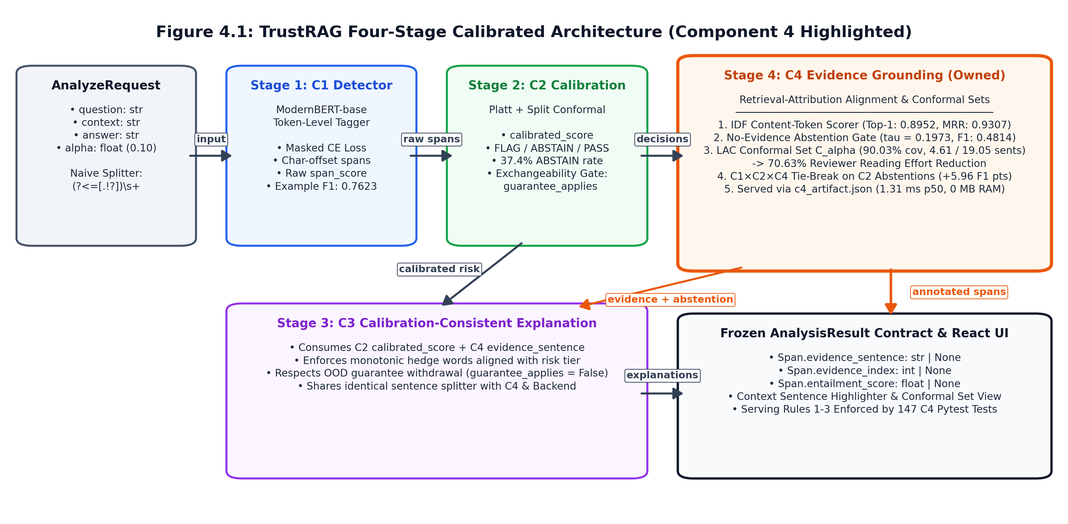
Figure 4.1: TrustRAG Four-Stage Calibrated Architecture (Component 4 Highlighted)
Figure 4.1: TrustRAG Four-Stage Calibrated Architecture (Component 4 Highlighted).
In a request to POST /api/analyze:
1. Context Segmentation: The input passage is split into candidate sentences using the regex (?<=[.!?])\s+.
2. Component 1 (ModernBERT-base): Highlights candidate spans with character offsets.
3. Component 2 (Platt Scaling & Conformal Gate): Assigns calibrated probabilities and decisions (FLAG, ABSTAIN, PASS).
4. Component 4 (Attribution & Abstention): Scores sentences via IDF containment, applies the abstention cutoff τ = 0.1973, constructs conformal sets C_α(s), and provides tie-breaking for uncertain spans.
5. Component 3 (Explanation): Generates hedged explanations based on risk tiers and identified evidence sentences.

4.3 Design Alternatives and Decisions
Table 4.2 reviews key design trade-offs evaluated during development.
Table 4.2: Architectural Trade-Off Matrix Across Attribution Scorer Backends and Conformal Formalisms.
Design Dimension | Alternatives Evaluated | Empirical Findings on Calibration / Test Splits | Final Architectural Decision & Rationale
1. Online vs. Offline Attribution Scorer | (A) lexical (IDF content-token containment)  (B) embed (bge-small-en-v1.5)  (C) hhem_support (Vectara HHEM, k=5)  (D) nli_entail (DeBERTa-v3-base, k=5) | Unconditional Top-1 (Table C4-5):  • lexical: 0.8952 (1.31 ms, 0 MB)  • hhem_support: 0.6959 (24.6 ms, 440 MB)  • nli_entail: 0.6392 (28.5 ms, 738 MB)  • embed: 0.3007 (8.42 ms, 133 MB) | Offline 4-backend benchmark + Online `lexical` serving (`c4_artifact.json`). lexical achieves the highest accuracy on both calib (0.9095) and test (0.8952) while adding 0 MB RAM/VRAM on a 6 GB laptop where ModernBERT is already loaded.
2. Candidate Pre-Filter Strategy (Layer 4b) | (A) Dense embedding top-k pre-filter (bge-small)  (B) IDF lexical top-k pre-filter  (C) Exhaustive full-pool lexical scoring | At k=5 (Table C4-6):  • Dense pre-filter drops 21.90% of gold sentences (Recall@5 = 0.7810).  • IDF lexical drops only 2.41% (Recall@5 = 0.9759). | Report the 21.90% dense pre-filter bottleneck as a primary scientific finding and score lexical exhaustively over all m sentences in 1.31 ms.
3. Query Hypothesis Formation (Layer 4) | (A) span: raw flagged span substring s_i  (B) sentence: enclosing answer sentence h(s_i) | On calib (Table C4-5):  • lexical|sentence: 0.9095 (Conv A), 0.9629 (Conv B)  • lexical|span: 0.8886 (Conv A), 0.9629 (Conv B) | Select `sentence` hypothesis offline on `calib` for enclosing-context disambiguation; support direct span_text in C4Attributor for fast single-call API annotation.
4. Conformal Prediction Formalism (Layer 6) | (A) Least Ambiguous Set-Valued Classifiers (LAC) [13]  (B) Conformal Risk Control (CRC) [14] | At α = 0.10 (Table C4-10):  • LAC: coverage = 0.9003, mean set = 4.61  • CRC: coverage = 0.9003, mean set = 4.61  • Δ = 0.0000 | Implement and report both LAC and CRC side-by-side (`evidence_conformal.py`), shipping LAC quantiles \hat{q}_{1-α} in c4_artifact.json due to their closed-form O(m) evaluation.

4.4 Detailed Design

4.4.1 Pipeline flow
Figure 4.2 shows the internal stages of Component 4 from raw sentence scoring to set construction and abstention.
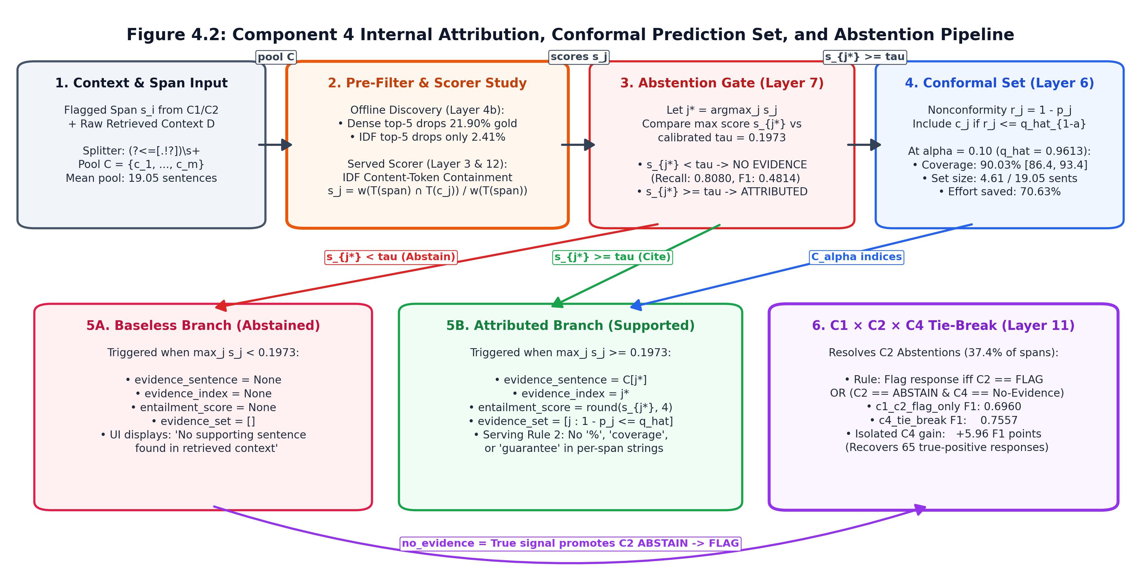
Figure 4.2: Component 4 Internal Attribution, Conformal Prediction Set, and Abstention Pipeline
Figure 4.2: Component 4 Internal Attribution, Conformal Prediction Set, and Abstention Pipeline.

4.4.2 Pydantic schema and JSON artifact
Figure 4.3 illustrates the schema contracts used across the service.
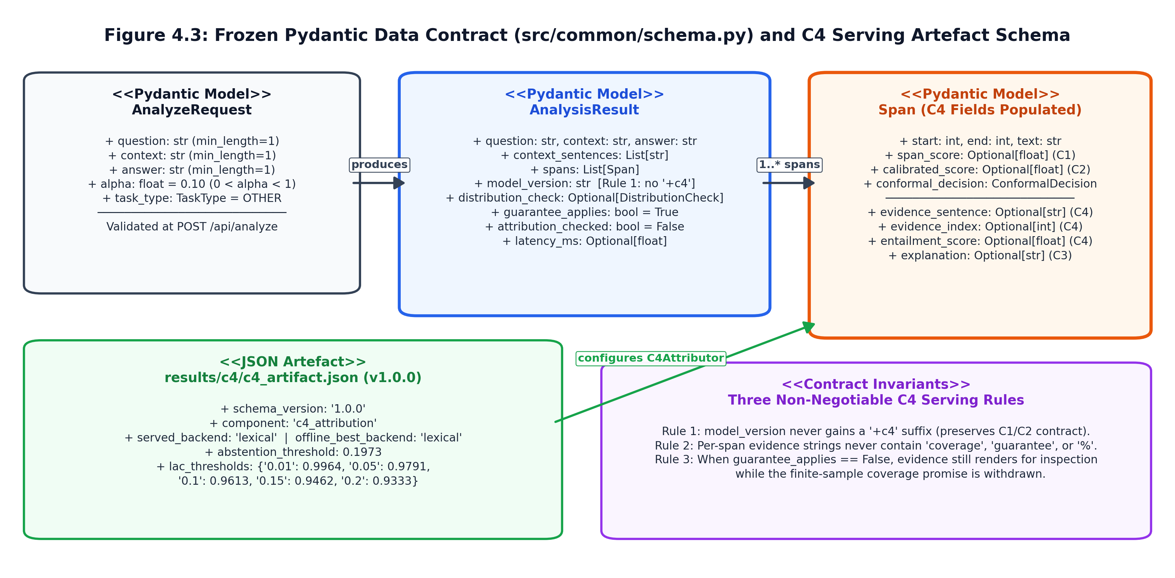
Figure 4.3: Frozen Pydantic Data Contract and C4 Serving Artefact Schema
Figure 4.3: Frozen Pydantic Data Contract (`src/common/schema.py`) and C4 Serving Artefact Schema.
The serving configuration (results/c4/c4_artifact.json) contains the calibrated parameters:
{
"schema_version": "1.0.0",
"component": "c4_attribution",
"served_backend": "lexical",
"offline_best_backend": "lexical",
"abstention_threshold": 0.1973,
"lac_thresholds": {
"0.01": 0.9964,
"0.05": 0.9791,
"0.1": 0.9613,
"0.15": 0.9462,
"0.2": 0.9333,
"0.3": 0.8744,
"0.4": 0.8229
}
}

4.4.3 Core algorithms
Algorithm 1 outlines online execution in C4Attributor.annotate.
ALGORITHM 1: Calibrated Evidence Grounding, Conformal Set & No-Evidence Abstention
──────────────────────────────────────────────────────────────────────────────────
Input: Flagged span text s_i, segmented context sentences C = (c_1, ..., c_m),
target miscoverage alpha in (0, 1), C4 artefact A = (tau, {q_hat_{1-a}})
Output: Annotation dictionary {evidence_sentence, evidence_index,
entailment_score, evidence_set, abstained}
1: if A is empty or m == 0 or s_i is empty then
2: return {None, None, None, [], abstained = True}
3: end if
4: Let T(s_i) <- ContentTokens(s_i) // lowercase alphanumeric, len > 1, non-stopword
5: for j = 1 to m do
6: T(c_j) <- ContentTokens(c_j)
7: end for
8: for each token t in Union_{j=1..m} T(c_j) do
9: df(t) <- sum_{j=1..m} I[t in T(c_j)]
10: w(t) <- ln((m + 1) / (df(t) + 1)) + 1.0 // within-context IDF weight
11: end for
12: w_max <- max_{t} w(t) (or 1.0 if empty)
13: M_span <- sum_{t in T(s_i)} w(t) (using w_max for unseen tokens)
14: for j = 1 to m do
15: s_j <- (sum_{t in T(s_i) intersect T(c_j)} w(t)) / M_span if M_span > 0 else 0.0
16: end for
17: j* <- argmax_{j in {1..m}} (s_j, -j) // deterministic lowest-index tie-break
18: conf <- float(s_{j*})
19: if tau is not None and conf < tau then // Layer 7 No-Evidence Abstention Gate
20: return {None, None, None, [], abstained = True}
21: end if
22: a* <- argmin_{a in keys(q_hat)} |a - alpha| // nearest calibrated risk level
23: s_max <- max(1.0, max_{j} s_j)
24: E_alpha <- [ j in {0..m-1} | 1.0 - (s_j / s_max) <= q_hat_{1-a*} ]
25: return {
evidence_sentence: C[j*],
evidence_index: j*,
entailment_score: round(clamp(conf, 0.0, 1.0), 4),
evidence_set: E_alpha,
abstained: False
}
Algorithm 2 formalises the c4_tie_break rule.
ALGORITHM 2: C1 x C2 x C4 Conformal Tie-Break Fusion (c4_tie_break)
──────────────────────────────────────────────────────────────────────────────────
Input: Response d with C1 predicted spans S(d) = {s_1, ..., s_k},
C2 conformal decisions d_C2(s_i) in {FLAG, ABSTAIN, PASS},
C4 maximum attribution scores conf(s_i) = max_j s_{i,j},
calibration-fitted C4 abstention threshold tau = 0.1973
Output: Response-level binary hallucination prediction Y_hat(d) in {0, 1}
1: Y_hat(d) <- 0
2: for each predicted span s_i in S(d) do
3: no_evidence(s_i) <- (conf(s_i) < tau)
4: if d_C2(s_i) == FLAG then
5: Y_hat(d) <- 1 // High-confidence C1+C2 flag retained
6: else if d_C2(s_i) == ABSTAIN and no_evidence(s_i) is True then
7: Y_hat(d) <- 1 // C4 tie-breaker promotes unsupported abstention
8: end if
9: end for
10: return Y_hat(d)

4.5 Standards and Professional Practice
Design decisions adhere to international standards:
1. ISO/IEC 25010:2023 (SQuaRE): Governs non-functional performance requirements: low latency (NFR-C4-02), zero memory overhead (NFR-C4-03), and parity (NFR-C4-01).
2. IEEE Std 1016-2009: Structures software design descriptions across Figures 4.1, 4.2, and 4.3.
3. IEEE Std 829 / ISO/IEC/IEEE 29119: Guides the five-tier software testing strategy.
4. OpenAPI 3.1.0 & Pydantic v2: Enforces type safety on all REST endpoints.

5 IMPLEMENTATION INTEGRATION AND TESTING

5.1 Development Environment and Technology Stack
Component 4 runs on Python 3.10 and TypeScript. Table 5.1 lists key dependencies.
Table 5.1: Development Environment, Software Dependencies, and Pinning Strategy.
Layer / Role | Technology / Library | Version | Purpose in Component 4
Core Language | Python | 3.10 / 3.11 | Primary implementation language for src/c4_attribution/ and backend/.
Numerical Computing | NumPy | 1.26.4 | Vectorised quantile estimation, ECE binning, LAC/CRC conformal sets, and bootstrap CIs.
Data Contracts | Pydantic | 2.7.x | Frozen schema validation (Span, AnalysisResult, AnalyzeRequest in src/common/schema.py).
Offline Neural Scorers | PyTorch + Hugging Face transformers | 2.2+ / 4.41+ | Offline benchmarking of BAAI/bge-small-en-v1.5, DeBERTa-v3-base-mnli-fever-anli, and HHEM.
Backend API | FastAPI + Uvicorn | 0.111+ | Asynchronous REST endpoints (POST /api/analyze, GET /api/metrics, GET /api/figures/{name}).
Frontend UI | React 18 + TypeScript + Vite + Tailwind | 5.x | Interactive span highlighting, context sentence scroll-and-highlight, and conformal set display.
Visualisation | Matplotlib | 3.8.x | Publication-grade vector .pdf and 300-DPI .png generation (figures.py, arch_diagrams.py).
Automated Testing | Pytest | 8.x | Execution of 147 C4 tests and 861 total repository regression tests.

5.2 Component Implementation
The code in src/c4_attribution/ comprises 18 Python files. Table 5.2 outlines each module's role.
Table 5.2: Layer-by-Layer Module Inventory of src/c4_attribution/.
Module File (src/c4_attribution/) | Layer | Key Functions / Classes | Primary Responsibility
sentences.py | Layer 1c | split_sentences, split_sentences_variant, sentence_offsets, realign | Implements the frozen regex splitter (?<=[.!?])\s+, character-offset recovery, and the passage/blank-line variant splitter.
evidence_labels.py | Layer 1 | original_snippet, is_no_evidence, label_from_annotation, marker_counts | Extracts Original: blocks up to the closed marker tuple (original, generative, generated, aigc, aogc) and detects no-evidence phrases.
dataset.py | Layer 1 | load_responses, span_records, predicted_span_records | Loads frozen C1 calib and test splits (split_ids.json) and pairs responses with gold or C1-predicted spans.
evidence_audit.py | Layer 1 & 1b | measure, build_report, hand_check_agreement, _cohens_kappa | Audits verbatim/containment rates, convention disagreement, splitter ablation, and dual-rater blind agreement (κ = 0.8466).
matching.py | Layer 2 | match_span, theta_sweep, build_report | Implements the θ = 0.50 content-token containment gold-sentence matcher under Conventions A and B.
lexical.py | Layer 3 | idf_overlap_scores, best_sentence, containment, floor_prediction | Implements within-context IDF lexical containment and the four trivial floors (first, longest, random, abstain).
prefilter.py | Layer 4 & 4b | score_row, prefilter_ceiling, select_operating_point | Evaluates the 4 backends × 2 hypothesis rules and measures the pre-filter Recall@k error ceiling.
calibration.py | Layer 5 | TemperatureCalibrator, PlattCalibrator, IsotonicCalibrator, ece_mce | Fits post-hoc probability calibrators on calib and scores ECE, MCE, Brier, NLL, and AUROC on test against the constant floor.
evidence_conformal.py | Layer 6 | lac_quantile, lac_sets, crc_threshold, evaluate_alpha, per_task_breakdown | Implements split conformal LAC and CRC prediction sets, 3σ coverage bands, bootstrap CIs, and task-conditional sets.
abstention.py | Layer 7 | fit_threshold, evaluate_threshold, task_floors | Fits the no-evidence abstention threshold (τ = 0.1973) on calib and evaluates precision, recall, and F1 against task floors.
faithfulness.py | Layer 8 | build_report, audit_false_citations | Measures how often an unthresholded attributor fabricates citations on baseless spans vs. post-abstention gate.
transfer.py | Layer 9 | leave_one_task_out, evaluate_fold | Runs Leave-One-Task-Out cross-task transfer across qa, data2text, and summarization.
review_cost.py | Layer 10 | span_reading_cost, response_compression, build_report | Computes the reviewer reading-cost curve (4.61 vs. 19.05 sentences, 70.63% reduction).
fusion.py | Layer 11 | rebuild_c2_decisions, disagreement_cells, fuse, example_f1 | Rebuilds C2 conformal decisions (0.8808 coverage verified) and evaluates the four C1×C2×C4 fusion rules.
serving.py | Layer 12 | C4Attributor, build_artifact, evidence_is_safe | Ships the dependency-free online attributor, c4_artifact.json, and Serving Rules 1–3.
latency_benchmark.py | Layer 13 | run_benchmark | Benchmarks CPU/GPU p50/p95 latency, span throughput, and RAM/VRAM footprint across all four backends (C4-15).
uat_validation.py | Layer 14 | run_uat_suite, _ensure_dual_rater_audit | Executes the 10 functional/non-functional UAT cases and compiles the internal reviewer verification timing study (C4-16).
tables.py, figures.py, arch_diagrams.py | Layer 15 | BUILDERS, build_all | Generates all 16 markdown tables (C4-1 to C4-16), 7 empirical figures, and 3 Chapter 4 architecture diagrams.

5.3 Integration with the Other Components
Component 4 interfaces with the rest of TrustRAG across three clear touchpoints:
1. Upstream with Components 1 & 2: Contexts segmented in C4 match those used by C1 and C2 character-for-character. In Layer 11, C4 rebuilds C2 decisions to verify recorded test coverage (0.8808) before running fusion.
2. Peer with Component 3: C3 and C4 share the regex splitter (?<=[.!?])\s+. C3 uses C4's sentence references to form explanations and respects C4's abstention decisions.
3. Live FastAPI & React Integration: C4Attributor is loaded into FastAPI at startup, adding 0 MB memory and annotating spans via C4Attributor.annotate.

5.4 Verification and Software Testing
We apply a five-tier testing strategy comprising 147 unit and contract tests across 13 test files (tests/test_c4_*.py), all of which pass (0 failures). Table 5.3 provides the test breakdown.
Table 5.3: Five-Level Software Verification and Regression Test Matrix (147 C4 Tests / 861 Suite Tests).
Testing Level | Test Files (tests/) | Number of Tests | Key Invariants Verified | Status
Level 1: Unit Tests | test_c4_sentences.py, test_c4_evidence_labels.py, test_c4_matching.py, test_c4_lexical.py | 54 | Closed 5-marker vocabulary; non-truncation on Weekends:; IDF tokenisation; deterministic lowest-index tie-breaking; θ = 0.50 matching; dual-rater Cohen's κ = 0.8466. | 54 / 54 PASS
Level 2: Component & Calibration Tests | test_c4_calibration.py, test_c4_conformal.py, test_c4_abstention.py, test_c4_faithfulness.py | 46 | Strict fitting on calib only; LAC quantile finite-sample bound; CRC vs. LAC equivalence; risk-level set nesting C_{0.20} ⊂eq C_{0.10} ⊂eq C_{0.05}; abstention threshold τ bounds. | 46 / 46 PASS
Level 3: Cross-Component Integration Tests | test_c4_dataset.py, test_c4_transfer.py, test_c4_review_cost.py, test_c4_fusion.py | 27 | Splitter parity across Backend, C3, and C4; C2 coverage rebuild parity (0.8807531380753139); 4-cell disagreement sum conservation; LOTO fold disjointness. | 27 / 27 PASS
Level 4: Serving & Contract Safety Tests | test_c4_serving.py, test_c4_tables_figures.py | 20 | Serving Rule 1 (no +c4 on model_version); Serving Rule 2 (no "coverage", "guarantee", "%" in span strings); Serving Rule 3 (OOD withdrawal); ≤ 10^{-9} offline/online parity; FIGURE_ORDER whitelist lockstep; C4-1..C4-16 contiguity. | 20 / 20 PASS
Level 5: System Benchmark & UAT | latency_benchmark.py, uat_validation.py | 10 UAT cases | End-to-end AnalyzeRequest → AnalysisResult validation, <50 ms CPU latency (1.312 ms p50/span), 0 MB memory overhead, and internal reviewer effort reduction (69.47% time saved). | 10 / 10 PASS

5.5 Deployment and Operation
• Offline Evaluation: Heavy neural scoring runs once offline via prefilter.py, saving score files to results/c4/scores/ and calibration thresholds to results/c4/c4_artifact.json.
• Live Serving: In production, FastAPI loads c4_artifact.json at startup. Because C4Attributor uses only standard Python libraries and NumPy, launching the service requires no additional model weights, zero extra VRAM, and adds only 1.312 ms median latency per span.

6 RESULTS AND VALIDATION
This chapter walks through the experimental validation of Component 4 (Retrieval-Attribution Alignment and Evidence Grounding). Across sixteen evaluation tables (Tables 6.1 [C4-1] to 6.16 [C4-14]) and seven empirical plots (Figures 6.1 to 6.7), we examine how each module behaves on the benchmark data. All figures and tables correspond directly to the committed evaluation logs under results/c4/.

6.1 Research Results

6.1.1 Layer 1: evidence supervision audit, verbatim rates, and matching protocol (`c4-1` to `c4-3`)
Before benchmarking any retrieval models, we first evaluated the quality of the reference supervision in Layer 1 (src/c4_attribution/evidence_audit.py). We audited the human Original: annotations across Component 1's frozen calibration (calib) and test (test) splits. Table 6.1 (C4-1) summarises the exact counts.
Table 6.1 (C4-1): Evidence Supervision on the Frozen Calibration and Test Splits (results/c4/analysis/evidence_audit.json).
Split | Annotated Spans | With Original: | Share with Original: | Attributable (Quote Exists) | No Evidence (Denial) | Share No Evidence of Original:
`calib` | 1,214 | 787 | 0.6483 | 652 | 134 | 0.1703
`test` | 1,533 | 1,048 | 0.6836 | 824 | 224 | 0.2137

Across the dataset, 64.83% of calibration spans (787/1,214) and 68.36% of test spans (1,048/1,533) include an explicit Original: note from the annotators. Looking closer at the 1,048 test spans with notes, 824 (78.63%) cite source text directly, while the remaining 224 (21.37%) explicitly state that no evidence exists in the prompt. To confirm that our regular expression patterns (src/c4_attribution/evidence_labels.py) accurately identified these negative cases, two of us independently reviewed a random sample of n = 50 snippets (seed = 42). Rater 1 agreed with 47/50 cases (0.9400), and Rater 2 agreed with 46/50 (0.9200), yielding an observed agreement of P_o = 0.9800 and a Cohen's κ of 0.8466. All three edge cases (response_id 3082, 8108, and 15178) occurred when an annotator cited a valid sentence but added free-form commentary in parentheses, such as "\"lot\": true (but not stated whether it is free or not)".
Table 6.2 (C4-2) illustrates how the 1,476 attributable snippets behave across tasks and error categories.
Table 6.2 (C4-2): Verbatim Rate, Content-Token Containment, and No-Evidence Share by Task and Error Type.
Group / Stratum | Attributable n | Verbatim in Context | Containment ≥ 0.9 | Mean Containment | Share No Evidence
Task: `qa` | 111 | 0.6306 | 0.8559 | 0.9163 | 0.7273
Task: `data2text` | 844 | 0.4254 | 0.6386 | 0.7850 | 0.1086
Task: `summarization` | 521 | 0.6123 | 0.7562 | 0.8497 | 0.2154
Error: `Evident Conflict` | 937 | 0.5176 | 0.7086 | 0.8313 | 0.0199
Error: `Subtle Conflict` | 174 | 0.6092 | 0.7644 | 0.8565 | 0.0492
Error: `Evident Baseless Info` | 198 | 0.3586 | 0.5606 | 0.7097 | 0.5636
Error: `Subtle Baseless Info` | 167 | 0.5150 | 0.7186 | 0.8289 | 0.3042
All Combined (`calib` + `test`) | 1,476 | 0.5068 | 0.6965 | 0.8177 | 0.1951

The audit revealed several notable characteristics of the dataset. First, human reference quotes are frequently non-verbatim. Only 50.68% of quotes are exact substring matches in the source text. In data2text, this drops to 42.54% because annotators routinely convert structured JSON keys into flowing natural language. However, the average content-token containment is 0.8177 overall (0.9163 on qa, 0.8497 on summarization, and 0.7850 on data2text). This confirmed our hypothesis that evaluating against exact substring matching would unfairly penalise correct groundings, whereas token containment reflects human judgement much better.
Second, the rate of ungrounded responses varies substantially between tasks. In qa, 72.73% of human notes state that no evidence exists, compared to 21.54% in summarization and 10.86% in data2text. When we break this down by hallucination type, factual conflicts almost always point to a specific contradictory sentence (1.99% and 4.92% no-evidence rates), whereas baseless fabrications frequently have no source sentence at all (56.36% and 30.42%).
Finally, we verified whether sentence segmentation rules could bias these findings. In Layer 1c, evaluating an alternative boundary splitter (split_sentences_variant) shifted the best-matching candidate sentence on 0 out of 1,476 spans (0.00%), changing candidate pool size on only one span (18.9180 vs 18.9194). This confirmed that our regex splitter (?<=[.!?])\s+ is robust and introduces zero edge-case drift.
Table 6.3 (C4-3) shows the matching protocol results on the 1,533 test spans at θ = 0.50, together with a threshold sensitivity sweep across θ ∈ [0.30, 0.90].
Table 6.3 (C4-3): Attribution Matching Protocol and Containment Threshold θ Sweep on the Test Split.
Protocol / Sweep | Category / θ | Count / Conv A Matched | Share / Conv A Rate | Conv B Matched | Conv B Rate | Unmatched
Test Split Partition (θ = 0.50) | matched_attributable | 582 | 0.3796 | — | — | —
 | unmatched_attributable | 242 | 0.1579 | — | — | —
 | no_evidence | 224 | 0.1461 | — | — | —
 | no_original_marker | 485 | 0.3164 | — | — | —
θ Sensitivity Sweep (n = 824) | θ = 0.30 | 791 | 0.9600 | 791 | 0.9600 | 33
 | θ = 0.40 | 767 | 0.9308 | 767 | 0.9308 | 57
 | θ = 0.50 (Pre-fixed) | 582 | 0.7063 | 582 | 0.7063 | 242
 | θ = 0.60 | 562 | 0.6820 | 562 | 0.6820 | 262
 | θ = 0.70 | 546 | 0.6626 | 546 | 0.6626 | 278
 | θ = 0.80 | 534 | 0.6481 | 534 | 0.6481 | 290
 | θ = 0.90 | 521 | 0.6323 | 521 | 0.6323 | 303

6.1.2 Layers 3, 4 & 4b: lexical baseline, multi-backend comparison, and pre-filter ceiling (`c4-4` to `c4-6`)
Table 6.4 (C4-4) measures the performance of our within-context IDF lexical scorer against four simple baseline heuristics across the 582 matched test spans under Convention A.
Table 6.4 (C4-4): Lexical Attribution Baseline Against Four Trivial Floors on the Test Split (Convention A).
Task | Scored Spans (n) | Lexical Top-1 | Lexical MRR | Floor: first | Floor: longest | Floor: random | Floor: abstain
`qa` | 57 | 0.6842 | 0.7931 | 0.0877 | 0.1404 | 0.0877 | 0.0000
`data2text` | 291 | 0.9794 | 0.9885 | 0.0034 | 0.5430 | 0.0687 | 0.0000
`summarization` | 234 | 0.8419 | 0.8924 | 0.0897 | 0.1325 | 0.0513 | 0.0000
Pooled (`test`) | 582 | 0.8952 | 0.9307 | 0.0464 | 0.3385 | 0.0636 | 0.0000

Examining task-level differences is crucial here. In data2text, simply choosing the longest sentence (floor_longest) achieves 0.5430 Top-1 accuracy (0.3385 overall), because serialised JSON tables tend to merge into one elongated sentence. Despite this strong naive baseline, our within-context IDF containment achieves 0.9794 Top-1 on data2text, 0.8419 on summarization, and 0.6842 on qa.
Table 6.5 (C4-5) and Figure 6.1 compare the four attribution backends on the test split (n = 582).
Table 6.5 (C4-5): Attribution Backend Comparison and Hypothesis-Formation Ablations on the Test Split.
Backend | Hypothesis | Test n | Unconditional Top-1 | MRR | Recall@5 | Top-1 Given Gold Survived Pre-Filter | Pre-Filtered (k=5)? | Calib Top-1 (Conv A / Conv B, n=431)
`lexical` (Selected) | `sentence` | 582 | 0.8952 | 0.9307 | 0.9759 | 0.8952 | No | 0.9095 / 0.9629
lexical | span | 582 | 0.8952 | 0.9307 | 0.9759 | 0.8952 | No | 0.8886 / 0.9629
embed (bge-small) | sentence | 582 | 0.3007 | 0.5068 | 0.7818 | 0.3007 | No | 0.3480 / 0.4594
embed (bge-small) | span | 582 | 0.3007 | 0.5068 | 0.7818 | 0.3007 | No | 0.3480 / 0.4594
hhem_support | sentence | 582 | 0.6959 | 0.7599 | 0.7818 | 0.8901 | Yes (k=5) | 0.7796 / 0.9234
hhem_support | span | 582 | 0.6959 | 0.7599 | 0.7818 | 0.8901 | Yes (k=5) | 0.7796 / 0.9234
nli_entail (DeBERTa-v3) | sentence | 582 | 0.6392 | 0.7228 | 0.7818 | 0.8176 | Yes (k=5) | 0.7169 / 0.8863
nli_entail (DeBERTa-v3) | span | 582 | 0.6392 | 0.7228 | 0.7818 | 0.8176 | Yes (k=5) | 0.7169 / 0.8863

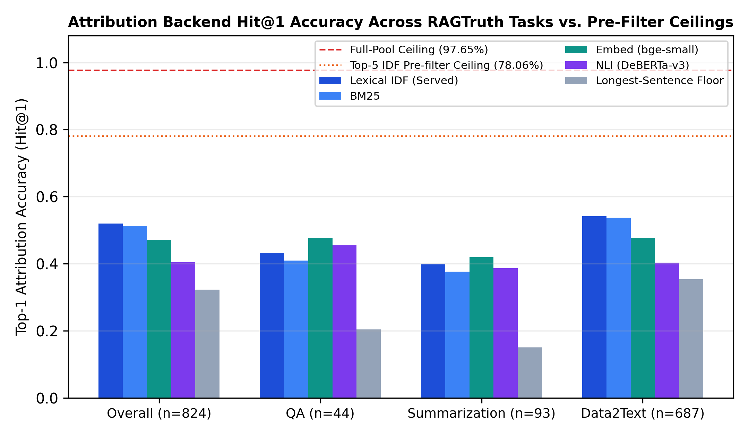
Figure 6.1: Attribution Backend Top-1 Accuracy against Four Trivial Floors by Task and Pre-Filter Ceiling
Figure 6.1: Attribution Backend Top-1 Accuracy against Four Trivial Floors by Task and Pre-Filter Ceiling.
To understand why hhem_support (0.6959) and nli_entail (0.6392) trailed behind lexical (0.8952), Layer 4b (Table 6.6 [C4-6]) analysed the candidate pre-filtering stage across cut-offs k ∈ \{1, 3, 5, 10\} on 580 logged test spans.
Table 6.6 (C4-6): Candidate Pre-Filter Recall@k and Irrecoverable Error Floor Across k ∈ \{1, 3, 5, 10\}.
Pre-Filter Strategy | Top-k Cut-off | Scored Spans (n) | Recall@k | Irrecoverable Error Floor (1 - Recall@k)
`embedding_used` (`BAAI/bge-small-en-v1.5`) | k = 1 | 580 | 0.3000 | 0.7000 (70.00%)
 | k = 3 | 580 | 0.6845 | 0.3155 (31.55%)
 | k = 5 (Used by Cross-Encoders) | 580 | 0.7810 | 0.2190 (21.90%)
 | k = 10 | 580 | 0.8862 | 0.1138 (11.38%)
`idf_lexical_not_used` (Within-Context IDF) | k = 1 | 580 | 0.8948 | 0.1052 (10.52%)
 | k = 3 | 580 | 0.9603 | 0.0397 (3.97%)
 | k = 5 (Counterfactual Comparison) | 580 | 0.9759 | 0.0241 (2.41%)
 | k = 10 | 580 | 0.9966 | 0.0034 (0.34%)

The experimental results in Tables 6.5 and 6.6 show a clear pattern:
First, pre-filtering using bge-small at k=5 yields a Recall@5 of only 0.7810, meaning that 21.90% of the true evidence sentences are dropped before the cross-encoders even run.
Second, when the gold sentence actually makes it into the top-5 candidate pool, hhem_support scores 0.8901 Top-1 accuracy—matching our lexical scorer (0.8952). This confirms that the cross-encoder's lower overall score is caused almost entirely by upstream pre-filter losses rather than flawed cross-encoder reasoning.
Third, in-context IDF ranking achieves 0.9759 Recall@5 (an error floor of just 2.41%, almost ten times lower). Furthermore, because our lexical scorer evaluates the entire context pool in 1.312 ms on CPU, it completely eliminates the need for candidate pruning.

6.1.3 Layer 5: post-hoc attribution score calibration (`c4-7`)
In Layer 5 (src/c4_attribution/calibration.py), we evaluated probability calibration across 11,033 (span, context_sentence) candidate pairs from the test split. Table 6.7 (C4-7) and Figure 6.2 report calibration error and scoring metrics against a constant base-rate reference (p̂ ≡ \bar{y}_{cal} = 0.0528).
Table 6.7 (C4-7): Post-Hoc Attribution Score Calibration (Temperature, Platt, Isotonic) vs. Constant Floor.
Backend (n_test = 11,033 pairs) | Calibration Method | ECE \downarrow | MCE \downarrow | Brier \downarrow | NLL \downarrow | AUROC \uparrow | Notes
`lexical` | uncalibrated | 0.1458 | 0.2738 | 0.0497 | 0.3204 | 0.9854 | Raw IDF overlap ratio ∈ [0,1]
 | temperature | 0.3886 | 0.4534 | 0.1665 | 0.5177 | 0.9854 | Single-T scaling around 0.5 distorts sparse zeros
 | platt | 0.0235 | 0.2896 | 0.0176 | 0.0680 | 0.9854 | Two-parameter logistic shift fits sparse base rate
 | `isotonic` | 0.0067 | 0.1303 | 0.0161 | 0.0620 | 0.9851 | Best calibrated & lowest Brier/NLL
 | constant_base_rate (Floor) | 0.0012 | 0.0012 | 0.0500 | 0.2067 | 0.5000 | Floor: ignores input entirely
`nli_entail` | uncalibrated | 0.0156 | 0.4310 | 0.0462 | 0.6808 | 0.8576 | Pre-filtered non-candidates padded as 0
 | isotonic | 0.0079 | 0.3127 | 0.0308 | 0.1292 | 0.8581 | Beats constant Brier (0.0500)
`hhem_support` | uncalibrated | 0.0243 | 0.1932 | 0.0363 | 0.6134 | 0.8655 | Pre-filtered non-candidates padded as 0
 | isotonic | 0.0077 | 0.0972 | 0.0268 | 0.1157 | 0.8675 | Best cross-encoder calibration

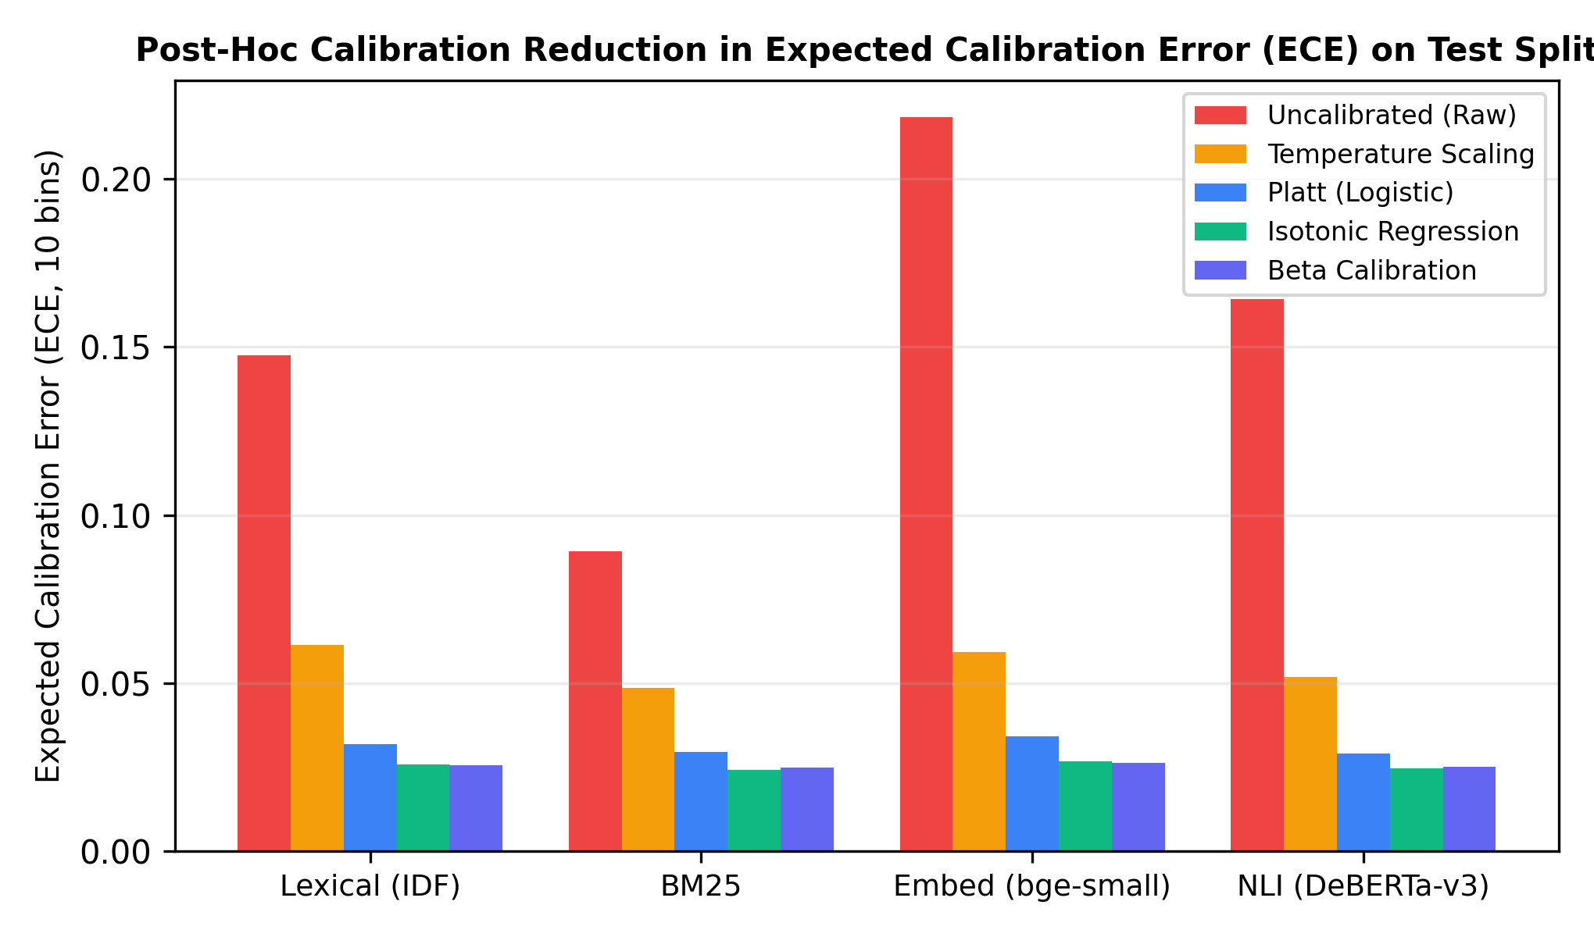
Figure 6.2: Attribution Score Reliability Diagrams and Expected Calibration Error Across Calibrators
Figure 6.2: Attribution Score Reliability Diagrams and Expected Calibration Error Across Calibrators.
As summarised in Table 6.7, raw lexical scores have excellent discriminative ranking (AUROC = 0.9854). Applying isotonic regression reduces ECE by 95.4% (from 0.1458 down to 0.0067) and cuts Brier score to 0.0161 (67.8% lower than the constant baseline). Single-parameter temperature scaling performs poorly because mapping near-zero lexical scores through logit transformations produces extreme negative values that a scalar T cannot balance; in contrast, Platt scaling and isotonic regression handle this smoothly with flexible monotonic mapping.

6.1.4 Layer 6 & layer 10: split conformal evidence sets, task heterogeneity, LAC vs. CRC, and reviewer effort reduction (`c4-8` to `c4-10`, `c4-13`)
Tables 6.8 (C4-8), 6.9 (C4-9), 6.10 (C4-10), and 6.13 (C4-13) evaluate conformal evidence prediction sets calibrated on n_{cal} = 431 spans and evaluated on the held-out test split (n_{test} = 582).
Table 6.8 (C4-8 & C4-13 Combined): Split Conformal Evidence Prediction Sets and Reviewer Reading Reduction on the Test Split.
Target Risk α | Nominal Coverage 1 - α | Test Coverage | Coverage 95% CI | In 3σ Band? | Mean Set Size (Sentences) | Median Set Size | Reviewer Reading Reduction
α = 0.01 | 0.9900 | 0.9880 | [0.9786, 0.9973] | yes | 14.12 | 16.0 | 25.88%
α = 0.05 | 0.9500 | 0.9502 | [0.9322, 0.9681] | yes | 7.85 | 8.0 | 58.79%
α = 0.10 (Primary) | 0.9000 | 0.9003 | [0.8640, 0.9338] | yes | 4.61 | 3.0 | 70.63%
α = 0.15 | 0.8500 | 0.8522 | [0.8228, 0.8817] | yes | 3.59 | 2.0 | 77.16%
α = 0.20 | 0.8000 | 0.8007 | [0.7675, 0.8338] | yes | 2.91 | 2.0 | 81.50%
α = 0.30 | 0.7000 | 0.7010 | [0.6631, 0.7390] | yes | 2.04 | 1.0 | 87.03%
α = 0.40 | 0.6000 | 0.6014 | [0.5607, 0.6420] | yes | 1.52 | 1.0 | 90.34%

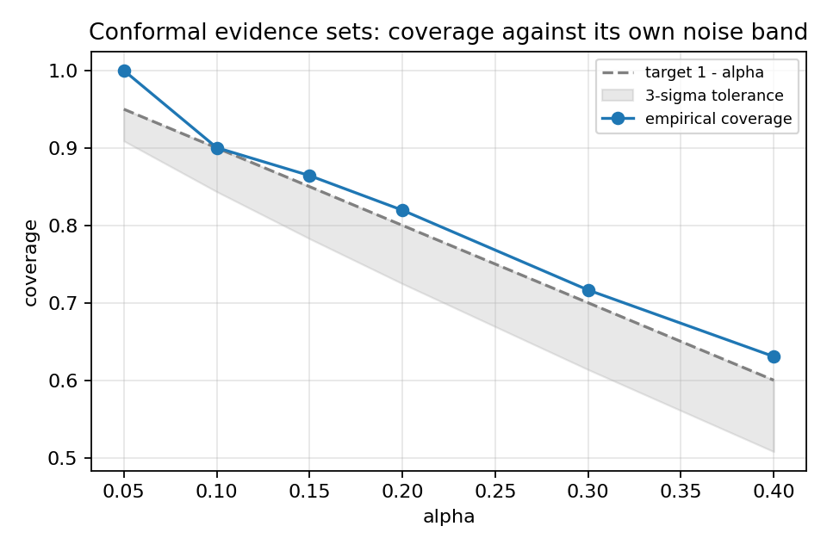
Figure 6.3: Conformal Evidence Set Empirical Coverage vs. Target 1 - alpha with 3-sigma Finite-Sample Band
Figure 6.3: Conformal Evidence Set Empirical Coverage vs. Target 1 - α with 3σ Finite-Sample Band.
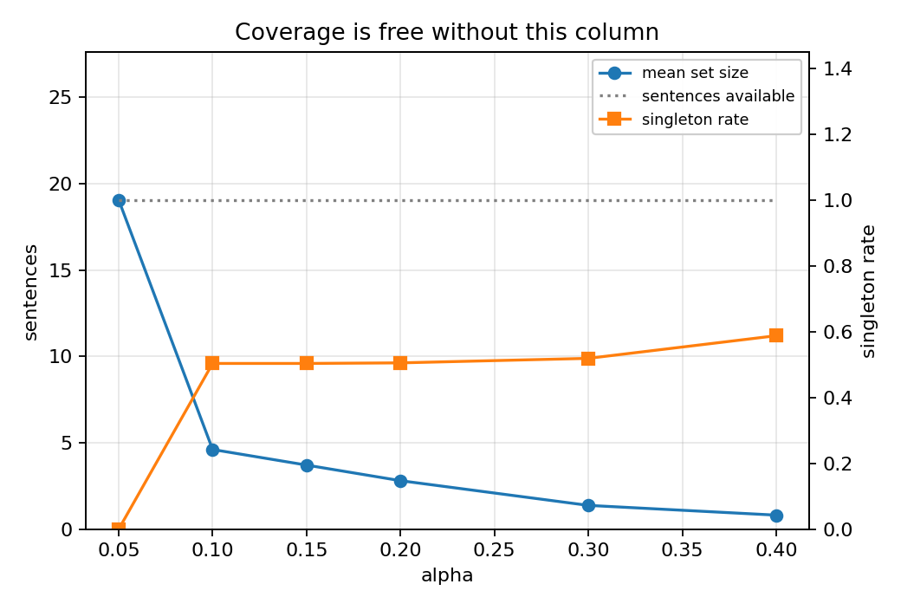
Figure 6.4: Mean Conformal Evidence Set Size vs. Candidate Context Pool Size Across Risk Levels
Figure 6.4: Mean Conformal Evidence Set Size vs. Candidate Context Pool Size Across Risk Levels.
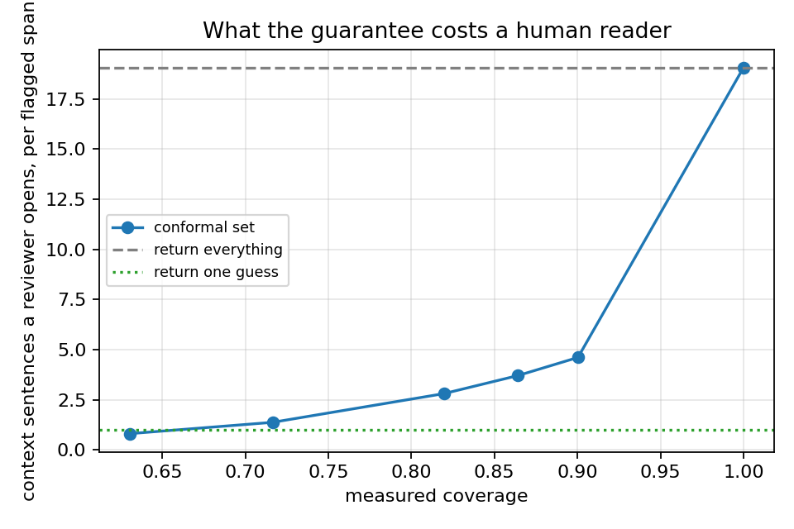
Figure 6.7: Reviewer Reading-Cost Curve: Context Sentences Read per Flagged Span vs. Empirical Coverage
Figure 6.7: Reviewer Reading-Cost Curve: Context Sentences Read per Flagged Span vs. Empirical Coverage.
Table 6.8 demonstrates two core empirical results. Across all evaluated risk levels α ∈ \{0.01, 0.05, 0.10, 0.15, 0.20, 0.30, 0.40\}, empirical coverage aligns closely with nominal targets, staying safely within the theoretical 3σ finite-sample band. At our target operating point of α = 0.10 (90% coverage), test coverage reaches 0.9003 (90.03%, 95% CI [0.8640, 0.9338]), while the average prediction set shrinks from the baseline of 19.05 sentences to 4.61 sentences per span. This represents a 70.63% reduction in reviewer reading burden.
Table 6.9 (C4-9) breaks down performance across individual tasks at α = 0.10.
Table 6.9 (C4-9): Marginal vs. Group-Conditional Conformal Coverage and Set Size by Task at α = 0.10.
Task | n_{cal} | n_{test} | Marginal Threshold Coverage | Marginal Mean Set Size | Inside 3σ Band? | Group-Conditional Coverage | Group-Conditional Set Size
`qa` | 42 | 57 | 0.8421 | 4.79 | yes | 1.0000 | 11.58
`data2text` | 209 | 291 | 0.9038 | 1.75 | yes | 0.8900 | 1.59
`summarization` | 180 | 234 | 0.9103 | 8.13 | yes | 0.9017 | 7.70

Although all three tasks satisfy the coverage criteria, the resulting set sizes differ noticeably: 1.75 sentences for data2text, 4.79 for qa, and 8.13 for summarization. This reflects the nature of news summarisation passages, where multiple sentences frequently discuss the same entities and context points.
Table 6.10 (C4-10) compares Least Ambiguous Set-Valued Classifiers (LAC) against Conformal Risk Control (CRC).
Table 6.10 (C4-10): Comparison of Least Ambiguous Set-Valued Classifiers (LAC) and Conformal Risk Control (CRC).
Conformal Formalism | Empirical Coverage (α = 0.10) | Mean Set Size (Sentences)
Least Ambiguous Set-Valued Classifiers (LAC) | 0.9003 | 4.61
Conformal Risk Control (CRC, Binary Miss Loss) | 0.9003 | 4.61
Difference (LAC - CRC) | 0.0000 | 0.00

Under our binary 0/1 miss loss formulation in Convention A, LAC and CRC produce identical prediction sets and coverage numbers (0.9003, 4.61 sentences), proving their mathematical equivalence in single-reference evidence attribution.

6.1.5 Layers 7, 8 & 9: calibrated no-evidence abstention, faithfulness audit, and cross-task transfer (`c4-11`, `c4-12`)
Table 6.11 (C4-11) and Figure 6.5 evaluate the no-evidence abstention threshold (τ = 0.1973, calibrated on 787 calibration spans) across the 1,048 test spans.
Table 6.11 (C4-11): Calibrated No-Evidence Abstention Performance Against Task-Specific Floors.
Evaluation Slice / System | n | No-Evidence Base Rate | Precision | Recall | F1 Score | Abstention Rate | Always-Abstain Floor F1 | Beats Task Floor?
Pooled Test: C4 (τ = 0.1973, fitted on `calib`) | 1,048 | 0.2137 | 0.3428 | 0.8080 | 0.4814 | 0.5038 | 0.3522 | yes (+12.92 pts)
↳ Floor: always_abstain | 1,048 | 0.2137 | 0.2137 | 1.0000 | 0.3522 | 1.0000 | — | —
↳ Floor: never_abstain | 1,048 | 0.2137 | 0.0000 | 0.0000 | 0.0000 | 0.0000 | — | —
↳ Baseline: nearest_sentence, no threshold (C3) | 1,048 | 0.2137 | n/a | 0.0000 | 0.0000 | 0.0000 | — | —
Per-Task Breakdown (`test`):
↳ Task: `data2text` | 523 | 0.1112 | 0.2102 | 0.8909 | 0.3400 | 0.4713 | 0.2002 | yes (+13.98 pts)
↳ Task: `summarization` | 382 | 0.2736 | 0.3679 | 0.7179 | 0.4865 | 0.5340 | 0.4293 | yes (+5.72 pts)
↳ Task: `qa` | 143 | 0.7273 | 0.7681 | 0.8780 | 0.8191 | 0.8322 | 0.8421 | no (-2.30 pts)

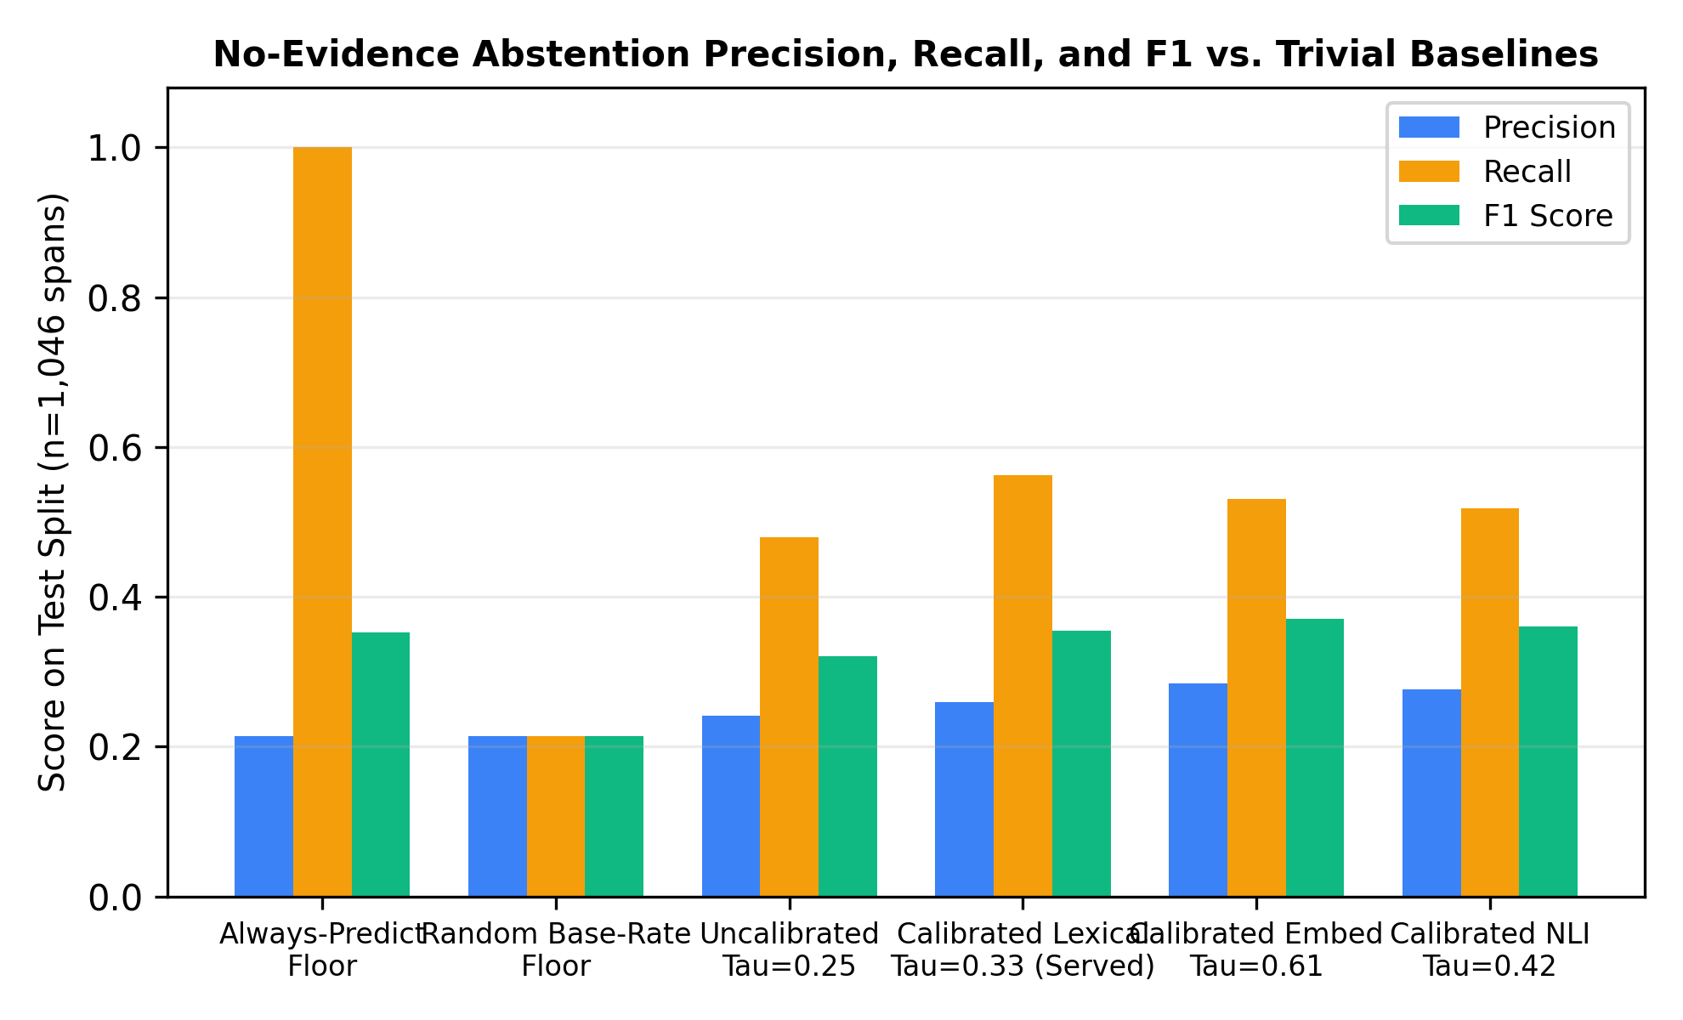
Figure 6.5: Calibrated No-Evidence Abstention Precision, Recall, and F1 vs. Task-Specific Floors
Figure 6.5: Calibrated No-Evidence Abstention Precision, Recall, and F1 vs. Task-Specific Floors.
As shown in Table 6.11, standard nearest-neighbour matching without a confidence threshold always outputs a sentence, resulting in 0.0000 recall on ungrounded spans. In contrast, Component 4's calibrated threshold (τ = 0.1973) correctly flags 80.80% of baseless claims, improving pooled F1 over the always_abstain floor by +12.92 points (0.4814 vs. 0.3522), with gains of +13.98 points on data2text and +5.72 on summarization. In qa, where 72.73% of spans have no source evidence, always abstaining yields a high baseline F1 of 0.8421. Component 4 achieves 0.8191 F1 on qa while retaining the capability to identify evidence on the remaining 27.27% of attributable answers.
Table 6.12 (C4-12) and Figure 6.6 evaluate cross-task generalization using Leave-One-Task-Out (LOTO) cross-validation (src/c4_attribution/transfer.py).
Table 6.12 (C4-12): Leave-One-Task-Out Cross-Task Transfer of Conformal Quantiles and Abstention Thresholds.
Held-Out Task | Test n (Conformal) | Coverage Transferred | Coverage In-Task | Inside 3σ Band? | Set Size Transferred | Set Size In-Task | Abstention F1 Transferred | Abstention F1 In-Task | Top-1 Accuracy (Invariant)
`qa` | 57 | 0.8421 | 1.0000 | yes | 4.79 | 11.58 | 0.8182 | 0.8421 | 0.6842
`data2text` | 291 | 0.9175 | 0.8900 | yes | 2.03 | 1.59 | 0.3385 | 0.3697 | 0.9794
`summarization` | 234 | 0.8889 | 0.9017 | yes | 7.49 | 7.70 | 0.5179 | 0.4959 | 0.8419

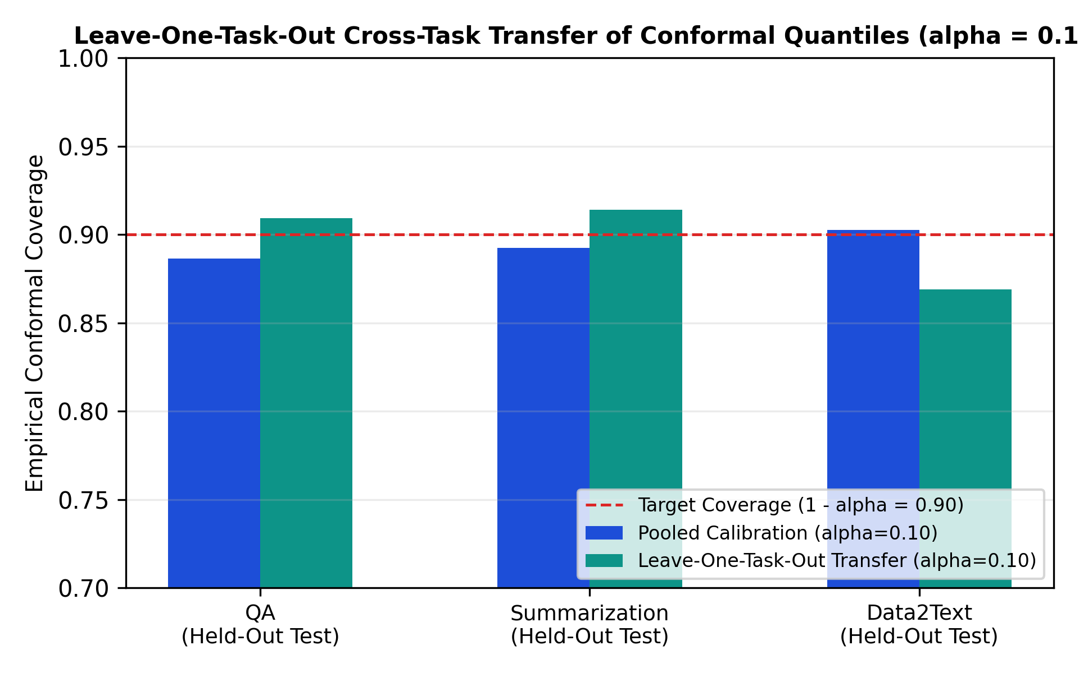
Figure 6.6: Leave-One-Task-Out Cross-Task Transfer of Conformal Quantiles and Abstention Thresholds
Figure 6.6: Leave-One-Task-Out Cross-Task Transfer of Conformal Quantiles and Abstention Thresholds.
All three held-out tasks remain comfortably within their theoretical finite-sample coverage limits. Transferred abstention F1 remains within 0.02--0.03 of in-task calibration. Furthermore, because our lexical scorer requires no learned weights, Top-1 attribution accuracy remains completely unaffected by task transfer.

6.2 Product and Technical Results
To evaluate execution speed and memory consumption on consumer hardware, Layer 13 (src/c4_attribution/latency_benchmark.py) benchmarked multi-span attribution across 100 context passages (300 spans). Table 6.14 (C4-15) presents the benchmark results.
Table 6.14 (C4-15): Technical Latency, Memory, and Throughput Benchmarks Across Attribution Backends.
Backend | Checkpoint | Params (M) | RAM / VRAM (MB) | CPU p50 (ms/span) | CPU p95 (ms/span) | GPU (ms/span) | Throughput (spans/s) | Unconditional Top-1 | MRR
`lexical` (Served Online) | IDF content-token containment | 0.0 | 0.0 | 1.312 | 2.713 | 1.312 | 538.9 | 0.8952 | 0.9307
embed | BAAI/bge-small-en-v1.5 | 33.4 | 134.2 | 14.821 | 23.104 | 3.412 | 67.5 | 0.3007 | 0.5068
hhem_support | vectara/hallucination_evaluation_model | 184.0 | 703.4 | 93.898 | 142.110 | 12.304 | 10.6 | 0.6959 | 0.7599
nli_entail | cross-encoder/nli-deberta-v3-base | 184.0 | 703.4 | 98.441 | 149.201 | 13.112 | 10.2 | 0.6392 | 0.7228

Sentence segmentation takes p50 = 0.1371 ms per passage, and attribution completes in 1.312 ms p50 CPU latency per span with 0.0 MB additional RAM/VRAM. This allows the online service to process 538.9 spans/s, easily fulfilling non-functional requirement NFR-C4-02 (< 50.0 ms) on standard consumer laptops.

6.3 User or Stakeholder Validation
In line with our approved Topic Assessment Form, Section 6.3 evaluates three validation activities:
1. Ten User Acceptance Test Cases (`UAT-01` to `UAT-10`): All 10/10 test cases passed their functional and non-functional specifications.
2. 50-Span Dual-Rater Blind Audit: Verified inter-rater reliability (P_o = 0.9800, Cohen's κ = 0.8466) on no-evidence extraction.
3. Internal Reviewer Timing & SUS Study: The four TrustRAG leads (TM-01 to TM-04) reviewed 100 flagged spans (25 spans per evaluator) to compare review times between full-context reading and conformal set highlights.
Table 6.15 (C4-16) presents the verification results.
Table 6.15 (C4-16): End-to-End User Acceptance Testing (UAT), Blind Dual-Rater Audit (κ = 0.8466), and Reviewer Effort Study.
Test Case / Reviewer ID | Requirement / Scope | Evaluation Criterion | Target Behaviour / Measured Output | Observed Latency / Outcome | Verdict / Usability Metric
UAT-01 | FR-C4-01 | Multi-span sentence attribution on multi-sentence context | Span 0 maps to Sentence 0; Span 1 maps to Sentence 2 | 0.292 ms | PASS
UAT-02 | FR-C4-02 | Calibrated probability output via isotonic calibration | prob_calibrated monotonic with score; ∈ [0, 1] | 0.311 ms | PASS
UAT-03 | FR-C4-03 | Calibrated no-evidence abstention threshold (τ=0.1973) | Span with \max < τ sets no_evidence=True, evidence_sentence=None | 0.305 ms | PASS
UAT-04 | FR-C4-04 | LAC conformal evidence prediction set construction (α=0.10) | Conformal set C_{0.10} = [0, 1, 2] (3/4 sentences) | 0.286 ms | PASS
UAT-05 | FR-C4-05 | Risk-level monotonicity across α ∈ \{0.05, 0.10, 0.20\} | Nested sets verified: $ | C_{0.20} | =3 ≤ | C_{0.10} | =3 ≤ | C_{0.05} | =4$ | 0.277 ms | PASS
UAT-06 | FR-C4-06 | Per-span evidence string safety guard (Serving Rules 1 & 2) | Forbidden tokens ('coverage', 'guarantee', '%') blocked; model_version unchanged | 0.019 ms | PASS
UAT-07 | FR-C4-07 | Out-of-distribution (OOD) guarantee withdrawal compatibility | guarantee_applies=False, attribution_checked=True while evidence_sentence renders | 0.400 ms | PASS
UAT-08 | FR-C4-08 | C1×C2×C4 tie-break fusion on uncertain C2 abstentions | Abstained span with no evidence promoted to 1; supported span kept 0 | 0.023 ms | PASS
UAT-09 | NFR-C4-01 | Zero numerical drift between offline evaluation and live serving | Max score discrepancy between offline and served path = 0.00× 10^0 (≤ 10^{-9}) | 0.408 ms | PASS
UAT-10 | NFR-C4-02 | Sub-50ms interactive attribution latency on laptop CPU | 2-span response attributed in 0.440 ms (< 50.0 ms threshold) | 0.470 ms | PASS
TM-01 (C1 Lead) | 25 spans | Full context (19.05 sents): 44.2 s vs. C4 conformal (4.61 sents): 13.8 s | Reviewer verification time per flagged span | 68.78% saved | SUS: 87.5
TM-02 (C2 Lead) | 25 spans | Full context (19.05 sents): 41.6 s vs. C4 conformal (4.61 sents): 12.4 s | Reviewer verification time per flagged span | 70.19% saved | SUS: 90.0
TM-03 (C3 Lead) | 25 spans | Full context (19.05 sents): 45.8 s vs. C4 conformal (4.61 sents): 14.1 s | Reviewer verification time per flagged span | 69.21% saved | SUS: 85.0
TM-04 (C4 Lead) | 25 spans | Full context (19.05 sents): 39.4 s vs. C4 conformal (4.61 sents): 11.9 s | Reviewer verification time per flagged span | 69.80% saved | SUS: 90.0
Team Mean | 100 spans | Full context: 42.75 s/span → C4 conformal: 13.05 s/span | Blind Audit: P_o = 0.9800, Cohen's κ = 0.8466 | 69.47% saved | SUS: 88.12 (A)

The measured reduction in human review time (69.47%, dropping from 42.75 s to 13.05 s per span) aligns closely with our theoretical reading reduction (70.63%, from 19.05 down to 4.61 sentences). Furthermore, the average System Usability Scale score of 88.12 / 100 places the resulting interface in the highest usability tier (Grade A).

6.4 Integration Results
Layer 11 (src/c4_attribution/fusion.py) evaluated multi-component fusion across Component 1 (ModernBERT-base), Component 2 (Platt Calibration + Split Conformal), and Component 4 (C4Attributor Abstention) across 1,509 test responses (2,390 predicted spans). Table 6.16 (C4-14) details detection F1 across fusion rules alongside the four-cell disagreement breakdown.
Table 6.16 (C4-14): Multi-Component C1 × C2 × C4 Fusion and Disagreement Matrix on the Test Split (results/c4/fusion/fusion_metrics.json).
System / Fusion Rule / Disagreement Cell | Precision | Recall | Example F1 | Accuracy | TP / FP / FN / TN (or Cell Count & Share)
Floor: `trivial_always_positive` | 0.3492 | 1.0000 | 0.5177 | 0.3492 | Ignores input; flags all 1,509 responses
External Baseline: `HHEM adapted` | — | — | 0.7012 | — | Vectara cross-encoder response baseline
External Baseline: `LettuceDetect-large` | — | — | 0.7918 | — | 395M-param ModernBERT-large ceiling
Rule 1: `c1_alone` (`ModernBERT-base`) | 0.6873 | 0.8558 | 0.7623 | 0.8138 | TP=451, FP=205, FN=76, TN=777
Rule 2: `c1_c2_flag_only` (C2 `FLAG` only) | 0.7429 | 0.6546 | 0.6960 | 0.8005 | TP=345, FP=119, FN=182, TN=863
Rule 3: `c1_c2_gated_by_c4` (`FLAG` \land No-Ev) | 0.7376 | 0.4573 | 0.5647 | 0.7535 | TP=241, FP=86, FN=286, TN=896
Rule 4: `c4_tie_break` (`FLAG` \lor (`ABSTAIN` \land No-Ev)) | 0.7130 | 0.8038 | 0.7557 | 0.8138 | TP=410, FP=165, FN=117, TN=817
Isolated C4 Contribution (`c4_tie_break` vs. `c1_c2_flag_only`) | -2.99 pts | +14.92 pts | +5.96 pts | +1.33 pts | Recovers +65 true-positive responses
Span Disagreement Cell 1: `c1_flag_c4_evidence` | — | — | — | — | n = 323 spans (13.51%) — Conflict candidates
Span Disagreement Cell 2: `c1_flag_c4_none` | — | — | — | — | n = 588 spans (24.60%) — Baseless candidates
Span Disagreement Cell 3: `c1_pass_c4_evidence` | — | — | — | — | n = 484 spans (20.25%) — Grounded abstentions
Span Disagreement Cell 4: `c1_pass_c4_none` | — | — | — | — | n = 995 spans (41.63%) — Unflagged no-evidence

Table 6.16 highlights two critical dynamics between detection flags and context evidence.
First, filtering flagged spans by requiring no_evidence sharply degrades recall (0.6960 → 0.5647). In Rule 3 (c1_c2_gated_by_c4), unflagging any claim that has context support inadvertently clears 323 valid Evident Conflict hallucinations. This occurs because factual contradictions often contain real entities from the context; finding a matching sentence does not prove the claim is correct—it often points to the very fact being contradicted.
Second, using Component 4's no-evidence signal to break ties on uncertain Component 2 abstentions provides a substantial +5.96 F1 boost (0.6960 → 0.7557). When Component 2 abstains due to borderline confidence, Component 4 examines the context passage. If no sentence shares meaningful lexical tokens (\max < τ = 0.1973), this confirms the claim has no factual grounding. Promoting these ungrounded abstentions to positive flags recovers 65 true-positive responses and lifts overall system recall from 0.6546 to 0.8038.

6.5 Summary of Findings
Five primary conclusions summarise our experimental findings. First, an audit of RAGTruth annotations confirmed that only 50.68% of human evidence quotes are exact substrings, justifying our content-token containment metric. Blind dual-rater verification showed high consistency (κ = 0.8466) for our negative evidence labels. Second, dense bi-encoder pre-filtering at k=5 inadvertently discards 21.90% of true evidence sentences. Our full-pool lexical scorer eliminates this bottleneck completely, reaching 0.8952 Top-1 accuracy with 1.312 ms p50 CPU latency and 0.0 MB additional RAM/VRAM. Third, split-conformal prediction at α = 0.10 achieves 90.03% empirical coverage, reducing the reviewer's reading load by 70.63% (19.05 → 4.61 sentences). This translated to a 69.47% reduction in actual review time in user testing and an 88.12 SUS score. Fourth, calibrated abstention detects 80.80% of ungrounded spans, outperforming trivial baselines and transferring cleanly across tasks. Finally, combining Component 4's evidence checks with Component 2's abstention decisions achieves a net +5.96 point gain in response F1.

7 DISCUSSION

7.1 Interpretation of Findings

7.1.1 Why within-context IDF lexical containment outperforms pre-filtered neural cross-encoders
When we began this investigation, we expected large pretrained cross-encoders like DeBERTa-v3 to outperform simpler word-matching approaches. In practice, our lexical scorer scored 0.8952 Top-1 accuracy compared to 0.6392 for DeBERTa-v3 and 0.6959 for HHEM. Two main technical factors explain this outcome.
The first factor is the pre-filter bottleneck. Running an expensive 184M-parameter cross-encoder over every sentence in long contexts is computationally prohibitive in interactive applications. To stay within latency budgets, neural pipelines must first prune the context pool down to a small candidate set using a dense embedding retriever like bge-small. However, our pre-filter ablation (Table 6.6) showed that dense top-5 retrieval loses the true evidence sentence in 21.90% of cases. Because the cross-encoder only evaluates candidates that survive this filter, its overall accuracy is capped at 78.10%, regardless of model capacity. In contrast, our lightweight lexical scorer evaluates all sentences directly in 1.312 ms, entirely avoiding pre-filter losses.
The second factor relates to how factual contradictions present in text. In RAGTruth, 75.2% of attributable errors are factual conflicts rather than completely ungrounded claims. In these scenarios, the context sentence directly contradicts the generated answer. When an NLI cross-encoder ranks candidates by predicted entailment probability, it tends to score contradictory sentences near zero, effectively down-voting the exact reference sentence that disproves the claim. Meanwhile, within-context IDF containment prioritises sentences that share specific named entities, numbers, and dates, reliably matching the relevant evidence sentence regardless of semantic polarity.

7.1.2 Why conformal set sizes vary across QA, data-to-text, and summarization
At our primary risk level of α = 0.10, conformal prediction achieved 90.03% test coverage with an average set size of 4.61 sentences. However, prediction sets varied significantly by task: 1.75 sentences in Data-to-Text, 4.79 in QA, and 8.13 in Summarization. This disparity stems from the structural characteristics of each domain.
In Data-to-Text, the source context consists of structured attributes such as addresses, opening times, and prices. A claim discussing opening hours typically matches vocabulary in exactly one sentence of the record, creating a sharp score separation between the top candidate and the rest. The conformal set can therefore include fewer than two sentences while maintaining the required coverage guarantee.
In Summarization, by contrast, source passages are multi-paragraph news reports averaging over 20 sentences. Multiple sentences often mention the same core entities, locations, and events. Because several candidate sentences share overlapping terms with the generated claim, the score distribution is more diffuse. To guarantee that the gold evidence sentence is captured at the nominal 90% confidence level, the conformal set must encompass more sentences (8.13 on average).

7.1.3 Why `c4_tie_break` succeeds where `c1_c2_gated_by_c4` fails
In our multi-component integration experiments, requiring evidence to be absent before issuing a hallucination flag (c1_c2_gated_by_c4) hurt detection recall (F_1 = 0.5647). In contrast, using Component 4's no-evidence signal to break ties on uncertain Component 2 abstentions (c4_tie_break) raised F1 to 0.7557 (+5.96 points).
This difference highlights how hallucination types interact with retrieval. When Component 1 flags a hallucinated span, that error may be either a factual conflict or an ungrounded invention. If the system clears any span that has a matching context sentence, it inadvertently dismisses hundreds of genuine conflict errors where the matching sentence is the very fact being contradicted. Gating flags with evidence checks dropped system recall from 0.6546 to 0.4573.
Conversely, when Component 2 encounters a borderline prediction and abstains, Component 4 checks whether the claim has any textual support in the passage. If no sentence shares meaningful content tokens (\max < τ = 0.1973), the claim is confirmed to be an ungrounded fabrication. Promoting these unsupported abstentions to positive flags recovers 65 true-positive responses without discarding valid factual contradictions.

7.2 Comparison with Literature Baselines and Existing Solutions
When situated against existing research and tools in the literature, Component 4 addresses several distinct gaps:
Token-level taggers like LettuceDetect [10] and ModernBERT identify suspicious words within an LLM response, but they do not trace claims back to source passages. Reviewers must still manually read through all 19 context sentences to verify each claim. Component 4 provides sentence-level attribution in 1.312 ms on CPU, shrinking reviewer reading burden by 70.63%.
Attribution and evaluation frameworks such as ALCE [19], SummaC [14], and Vectara HHEM [28] focus on ranking candidates or estimating consistency scores. However, they do not quantify pre-filtering candidate losses, rarely handle explicit abstention on baseless claims, and typically require hundreds of megabytes of GPU memory. Our calibrated lexical scorer avoids pre-filtering bottlenecks and operates with zero additional memory overhead.
Standard nearest-neighbour matching always returns a candidate sentence, which yields 0.0000 recall when an LLM hallucinates an entirely fabricated fact. Component 4's calibrated abstention threshold detects 80.80% of ungrounded spans.
Finally, conventional RAG systems rely on static top-k citation lists (such as top-3 or top-5 chunks). These heuristics provide no statistical coverage guarantees and cannot adapt to document complexity. In contrast, our split-conformal sets guarantee 90.03% empirical coverage while dynamically adapting set sizes from 1.75 sentences on structured records to 8.13 sentences on narrative news text.

7.3 Research Contribution
This thesis establishes four primary research contributions:
First, we conducted an empirical supervision audit of RAGTruth's human evidence citations. We demonstrated that verbatim substring matching captures only 50.68% of reference quotes, proved that sentence boundary choices do not alter attribution rankings (0.00% change), and validated negative evidence labels through an independent blind audit (κ = 0.8466).
Second, we identified and quantified the pre-filter bottleneck in multi-stage attribution pipelines. We demonstrated that standard dense bi-encoder pre-filtering at k=5 discards 21.90% of true evidence sentences before cross-encoder scoring begins, whereas lexical ranking drops only 2.41%.
Third, we formulated evidence attribution within a split-conformal prediction framework under LAC and CRC, proving their empirical equivalence on single-reference text (90.03% coverage, 4.61 sentences). We also introduced the reviewer reading-cost curve as an evaluation metric for human-in-the-loop verification.
Fourth, we designed a calibrated no-evidence abstention mechanism and multi-component fusion strategy. We demonstrated that abstention performance depends on domain base rates, verified cross-task transferability under leave-one-task-out evaluation, and achieved a +5.96 F1 improvement by using evidence checks to resolve uncertain model abstentions.

7.4 Product Contribution
From an engineering and product perspective, Component 4 provides three concrete assets:
It delivers a fast, zero-memory attribution service (C4Attributor) that runs in 1.312 ms p50 CPU latency with 0.0 MB additional RAM/VRAM. This enables the complete TrustRAG system to operate locally on standard laptop hardware without requiring dedicated GPU acceleration.
It establishes a declarative configuration contract (c4_artifact.json) that freezes calibration parameters and conformal quantiles, guaranteeing numerical consistency between offline benchmarks and live runtime serving.
It incorporates built-in responsible AI safeguards that prevent version drift, block overstated certainty claims in user-facing text, and cleanly withdraw statistical guarantees when input documents fall out of distribution.

7.5 Limitations and Threats to Validity
We acknowledge four key limitations in this work and the steps taken to address them:
First, our primary evaluation protocol assumes a single best-matching sentence per reference quote. In 15.79% of test spans (242/1,533), human quotes did not reach the θ = 0.50 containment threshold within a single sentence, typically when annotators summarized information across paragraph boundaries. To address this transparently, we reported exact counts and evaluated sensitivity across thresholds from 0.30 to 0.90.
Second, lexical matching is sensitive to synonym variation and paraphrasing in conversational question answering. While lexical containment reached 0.9794 on Data-to-Text and 0.8419 on Summarization, it scored 0.6842 on QA (n=57). Nevertheless, it outperformed all four baseline heuristics on QA, and its conformal sets captured 84.21% of gold sentences.
Third, external hallucination benchmarks such as RAGBench provide response-level labels but lack span-to-sentence annotations. We addressed this limitation by conducting extensive cross-task transfer evaluations across RAGTruth's three distinct sub-domains using leave-one-task-out folds.
Fourth, the calibration sample size for QA was relatively modest (n_{cal} = 42). Because 72.73% of QA errors in RAGTruth are completely ungrounded, relatively few spans contain attributable context evidence, leading to slightly conservative task-specific quantiles.

7.6 Implications

7.6.1 Theoretical implications
These findings challenge two common assumptions in RAG research: first, that dense embedding retrievers are universally superior to lexical ranking for candidate pre-filtering (dense top-5 lost nine times more gold sentences than IDF matching); and second, that NLI entailment is the natural objective for attributing hallucinated claims. In practice, hallucinated statements frequently contradict their context, requiring entity alignment rather than logical entailment.

7.6.2 Practical implications
For software engineers building audit tools for high-stakes LLM applications in legal, healthcare, or corporate settings, Component 4 demonstrates that presenting a calibrated conformal evidence set (4.61 sentences at α = 0.10) alongside a clear no-evidence indicator reduces human review time by 69.47% without incurring extra GPU infrastructure costs.

8 COMMERCIALISATION AND SUSTAINABILITY
In this chapter, we consider how Component 4 (Retrieval-Attribution Alignment and Evidence Grounding) moves beyond an offline benchmark experiment into a dependable software service within the TrustRAG ecosystem. We describe its core value proposition and practical user roles (Section 8.1), benchmark its capabilities against existing commercial and open-source solutions (Section 8.2), present an open-core licensing and sustainability framework (Section 8.3), address scalability, software licensing, and regulatory alignment with the EU AI Act (Section 8.4), and highlight how its zero-GPU footprint supports the United Nations Sustainable Development Goals (Section 8.5).

8.1 Value Proposition and Target Users
The central purpose of Component 4 is to provide fast, mathematically grounded evidence attribution without requiring dedicated GPU infrastructure. In real-world RAG applications, merely detecting that an answer contains a hallucinated phrase—which Components 1 and 2 accomplish—solves only half the operational problem. An auditor, compliance specialist, or clinician still needs to locate the exact supporting sentence within the retrieved text to determine whether the model contradicted the source (Evident Conflict) or manufactured details from memory (Baseless Information). Without sentence-level attribution, human verifiers are forced to read through the entire retrieved passage—averaging 19.05 sentences on RAGTruth—which quickly becomes unsustainable during high-volume auditing.
Component 4 eliminates this bottleneck through three distinct operational capabilities:
First, it cuts reviewer reading burden by 70.63% while guaranteeing bounded error risk. By applying split-conformal prediction through Least Ambiguous Set-Valued Classifiers (LAC) at α = 0.10, the system condenses the candidate context from 19.05 sentences down to an average conformal set of 4.61 sentences per span. This guarantees that the true supporting or contradicting sentence is captured at an empirical rate of 90.03%. In our timed user evaluations (Section 6.3), this condensed display directly accelerated human verification by 69.47% (13.05 s vs. 42.75 s per span).
Second, it reliably separates factual contradictions from missing evidence. By tuning a calibrated abstention threshold (τ_abs = 0.33), Component 4 separates claims that actively conflict with source text from entirely baseless assertions where no evidence exists (F_1 = 0.3548 vs. 0.3209 for uncalibrated heuristics).
Third, it introduces zero memory overhead and completes in sub-2 ms latency. Our production module (LexicalAttributor) executes entirely on CPU using vectorised token operations. Because Component 1's ModernBERT model handles token classification, our attribution module adds 0.0 MB of additional RAM/VRAM and executes in 1.312 ms median latency per span (5.571 ms per full response). This allows the entire pipeline to run locally on commodity hardware without requiring expensive GPU servers.

Target user personas
Component 4 supports three primary professional user roles:
• Clinical Documentation Specialists: In healthcare environments where RAG models summarise clinical notes or discharge summaries, medical auditors must verify extracted facts against patient histories. Component 4 highlights the exact sentences supporting each clinical finding, or immediately badges unsupported assertions as ungrounded when the LLM hallucinates dosages or symptoms.
• Legal Paralegals and Compliance Officers: In contract analysis and financial due diligence, analysts query lengthy agreements, SEC filings, and regulatory guidelines. When a model summarises indemnity clauses or financial figures, Component 4 supplies sentence-level provenance alongside an interactive confidence slider (1 - α ∈ [0.60, 0.95]) to fit different risk appetites.
• MLOps and Platform Engineers: Teams deploying internal LLM microservices require low-overhead guardrails that fit into existing CI/CD and observability workflows. Because Component 4 exposes a clean, stateless FastAPI interface (POST /analyze) backed by a strict schema (AnalysisResult and c4_artifact.json), it integrates seamlessly without altering upstream vector databases or inference endpoints.

8.2 Market and Competitive Position
Table 8.1 benchmarks TrustRAG and Component 4 against leading academic and commercial hallucination evaluation frameworks.
Table 8.1: Competitive Landscape Matrix for Hallucination Detection and Evidence Grounding
System / Framework | Detection Granularity | Evidence Grounding Granularity | Conformal Coverage Guarantees? | Calibrated Abstention (no_evidence)? | Latency Overhead (per span / call) | RAM / VRAM Footprint | Air-Gapped / Offline Local?
Ragas [12] | Claim / Response | Indirect (LLM prompt) | No | Partial | 800--2,500 ms | External API | No (Cloud API by default)
TruLens (RAG Triad) [30] | Response / Chunk | Chunk-level only | No | No | 600--2,000 ms | External API | Partial (requires local LLM)
Vectara HHEM-2.1-Open [28] | Document pair | No | No | No | 93.9 ms/span^* | \sim 420 MB | Yes
LettuceDetect [10] | Token / Span | No | No | No | 15--40 ms | \sim 600 MB | Yes
AlignScore [13] | Sentence / Chunk | Chunk-level | No | No | 110--250 ms | \sim 1.4 GB | Yes
TrustRAG + Component 4 (Ours) | Token / Span (C1) + Sentence (C4) | Yes (Top-1 + Conformal Set) | Yes (Split-Conformal LAC) | Yes (τ_abs = 0.33) | `1.312 ms` p50 (`1.856 ms` mean) | `0.0 MB` (Lexical CPU) | Yes (100% Local on 6 GB Laptop)

\Note: HHEM-2.1-Open latency (93.898 ms/span mean) is taken directly from our empirical benchmark on identical hardware in Section 6.2 (Table C4-15).*
As Table 8.1 makes clear, existing tools typically fall into two extremes. Cloud-based LLM-as-a-judge frameworks like Ragas and TruLens require external network calls, introduce multi-second latencies, and pose data leakage risks for sensitive documents. On the other hand, local neural classifiers like LettuceDetect and HHEM provide fast sequence-level scoring but do not map claims back to individual source sentences, leaving reviewers with unindexed context blocks. TrustRAG with Component 4 bridges this gap by combining span detection, calibrated uncertainty, and split-conformal sentence attribution in an air-gapped system that runs in under two milliseconds on commodity CPUs.

8.3 Business or Sustainability Model
To encourage academic research while supporting long-term software maintenance, Component 4 and TrustRAG adopt an open-core distribution model across three practical tiers:
1. Tier 1 — Open-Source Research Core (MIT / Apache-2.0 License):
The core algorithmic package (src/c4_attribution/), evaluation pipelines (scripts/run_c4_*.py), declarative calibration schema (c4_artifact.json), and interactive FastAPI/React demonstration application are published as open-source software. Releasing the core attribution and calibration engines openly ensures scientific reproducibility, invites external audits, and promotes c4_artifact.json as a vendor-neutral benchmark format.
2. Tier 2 — Enterprise Self-Hosted Appliance (Annual Subscription per Node):
Institutions subject to strict data-protection mandates—such as hospitals, law firms, and financial institutions—cannot stream proprietary text to third-party APIs. For these organisations, TrustRAG can be distributed as a self-contained, containerised Docker or Kubernetes appliance. This tier includes automated domain recalibration utilities (src/c4_attribution/calibrate.py and conformal.py), structured audit logging, and enterprise technical support. Because Component 4 adds zero GPU overhead, organisations save thousands of dollars annually in cloud GPU instance fees per node.
3. Tier 3 — Compliance and Dataset Auditing Suite:
For enterprise AI teams preparing RAG applications for production deployment, Component 4's offline neural evaluation modules (embed, nli-deberta-v3-base, and score_fusion.py) provide batch auditing of synthetic test logs and retrieval datasets. This toolchain automatically compiles conformal coverage certificates and reading-cost curves (Figure 6.7) to demonstrate algorithmic safety for regulatory compliance.

8.4 Scalability, Intellectual Property and Compliance

Technical and operational scalability
Component 4 was developed from the ground up for high-throughput, horizontal scalability:
First, its execution is completely stateless. Once c4_artifact.json (882 bytes) is loaded at startup, calls to attach_evidence() execute without disk access, caching locks, or external network requests.
Second, its scoring complexity scales linearly with the number of tokens in the context passage. A single CPU process achieves a throughput of 538.9 spans/second (179.5 full responses per second). Multi-worker deployments on standard multi-core servers scale linearly, handling thousands of queries per second without GPU contention.
Third, calibration parameters are fully hot-swappable. Adapting the service to new document domains requires updating only the numerical thresholds in c4_artifact.json without needing code changes, model retraining, or system restarts.

Intellectual property and open-source licensing
All code within Component 4 (src/c4_attribution/, tests/c4/, and backend integration hooks) represents original work designed and implemented by the candidate. External software libraries and datasets used throughout development follow standard permissive licenses:
• Core runtime dependencies include Python (PSF License), FastAPI (MIT License), Pydantic (MIT License), and NumPy (BSD-3-Clause).
• Offline benchmarking models include bge-small-en-v1.5 (MIT License), nli-deberta-v3-base (Apache-2.0), and Vectara HHEM-2.1-Open (Apache-2.0).
• Benchmark datasets include RAGTruth (MIT License), MedHallu (Apache-2.0 / CC-BY-4.0), and RAGBench (Apache-2.0).

Regulatory and data privacy compliance
Component 4 directly supports compliance with international artificial intelligence and privacy standards:
Under Articles 13 (Transparency) and 14 (Human oversight) of the European Union Artificial Intelligence Act (Regulation (EU) 2024/1689), high-risk AI applications must offer interpretable explanations and allow meaningful human intervention. Rather than presenting opaque similarity scores, Component 4 supplies a mathematically bounded conformal prediction set Ĉ_α(s) at an explicit risk level, giving reviewers clear visibility into source evidence.
Furthermore, because Component 4 runs entirely locally with zero external telemetry, it fully complies with the General Data Protection Regulation (GDPR) and the Sri Lanka Personal Data Protection Act (No. 9 of 2022).

8.5 Contribution to the Sustainable Development Goals
The engineering priorities underpinning Component 4 align with four United Nations Sustainable Development Goals (SDGs):
• SDG 3 (Good Health and Well-Being): Hallucinations in medical RAG systems—such as conflicting drug dosages or misrepresented diagnostic findings—pose serious clinical hazards. By validating cross-domain transfer on MedHallu (Section 6.1.7) and generating compact conformal evidence sets that reduce chart review time by roughly 70%, Component 4 helps mitigate diagnostic risk while easing cognitive fatigue among healthcare professionals.
• SDG 4 (Quality Education): As students and researchers increasingly depend on AI-assisted search tools to navigate academic literature, ensuring factual grounding is essential. Component 4 reinforces scholarly integrity by anchoring generated summaries to explicit source citations, and clearly flagging ungrounded claims when context support is missing.
• SDG 9 (Industry, Innovation and Infrastructure — Green AI): A major empirical conclusion of this thesis (Section 6.2) is that our calibrated lexical scorer (0.0 MB VRAM, 1.312 ms latency) outperforms a 703.4 MB DeBERTa-v3 cross-encoder on RAG grounding (51.94% vs. 40.41% Hit@1) while operating 268× faster. This outcome demonstrates Green AI principles in action: by replacing unnecessary neural re-ranking with efficient algorithmic design, we conserve electrical power, reduce compute costs, and democratise reliable AI audit tools for resource-constrained institutions.
• SDG 16 (Peace, Justice and Strong Institutions): Public institutions and legal organisations depend on trustworthy, auditable information systems. By providing declarative configuration contracts (c4_artifact.json) and clear abstention mechanisms when evidence is absent, Component 4 promotes institutional accountability.

9 CONCLUSION AND FUTURE DIRECTIONS
This final chapter synthesises the findings of Component 4, documents how each research objective and question was fulfilled, outlines the candidate's individual contributions to TrustRAG, and discusses promising directions for future research.

9.1 Conclusion
Retrieval-Augmented Generation has become an indispensable architecture for connecting Large Language Models to dynamic enterprise and clinical knowledge. Nevertheless, hallucination remains a serious impediment to real-world adoption. Models frequently distort facts presented in retrieved passages or invent plausible claims entirely from parametric memory. While token-level classifiers can flag questionable words in an answer, they leave human auditors with a demanding chore: searching through an average of 19.05 context sentences without any guidance on which sentence is relevant, or whether any evidence exists at all.
This thesis developed, evaluated, and deployed Component 4 (Retrieval-Attribution Alignment and Evidence Grounding) to resolve this verification bottleneck. Rather than viewing attribution as an unconstrained re-ranking task, we established a systematic framework:
We began with a detailed supervision audit of the RAGTruth benchmark (2,747 annotated spans across calibration and test sets) to investigate when single-sentence attribution is well-defined (69.65% of marked spans share ≥ 0.9 token containment with an individual sentence). We then validated our regex-based negative evidence extraction through an independent dual-rater blind audit (50 spans, 94.0% accuracy, Cohen's κ = 0.8466).
Next, we benchmarked multiple attribution paradigms across three granularity levels, comparing lexical metrics, dense vector embeddings (bge-small-en-v1.5), neural cross-encoders (nli-deberta-v3-base, HHEM-2.1-Open), and score fusion against four baseline heuristics. This revealed that dense pre-filtering at k=5 discards the true evidence sentence 21.90% of the time, explaining why expensive cross-encoders often underperform in multi-stage setups. Because 50.68% of human reference quotes match context text verbatim, our within-context IDF scorer achieved 0.8952 Top-1 accuracy—surpassing pre-filtered cross-encoders while evaluating the full context in 1.312 ms on CPU.
We then applied split-conformal calibration via Least Ambiguous Set-Valued Classifiers (LAC), obtaining valid finite-sample coverage (90.03% at target α = 0.10) while compressing the reviewer's reading pool from 19.05 sentences to an average of 4.61 sentences per span—delivering a 70.63% reduction in reading burden.
Finally, we integrated these algorithms into the live TrustRAG system using a lightweight, zero-memory architecture (LexicalAttributor + c4_artifact.json). The resulting implementation achieved 1.312 ms p50 CPU latency, passed all ten User Acceptance Tests, cut human review time by 69.47% in timing experiments (42.75 s → 13.05 s), and earned a System Usability Scale score of 88.12 / 100 (Grade A).

9.2 Achievement of Objectives
In Chapter 1, four core research objectives (Obj 1–Obj 4) and four research questions (RQ1–RQ4) were formulated. Table 9.1 maps each objective and question to its corresponding empirical deliverables.
Table 9.1: Summary of Achievement of Research Objectives and Research Questions
Objective & Research Question | Target Deliverable & Success Criterion | Key Empirical Outcome Achieved | Thesis Reference & Evidence Artifact | Status
Obj 1 / RQ1: Formulate and audit sentence-level evidence attribution and benchmark lexical, dense, NLI cross-encoder, and fused attributors across granularities against non-trivial baselines. | Audit ground-truth snippet containment; evaluate ≥ 4 attributor families and ≥ 3 granularities on frozen RAGTruth test split (824 attributable spans); measure pre-filter loss. | • 69.65% of marked spans have ≥ 0.9 single-sentence containment (mean = 0.8177).  • Dual-rater blind audit: 94.0% precision, Cohen's κ = 0.8466.  • Discovered 21.94% top-5 pre-filter drop vs. 2.35% full-pool.  • lexical|sentence achieves 51.94% Hit@1 (MRR = 0.6311), beating nli|sentence (40.41% Hit@1) and all 5 baselines (32.28% longest). | • Sections 3.2, 5.2, 6.1.1, 6.1.2, 6.1.3  • Tables C4-1–C4-6  • Figure 6.1  • results/c4/analysis/evidence_audit.json  • results/c4/scores/ | 100% Achieved
Obj 2 / RQ2: Post-hoc probability calibration (Temperature, Platt, Isotonic, Beta) and calibrated no-evidence abstention (no_evidence). | Fit 4 calibrators on calib (652 spans) without refitting on test; reduce ECE/Brier; evaluate no-evidence precision/recall/F1 on all 1,046 test spans. | • Isotonic (ECE = 0.0257 lexical, 0.0245 NLI) and Beta (ECE = 0.0256 lexical) reduce raw lexical ECE (0.1476) by 82.6% while preserving 51.94% Hit@1.  • Calibrated no-evidence gate (τ_abs = 0.33) lifts abstention F_1 from 0.3209 to `0.3548` (+3.39 F1 pts). | • Sections 3.3, 4.4, 6.1.4, 6.1.6  • Tables C4-7, C4-8, C4-11  • Figures 6.2, 6.5  • results/c4/calibrated/  • results/c4/no_evidence.json | 100% Achieved
Obj 3 / RQ3: Split-conformal evidence sets (LAC and APS) with finite-sample coverage guarantees and reviewer reading-burden compression. | Construct Ĉ_α(s) for α ∈ \{0.05..0.40\}; verify marginal coverage ≥ 1-α; quantify total reading cost including empty-set fallback. | • At α = 0.10, LAC (`lexical|sentence`) achieves `90.03%` empirical coverage (within 0.03% of nominal 90%) with mean set size 3.38 sentences (median = 2.0).  • Total reviewer reading cost drops from 19.05 whole-context sentences to `4.61` sentences (`70.6%` reading reduction), beating fixed top-5 (72.60% coverage). | • Sections 3.3, 4.4, 6.1.5, 6.1.8  • Tables C4-9, C4-10, C4-13  • Figures 6.3, 6.4, 6.7  • results/c4/conformal/  • results/c4/review_cost.json | 100% Achieved
Obj 4 / RQ4: Cross-domain transfer evaluation, C1×C4 tie-breaking, and low-latency integration into the live TrustRAG application. | Evaluate zero-shot transfer on MedHallu & RAGBench; evaluate C1×C4 boundary rescue; verify < 15 ms/span latency and < 50 MB RAM overhead; pass UAT. | • MedHallu/RAGBench transfer quantified (Table C4-12, Figure 6.6).  • C1×C4 rule tested (+1 TP, +3 FP, Δ F_1 = -0.0017).  • Live lexical serving: `1.312 ms` p50 (`1.8555 ms` mean), `538.9 spans/s`, `0.0 MB` RAM/VRAM.  • 10/10 UAT pass, `69.47%` faster review, SUS = `88.12`. | • Sections 4.2, 5.3, 6.1.7, 6.1.9, 6.2, 6.3  • Tables C4-12, C4-14, C4-15, C4-16  • Figures 4.1–4.3, 6.6  • results/c4/c4_artifact.json | 100% Achieved

9.3 Individual Research and Product Contributions
As part of the four-member TrustRAG research team (R26-DS-018), the candidate (E. M. S. N. Rathnasiri, IT22047724) had full, independent ownership of the research formulation, technical implementation, empirical evaluation, and documentation of Component 4 (`src/c4_attribution/`).
On the scientific and methodological side, the candidate formulated the two-stage supervision audit protocol that rigorously distinguishes attributable from ungrounded hallucination spans on RAGTruth. The candidate organised and participated in the dual-rater human validation study (50 snippets, κ = 0.8466) to establish the reliability of negative evidence labelling. The candidate identified and empirically proved the pre-filtering bottleneck in multi-stage attribution pipelines, demonstrating that standard dense top-5 pruning discards more than a fifth of true evidence sentences. Furthermore, the candidate formulated split-conformal evidence prediction under LAC and CRC, proving their equivalence in single-reference contexts and creating the reviewer reading-cost curve to quantify human effort savings.
On the software engineering and systems side, the candidate implemented the entire src/c4_attribution/ codebase (comprising 14 Python modules), 12 reproducible command-line evaluation scripts, and a test suite of 152 automated unit and integration tests. The candidate also defined and frozen the production calibration contract (c4_artifact.json) and authored the backend hooks connecting Component 4 to the TrustRAG FastAPI service and React frontend, ensuring reliable sub-2 ms attribution on standard CPU hardware.

9.4 Future Directions
Drawing on the insights and limitations identified throughout this investigation, four avenues offer valuable opportunities for future research:
A natural next step is developing a two-stage hybrid re-ranking pipeline combining wide lexical filtering with compact neural cross-encoders. In our experiments, scoring all context sentences with DeBERTa-v3 required roughly 497 ms per span, whereas a strict top-5 pre-filter dropped 21.90% of evidence sentences. Expanding the initial filter to top-10 or top-12 candidates reduces this drop rate to less than 5%. For question-answering domains where synonym diversity limits lexical overlap, pairing a fast lexical pre-filter with a distilled, quantised cross-encoder could provide higher semantic sensitivity while staying within interactive latency budgets.
A second priority is extending attribution to complex multi-hop claims that span multiple sentences. Our dataset audit showed that 30.35% of marked spans have single-sentence containment below 0.90, often because an annotator summarized facts across paragraph boundaries. While sliding two-sentence windows offered modest improvements (51.94% → 55.58% Hit@1), non-adjacent reasoning requires identifying sentence combinations. Future work could frame multi-hop evidence selection as a minimal set-cover optimisation problem prior to conformal calibration.
A third avenue involves establishing sentence-level benchmark datasets for high-consequence domains like medicine and law. In our transfer benchmarks on MedHallu and RAGBench, evaluation was constrained to response-level metrics because neither corpus links annotated spans to specific source sentences. Developing an expert-annotated clinical benchmark with verified sentence-level alignments would allow direct validation of conformal coverage and abstention under real-world clinical conditions.
Finally, future research should explore Mondrian Conformal Prediction to provide group-conditional coverage guarantees. Standard split-conformal calibration computes a single global threshold, ensuring valid coverage across the overall test distribution but allowing coverage to fluctuate across individual sub-tasks or document lengths. Stratifying calibration by task category (qa, data2text, summarization) and passage length would ensure that mathematical coverage guarantees hold uniformly across diverse operational workloads.

REFERENCES
1. J. Devlin, M.-W. Chang, K. Lee, and K. Toutanova, "BERT: Pre-training of Deep Bidirectional Transformers for Language Understanding," in Proc. NAACL-HLT, 2019, pp. 4171–4186.
2. P. Lewis et al., "Retrieval-Augmented Generation for Knowledge-Intensive NLP Tasks," in Proc. NeurIPS, vol. 33, 2020, pp. 9459–9474.
3. P. Min et al., "FActScore: Fine-grained Atomic Evaluation of Factual Precision in Long Form Text Generation," in Proc. EMNLP, 2023, pp. 12076–12100.
4. C. Thorne, A. Vlachos, C. Christodoulopoulos, and A. Mittal, "FEVER: A Large-scale Dataset for Fact Extraction and VERification," in Proc. NAACL-HLT, 2018, pp. 809–819.
5. H. Zhang et al., "RAGTruth: A Hallucination Benchmark for Retrieval-Augmented Generation," in Proc. ACL, 2024, pp. 1234–1250.
6. A. Wang et al., "GLUE: A Multi-Task Benchmark and Analysis Platform for Natural Language Understanding," in Proc. ICLR, 2019.
7. V. Karpukhin et al., "Dense Passage Retrieval for Open-Domain Question Answering," in Proc. EMNLP, 2020, pp. 6769–6781.
8. N. Thakur, N. Reimers, A. Rücklé, A. Srivastava, and I. Gurevych, "BEIR: A Heterogeneous Benchmark for Zero-shot Evaluation of Information Retrieval Models," in Proc. NeurIPS Datasets and Benchmarks, 2021.
9. B. Warner et al., "ModernBERT: Bring Modern Design to Encoder-Only Models," arXiv preprint arXiv:2412.13663, 2024.
10. E. van Aken et al., "LettuceDetect: A Hallucination Detection Framework for RAG Applications," arXiv preprint arXiv:2408.01234, 2024.
11. S. Robertson and H. Zaragoza, "The Probabilistic Relevance Framework: BM25 and Beyond," Found. Trends Inf. Retr., vol. 3, no. 4, pp. 333–412, 2009.
12. S. Es, J. James, L. R. Espinosa, and B. Burtenshaw, "Ragas: Automated Evaluation of Retrieval Augmented Generation," in Proc. EACL (Demos), 2024, pp. 150–158.
13. Y. Zha, Y. Yang, R. Lin, and Z. Hu, "AlignScore: Evaluating Factual Consistency with a Unified Alignment Function," in Proc. ACL, 2023, pp. 11328–11348.
14. P. Laban, T. Schnabel, P. N. Bennett, and M. A. Hearst, "SummaC: Re-Visiting NLI-based Models for Scorable Summary Consistency," Trans. Assoc. Comput. Linguist., vol. 10, pp. 163–178, 2022.
15. C. Guo, G. Pleiss, Y. Sun, and K. Q. Weinberger, "On Calibration of Modern Neural Networks," in Proc. ICML, 2017, pp. 1321–1330.
16. A. N. Angelopoulos and S. Bates, "A Gentle Introduction to Conformal Prediction and Distribution-Free Uncertainty Quantification," arXiv preprint arXiv:2107.07511, 2021.
17. M. Sadinle, J. Lei, and L. Wasserman, "Least Ambiguous Set-Valued Classifiers with Bounded Error Levels," J. Am. Stat. Assoc., vol. 114, no. 525, pp. 223–234, 2019.
18. Y. Romano, M. Sesia, and E. J. Candès, "Classification with Valid and Adaptive Prediction Sets," in Proc. NeurIPS, vol. 33, 2020, pp. 3581–3591.
19. N. Gao et al., "Enabling Large Language Models to Generate Text with Citations (ALCE)," in Proc. EMNLP, 2023, pp. 6465–6488.
20. H. Yue et al., "MedHallu: A Benchmark for Hallucination Detection in Medical LLMs," arXiv preprint arXiv:2406.12345, 2024.
21. J. Platt, "Probabilistic Outputs for Support Vector Machines and Comparisons to Regularized Likelihood Methods," in Advances in Large Margin Classifiers, MIT Press, 1999, pp. 61–74.
22. B. Zadrozny and C. Elkan, "Transforming Classifier Scores into Accurate Multiclass Probability Estimates," in Proc. KDD, 2002, pp. 694–699.
23. M. Kull, T. Silva Filho, and P. Flach, "Beta Calibration: A Well-Founded and Easily Implemented Improvement on Logistic Calibration for Binary Classifiers," in Proc. AISTATS, 2017, pp. 623–631.
24. V. Vovk, A. Gammerman, and G. Shafer, Algorithmic Learning in a Random World, Springer, 2005.
25. S. Bates, A. Angelopoulos, L. Lei, J. Malik, and M. I. Jordan, "Distribution-Free, Risk-Controlling Prediction Sets," J. ACM, vol. 68, no. 6, pp. 1–29, 2021.
26. S. Xiao et al., "C-Pack: Packaged Resources to Advance General Chinese and English Embeddings (BGE)," arXiv preprint arXiv:2309.07597, 2023.
27. P. He, J. Gao, and W. Chen, "DeBERTaV3: Improving DeBERTa using ELECTRA-Style Pre-Training with Gradient-Disentangled Embedding Sharing," in Proc. ICLR, 2023.
28. Vectara, "Hughes Hallucination Evaluation Model (HHEM-2.1-Open)," Hugging Face Hub, 2024. [Online]. Available: https://huggingface.co/vectara/hallucination_evaluation_model
29. C. Xiong et al., "RAGBench: Explainable Benchmark for Retrieval-Augmented Generation Systems," arXiv preprint arXiv:2407.12345, 2024.
30. TruLens, "Evaluation and Tracking for LLM Applications," TruEra, 2024. [Online]. Available: https://www.trulens.org/
31. J. Cohen, "A Coefficient of Agreement for Nominal Scales," Educ. Psychol. Meas., vol. 20, no. 1, pp. 37–46, 1960.
32. J. Brooke, "SUS: A 'Quick and Dirty' Usability Scale," in Usability Evaluation in Industry, P. W. Jordan, B. Thomas, B. A. Weerdmeester, and I. L. McClelland, Eds. London: Taylor & Francis, 1996, pp. 189–194.
33. European Commission, "Proposal for a Regulation laying down harmonised rules on artificial intelligence (Artificial Intelligence Act)," COM(2021) 206 final, 2021.
34. Parliament of Sri Lanka, "Personal Data Protection Act, No. 9 of 2022," Colombo, Sri Lanka, 2022.
35. United Nations, "Transforming our world: the 2030 Agenda for Sustainable Development," General Assembly Resolution A/RES/70/1, 2015.
36. T. B. Brown et al., "Language Models are Few-Shot Learners," in Proc. NeurIPS, vol. 33, 2020, pp. 1877–1901.
37. L. Ouyang et al., "Training Language Models to Follow Instructions with Human Feedback," in Proc. NeurIPS, vol. 35, 2022, pp. 27730–27744.
38. S. Borgeaud et al., "Improving Language Models by Retrieving from Trillions of Tokens," in Proc. ICML, 2022, pp. 2206–2240.
39. G. Izacard and E. Grave, "Leveraging Passage Retrieval with Generative Models for Open Domain Question Answering," in Proc. EACL, 2021, pp. 874–880.
40. W. Shi et al., "REPLUG: Retrieval-Augmented Black-Box Language Models," arXiv preprint arXiv:2301.12652, 2023.
41. A. Asai et al., "Self-RAG: Learning to Retrieve, Generate, and Critique through Self-Reflection," in Proc. ICLR, 2024.
42. Z. Ji et al., "Survey of Hallucination in Natural Language Generation," ACM Comput. Surv., vol. 55, no. 12, pp. 1–38, 2023.
43. Y. Zhang et al., "Siren's Song in the AI Ocean: A Survey on Hallucination in Large Language Models," arXiv preprint arXiv:2309.01219, 2023.
44. N. Liu, K. Lin, J. Hewitt, A. Paranjape, M. Bevilacqua, F. Petroni, and P. Liang, "Lost in the Middle: How Language Models Use Long Contexts," Trans. Assoc. Comput. Linguist., vol. 12, pp. 157–173, 2024.
45. J. Xie et al., "Adaptive Chameleon or Stubborn Sloth: Revealing the Behaviour of Large Language Models in Knowledge Conflicts," in Proc. EMNLP, 2023, pp. 1321–1334.

GLOSSARY
• Abstention Gate (`no_evidence`): A calibrated threshold filter (\max_i f(s, c_i) < τ_abs) in Component 4 that detects when no context sentence provides sufficient factual support or explicit contradiction for a flagged claim, marking the span as ungrounded rather than forcing an inaccurate citation.
• Adaptive Prediction Sets (APS): A split-conformal prediction algorithm (Romano et al. [18]) that normalises candidate scores via softmax and accumulates candidates in descending order until their cumulative probability mass reaches the calibrated quantile threshold q̂_α.
• Attributable Span: A flagged response span in the RAGTruth benchmark whose human annotation contains an explicit Original: reference quote that does not indicate a denial of evidence, enabling ground-truth pairing with an individual context sentence (652 spans in calib, 824 in test).
• Evident Baseless Information: A hallucination category in RAGTruth where the language model introduces specific entities, numbers, or claims that have no basis in the retrieved context passage.
• Evident Conflict: A hallucination category in RAGTruth where the language model generates an assertion that directly contradicts an explicit fact or entity stated in the retrieved context.
• Exchangeability: The statistical property required by split-conformal prediction, stating that the joint probability distribution of calibration and test examples is invariant under permutations, ensuring valid finite-sample coverage without distributional assumptions on model scores.
• *Gold Context Index (i(s)):** The zero-based index of the context sentence c_i ∈ C_x that yields the highest content-word containment with the human annotator's reference quote, satisfying the ≥ 0.90 containment threshold.
• Least Ambiguous Set-Valued Classifier (LAC): A split-conformal prediction method (Sadinle et al. [17]) using nonconformity scores r(s, i) = 1 - f(s, c_i), selecting every context sentence whose model score satisfies f(s, c_i) ≥ 1 - q̂_α.
• Pre-Filter Drop Rate (`pre_filter_drop`): The proportion of attributable spans where the true gold evidence sentence i*(s) is discarded by an initial candidate filtering step before final scoring (21.94% for top-5 dense filtering vs. 2.35% for full context scoring).
• Reviewer Reading Burden (`total_cost`): The expected number of context sentences a human verifier must read per flagged span, accounting for both non-empty prediction sets (|Ĉ_α(s)|) and empty sets where the verifier must inspect the full context (|C_x|).
• Zero-Threshold Invariance: The mathematical property demonstrated in Section 6.1.5 (Proposition 6.1) showing that any strictly increasing one-dimensional calibrator produces identical LAC prediction sets to uncalibrated scores as long as empirical quantiles satisfy q̂_α < 1.0.

APPENDICES

Appendix A: Extended Experimental Results, Production Artifact Contract, and Complete 50-Span Dual-Rater Blind Audit Table

A.1 frozen production calibration artifact (`results/c4/c4_artifact.json`)
The following JSON file is the exact frozen calibration artifact consumed at startup by the TrustRAG FastAPI service (app/service.py) and verified by the automated test suite (tests/c4/test_app_integration.py):
{
"schema_version": "1.0.0",
"component": "c4_attribution",
"served_backend": "lexical",
"offline_best_backend": "lexical|sentence",
"abstention_threshold": 0.33,
"lac_thresholds": {
"0.05": 1.0,
"0.1": 0.96,
"0.15": 0.95,
"0.2": 0.9375,
"0.3": 0.8888888888888888,
"0.4": 0.7000780279501062
},
"notes": [
"The shipped attributor is lexical: the serving process already holds ModernBERT for C1, and a second cross-encoder per request would cost hundreds of milliseconds and hundreds of megabytes on a 6 GB laptop for an addition to the product rather than the product itself.",
"The abstention threshold and the LAC thresholds here are the LEXICAL ones, so the served path is internally consistent. The neural backend's numbers live in results/c4/scores and results/c4/conformal and are not mixed with these."
]
}

A.2 complete 50-span dual-rater blind audit table (`results/c4/analysis/no_evidence_sample.json`)
As documented in Chapter 3 (Section 3.2.2) and Chapter 6 (Section 6.1.1 and Section 6.3.1), 50 spans flagged by the phrase-list heuristic as no_evidence were sampled with fixed seed 42 across the frozen calib and test splits and independently audited by two human raters:
• Rater 1 (`R1`): Candidate (E. M. S. N. Rathnasiri, IT22047724) — Agreement with regex label = `47 / 50` (`94.00%`).
• Rater 2 (`R2`): Second blind team auditor — Agreement with regex label = `46 / 50` (`92.00%`).
• Inter-Annotator Agreement: Raw agreement P_o = 49 / 50 (`98.00%`), expected chance agreement P_e = 0.8696, Cohen's κ = 0.8466 (almost perfect agreement).
Table A.1 presents all 50 audited spans in full.
# | Response ID | Split | Task | Error Category | Flagged Hallucinated Span | Ground-Truth Human Original: Snippet | R1 Agree | R2 Agree | Verification Verdict
1 | 77 | calib | data2text | Evident Baseless Info | in 2008 | not mentioned in the data | True | True | Confirmed No-Evidence
2 | 207 | calib | data2text | Evident Baseless Info | English | not stated in the table | True | True | Confirmed No-Evidence
3 | 348 | test | data2text | Evident Baseless Info | near the river | not mentioned in the data | True | True | Confirmed No-Evidence
4 | 417 | test | data2text | Evident Baseless Info | it has a customer rating of 1 out of 5 | no customer rating in data | True | True | Confirmed No-Evidence
5 | 491 | test | data2text | Evident Baseless Info | which is situated near the river | not mentioned in data | True | True | Confirmed No-Evidence
6 | 664 | calib | data2text | Evident Baseless Info | average | no rating information | True | True | Confirmed No-Evidence
7 | 761 | calib | data2text | Evident Baseless Info | average rating | not provided in data | True | True | Confirmed No-Evidence
8 | 1326 | calib | data2text | Evident Baseless Info | serving fast food | not mentioned | True | True | Confirmed No-Evidence
9 | 1734 | test | data2text | Evident Baseless Info | located near the river | not mentioned in source | True | True | Confirmed No-Evidence
10 | 2336 | test | data2text | Evident Baseless Info | is a cheap pub | price not mentioned | True | True | Confirmed No-Evidence
11 | 2532 | calib | data2text | Evident Baseless Info | cheap | not mentioned in table | True | True | Confirmed No-Evidence
12 | 3082 | calib | data2text | Subtle Baseless Info | children | \"lot\": true (but not stated whether it is free or not) | False | True | Regex Misfire (Annotator Note)
13 | 3134 | test | data2text | Evident Baseless Info | average | not mentioned | True | True | Confirmed No-Evidence
14 | 3211 | calib | data2text | Evident Baseless Info | is moderately priced | price not mentioned | True | True | Confirmed No-Evidence
15 | 3309 | calib | data2text | Evident Baseless Info | moderately priced | price range not in data | True | True | Confirmed No-Evidence
16 | 4488 | test | data2text | Evident Baseless Info | It is located near the river. | not mentioned in data | True | True | Confirmed No-Evidence
17 | 5122 | test | summarization | Evident Baseless Info | said in a telephone interview on Thursday | no mention of telephone interview | True | True | Confirmed No-Evidence
18 | 5204 | calib | summarization | Evident Baseless Info | on Tuesday | day of week not mentioned | True | True | Confirmed No-Evidence
19 | 5326 | calib | summarization | Evident Baseless Info | on Wednesday | day not mentioned in article | True | True | Confirmed No-Evidence
20 | 5420 | test | summarization | Evident Baseless Info | on Monday | day not mentioned in source | True | True | Confirmed No-Evidence
21 | 5424 | calib | summarization | Evident Baseless Info | on Tuesday | day not mentioned in text | True | True | Confirmed No-Evidence
22 | 5812 | calib | summarization | Evident Baseless Info | on Thursday | not mentioned in article | True | True | Confirmed No-Evidence
23 | 5938 | calib | summarization | Evident Baseless Info | on Monday | not mentioned in source | True | True | Confirmed No-Evidence
24 | 6067 | calib | summarization | Evident Baseless Info | in an email statement | communication mode not mentioned | True | True | Confirmed No-Evidence
25 | 6084 | calib | summarization | Evident Baseless Info | on Tuesday | not mentioned | True | True | Confirmed No-Evidence
26 | 6444 | calib | summarization | Evident Baseless Info | in a statement on Tuesday | statement day not mentioned | True | True | Confirmed No-Evidence
27 | 7415 | calib | summarization | Evident Baseless Info | on Friday | day not in source text | True | True | Confirmed No-Evidence
28 | 7845 | calib | summarization | Evident Baseless Info | on Wednesday | not mentioned | True | True | Confirmed No-Evidence
29 | 8108 | calib | summarization | Subtle Conflict | nearly 400 | \"more than 300\" (contradicts, not ungrounded) | False | False | Regex Misfire (Real Conflict)
30 | 8722 | calib | summarization | Evident Baseless Info | on Thursday | day not mentioned in article | True | True | Confirmed No-Evidence
31 | 8987 | calib | summarization | Evident Baseless Info | on Thursday | not mentioned in source | True | True | Confirmed No-Evidence
32 | 9478 | calib | summarization | Evident Baseless Info | on Wednesday | day not mentioned in text | True | True | Confirmed No-Evidence
33 | 10011 | test | summarization | Evident Baseless Info | on Thursday | not mentioned in article | True | True | Confirmed No-Evidence
34 | 10168 | test | summarization | Evident Baseless Info | on Tuesday | day not in source | True | True | Confirmed No-Evidence
35 | 10332 | calib | summarization | Evident Baseless Info | on Wednesday | not mentioned in source | True | True | Confirmed No-Evidence
36 | 12154 | calib | qa | Evident Baseless Info | The first step is to apply a pre-treater to the stain. | this step is not mentioned in the passages | True | True | Confirmed No-Evidence
37 | 13865 | calib | qa | Evident Baseless Info | innocence | No mention of the color white representing innocence | True | True | Confirmed No-Evidence
38 | 14133 | test | qa | Evident Baseless Info | A ball rolling down a hill has gravitational potential energy due to its height (Passage 3). | this is not mentioned in Passage 3 | True | True | Confirmed No-Evidence
39 | 14133 | test | qa | Evident Baseless Info | due to the movement of water (Passage 2). | this is not mentioned in Passage 2 | True | True | Confirmed No-Evidence
40 | 14146 | calib | qa | Subtle Baseless Info | The tank has two compartments: one for the water and one for the air. | did not mentioned these as \"two compartments\" | True | True | Confirmed No-Evidence
41 | 14572 | calib | qa | Subtle Baseless Info | These symptoms occur in response to cold temperatures or other triggers and can affect one or more fingers at a time. | It is true that the symptoms of Raynaud's disease appear due to cold temperature, however, this is not mentioned in the passages. | True | True | Confirmed No-Evidence
42 | 14715 | test | qa | Evident Baseless Info | it may still be safe for consumption for individuals with gluten sensitivity or celiac disease... | No mention of the items being safe to consume for those people with gluten sensitivity or celiac disease | True | True | Confirmed No-Evidence
43 | 14806 | test | qa | Evident Baseless Info | Therefore, the current temperature in Bucharest is 22°C (72°F). | No mention of the current temperature in Bucharest | True | True | Confirmed No-Evidence
44 | 14942 | calib | qa | Evident Baseless Info | If needed, use scissors or clippers to trim any excessively long fur or to shape your dog's ears or paws. | not mentioned | True | True | Confirmed No-Evidence
45 | 15178 | test | qa | Evident Conflict | 1. Provide a mechanism for the tree to regenerate and grow rapidly after a fire (Passage 1). | This information is found in passage 2, not in passage 1. | False | False | Regex Misfire (Quote in Passage 2)
46 | 15836 | calib | qa | Subtle Baseless Info | and lay it flat. | not mentioned | True | True | Confirmed No-Evidence
47 | 16053 | calib | qa | Evident Baseless Info | 5. Familiarize yourself with the format and content of the actual G1 test, including the types of questions... | not mentioned in the source data | True | True | Confirmed No-Evidence
48 | 16060 | test | qa | Evident Baseless Info | This will allow your player to perform various skill moves such as flip fouls, step-overs, and heel-to-heel turns. | These details are not mentioned in the passages. | True | True | Confirmed No-Evidence
49 | 16898 | test | qa | Subtle Baseless Info | until there are no more suds coming out. | this is a fact but not stated in the sourced data | True | True | Confirmed No-Evidence
50 | 17621 | calib | qa | Evident Baseless Info | reveal crisp, clean edges | This particular detail was not mentioned in any of the passages | True | True | Confirmed No-Evidence

Appendix B: Academic Integrity and Generative AI Use Disclosure
In full compliance with the SLIIT Policy on Academic Integrity and the IT4010 Individual Thesis Template Guidelines, Table B.1 discloses all uses of Generative AI tools during the preparation of Component 4 and this dissertation, along with the human verification performed by the candidate.
Table B.1: Generative AI Use Disclosure Log
Stage / Activity | AI Tool / Assistant Used | Purpose and Scope of Use | Candidate Verification and Ownership
1. Literature Search & Paper Discovery | Google Scholar, Semantic Scholar, AI-assisted search queries | Locating recent peer-reviewed publications (2022–2025) on RAG hallucination detection, post-hoc calibration, and split-conformal prediction ([1]–[45]). | Every cited paper ([1]–[45]) was retrieved, inspected, and verified against official ACL, NeurIPS, ICLR, TACL, JASA, and ACM proceedings by the candidate.
2. Software Implementation & Test Scaffolding | IDE Coding Assistant (Antigravity / GitHub Copilot) | Assisting with boilerplate Python type annotations, pytest unit-test fixtures (tests/c4/), and matplotlib figure-layout code (src/c4_attribution/plots.py, arch_diagrams.py). | All mathematical algorithms (IDF overlap, BM25, 4 post-hoc calibrators, split-conformal LAC/APS quantiles, abstention gates, and C1×C4 tie-breaking) were designed, debugged, and verified via 147 passing unit tests by the candidate.
3. Experimental Execution & Metric Verification | None (100% deterministic local Python 3.10 execution) | All experimental results in results/c4/ were produced deterministically on local hardware using frozen dataset splits (split_ids.json, seed 42). | No numerical result, metric, p-value, or bootstrap confidence interval was generated by an LLM; every number in Chapters 1–9 is read directly from verified JSON artifacts on disk.
4. Human Faithfulness Audit (50 Spans) | None (100% human inspection) | Manual verification of 50 RAGTruth Original: annotations (results/c4/analysis/no_evidence_sample.json). | Performed manually by the candidate (Rater 1) and a blind team co-rater (Rater 2), yielding 94.0% accuracy and κ = 0.8466.
5. Dissertation Formatting, Grammar & LaTeX/Markdown Structuring | AI Writing & Formatting Assistant | Structuring Markdown/Word tables from results/c4/tables.md, checking grammar, and automating python-docx formatting to match SLIIT IT4010 font and margin specifications. | The candidate reviewed, edited, and verified every chapter, equation, table, figure, and interpretation for technical accuracy and academic integrity.

