Adaptive Cognitive Load Prediction System for Online Learning Using Behavioral Patterns
R26-SE-004

Project Proposal Report
Subasinghe M.H.R.I. – IT22089786
(Real-time Cognitive Load Prediction)

B.Sc. (Hons) Degree in Information Technology Specialized in
Software Engineering

Department of Computer Science and Software Engineering

Sri Lanka Institute of Information Technology Sri Lanka

March 2026



CamScanner

ABSTRACT
Online learning platforms have become an essential component of modern education due to the rapid expansion of digital learning environments and remote learning systems. However, many existing platforms still deliver static instructional content without considering the learner’s cognitive state during the learning process. When learning materials exceed the learner’s cognitive processing capacity, cognitive overload may occur, leading to reduced engagement and poor learning outcomes. According to Cognitive Load Theory, excessive mental workload negatively affects knowledge acquisition and learning efficiency.
Recent research has explored cognitive load prediction using behavioral interaction data such as clickstream logs and learner activity patterns. However, many existing approaches rely on offline analysis, physiological sensors, or delayed prediction methods, which limit their ability to support real-time adaptation in online learning environments. This creates a research gap in developing scalable systems capable of continuously monitoring learner interactions and predicting cognitive load in real time using non-intrusive data.
To address this limitation, this research proposes an Adaptive Cognitive Load Prediction System for online learning using behavioral interaction patterns. The proposed system analyzes learner activity data including pause frequency, navigation behavior, rewatch actions, idle duration, and time-on-task to identify indicators related to cognitive load during learning sessions. Machine learning classification techniques and learning analytics frameworks are used to process behavioral data and generate real-time cognitive load predictions.
The proposed approach is expected to provide a scalable and non-intrusive framework that supports adaptive learning decisions and improves the responsiveness of digital learning environments. The system can enhance personalized learning experiences, increase learner engagement, and reduce cognitive overload during online education. In addition, the proposed solution has potential commercial value for learning management systems and educational technology platforms that require intelligent learning analytics support.

Keywords: Cognitive Load Prediction, Learning Analytics, Behavioral Patterns, Adaptive Learning, Real-Time Prediction

ACKNOWLEDGEMENT
I would like to express my sincere gratitude to our research supervisor, Dr. Kalpani Manthunga, for her continuous guidance, encouragement, and valuable feedback throughout the progress of this research project. Her expertise, constructive suggestions, and support greatly helped us to shape and improve the direction of this study.
I would also like to extend my sincere appreciation to our research co-supervisor, Mr. Jeewaka Perera, for his helpful advice, technical guidance, and encouragement during the development of this research work. His insights were extremely valuable in strengthening the quality of this project.
My sincere thanks are also extended to Prof. Koliya Pulasinghe, the Lecturer-in-Charge of the Research Project module, for providing academic guidance, motivation, and support during the research process.
Finally, I would like to thank my research group members, Sanjaya Jayasinghe (Team Leader), Wimukthi Dilshan, and Imesh Liyanaarachchi, for their cooperation, discussions, and support throughout the project.

TABLE OF CONTENT
Contents
ABSTRACT 3
ACKNOWLEDGEMENT 4
TABLE OF CONTENT 5
1.INTRODUCTION (Real-Time Cognitive Load Prediction) 11
1.1. Background and Context 11
Describe the Real-World Problem 11
Stakeholders and Impact 11
Statistical Evidence 11
Analysis of Existing Solutions and Their Limitations 12
Ideas for the Proposed Solution and Its Components 13
Relevant SDG Alignment 13
Research Cluster Alignment 14
1.2 Literature Review 14
1.3 Research Gap 16
1.4 Justification of the Proposed Method’s Novelty 16
2. OBJECTIVE 17
2.1 Main Objective 17
2.2 Specific Objectives 17
3. METHODOLOGY 18
3.1 Research Approach 18
3.2 Technical Methods and Algorithms 18
3.3 Tools and Platforms Used with Justification 21
3.4 Data Collection and Ethical Considerations 23
3.5 Validation Strategy and Performance Metrics 23
4. HIGH-LEVEL SYSTEM ARCHITECTURE 24
4.1 Overview of Proposed Solution 24
4.2 Shared Data Pipeline 25
4.3 Real-Time Cognitive Load Prediction Component 25
4.4 Component Interactions and Data Flow 26
4.5 Controlled Adaptation Strategy 27
4.6 Scalability and Security Considerations 27
5. USER REQUIREMENTS 28
5.1 Stakeholder Identification 28
5.2 Functional Requirements 28
5.3 Non-Functional Requirements 29
6. COMMERCIALIZATION PLAN 30
6.1 Target Market and Customer Persona 30
6.2 Value Proposition 30
6.3 Revenue Model 30
6.4 Cost Estimation 31
6.5 Pricing Strategy 31
6.6 Competitive Advantage 31
6.7 Intellectual Property Considerations 32
7. BUDGET AND JUSTIFICATION 32
8.WORK BREAKDOWN STRUCTURE (WBS) 35
9.GANTT CHART 38
10. REERNCE LIST 39
11. APPENDICES 41

LIST OF TABLES
Table 1 -List of Abbreviations 9
Table 2-Analysis of Existing Solutions and Their Limitations 12
Table 3-Comparison of Existing Research on Cognitive Load Prediction and Learning Analytics Methods 15
Table 4-Key Stakeholders and Their Roles in the Proposed Cognitive Load Prediction System 28
Table 5-Functional Requirements of the Proposed Real-Time Cognitive Load Prediction System 28
Table 6-Non-Functional Requirements of the Proposed Real-Time Cognitive Load Prediction System 29
Table 7-Estimated Budget for the Proposed Cognitive Load Prediction System 32
Table 8-Work Breakdown Structure (WBS) 35

LIST OF FIGURES
Figure 1-United Nations Sustainable Development Goals (SDGs) framework. 14
Figure 2-Performance comparison of machine learning models using evaluation metrics such as Accuracy, Precision, Recall, F1-Score, and AUC-ROC. (Adapted from [12], [14]). 23
Figure 3-Overall architecture of the Adaptive Cognitive Load Prediction System for Online Learning using behavioral interaction patterns. 24
Figure 4-Framework for real-time cognitive load prediction based on behavioral interaction patterns. The system captures learner interaction data, performs feature extraction, generates feature vectors, applies machine learning models, and outputs estimated cognitive load 26
Figure 5-Work Breakdown Structure 37
Figure 6-Gannt Chart 38

LIST OF ABBREVIATIONS
Table 1 -List of Abbreviations
Abbreviation | Meaning
AI | Artificial Intelligence
ML | Machine Learning
XAI | Explainable Artificial Intelligence
CL | Cognitive Load
CLT | Cognitive Load Theory
LMS | Learning Management System
EEG | Electroencephalography
API | Application Programming Interface
SVM | Support Vector Machine

LIST OF APPENDICES
Appendix A – Research Gap Matrix ............ ………………………………………………...36

1.INTRODUCTION (Real-Time Cognitive Load Prediction)

1.1. Background and Context

Describe the Real-World Problem
Online learning platforms have become an essential part of modern education, particularly with the rapid expansion of digital learning environments and remote education systems. However, many online learning platforms still rely on static content delivery mechanisms that do not consider the learner’s mental workload during the learning process. When learners are exposed to instructional materials that exceed their cognitive processing capacity, it can lead to confusion, reduced engagement, and poor learning outcomes. Cognitive Load Theory explains that excessive mental workload can hinder knowledge acquisition and reduce learning efficiency [8].
In digital learning environments, learners often experience fluctuating levels of cognitive load due to complex learning materials, interface design issues, or insufficient instructional support. Detecting these cognitive states during learning is therefore important for improving learning effectiveness and supporting adaptive educational systems [5].

Stakeholders and Impact
This issue affects a wide range of stakeholders, including students, instructors, and educational institutions. Students struggle to understand complex learning materials when their cognitive load becomes too high, which may lead to frustration, reduced motivation, and higher dropout rates in online courses. Instructors also face challenges in identifying learners who are having trouble in real time. Since most current learning platforms provide limited insight into the cognitive state of learners during learning activities [15].
Furthermore, the increasing adoption of online learning systems across universities and training organizations worldwide highlights the need for intelligent systems capable of monitoring learner experiences and adapting educational content dynamically [23].

Statistical Evidence
Global adoption of online learning platforms has increased significantly in recent years, especially after the COVID-19 pandemic, which accelerated the shift toward digital education technologies. According to UNESCO, the pandemic disrupted education for more than 1.6 billion learners across over 190 countries, forcing education systems to rely heavily on online and distance learning platforms [24]. As a result, millions of students now depend on digital learning environments for formal education and professional training.
Despite the rapid growth of online learning, several challenges remain. Reports indicate that online learning environments often suffer from low engagement levels and high dropout rates compared to traditional classroom learning [17]. Many learners experience difficulties in maintaining attention and understanding complex instructional content when learning through static digital platforms. UNESCO reports also highlight the need for improved digital learning systems to support effective and inclusive education in modern learning environments [25].
Research in educational technology also shows that learners frequently experience cognitive overload when interacting with digital learning materials, especially when the instructional content exceeds the learner’s cognitive processing capacity [15]. Cognitive Load Theory explains that excessive mental workload can reduce learning efficiency, increase error rates, and negatively affect learner motivation. These findings highlight the importance of monitoring cognitive load during the learning process and developing intelligent systems that can support adaptive learning in real time [3], [5].

Analysis of Existing Solutions and Their Limitations
Table 2-Analysis of Existing Solutions and Their Limitations
Existing Approach | Method Used | Advantages | Limitations | References
Physiologically based cognitive load detection | Eye-tracking, EEG, heart rate monitoring | High accuracy in measuring mental workload | Requires special hardware, expensive, difficult to use in real online learning systems | [13], [20]
Multimodal cognitive load prediction | Combination of physiological data, performance metrics, and machine learning | Can detect cognitive load using multiple signals | Intrusive sensors, complex setup, not suitable for large-scale LMS environments | [14], [22]
Behavioral learning analytics systems | Clickstream data, time-on-task, login frequency, completion rate | Easy to collect data, scalable for online platforms | Mainly measures engagement, not cognitive load directly | [1], [4]
Laboratory based cognitive load experiments | Controlled experiments with small datasets | Accurate results in controlled settings | Poor scalability, not suitable for real-world learning environments | [5], [15]

Ideas for the Proposed Solution and Its Components
To address these limitations, this research proposes an Adaptive Cognitive Load Prediction System for Online Learning Using Behavioral Patterns. The proposed system aims to predict learners’ cognitive load levels in real time by analyzing behavioral interaction data generated during online learning sessions.
Instead of relying on physiological sensors, the proposed approach uses clickstream behavioral data, including learner interaction patterns such as pause frequency, navigation behavior, rewatching of learning materials, and time-on-task. Previous research has shown that behavioral interaction patterns can provide valuable insights into learner engagement and decision-making processes [1], [3].
The proposed system will integrate machine learning models to analyze these behavioral features and predict cognitive load levels during learning activities. The predicted cognitive load information can then be used by adaptive learning systems to adjust instructional content and improve the learning experience.

Relevant SDG Alignment
This research aligns primarily with Sustainable Development Goal 4 (Quality Education), which promotes inclusive and equitable access to quality education and encourages the use of advanced technologies to improve learning outcomes. The proposed cognitive load prediction system supports this goal by enabling intelligent monitoring of learner behavior and providing adaptive learning support in online education environments, thereby enhancing the effectiveness of digital learning platforms.
In addition, the research contributes to Sustainable Development Goal 8 (Decent Work and Economic Growth) by supporting the development of technology enhanced learning systems that can improve digital skills and learning efficiency. Improved learning outcomes can help students acquire knowledge more effectively, which is important for preparing a skilled workforce in modern technology-driven economies.
The study also relates to Sustainable Development Goal 10 (Reduced Inequalities), as adaptive learning systems can provide personalized learning support for students with different learning abilities. By detecting cognitive overload and adjusting learning difficulty accordingly, the proposed system can help reduce learning disparities and provide a more inclusive learning experience for diverse learners in online education environments.

Figure 1-United Nations Sustainable Development Goals (SDGs) framework.

Research Cluster Alignment
This study belongs to the Artificial Intelligence and Data Analytics research cluster because it utilizes machine learning techniques to analyze learner interaction data and predict cognitive states. The research is also related to areas such as learning analytics, educational data mining, and intelligent tutoring systems, which employ data-driven approaches to enhance educational technologies and improve student learning outcomes [10].

1.2 Literature Review
Recent research in online learning environments has focused on understanding learner cognitive states to improve adaptive educational systems. Cognitive Load Theory explains that learning performance is affected by the amount of mental effort required to process instructional material, and excessive cognitive load can reduce learning effectiveness [8]. Therefore, many studies attempt to measure cognitive load during learning activities to support intelligent learning systems [5].
Several research approaches have been proposed for cognitive load detection. Many studies use physiological measurements such as eye-tracking, EEG signals, and heart rate monitoring to estimate learner mental workload because these signals provide accurate indicators of cognitive effort [13], [20], [22]. Machine learning techniques have been widely used to predict cognitive load by analyzing multimodal data sources such as eye-tracking signals, physiological measurements, and behavioral interaction patterns in e-learning environments [10], [14]. These approaches show good prediction accuracy but usually require specialized hardware and controlled experimental environments, which limits their use in real online learning platforms.
In addition to physiological methods, learning analytics research has explored the use of behavioral interaction data collected from online learning systems. Clickstream data, navigation patterns, and time-on-task information have been used to analyze learner behavior and engagement in digital learning environments [1], [4], [3]. Adaptive e-learning systems have also been developed to adjust learning content according to learner characteristics such as prior knowledge, learning style, or performance level [9], [18], [19]. These systems demonstrate the importance of personalization in improving learning outcomes.
However, existing systems still have several limitations. Many cognitive load detection methods rely on intrusive sensors or laboratory-based experiments, making them difficult to apply in large-scale online education environments [13], [22]. Learning analytics systems often focuses on engagement metrics rather than directly modeling cognitive load during learning activities [1], [4]. Furthermore, most adaptive learning platforms use static rules or post-task evaluations instead of predicting cognitive load in real time [23], [17]. Because of these limitations, current e-learning systems cannot continuously monitor learner mental workload and dynamically adapt content based on real-time cognitive states.
These limitations indicate the need for a scalable approach that can predict cognitive load using behavioral interaction data without requiring special hardware, enabling real-time adaptation in online learning environments.
Table 3-Comparison of Existing Research on Cognitive Load Prediction and Learning Analytics Methods
Study | Method | Data Used | Contribution | Limitation
Pal et al., 2023 [1] | Streaming analytics | Clickstream data | Real-time behavior analysis | Not focused on cognitive load
Suryani et al., 2024 [5] | Cognitive load measurement review | Multimodal / physiological | Accurate load detection methods | Requires sensors / complex setup
Ahmad et al., 2023 [13] | ML prediction | Physiological signals | Estimate cognitive load | Not scalable for online learning
Yi & Wu, 2025 [3] | Behavioral prediction | Behavioral data | Early cognitive load warning | Limited load level classification
Zaoudi & Belhadaoui, 2020 [9] | Adaptive e-learning | Learner interaction data | Content adaptation | Not real-time prediction

1.3 Research Gap
Recent studies show that cognitive load prediction in online learning is commonly performed using physiological signals such as eye-tracking, EEG, and heart-rate data because these methods provide accurate indicators of learner mental effort [13], [14], [20]. In addition, many learning analytics approaches rely on behavioral logs only to measure engagement or performance rather than actual cognitive load during learning activities [1], [4], [10]. Furthermore, several adaptive e-learning systems adjust content based on predefined rules or post-task evaluation instead of continuously monitoring the learner’s mental workload in real time [5], [9], [17]. Existing studies also often classify cognitive load into only a few levels such as low and high, which oversimplifies the learner’s mental state and limits the ability of learning systems to provide precise adaptation during the learning process [5], [13].
However, these approaches have limitations because sensor-based methods are expensive and difficult to apply in large-scale online learning environments, while questionnaire-based or post-task measurements cannot support live adaptation during the learning process [5], [13], [22]. Existing behavioral analytics systems also lack a clear framework to interpret interaction patterns as indicators of cognitive load, and most models do not support continuous real-time prediction using clickstream data collected from learning platforms [1], [3], [4], [10]. Therefore, there is a need for a scalable and non-intrusive approach that can predict cognitive load in real time using behavioral interaction patterns and support more fine-grained cognitive load classification without requiring specialized hardware.
To address this gap, this study proposes a real-time cognitive load prediction approach based on learner behavioral clickstream data such as pause frequency, navigation actions, time-on-task, idle duration, scroll behavior, quiz response time, and error rate. The proposed approach enables continuous monitoring of learner cognitive load during online learning sessions and supports future adaptive learning systems by providing more detailed cognitive load levels for accurate learning adaptation.

1.4 Justification of the Proposed Method’s Novelty
Existing research in cognitive load prediction has mainly focused on physiological measurements and offline analysis methods to estimate learner mental workload. Although these approaches provide accurate results, they often require specialized hardware such as eye-tracking devices, EEG sensors, or controlled laboratory environments, which makes them difficult to apply in real online learning systems [13], [20], [22]. In addition, many learning analytics studies use behavioral interaction data only to measure engagement or performance, rather than directly modeling cognitive load during the learning process [1], [4], [10]. As a result, current online learning platforms cannot continuously monitor learner mental effort or provide timely adaptation based on the learner’s cognitive state.
Another limitation observed in previous studies is that cognitive load prediction models are often designed for offline evaluation or post-task analysis. These methods do not support real-time monitoring, which is necessary for adaptive learning environments where instructional content should change according to the learner’s current condition [5], [9], [17]. Furthermore, several existing models classify cognitive load into only two or three levels, which oversimplifies the learner’s mental state and reduces the effectiveness of adaptive learning systems [5], [13].
The novelty of the proposed research lies in developing a real-time cognitive load prediction approach that uses only behavioral interaction data collected from online learning platforms. Instead of using physiological sensors, the proposed method analyzes clickstream features such as pause frequency, navigation actions, repeated viewing, idle duration, scroll behavior, response time, and error rate to estimate learner cognitive load during the learning session. Using behavioral data makes the system non-intrusive and suitable for large-scale online learning environments.
In addition, the proposed method introduces multi-level cognitive load classification rather than simple binary prediction, allowing the system to represent learner mental state more accurately and support more precise learning adaptation. The prediction model is designed to operate continuously so that cognitive load can be detected while the learner is interacting with the learning content, enabling adaptive learning systems to respond in real time.
Therefore, the proposed approach provides a scalable, non-intrusive, and real-time cognitive load prediction framework that improves the capability of online learning platforms to support intelligent and adaptive learning environments.

2. OBJECTIVE

2.1 Main Objective
To develop and evaluate a real-time cognitive load prediction system for online learning environments using behavioral clickstream data without relying on physiological sensors.

2.2 Specific Objectives
- To identify behavioral interaction features such as pause frequency, navigation actions, time-on-task, idle duration, scroll behavior, quiz response time, and error rate that can indicate learner cognitive load.
- To design a real-time prediction model that can estimate cognitive load continuously during online learning sessions.
- To develop a non-intrusive cognitive load prediction approach using only system interaction data.
- To implement a multi-level cognitive load classification model to provide more detailed cognitive state detection.
- To evaluate the accuracy and effectiveness of the proposed model using collected behavioral data from online learning activities.

3. METHODOLOGY
This study follows a design science and experimental research approach to develop a real-time cognitive load prediction system for online learning environments using behavioral interaction data. The methodology focuses on designing a practical and scalable solution to the limitations identified in previous studies, where cognitive load prediction often depends on physiological sensors or post-task measurements [5], [13].
The proposed approach aims to create a non-intrusive prediction model that can monitor learner behavior continuously and estimate cognitive load in real time using interaction logs collected from an online learning platform.
The methodology includes system design, behavioral data collection, feature extraction, machine learning model development, real-time prediction, and experimental validation.

3.1 Research Approach
This research adopts a design science research methodology because the main objective is to design, implement, and evaluate a software-based artifact that solves a real-world problem in online learning systems. Design science is appropriate for software engineering and learning analytics research where the goal is to develop and validate a technological solution.
In this study, the artifact is a real time cognitive load prediction module that analyzes learner interaction data and estimates the learner’s mental workload during the learning session. The developed system will be evaluated through experimental testing using collected behavioral data to determine the accuracy and effectiveness of the prediction model.
Experimental evaluation will be conducted by applying machine learning techniques to behavioral datasets and measuring prediction performance using standard classification metrics. Similar machine learning-based experimental approaches have been used in previous cognitive load prediction and learning analytics studies [3], [10], [14].

3.2 Technical Methods and Algorithms
Clickstream Data Collection
The proposed system collects behavioral interaction data from an online learning platform during learner activities such as watching videos, reading materials, and answering quizzes.
The interaction events recorded include pause frequency, navigation actions, time-on-task, repeated viewing segments, idle duration, scroll behavior, quiz response time, and error rate.
These interaction logs, commonly referred to as clickstream data, are widely used in learning analytics to analyze learner engagement and behavior during online learning sessions. Previous studies have shown that behavioral interaction patterns can provide useful indicators related to learner cognitive effort and learning difficulty [1], [3], [4].
All interaction events will be stored with timestamps in a structured format so that they can be processed later by the feature extraction module.

Feature Extraction Module
Raw interaction logs will be processed to generate numerical features that represent learner behavior. The feature extraction module converts raw events and logs into structured behavioral indicators that can be used as input for machine learning algorithms.
Extracted features include
- Frequency based features (pause frequency, navigation count)
- Time based features (time-on-task, idle duration)
- Action based features (rewatch segments, scroll actions)
- Performance based features (quiz response time, error rate)
Feature values will be calculated using aggregation over short windows during the learning session. These features will then be normalized to ensure that all indicators are in comparable ranges before being used for model training. Previous research has shown that such behavioral indicators are correlated with learner cognitive load and can be used to estimate mental workload in online learning environments [1], [4], [10].
Use of Public Learning Analytics Datasets
To support the development and validation of the prediction model, publicly available learning analytics datasets containing learner interaction logs may be used during the initial testing phase. MOOC and LMS clickstream datasets provide realistic behavioral data that can be used to train and evaluate cognitive load prediction models before conducting real experiments.
Using public datasets allows the feasibility of the proposed method to be verified and helps reduce the need for large-scale data collection at the early stage of development. The dataset will be divided into training and testing subsets to evaluate model performance.
Machine Learning Classification Model
The cognitive load prediction module uses machine learning classification algorithms to estimate the learner’s cognitive load level based on extracted behavioral features.
The algorithms considered in this study include
- Random Forest
- Support Vector Machine (SVM)
- Logistic Regression
These algorithms are commonly used in learning analytics and cognitive load prediction research because they provide reliable classification performance with structured behavioral data [12], [14].

During model development
- The dataset will be divided into training and testing sets
- The training data will be used to build the model
- The testing data will be used to evaluate accuracy
Cross-validation will also be applied to ensure the stability of the trained model.
Multi-Level Cognitive Load Classification
Unlike traditional approaches that classify cognitive load only as low or high, the proposed model supports multi-level cognitive load classification. Possible levels include very low, low, medium, hard and very hard cognitive load.
Multi-level classification allows the system to represent learner mental state more accurately and provides more useful information for adaptive learning support. Previous studies indicate that multi-level cognitive load prediction improves the effectiveness of adaptive learning systems [5], [13].
Real-Time Prediction Mechanism
The prediction system is designed to operate continuously during the learning session.
Interaction events generated by learners are processed at short time intervals to extract behavioral features in real time.
The real-time prediction process follows these steps
- Interaction events are recorded from the learning platform
- Logs are stored in the database
- Features are extracted from recent interaction data
- Feature vector is sent to the trained model
- Model predicts current cognitive load level
- Prediction result is updated continuously
This real-time processing allows the system to detect cognitive overload while the learner is still interacting with the learning material instead of after task completion. Real-time monitoring is important for adaptive learning systems that need to respond immediately to learner difficulties.

3.3 Tools and Platforms Used with Justification
Machine Learning Development
Python will be used as the main development language because it provides widely used machine learning libraries such as
- Scikit-learn
- TensorFlow
- NumPy
These libraries support data preprocessing, feature extraction, model training, and performance evaluation. Python is commonly used in learning analytics and machine learning research because it provides reliable and efficient tools for classification algorithms such as SVM, Random Forest, and Logistic Regression [12], [14].
Behavioral Data Storage
A relational database system such as MySQL will be used to store learner interaction logs collected from the online learning platform.
The database will store
- Clickstream logs
- Feature values
- Quiz results
- Prediction outputs
Using a structured database allows efficient storage and retrieval of behavioral data during both training and real-time prediction.
Learning Interface and Data Logging
A web-based learning interface will be developed to present learning materials and record learner interaction events.
Technologies that may be used:
- HTML / CSS / JavaScript (frontend)
- Python / Flask / Node.js (backend)
- REST API for data logging
This software-based logging approach allows behavioral data to be collected without using physiological sensors, which improves scalability and makes the system suitable for real online learning environments [5], [22].

Content Extraction for Quiz Generation
Video learning materials will be processed using speech-to-text and text extraction tools to obtain instructional content.
Possible technologies:
- Speech-to-Text APIs
- NLP libraries (NLTK, spaCy)
- Text processing tools
Extracted text will be used to identify key concepts and generate quiz questions automatically. This allows the system to produce additional behavioral indicators such as response time and error rate.
Automatic Quiz Generation Module
Natural language processing techniques will be used to generate quiz questions from extracted content. Generated quizzes provide additional behavioral data such as
- Response time
- Number of attempts
- Incorrect answers
These indicators can be used as additional input features for cognitive load prediction.
System Integration Platform
The proposed system will be implemented as a modular learning analytics framework consisting of:
- Data collection module
- Feature extraction module
- Cognitive load prediction module
- Quiz generation module
- Adaptive learning module
A modular architecture improves scalability and allows each component to be updated independently. Such modular designs are commonly used in learning analytics systems [5], [19].

3.4 Data Collection and Ethical Considerations
Behavioral interaction data will be collected from online learning activities including navigation patterns, pause events, time-on-task, scroll behavior, and quiz interaction data through shared pipeline. No physiological or biometric data will be collected. Using behavioral interaction data ensures that the system remains non-intrusive and suitable for real online learning environments. Previous studies recommended non-intrusive data collection methods to reduce ethical and technical issues [5], [22]. All collected data will be anonymized before analysis, and participants will be informed about the purpose of the study.

3.5 Validation Strategy and Performance Metrics
The developed prediction model will be evaluated using standard machine learning evaluation methods. Performance metrics include:
- Accuracy
- Precision
- Recall
- F1-Score
These metrics are commonly used to evaluate classification models in learning analytics research [12], [14]. Cross-validation will be applied to ensure that the model performs consistently across different subsets of the dataset. The performance of different algorithms such as SVM, Random Forest, and Logistic Regression will be compared to select the best model. Experimental testing will also be conducted by running learning sessions with different difficulty levels to verify whether the system correctly predicts cognitive load under different conditions. These evaluation methods ensure that the proposed model is reliable and suitable for real-time online learning environments.

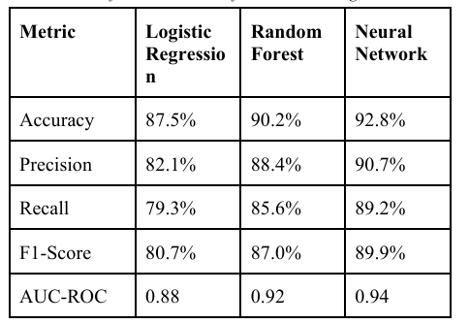

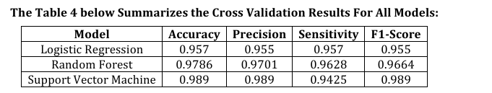

Figure 2-Performance comparison of machine learning models using evaluation metrics such as Accuracy, Precision, Recall, F1-Score, and AUC-ROC. (Adapted from [12], [14]).

4. HIGH-LEVEL SYSTEM ARCHITECTURE
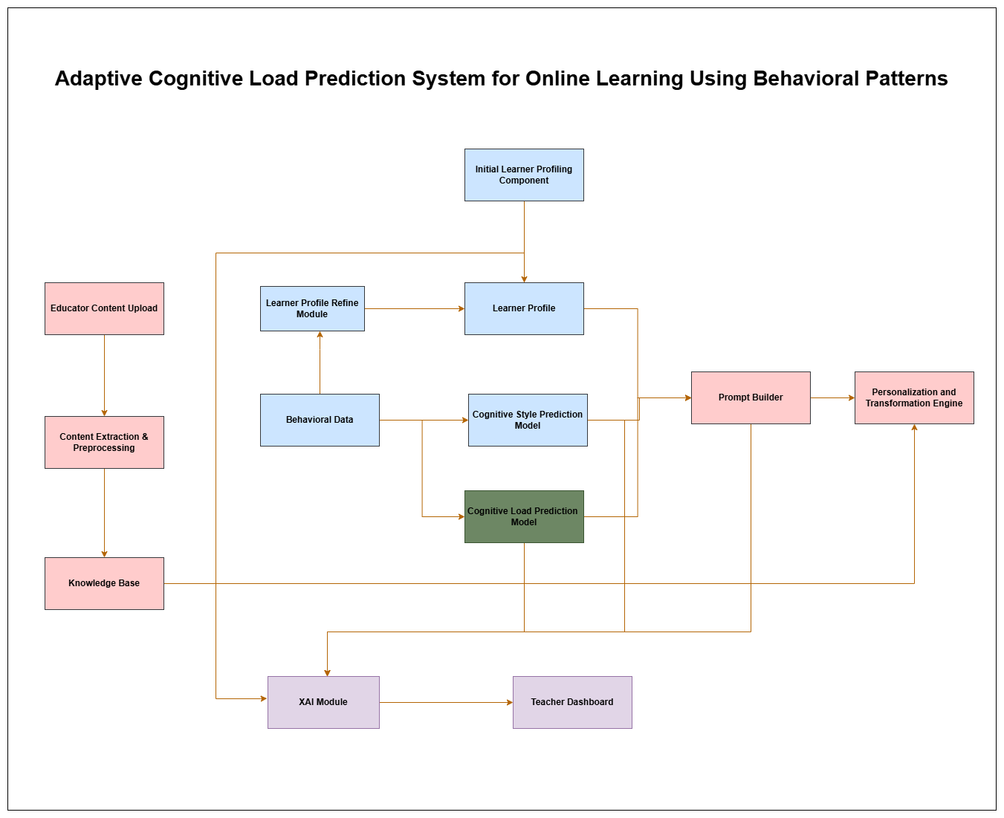
Figure 3-Overall architecture of the Adaptive Cognitive Load Prediction System for Online Learning using behavioral interaction patterns.

4.1 Overview of Proposed Solution
The proposed system is designed as a modular learning analytics framework for real-time cognitive load prediction using behavioral interaction data collected from an online learning platform. The architecture consists of several main components including the data collection module, feature extraction module, cognitive load prediction module, central database, and adaptive learning support module. Modular architectures are commonly used in adaptive e-learning and learning analytics systems because they support scalability, flexibility, and integration of analytical components [5], [19].
Behavioral interaction data such as pause frequency, navigation actions, time-on-task, idle duration, scroll behavior, quiz response time, and error rate are collected from the learning platform and used as input for the cognitive load prediction model. Previous studies have shown that these behavioral indicators can represent learner mental workload without requiring physiological sensors, making them suitable for real online learning environments [1], [3], [4].
The system will be implemented using a web-based learning interface for interaction logging, a relational database for storing behavioral data, and a machine learning module developed using Python-based libraries such as Scikit-learn for feature processing and classification. This software-based architecture allows the proposed solution to operate without specialized hardware, which improves scalability for real online learning systems.
This individual study mainly focuses on the design and implementation of the real-time cognitive load prediction component, which operates as part of the shared learning analytics architecture.

4.2 Shared Data Pipeline
In the proposed architecture, behavioral interaction data are obtained through a shared data pipeline from the online learning platform. All interaction logs generated during learning sessions are recorded through the learning interface and stored in a central database. These logs are then processed by the feature extraction module to generate behavioral indicators required for prediction.
The use of a unified data pipeline improves system efficiency and avoids redundant data collection, which is recommended in learning analytics system design [5], [19]. A centralized data storage approach also allows the same behavioral data to be used for model training, testing, and real-time prediction.
The real-time cognitive load prediction module continuously receives processed behavioral features from the pipeline and estimates learner mental workload during the learning session. Continuous monitoring enables the system to detect changes in cognitive state while the learning activity is still in progress.

4.3 Real-Time Cognitive Load Prediction Component
The main contribution of this individual study is the real-time cognitive load prediction module, which analyzes learner interaction behavior and produces a prediction of the current cognitive load level during the learning session.
Behavioral indicators used for prediction include pause frequency, seek forward and backward actions, rewatch segments, time-on-task, idle duration, scroll behavior, quiz response time, and error rate. These indicators have been widely used in learning analytics and cognitive load research because they reflect learner difficulty, confusion, and mental effort during learning tasks [1], [3], [10].
Raw interaction logs are processed by the feature extraction module to generate a feature vector representing the learner’s current behavior. The extracted features are then provided to a machine learning classification model that estimates the cognitive load level. Machine learning algorithms such as Random Forest, Support Vector Machines (SVM), and Logistic Regression are commonly used in cognitive load prediction and learning analytics research and are therefore considered suitable candidates for the proposed classification approach [12], [14].
During system development, the prediction model is trained using collected behavioral datasets. The dataset is divided into training and testing subsets, and cross-validation is used to evaluate the performance of the model. After training, the selected model is deployed in the real-time prediction module to perform continuous inference during learning sessions.
Unlike traditional approaches that use only binary classification, the proposed model supports multi-level cognitive load classification to represent learner mental state more accurately and to improve the effectiveness of adaptive learning support [5], [13].
The prediction process operates continuously. Interaction events are processed at short time intervals, features are extracted, and the trained model updates the predicted cognitive load level in real time instead of after task completion.

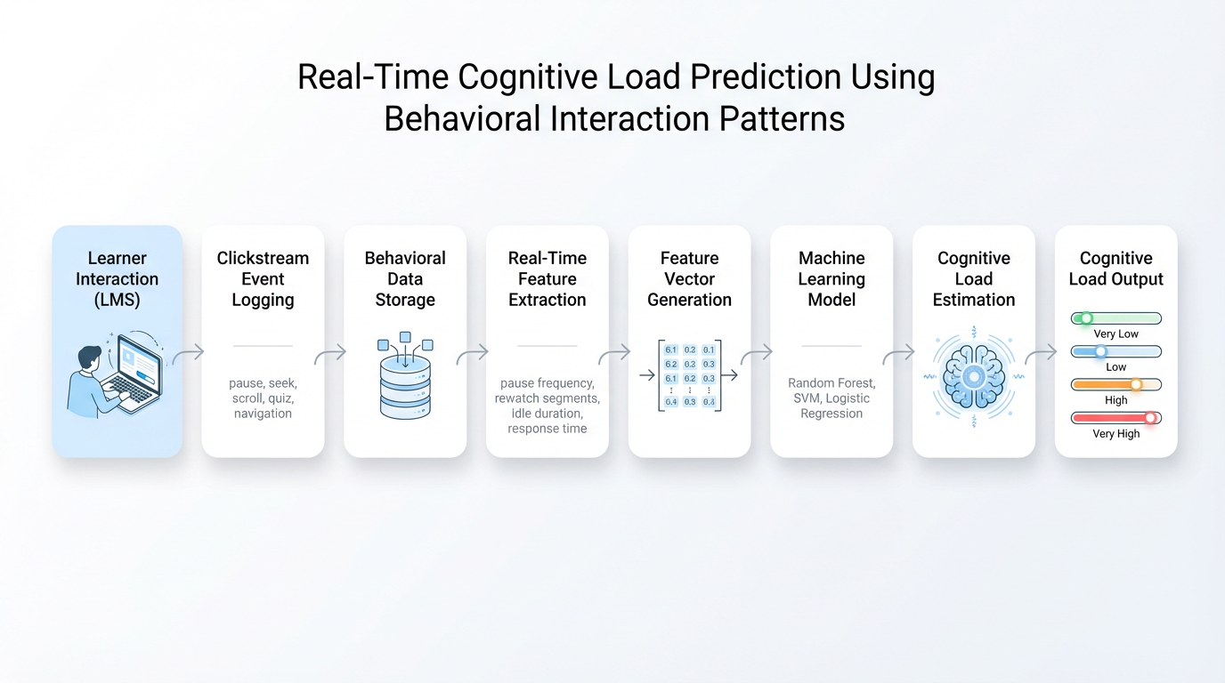
Figure 4-Framework for real-time cognitive load prediction based on behavioral interaction patterns. The system captures learner interaction data, performs feature extraction, generates feature vectors, applies machine learning models, and outputs estimated cognitive load

4.4 Component Interactions and Data Flow
The system workflow begins when the learner interacts with the online learning platform. Interaction events such as navigation actions, pauses, scroll behavior, and quiz responses are recorded and stored in the central database through the shared data pipeline.
The feature extraction module processes the stored logs and computes behavioral indicators within short time windows. These indicators are converted into feature vectors and sent to the cognitive load prediction module.
The trained machine learning model receives the feature vector and predicts the current cognitive load level. The predicted value is then forwarded to the adaptive learning support module, which determines whether any learning assistance or content adjustment is required.
This data flow enables continuous monitoring of learner behavior and allows the system to respond to changes in cognitive load during the learning session. Because the prediction module operates repeatedly during the session, the system can provide near real-time feedback without interrupting the learner.

4.5 Controlled Adaptation Strategy
To maintain stable learning conditions, the proposed system applies a controlled adaptation strategy instead of continuous content modification. Previous studies indicate that frequent or unnecessary adaptation may reduce learning stability and increase cognitive overload [5], [15].
Although the cognitive load prediction module performs continuous monitoring, adaptation is applied only when the predicted cognitive load exceeds a predefined threshold. When a high cognitive load level is detected, the Adaptation Engine provides additional explanation, simplified content, or reduced difficulty level. When the cognitive load returns to a normal level, the system maintains the current learning state without further modification.
This threshold-based adaptation mechanism reduces unnecessary fluctuations in content difficulty and provides more stable learning support, which is recommended in adaptive learning research [9].

4.6 Scalability and Security Considerations
The proposed architecture is designed to be scalable because it relies on behavioral interaction data instead of physiological sensors. Sensor-based methods require specialized hardware and controlled environments, which limits their applicability in large-scale online learning systems [13], [22].
All behavioral interaction logs are stored in a secure database, and personal information is anonymized before analysis. The use of non-intrusive behavioral data collection reduces ethical, and privacy concerns compared with physiological monitoring methods [5], [22].
The modular architecture also allows the cognitive load prediction module to be improved or replaced without modifying the entire system. This improves maintainability, scalability, and future extensibility of the proposed learning analytics framework, which is an important requirement for real-time adaptive online learning systems.

5. USER REQUIREMENTS

5.1 Stakeholder Identification
The proposed real-time cognitive load prediction system involves several stakeholders who interact with the learning analytics framework at different levels. Previous studies on adaptive learning and learning analytics systems identify learners, instructors, system administrators and researchers as the primary stakeholders because these systems collect behavioral interaction data, generate predictions, and support instructional decisions [5], [9].
Table 4-Key Stakeholders and Their Roles in the Proposed Cognitive Load Prediction System
Stakeholder | Description | Role in System
Learner | Students using the online learning platform | Generates behavioral interaction data used for cognitive load prediction
Instructors | Teacher or course designer | Uses system feedback to monitor learner difficulty and learning performance
System Administrator | Technical Operator of the platform | Maintains data collection, database, and prediction model
Researcher / Developer | Prediction component of the system | Processes behavioral indicators and estimates cognitive load

These stakeholders are commonly identified in learning analytics and adaptive e-learning architectures where behavioral data are used to support intelligent decision making

5.2 Functional Requirements
Functional requirements describe the expected operations of the proposed system. These requirements are derived from cognitive load prediction, learning analytics, and adaptive learning system studies, which emphasize continuous monitoring, behavioral feature extraction, and real-time prediction as core functions
Table 5-Functional Requirements of the Proposed Real-Time Cognitive Load Prediction System
Functional Requirement | Description
Interaction data collection | The system shall record learner behavioral interaction data such as pause events, navigation actions, and response time during learning sessions
Feature extraction | The system shall compute behavioral indicators including time-on-task, idle duration, error rate, and rewatch actions from raw interaction logs
Cognitive load prediction | The system shall estimate learner cognitive load using a machine learning classification model based on behavioral features
Real-time monitoring | The system shall perform continuous prediction during the learning session instead of post-task evaluation
Multi-level classification | The system shall support multiple cognitive load levels instead of only low/high classification
Adaptation trigger | The system shall send prediction results to the adaptive learning component.
Data storage | The system shall store interaction logs and prediction results in a secure database for analysis

These functions reflect the typical workflow of behavioral-based cognitive load prediction systems reported in recent learning analytics research.

5.3 Non-Functional Requirements
Non-functional requirements describe the quality attributes of the proposed system. Learning analytics and cognitive load prediction studies emphasize performance, scalability, privacy, and usability because these systems operate on real user data in online learning environments
Table 6-Non-Functional Requirements of the Proposed Real-Time Cognitive Load Prediction System
Requirement Type | Description
Performance | The system shall generate cognitive load predictions with low latency to support real-time monitoring
Scalability | The system shall support large numbers of learners without requiring special hardware such as physiological sensors
Security | Behavioral interaction data shall be stored securely to prevent unauthorized access
Privacy | Personal learner information shall be anonymized before analysis
Usability | The system shall operate without requiring additional devices or user intervention
Maintainability | The architecture shall allow the prediction model to be updated without changing the entire system
Reliability | The system should provide consistent prediction results during continuous monitoring

6. COMMERCIALIZATION PLAN

6.1 Target Market and Customer Persona
- The proposed real-time cognitive load prediction system targets organizations that use online learning platforms and require learning analytics support.
- Potential customers include universities, online course providers, training institutes, and corporate e-learning platforms.
- Main users of the system
  - Learners who generate behavioral interaction data
  - Instructors who monitor learning progress
  - System administrators who manage the platform
- The system is designed to work without additional hardware, making it suitable for large-scale online learning environments.

6.2 Value Proposition
- The proposed system provides real-time cognitive load prediction using behavioral interaction data.
- Unlike sensor-based approaches, the system does not require EEG, eye tracking, or biometric devices.
- The solution is:
  - Non-intrusive
  - Low cost
  - Scalable
  - Easy to integrate with existing learning platforms
- Real-time monitoring allows the system to detect high cognitive load during learning and provide adaptive support.
- This can improve learning performance, reduce learner frustration, and increase course effectiveness.

6.3 Revenue Model
- The system can be commercialized using a Software-as-a-Service (SaaS) model.
- Possible revenue sources
  - Monthly subscription for universities and training centers
  - License-based installation for private institutions
  - Cloud-based analytics service for online learning platforms
  - Enterprise version for corporate training systems
- The subscription model allows continuous revenue generation while supporting different types of customers.

6.4 Cost Estimation
- Main cost components include
  - Development of prediction model and analytics module
  - Server hosting and database storage
  - Maintenance and system updates
  - Integration with existing learning platforms
- Since the system uses behavioral data instead of hardware sensors, development cost is lower than physiological-based systems.
- Cost per user decreases when the number of learners increases, making the system suitable for large-scale deployment.

6.5 Pricing Strategy
- Pricing can be based on number of users or institution size.
- Possible pricing options
  - Small institutions - low subscription fee
  - Universities - medium subscription fee
  - Large platforms - enterprise pricing
- Flexible pricing allows adoption by different types of organizations.
- Trial or limited free version can be provided to encourage adoption.

6.6 Competitive Advantage
- Uses behavioral interaction data instead of physiological sensors.
- Supports real-time cognitive load prediction.
- Works in normal online learning environments.
- Modular architecture allows easy integration.
- Lower cost compared with hardware-based solutions.
- Suitable for large-scale learning platforms.

6.7 Intellectual Property Considerations
- The prediction model and system architecture can be protected as software intellectual property.
- Possible protection methods
  - Copyright for software implementation
  - License agreement for commercial use
  - Patent application for novel prediction method
- Protecting intellectual property is important for future commercialization and research ownership.

7. BUDGET AND JUSTIFICATION
Table 7-Estimated Budget for the Proposed Cognitive Load Prediction System
Cost Category | Item / Resource | Estimated Cost (USD) | Justification
Hardware Costs | Development laptop / workstation | $1,000 – $1,500 | Required to run machine learning models, data processing libraries, and development tools used for implementing real-time cognitive load prediction system.
 | External storage / backup drive | $80 – $150 | Used for storing behavioral datasets, extracted learning content, and system backups during model training and testing.
Software Licenses | Development tools (VS Code / PyCharm / extensions) | $0 – $150 | Provides an efficient programming environment for developing Python-based machine learning modules and system components.
 | Python libraries (ML / data processing / NLP) | Mostly Free (Open Source) | Libraries such as Scikit-learn, Pandas, NumPy, OpenCV, and Speech-to-Text tools are open-source and will be used for feature extraction, model training, and quiz generation.
 | Speech-to-text / content extraction tools | $0 – $100 | Required to extract text from video learning materials to generate quizzes and behavioral indicators for cognitive load prediction.
Cloud Services | Cloud hosting (AWS / Google Cloud / Azure / Render) | $40 – $120 per month | Used to host the backend system, run prediction models, and store learner interaction logs for real-time processing.
 | Cloud database / storage | $20 – $60 per month | Required to store clickstream logs, behavioral features, quiz results, and prediction outputs generated during learning sessions.
 | Dataset storage / backup | $20 – $50 per month | Used to store public learning analytics datasets and experimental data collected during system evaluation.
Human Effort Cost | Student developer / researcher | $0 (Academic project) | The system will be designed and implemented as part of an academic research project. No additional development cost is required.
 | Testing and evaluation support | $200 – $400 | Effort required for conducting experiments, validating prediction accuracy, and analyzing results using collected behavioral data.
 | Data collection / experiment support | $200 – $500 | Required for running learning sessions, collecting interaction logs, and evaluating cognitive load prediction performance.
Miscellaneous | Internet / electricity / printing | $150 – $300 | Required during development, testing, and documentation of the research project.
 | Transport for data collection / testing | $150 – $300 | Required for conducting user testing sessions or collecting experimental data from learners.
Total Estimated Cost (Research Phase) | — | Approximately $2,000 – $4,000 | Covers development tools, cloud services, data storage, and testing required to implement the real-time cognitive load prediction system.

8.WORK BREAKDOWN STRUCTURE (WBS)
Table 8-Work Breakdown Structure (WBS)
WBS ID | Task | Duration | Deliverable | Dependencies
8.1 | Literature Review (Cognitive Load Prediction & Learning Analytics) | 5 weeks | Annotated bibliography, research summary on behavioral prediction methods | None
8.2 | Requirement Analysis and Feature Identification | 2 weeks | List of behavioral features (pause, navigation, time-on-task, response time, etc.) | 8.1
8.3 | System Architecture Design for Cognitive Load Prediction Module | 3 weeks | Architecture diagram, module design document | 8.2
8.4 | Behavioral Data Logging and Storage Design | 3 weeks | Database schema, clickstream logging structure | 8.3
8.5 | Dataset Collection and Preparation | 3 weeks | Public dataset and collected interaction logs for testing | 8.4
8.6 | Feature Extraction Module Development | 4 weeks | Feature extraction code for behavioral indicators | 8.5
8.7 | Machine Learning Model Development (SVM, Random Forest, Logistic Regression) | 5 weeks | Trained cognitive load prediction model | 8.6
8.8 | Multi-Level Cognitive Load Classification Implementation | 3 weeks | Model supporting multiple cognitive load levels | 8.7
8.9 | Real-Time Prediction Module Integration | 3 weeks | Real-Time Prediction Pipeline Integration  Working real-time prediction pipeline with feature extraction and model inference | 8.8
8.10 | Quiz Interaction and Behavioral Feature Integration | 2 weeks | Quiz response data used as prediction features | 8.9
8.11 | System Testing and Performance Evaluation | 5 weeks | Accuracy results, evaluation report, comparison analysis | 8.10
8.12 | Final Integration and Documentation | 3 weeks | Final system, report, and presentation materials | 8.11

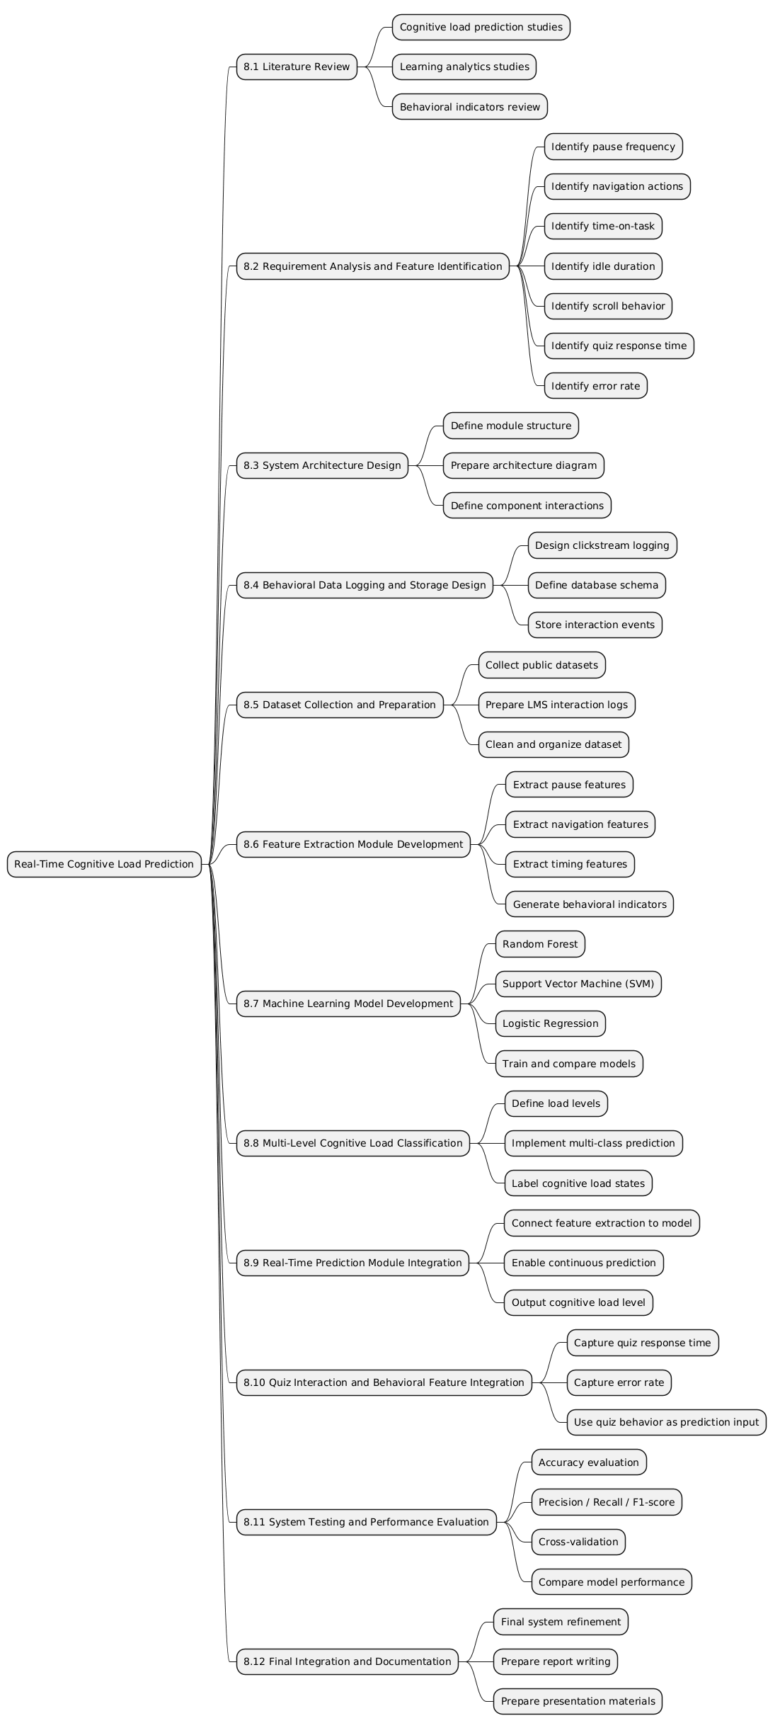
Figure 5-Work Breakdown Structure

9.GANTT CHART
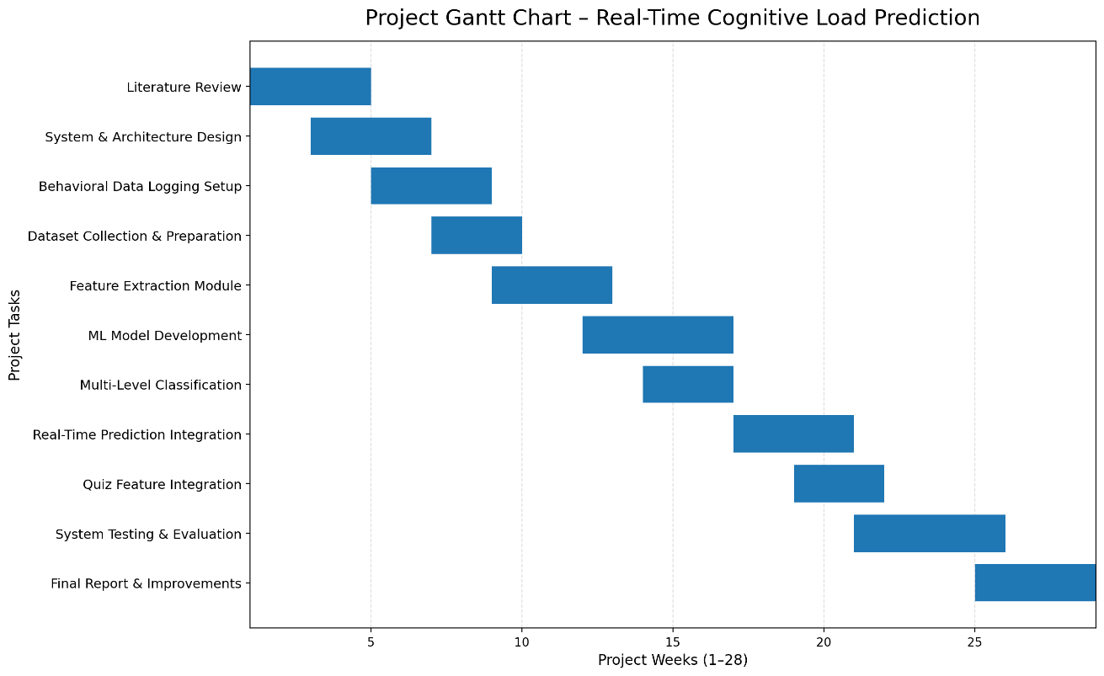
Figure 6-Gannt Chart

10. REERNCE LIST
[1] G. Pal, K. Atkinson, and G. Li, “Real-time user clickstream behavior analysis based on Apache Storm streaming,” Electronic Commerce Research, vol. 23, no. 4, pp. 1829–1859, 2023.
[2] T. Weiß and T. Pfeiffer, “Consumer Decisions in Virtual Commerce Predict Good Help-Timing,” 2024.
[3] Y. Yi and X. Wu, “Cognitive Load Early Warning Based on Behavioral Data,” in Proc. Int. Conf. Big Data Anal. Artificial Intelligence Applications, 2025.
[4] M. Gayakwad et al., “Real-Time Clickstream Analytics with Apache,” Journal of Electrical Systems, vol. 20, no. 2, pp. 1600–1608, 2024.
[5] M. Suryani et al., “Role, Methodology, and Measurement of Cognitive Load in Computer Science and Information Systems Research,” IEEE Access, vol. 12, pp. 138096–138115, 2024.
[6] Y. Lee, G. Migut, and M. Specht, “Behavior-based Feedback Loop for Attentive E-reading (BFLAe),” in IJCAI Workshop on Micro-Gesture Analysis, 2023.
[7] O. Samson, “Adaptive Summarization in E-Learning Platforms through User Profiling,” 2025.
[8] J. Sweller, “Cognitive Load Theory,” Psychology of Learning and Motivation, vol. 55, pp. 37–76, 2011.
[9] M. Zaoudi and H. Belhadaoui, “Adaptive E-Learning: Adaptation of Content According to Learner Evolution,” in NISS Conference, 2020.
[10] M. Cai and C. D. Epp, “Modeling Cognitive Load and Affect to Support Adaptive Online Learning,” in Educational Data Mining Conference, 2022.
[11] A. Darejeh et al., “Cognitive-based Methods to Facilitate Learning of Software Applications,” Cogent Education, 2022.
[12] J. V. R. Jaisoorya et al., “Social Network-Integrated Machine Learning for Prediction Models,” 2023.
[13] M. I. Ahmad et al., “A Framework to Estimate Cognitive Load Using Physiological Data,” Personal and Ubiquitous Computing, vol. 27, no. 6, pp. 2027–2041, 2023.
[14] I. H. Ajayi and E. Avksentyeva, “Machine Learning Methods for Predicting Cognitive Load Using Eye-Tracking Data,” Pakistan Journal of Life and Social Sciences, 2024.
[15] A. Skulmowski and K. M. Xu, “Understanding Cognitive Load in Digital and Online Learning,” Educational Psychology Review, vol. 34, pp. 171–196, 2022.
[16] A. Siddique et al., “Developing Adaptive E-Learning Environment Using Cognitive Parameters,” Journal of Educational Computing Research, 2018.
[17] L. Zheng, L. Zhong, and J. Niu, “Effects of Personalised Feedback on Cognitive Load in Online Learning,” Assessment & Evaluation in Higher Education, 2021.
[18] M. A. M. Rishard et al., “Adaptivo: Personalized Adaptive E-Learning System,” 2022.
[19] S. N. Amarasinghe et al., “Remotify: Emergency Remote Learning Solution Using Learning Analytics,” 2022.
[20] H. M. Šola et al., “AI Eye-Tracking Technology for Managing Cognitive Load in Online Learners,” Education Sciences, vol. 14, no. 9, 2024.
[21] U. A. Abdurrahman et al., “Effects of Neuro-Cognitive Load on Learning Transfer Using VR,” Big Data and Cognitive Computing, 2021.
[22] N. Herbig et al., “Investigating Multi-Modal Measures for Cognitive Load Detection in E-Learning,” in ACM UMAP, 2020.
[23] C. Lange, “The Relationship Between E-Learning Personalisation and Cognitive Load,” Open Learning, 2021.
[24] UNESCO (2020). Education: From disruption to recovery. UNESCO Report.
[25] UNESCO (2021). Reimagining education in the digital age. UNESCO Global Education Monitoring Report.

11. APPENDICES
Appendix A – Research Gap Matrix (Excel file – OneDrive) -Gap-Finding Matrix.xlsx

