Lab 1

1. WITHDRAW_MONEY Use Case Description: Main Flow

| User Action | System Response |
| --- | --- |
| 1. User types in PIN into main screen | 1. System checks validity of PIN and presents options to user on another screen |
| 1. User chooses the Withdrawal option from the screen. | 2. System presents another screen where it will ask the amount to enter for withdrawal. |
| 1. User types amount to withdrawal. | 3. System checks available amounts and cash out and then presents options to the user on another screen. |

2.

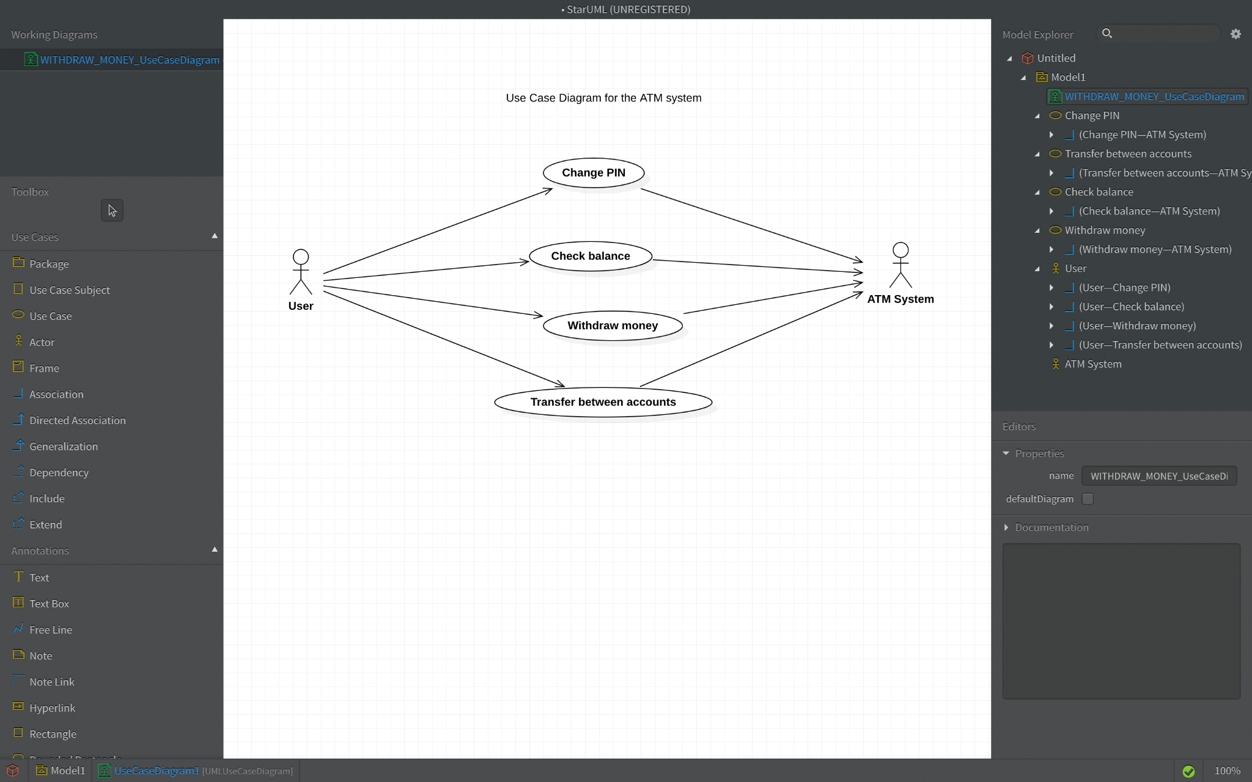

3. Project Management Tracking System

-Create a list of all the noun phrases from the problem description.

“A Project Manager manages multiple projects. A project, before final release, is required to have a specified feature set. Associated with a project are multiple releases. A release is a functional piece of the project being developed that includes a subset of the feature set for the project and which is to be delivered on a specified date (the feature set and release date are determined by the Project Manager). When the last release is delivered, the project is considered completed.

Associated with each feature for a project is a developer who is responsible for developing this feature for inclusion in the project. A developer has an id and provides, for each feature he is responsible for, the estimated time remaining to complete work on that feature. The Project Manager assigns features to developers to work on.”

List of Noun Phrases

* Project Manager
* projects
* project
* release
* feature set
* project
* releases
* release
* functional piece of the project
* subset of the feature set
* project
* specified date
* feature set
* release date
* Project Manager
* last release
* project
* feature
* developer
* feature
* project
* developer
* id
* feature
* estimated time
* feature
* Project Manager
* features
* developers

-Sort and Eliminate Duplicates

* developer
* estimated time
* feature set
* feature
* id
* release
* release date
* Project Manager
* project
* specified date

Eliminated terms

* estimated time
* release date
* specified date

Final List of Noun Phrases

* developer
* feature
* feature set
* id
* release
* Project Manager
* project

-Group “Synonyms”

developer

id

Project Manager

| project  release (for whole project) |
| --- |

| feature  release (for one feature) |
| --- |

-Choose Class Name/Attribute

Developer (id-attribute of Developer class)

ProjectManger

Project(projectRelease-attributes of Project class)

Feature(featureRelease-attributes of Feature class too)

-Ignore Implementation Classes During Analysis

No implementation class now

Final List of Classes Derived from Noun Phrases

* Developer
* ProjectManager
* Project
* Feature

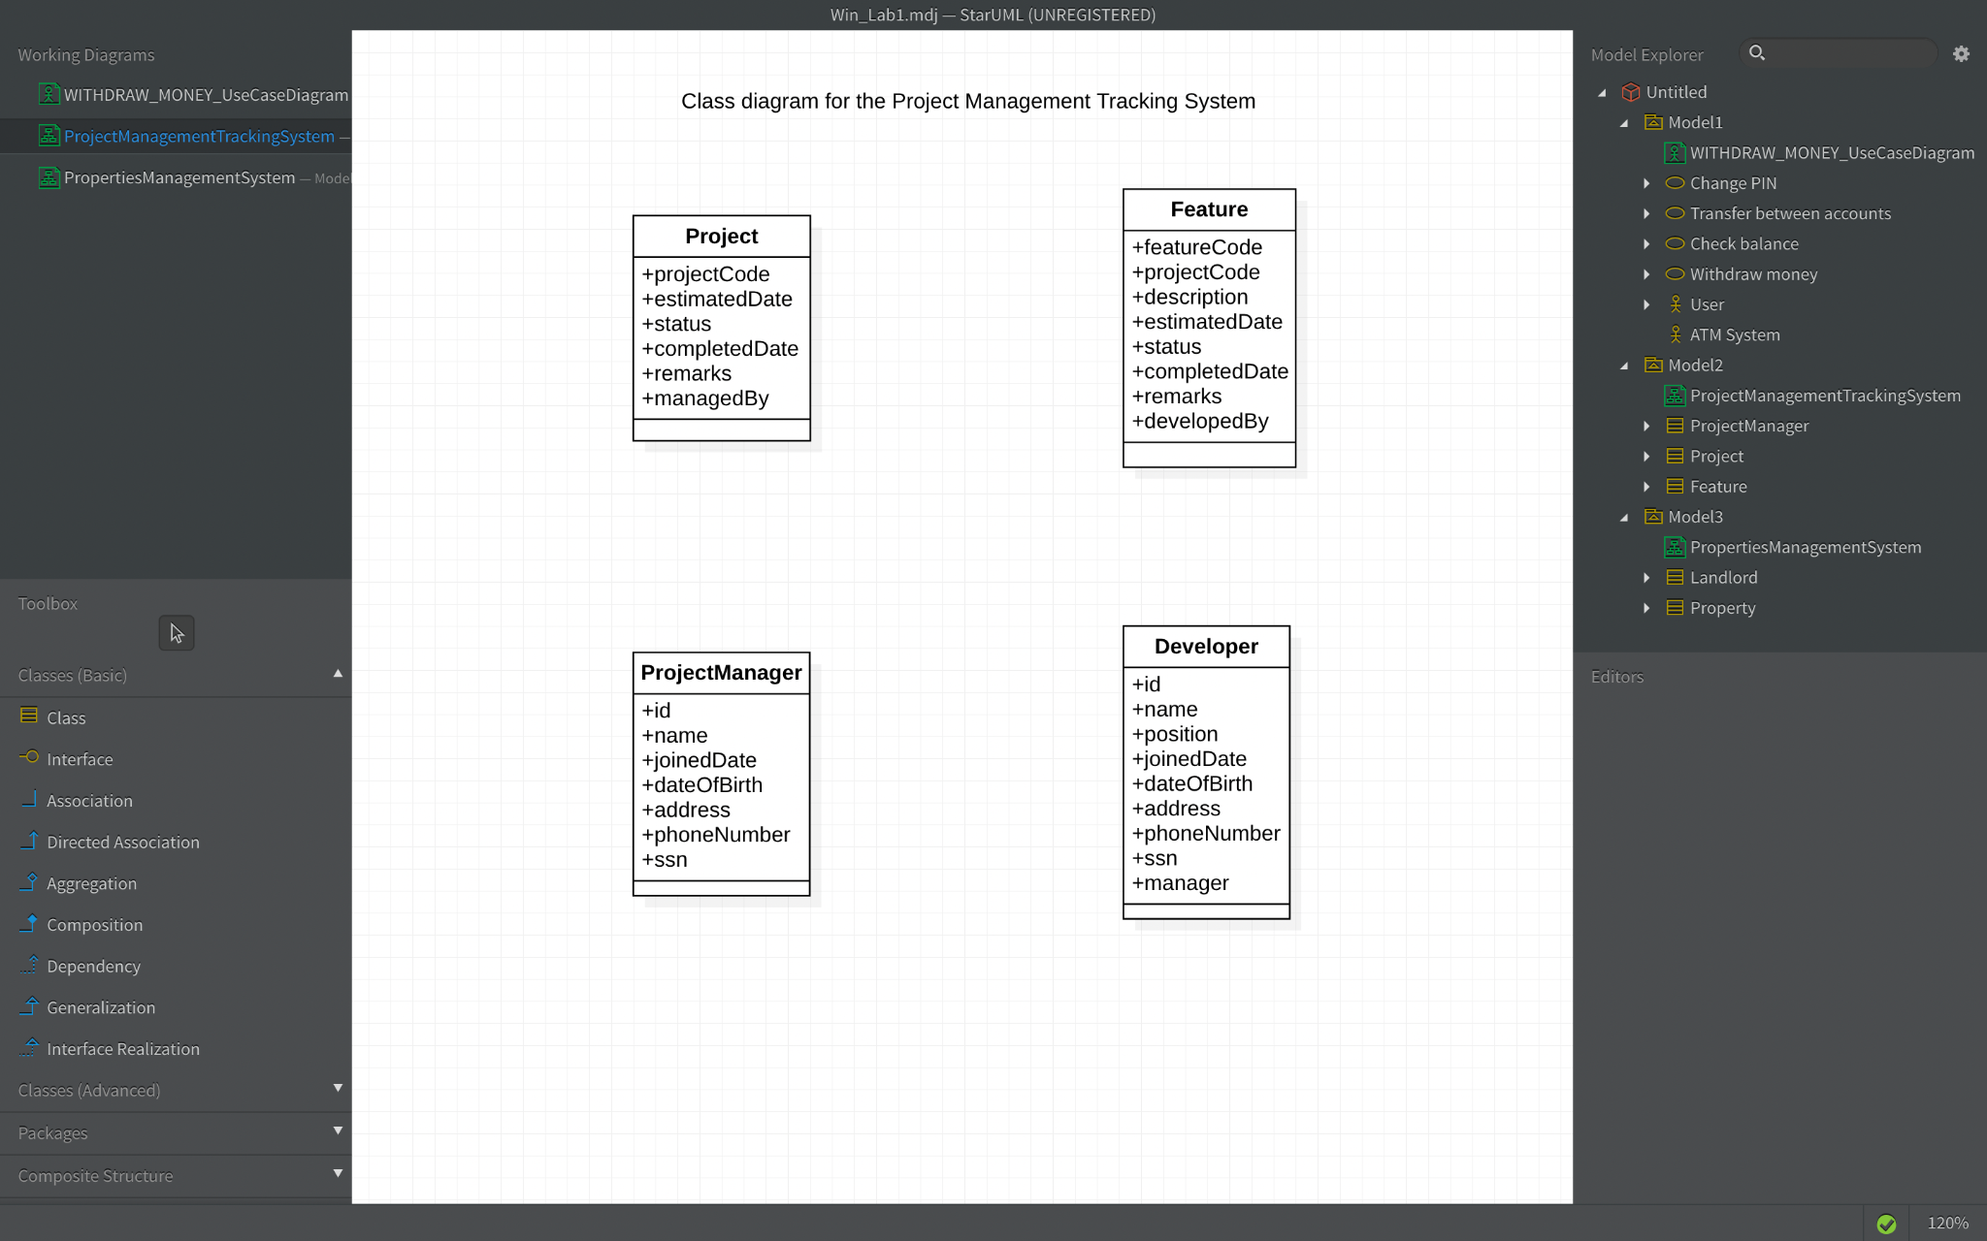

1. Properties Management System

-Create a list of all the noun phrases from the problem description.

A landlord owns several types of properties: houses, condominiums, and trailers. A house has an address and a lot size. Rent for a house is computed by rent = 0.1 * lot size A condominium has an address and a certain number of floors (1 floor, 2 floors, or 3 floors). Rent for a condominium is computed by rent = 400 * number of floors A trailer belongs to a particular trailer park (specified by the trailer park address). The rent for a trailer is always $500. The property managemet software is required to have an Admin module that supports various functions. One of these functions is to compute total rent for all the properties registered in the system. Another function is to list all properties in the system that are in a specified city.

List of Noun Phrases

* landlord
* types of properties
* houses
* condominiums
* trailers
* house
* address
* lot size
* Rent for a house
* condominium
* address
* number of floors
* Rent for a condominium
* trailer
* trailer park
* trailer park address
* rent for a trailer
* property management software
* Admin module
* functions
* One of these functions
* Total rent
* properties registered in the system
* properties in the system
* specified city

-Sort and Eliminate Duplicates

* address
* Admin module
* condominium
* functions
* house
* landlord
* lot size
* number of floors
* properties in the system
* types of properties
* trailer
* Total rent

Eliminated terms

* Admin module(because it’s system itself)
* Rent for a house
* Rent for a condominium
* property management software
* rent for a trailer
* properties in the system
* properties registered in the system
* trailer park
* trailer park address (because it’s the same with address noun)
* specified city (because it’s the same with address noun)

Final List of Noun Phrases

* address
* condominium
* functions
* house
* landlord
* lot size
* number of floors
* number of floors
* types of properties
* trailer
* Total rent

-Group “Synonyms”

landlord

| types of properties  house  condominium  trailer  address  lot size  number of floors  Total rent |
| --- |

function

-Choose Class Name/Attribute

Landlord

Property

-Ignore Implementation Classes During Analysis

function

* to compute total rent for all the properties registered in the system
* to list all properties in the system that are in a specified city

Final List of Classes Derived from Noun Phrases

* Landlord
* Property

