Lab 3

1. PersonWithJob is a subclass of Person class. In the main method, p1 is an object of PersonWithJob and p2 is an object of Person. p1.equals(p2) will check p2 is PersonWithJob instance and then its name and salary so that p2 is Person instance and we got false.

For p2.equals(p1), it will check p1 is Person instance and then its name so that p1 is PersonWithJob instance and we got true.

The solution by replacing inheritance with composition is outside of this file, together inside zip file.

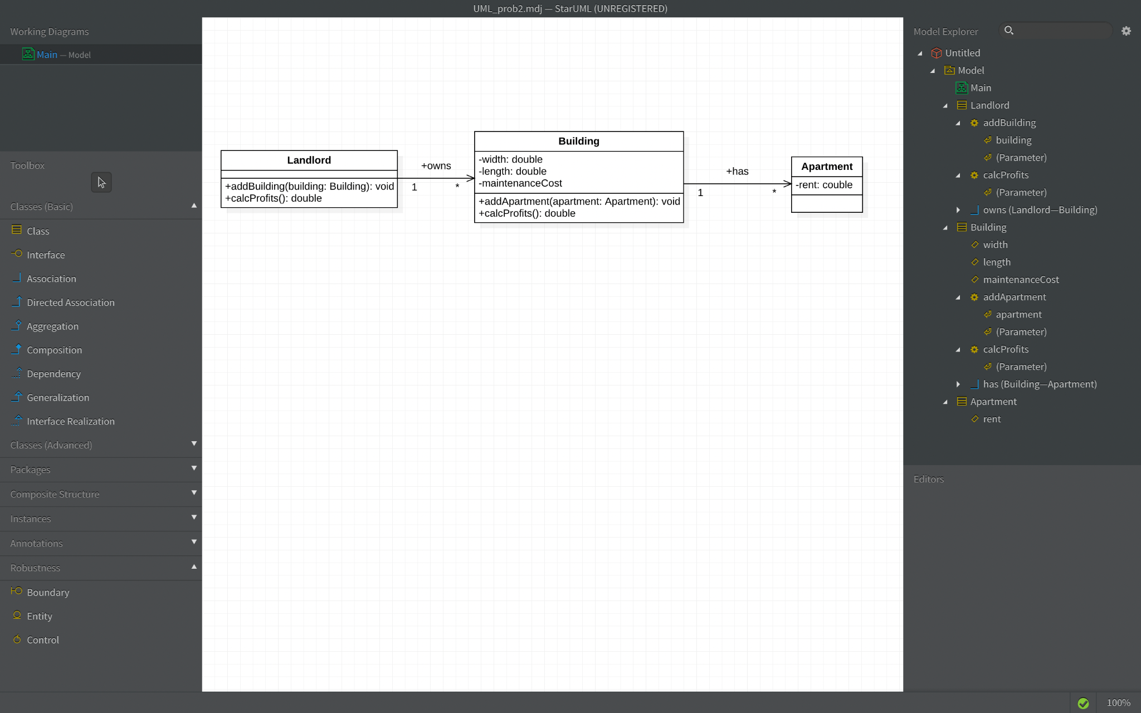

Code answers are outside of this file, together inside the zip file.

1. A. In UML classes Circle and Cylinder, it doesn’t make sense to use inheritance because it violates IS-A principle and Liskov Substitution Principle(LSP). Circle is not a Cylinder. And we may not use a Circle instance wherever a Cylinder instance is expected.

Java code for that diagram is outside of this file, together inside the zip file.

B.

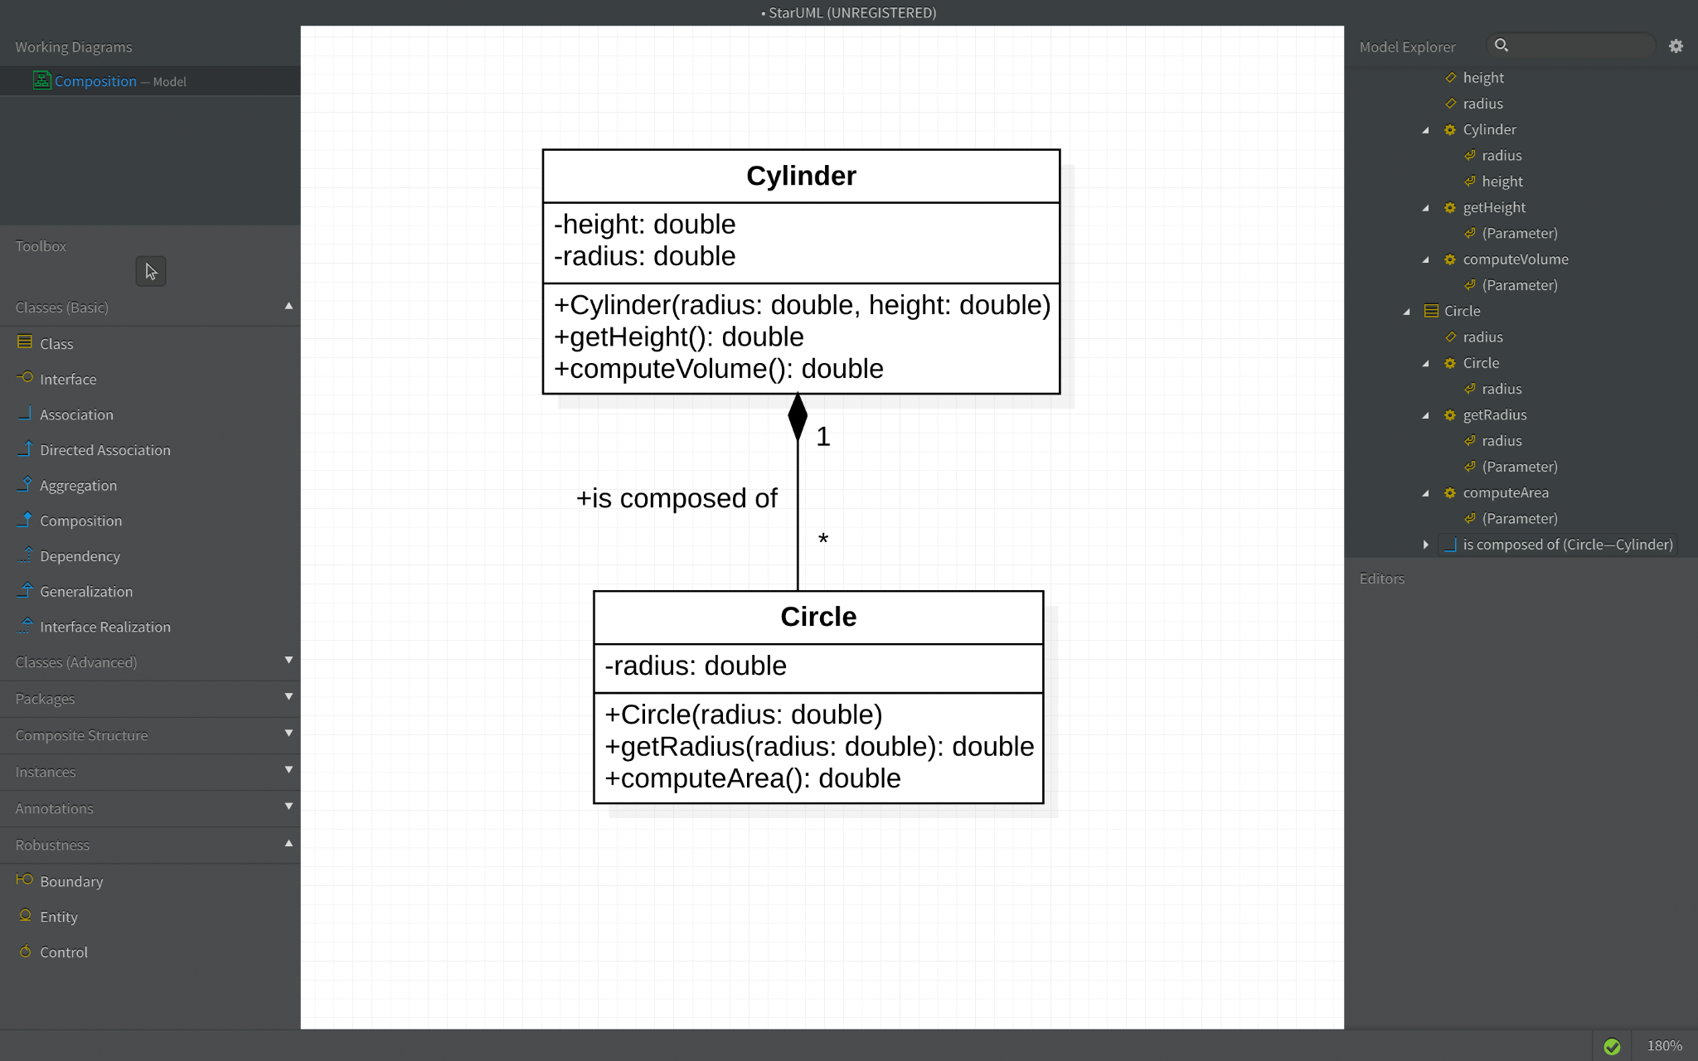

Java code for that diagram(multiplicity is one to many(exactly 2)), using composition, is outside of this file, together inside the zip file.

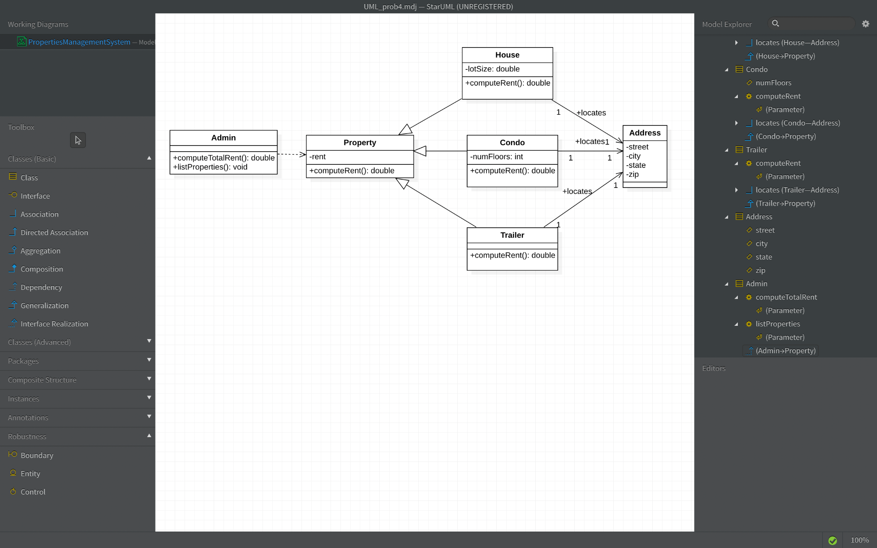

Code implementation is outside of this file, together inside the zip file.