Homework #1

Problem #1:

1. Figure (A) is taken with a perspective camera. Figure (B) is taken with an orthographic camera.
2. The camera projection matrix for a perspective camera: , d is the distance from the COP(Center of Projection) to the object.

The camera projection matrix for an orthographic camera: .

If we set d = -z, then the perspective projection will be , and the orthographic matrix is still . Obviously, in this condition, the perspective projection is equal to the orthographic projection.

1. The following figure identifies a set of lines in picture A that are intersecting in a varnishing point with a finite coordinates.

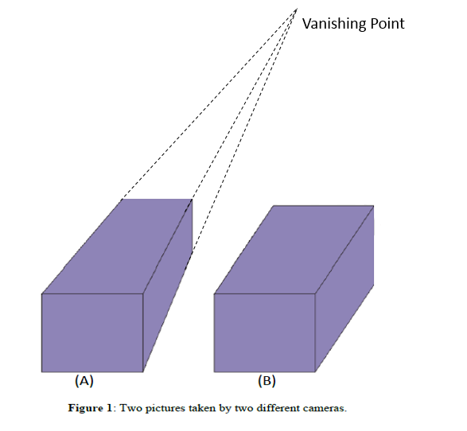

Problem #2:

1. y1 = , y2 = .

So in the Euclidean coordinates: y1 = ,

y2 = .

1. l1 = , l2 = .

So the intersection of two lines is

Solution 1:

Homogenous coordinates:

So the intersection point is

Solution 2:

Euclidean coordinates:

l1: 2x + 3y + 3 = 0

l2: x – y + 2 = 0

=> ;

So the intersection point is

Problem 3:

1. x1 = = ;

x2 = ;

So x1 represents, x2 represents

1. p1 = => x – y + 2z – 1 = 0

The normal vector is =>

So the normal vector is

The distance to the origin is D =

Problem 4: