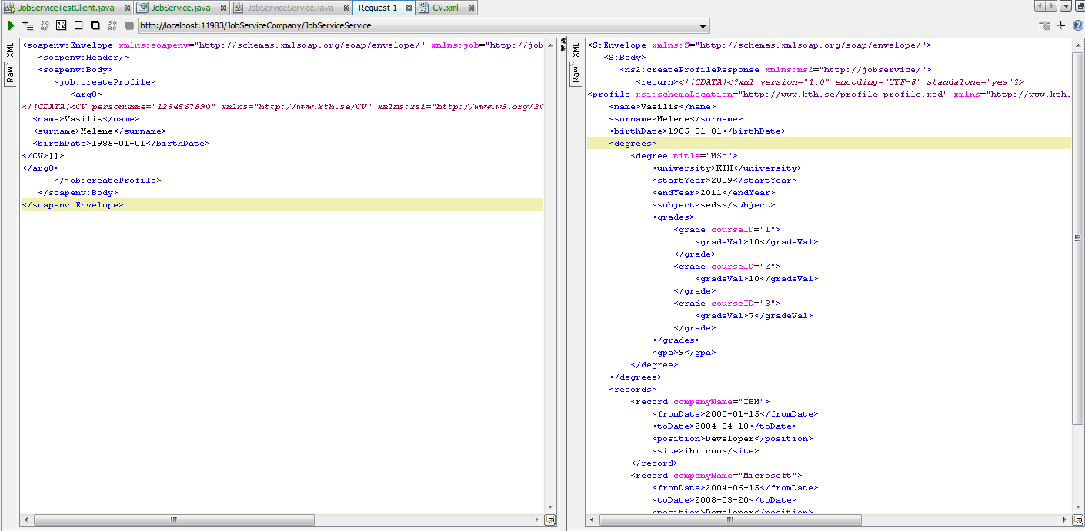

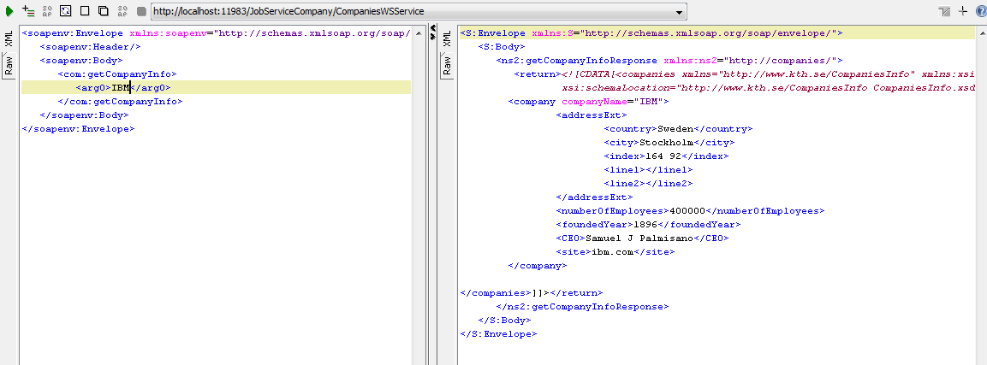

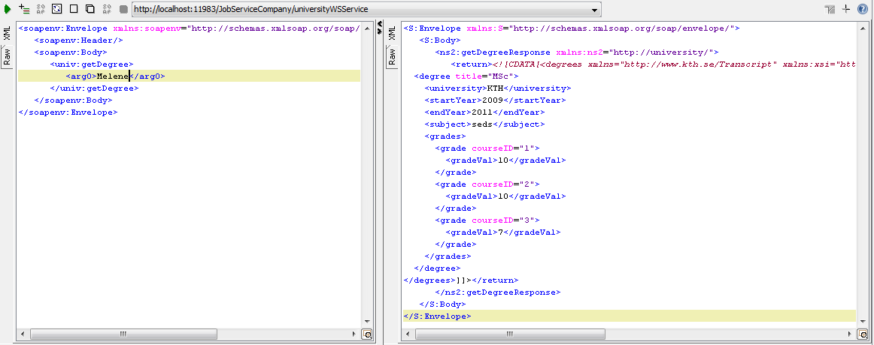

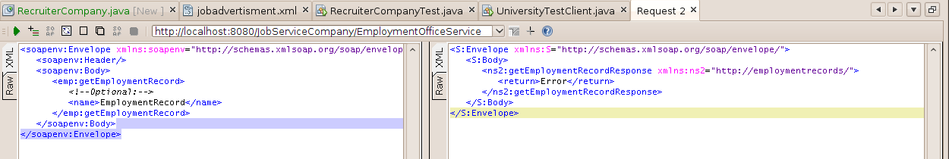

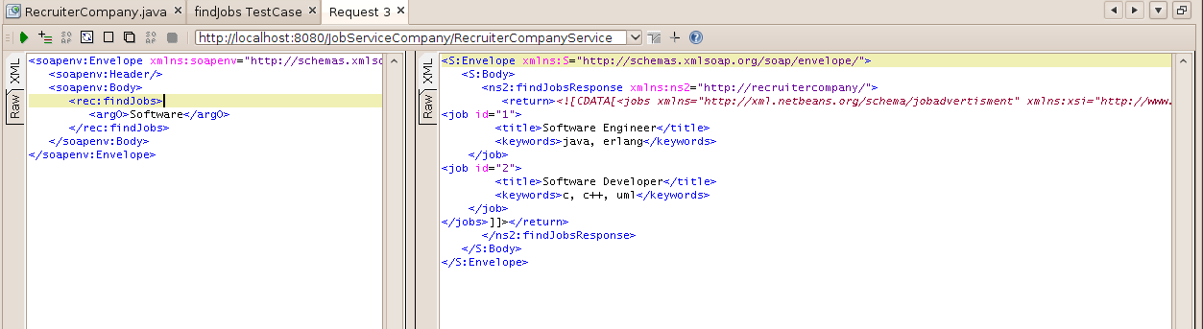

We first enabled the async service call in the service's WSDL. Then, in the

client we chose the "callback" approach. That means that we did an

asynchronous service call, and we attached a handler to it. So, when the call

returned, the handleMessage method of the handler executed, parsing the response.

The deployment and architecture of our application follows strictly the diagramm in page

55 of homework description. We created 5 different components that provide (and consume)

services and 1 client. The flow of information is the following:

-the JobServiceTestClient uses the service of the JobService to submit his CV

-the JobService uses the services from CompaniesWS, EmploymentOffice, universityWS

and RecruiterCompany to gather the information about the client. Specifically,

the job offerings that is getting from RecruiterCompany are taken both with

a synchronous and an asynchronous call of the service

-the JobService integrates the data and creates the profile of the client. This profile

is sent back to the JobServiceTestClient as results of its call

For the processing of XML files we used JAXB everywhere, except the RecruiterCompany where

we used in order to have easily searchable data.

