2. Information about HW platform
Computer: laptop Toshiba A300 - Core 2 Duo 2200, 4096 Mb RAM, 400 GB HDD
Operating system: openSuse Linux 11.2 (Linux kernel 2.6.31)

3. A list of Java software
- Java 1.6.0_17-b04
- Niche version 0.2.2
- Apache Ant version 1.7.1
- Apache HTTP server version 2.2.13
- PHP version 5.3.0

5. A clear instruction how to run the application.
Counter application needs installed and running Niche. So first of all it is necessary to install Niche. The detailed instruction how to do this is available in the document “Niche quick start guide”. The document can be downloaded from the web site http://niche.sics.se
To run Counter application you need to run Niche using jadeboot ant target and run at least three nodes using jadenode ant target. After this you can deploy Counter with testG4A-NicheCounter-Deploy ant target. After the deplyment you can run application with testG4A-NicheCounterStart task.

4. Detailed description of the application

Structure
The following diagram represents structure of the application:
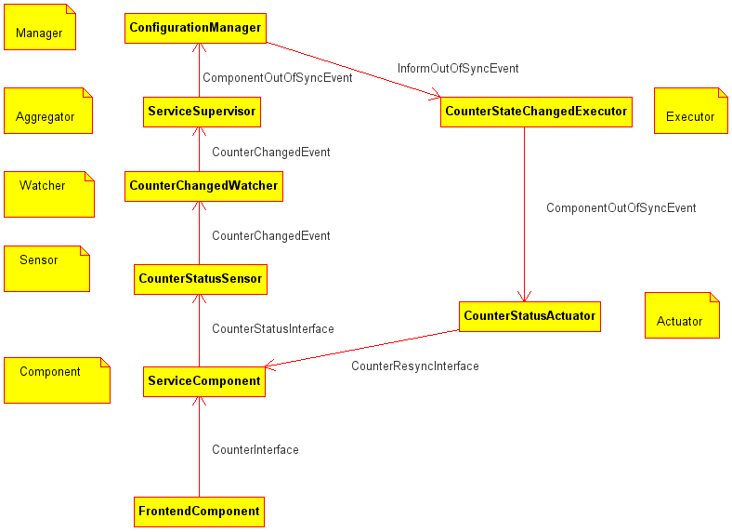
- FrontendComponent tells Service component to increase it's counter using CounteInterface. Frontend component sends unique transaction Id with each increase counter request.
- To simulate failure we have some small probability that Service component will not increase it's counter. If Service component increases it's counter it tells the counter to CounterStatusSensor via CounterStatusInterface.
- CounterStatusSensor just triggers a CounterChangedEvent to CounterChangedWatcher.
- CounterChangedWatcher promotes received event to ServiceSupervisor aggregator.
- ServiceSupervisor contains the logic of the application. It analyzes the received counters and if some of the ServiceComponents is out of order triggers ComponentOutOfSyncEvent to ConfigurationManager.
- ConfigurationManager triggers InformOutOfSynEvent to CounterStateChangedExecutor to re-synchronize components.
- Executor sends ComponentOutOfSyncEvents CounterStatusActuators
- Actuators inform ServiceComponents through CounterResyncInterface about synchronization.
- ServiceComponents receive counter number to synchronize and transaction Id. If component did not receive message with the same transaction Id it synchronizes and stores this transaction Id in the list to ignore this transaction in the future.

