
Royal Institute of Technology

MSc. Software Engineering of Distributed Systems

ID2210 Distributed Computing, Peer-to-Peer and GRIDS

Lab assignment 2

Trigonakis Vasileios | Andrei Shumanski
vtri@kth.se | andreish@kth.se
0707694420 | 0707761992

Stockholm 2010

Question 1

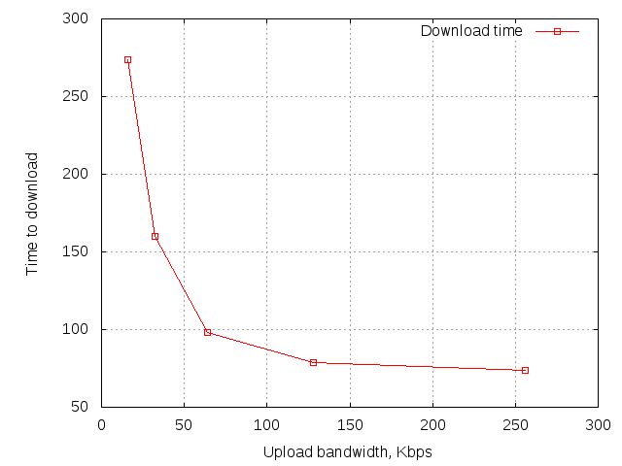

Motivation
As expected, the dissemination of the data in the whole system is done faster as the upload bandwidth increases. This is explained by the fact that the total download rate in the system (at any moment) equals with the total update rate. So, since we have nodes with greater download bandwidth than upload bandwidth, increasing the upload speed of the nodes, increases the data dissemination speed. We can notice that after the 128 Kbps the upload bandwidth does not affect much the download time.

Question 2

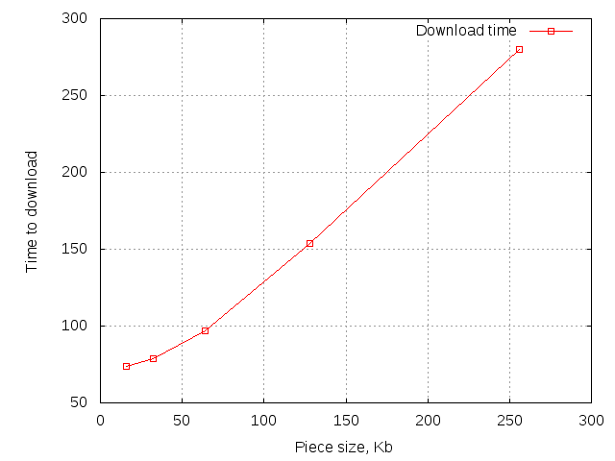

Motivation
Again, the diagram is as expected. Increasing the piece size increases the time that all nodes become peers. Since the nodes of the system have higher download rate than upload rate, each piece is transfered with the upload speed of the uploader node. So, each piece needs (piece size)/(upload bandwidth) time to be transfered, thus increasing the piece size, increases the transfer time.

Question 3

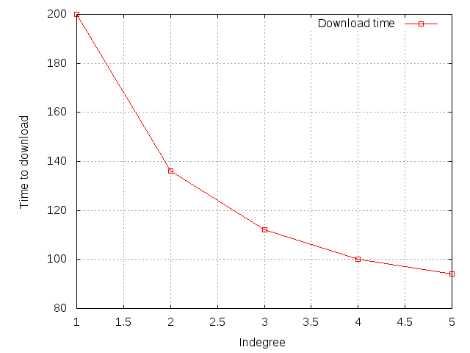

Motivation
In this experiment we can notice that increasing the in-degree decreases the download time in the system. That is rational, since if there are more upload slots available than download slots then there is no full utilization of the upload slots in some period of the download process. On the other hand, we noticed that even when we had 5 download slots and 4 upload ones, we had an increase over the case we had 4 and 4. This happened because in the end of the dissemination, where there are several seeders, the leechers can utilize all their 5 download slots.

Question 4

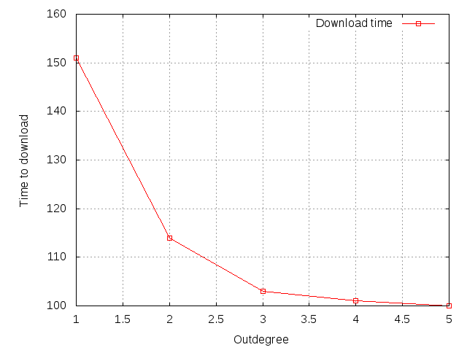

Motivation
The explanation behind the results in this experiment is the same with the previous one with one difference. We can see after 3 upload slots the increase of these slots does not increase the download speed. It means that there is a lack of download slots in the system that limits the download speed. The conclusion of questions 3 and 4 is that the download slots are the bottleneck in the system.

Question 5

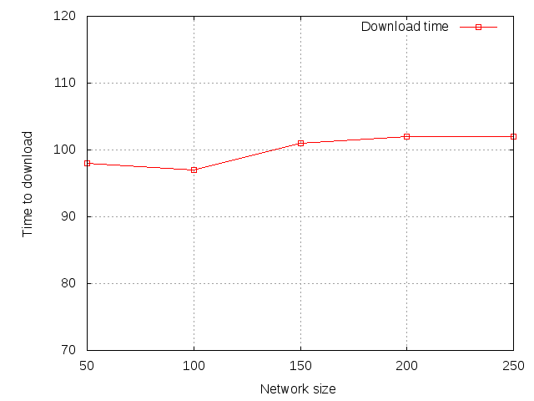

Motivation
Our results reveal that the algorithm scales very well. We noticed that there is almost no dependency in the data dissemination time and the network size. There is only a small tendency of increase. The results can be explained by the fact that each extra node, apart from consuming "system" bandwidth, it offers upload bandwidth. This is the main advantage of P2P systems.

