Exercise 1

- experiments

We tried the PFD with both 2 and 4 nodes in fully connected topologies.

Topology topology1 = new Topology() {
{
node(1, "127.0.0.1", 22031);
node(2, "127.0.0.1", 22032);
link(1, 2, 4000, 0).bidirectional();
}
};

Topology topology2 = new Topology() {
{
node(1, "127.0.0.1", 22031);
node(2, "127.0.0.1", 22032);
node(3, "127.0.0.1", 22033);
node(4, "127.0.0.1", 22034);
defaultLinks(1000, 0);
}
};

With the following values of γ and δ:

private static long GAMMA = 4000;
private static long DELTA = 1000;

- observations

The PFD worked as intended, reporting the crash of a node as you can observe in the following screenshots:

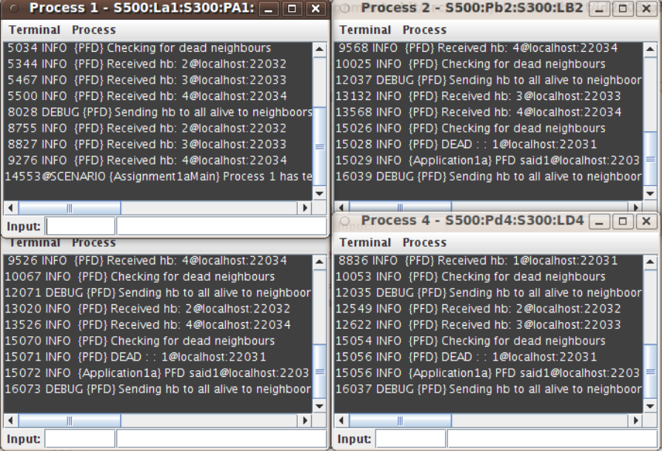
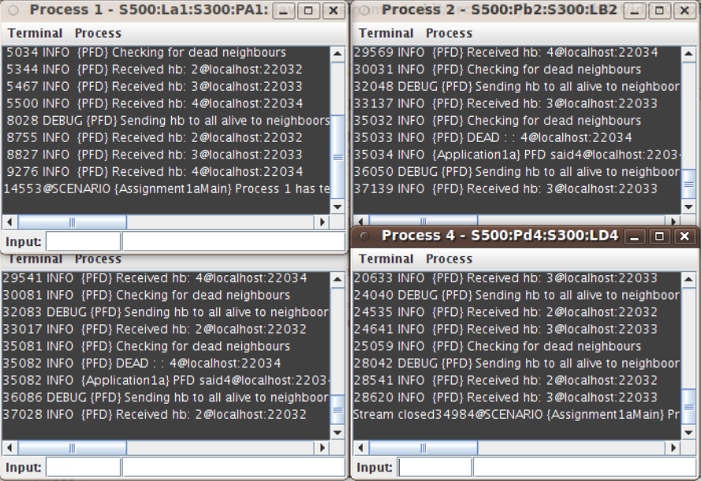
- conclusions

Our test showed that the algorithm and the implementation of the PFD works correctly and is consistent to the completeness property of it.

Exercise 2

- experiments

We tried the EPFD with both link delay shorter than the initial heartbeat period and longer than this. Also, in the first case, we also killed one process to test that the other PFD is detecting the failure.

Topology topology1 = new Topology() {
{
node(1, "127.0.0.1", 22031);
node(2, "127.0.0.1", 22032);
link(1, 2, 3213, 0).bidirectional();
}
};

Topology topology2 = new Topology() {
{
node(1, "127.0.0.1", 22031);
node(2, "127.0.0.1", 22032);
link(1, 2, 4000, 0).bidirectional();
}
};

With the following values of TimeDelay and Δ:
private static long TIMEDELAY = 4000;
private static long DELTA = 1000;

- Observations

The EPFD worked as intended, reporting the crash of a node in the 1st case and stabilizing in the 2nd case, as you can observe in the following screenshots:

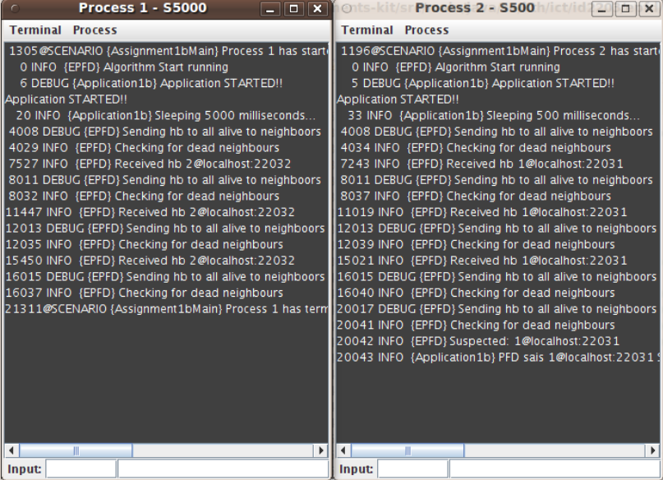

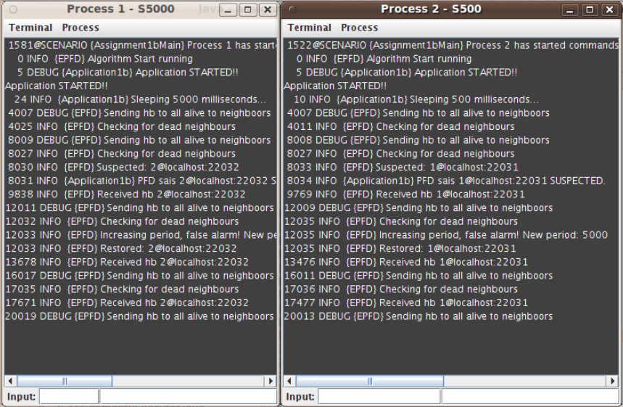

- conclusions

Our test showed that the algorithm and the implementation of the EPFD in the specific test cases are not that good. What is happening is that after the 1st stabilization of the period time, the heartbeat events keep coming every TimeDelay ms, so a second stabilization does not happen. Actually, this is not exactly a problem, because the EPFD correctly do not suspect the nodes, since they are not crashed.

Exercise 4

- experiments

We implemented the doRecover method, that is being run when a process recovers from a failure. It just prints an informational message to the logger. The topology and scenario that we used:

Topology topology1 = new Topology() {
{
node(1, "127.0.0.1", 22031);
node(2, "127.0.0.1", 22032);
link(1, 2, 3213, 0).bidirectional();
}
};

Scenario scenario3 = new Scenario(Assignment1bMain.class) {
{
command(1, "S500:Lmsg1:S6000:X").recover("R:S500:Pmsg3:S500:X", 10000);
command(2, "S500");
}
};

With the following values of TimeDelay and Δ:
private static long TIMEDELAY = 4000;
private static long DELTA = 1000;

- Observations

The results can be seen in the following screenshot:

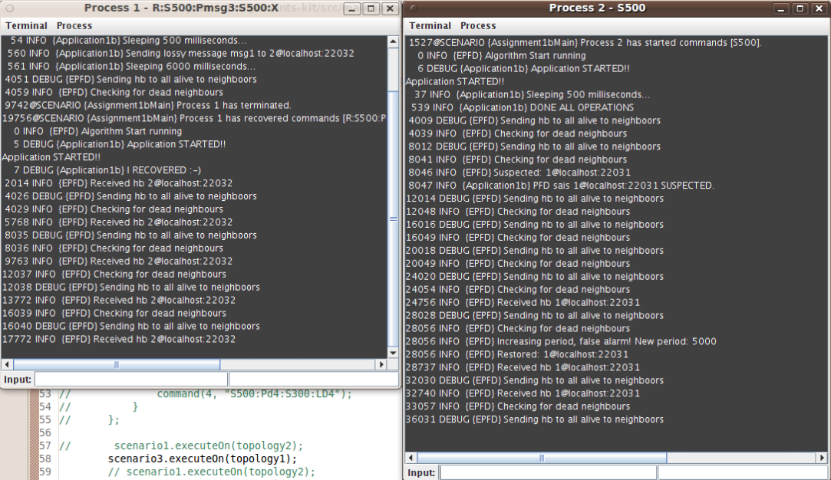

- conclusions

As we expected, the EPFD correctly suspected the process that failed. This is absolutely normal, since in exercise 2 we tested that the EPFD detected a crashed node. Moreover, we can see that after the node recovers, it starts sending heartbeats again, and the other node calls a “false alarm” about the suspected event. Finally, we can conclude that the nodes that suspect the crashed node, when this node recovers, they are not able to distinguish between a node failure and recovery, an omission failure or just if the period of checking was not set to the correct value.

