Exercise 1
Both Abortable Consensus (Algorithm 2 and Algorithm 3) and
Paxos Uniform Consensus (Algorithm 4 and Algorithm 5) use a seenIds set
to manage different concurrent instances of consensus. The seenIds set
grows indefinitely. Explain in your written report, for each algorithm in
part, how this set could be garbage collected.

Paxos Uniform Consensus
For the PUC algorithm, the garbage collection of seenIds is pretty simple. As soon as a process triggers a ucDecide, it can be sure that all processes will trigger it and, so no process will try to use this seenId again (assuming that processes increase its value before using it for a new instance of the PUC algorithm).

Abortable Consensus
In this algorithm the solution is not so intuitive. The problem is that this algorithm is used by the upper level algorithm, so not all processes can be sure that an seenId will not be reused. Our solution is:
- only discard the seenId for which a process is sending an acReturn with a non null value to the upper level. That way, the process can be sure that the upper level will never try to use this id again. This solution also lets an increasing seenIds list to most of the nodes.
- if we really want to garbage collect the seenIds to all processes, we need to beBroadcast that we acReturn a non null value to all processes (in the AC level), so they can also get rid of this seenId from their list

Exercise 2
Can PUC be used in a fail-recovery model? If so, under what
condition/assumption? If not, why?

The answer to this question is given into the paper “Consensus: the big misunderstanding form R Guerraoui, A Schiper - Proceedings of the 6th IEEE Computer, 1997 ”. Here we cite the excerpt that answer the question:

“2. The consensus problem, and the failure detectors, have been defined in a model in which processes do not recover. This simplifies the specification. Take for example a model with process recovery and a process p that crashes and later recovers. Is p a correct process? This is an important question, because the specification of the consensus problem requires that every “correct" process eventually decides. Thus, if the answer is “yes", p must eventually decide; if the answer is “no", p is not obliged to decide. However, the “crash-no recovery" model can be extended to include process recovery. Solving consensus in a “crash recovery" model using failure detectors is discussed in [14]. The solution is very close to the solution in the “crash-no recovery" model.”
[14] R. Oliveira, R. Guerraoui, and A. Schiper. Consensus in the Crash-Recover Model. Technical report, EPFL, Dept d'Informatique, July 1997.
In a nutshell: we use the fail-stop model because it is simpler. If we use a fail-recovery model, we have to use stable storage and also refine our eventual leader election algorithm so that it takes into account the processes' failures and recoveries.

Exercise 4
Construct a topology with 2 processes. Assign link delays and
initialize ELD period and increment in such a way that the two processes
that initiate concurrent PUC proposals abort at least once in AC. Present
the topology, the ELD parameter (Timedelay) and the operation sequences
(ops) of the two processes and explain the execution.

The values used are:
Topology topologyQ4 = new Topology() {
{
node(1, "127.0.0.1", 22031);
node(2, "127.0.0.1", 22032);
defaultLinks(1800, 0);
}
};

Scenario scenarioQ4 = new Scenario(Assignement4Main.class) {
{
command(1, "P1-12:W");
command(2, "P1-100:W");
}
};

private static long delta = 1000;
private static long timeDelay = 1000;

The resulting execution was:
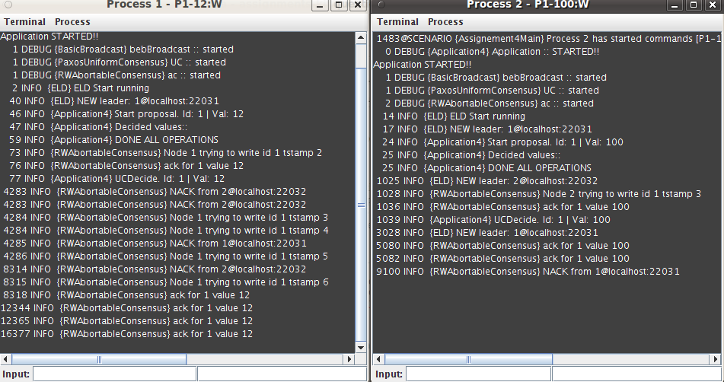

Explanation
- The nodes start concurrent consensus requests for the same id.
- Because of the timing delays we chose, the eld of the process 2 makes a false alarm for node 1, and elects process 2 as a leader.
- The algorithms prerequisites are not correct in this specific moment since we do not have majority of correct processes. Each node is considering itself as leader and ACK its request, resulting that the two nodes, accept their own proposal.

