Question 2
Here are the topology and scenario used:

Topology topology3 = new Topology() {
{
node(0, "127.0.0.1", 22031);
node(1, "127.0.0.1", 22032);
node(2, "127.0.0.1", 22033);
defaultLinks(1000, 0);
}
};

Scenario scenario4 = new Scenario(Assignement3bMain.class) {
{
command(0, "S500:W5:R:S5000:R:S30000");
command(1, "S500:W6:R:S5000:R:S30000");
command(2, "S500:R:S500:R:S10000", 15000);
}
};

This is a screenshot from the execution:
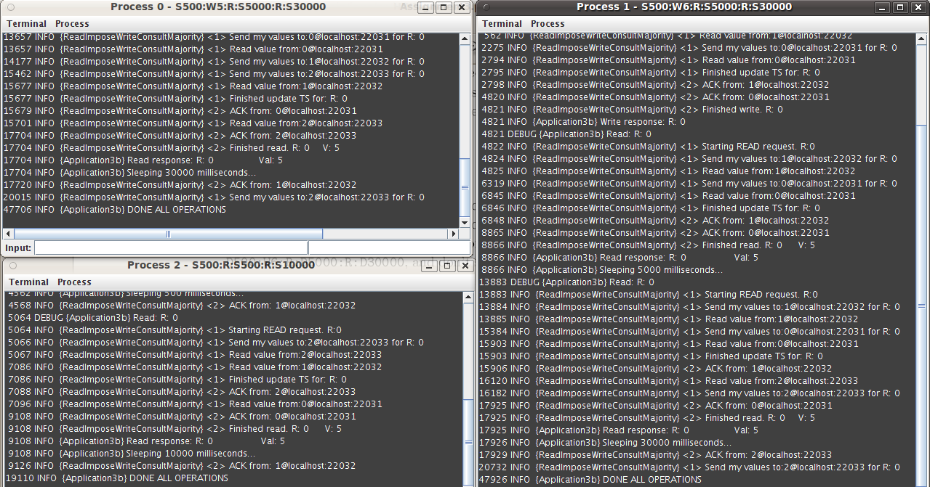

What is the value read by process 3? Explain why.
The value that node 3 reads is 5, that is the value that node 0 wrote. This is absolutely normal since in this specific scenario node 0 and node 1 were trying almost concurrently to write in the register and the process priority mechanism was used in order to “decide” on which node's value would be written. Since node 0 has higher priority than node 1, it was its value written in the register.

Can RIWCM be used in a fail-recovery model?
Yes, RIWCM can be used with a fail-recovery model with no problems. This is because before a node does an operation, it first retrieves the sequence number for doing the operation from the other nodes. So, if a node is dead and recovers has no difference from when a node is having an old sequence number for some reason! Of course, we assume that when the nodes reinitializes after a recovery, the value that it gets are the same with the values when it initializes for first time.

Question 4

Case 1
Linearization: W0(v0) → W1(v1) → R1 → W2(v2) →R1 → R0 → R2 → R0 → R2

Achieved with the following topology and scenario:
Topology topologyEx4_1 = new Topology() {
{
node(0, "127.0.0.1", 22031);
node(1, "127.0.0.1", 22032);
node(2, "127.0.0.1", 22033);
link(0, 1, 1000, 0).bidirectional();
link(0, 2, 2000, 0).bidirectional();
link(1, 2, 1750, 0).bidirectional();
}
};

Scenario scenarioE4_1 = new Scenario(Assignement3bMain.class) {
{
command(0, "S500:Wv0:R:S500:R:S8000", 200);
command(1, "S500:Wv1:R:S500:R:S8000", 100);
command(2, "S500:Wv2:R:S500:R:S8000");
}
};

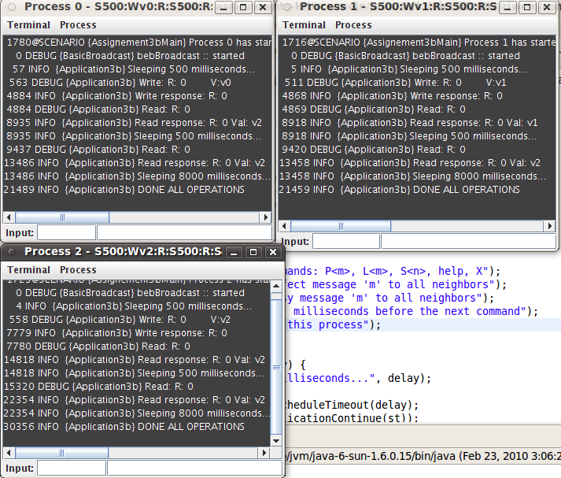

Case 2
Linearization: W0(v0) → R0 → R0 → W2(v2) →W1(v1) → R2 → R1 → R2 → R1
Achieved with the following topology and scenario:
Topology topologyEx4_2 = new Topology() {
{
node(0, "127.0.0.1", 22031);
node(1, "127.0.0.1", 22032);
node(2, "127.0.0.1", 22033);
link(0, 1, 1000, 0).bidirectional();
link(0, 2, 200, 0).bidirectional();
link(1, 2, 1750, 0).bidirectional();
}
};

Scenario scenarioE4_2 = new Scenario(Assignement3bMain.class) {
{
command(0, "S500:Wv0:R:S500:R:S8000", 200);
command(1, "S500:Wv1:R:S500:R:S8000", 100);
command(2, "S500:Wv2:R:S500:R:S8000");
}
};

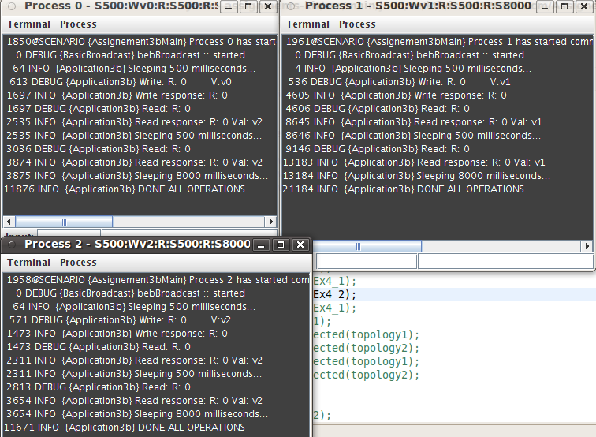

Case 3
Linearization: W1(v1) → W2(v2) → R1 → R2 → R1 → R2 → W0(v0) → R0 → R0
Achieved with the following topology and scenario:

Topology topologyEx4_3 = new Topology() {
{
node(0, "127.0.0.1", 22031);
node(1, "127.0.0.1", 22032);
node(2, "127.0.0.1", 22033);
link(0, 1, 1000, 0).bidirectional();
link(0, 2, 2332, 0).bidirectional();
link(1, 2, 123, 0).bidirectional();
}
};

Scenario scenarioE4_3 = new Scenario(Assignement3bMain.class) {
{
command(0, "S500:Wv0:R:S500:R:S8000", 200);
command(1, "S500:Wv1:R:S500:R:S8000", 100);
command(2, "S500:Wv2:R:S500:R:S8000");
}
};

