Architecture of Platform

JADE

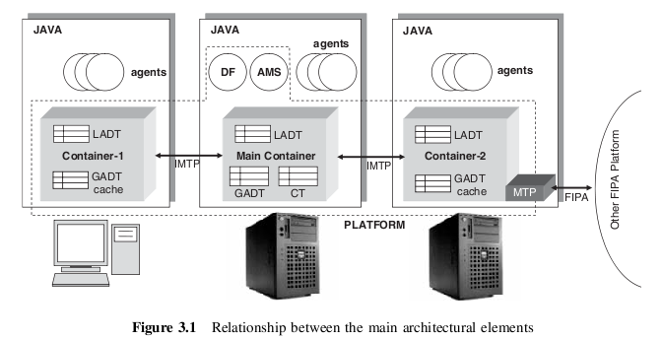
A JADE platform is com-

posed of agent containers that can be distributed over the network. Agents live in containers which

are the Java process that provides the JADE run-time and all the services needed for hosting and

executing agents. There is a special container, called the main container, which represents the

bootstrap point of a platform: it is the first container to be launched and all other containers must

join to a main container by registering with it.

The programmer identifies containers by simply using a logical name; by default the main

container is named ‘Main Container’ while the others are named ‘Container-1’, ‘Container-2’, etc.

Command-line options are available to override default names.

As a bootstrap point, the main container has the following special responsibilities:

- Managing the container table (CT), which is the registry of the object references and transport

addresses of all container nodes composing the platform;

- Managing the global agent descriptor table (GADT), which is the registry of all agents present

in the platform, including their current status and location;

- Hosting the AMS and the DF, the two special agents that provide the agent management and

white page service, and the default yellow page service of the platform, respectively.

TRYLLIAN

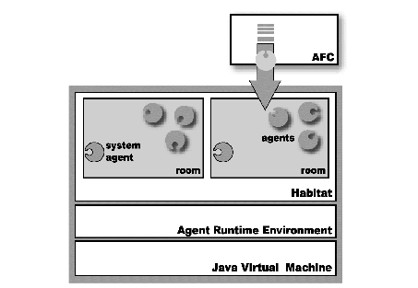

Two of the most important components of the AGENT RUNTIME ENVIRONMENT (ADK) are the AGENT FOUNDATION CLASSES (AFC) and the AGENT RUNTIME ENVIRONMENT (ARE). Most
developers will interact with the AFC to construct their agents. The AFC encapsulates
all the functionalities of the ARE and therefore you will normally not need to use the
ARE directly. When you want create functionalities that are not provided by the AFC,
you will then directly interact with the ARE.

The Tryllian ADK allows application programmers to define all of the components
that are required to build an agent-based application. The AFC is the interface layer
and contains all interfaces and classes needed to interact with the agent-based
elements. All of the API’s that are seen by the developer can also be found here.
An important part of understanding the development kit is the use of the
communication protocols. The ADK provides some easy to use tasks that
make the actual language used extremely simple.

Services provided by Platform

JADE
Jade platform provides the following services:
- Message Transport Service (MTS): The MTS is a service provided by an AP to transport FIPA-ACL messages between agents on any given AP and between agents on different APs. Messages
are providing a transport envelope that comprises the set of parameters detailing, for example, to
whom the message is to be sent.

- Directory Facilitator (DF) : The DF is an optional component of an AP providing yellow pages services to other agents. It maintains an accurate, complete and timely list of agents and must
provide the most current information about agents in its directory on a non-discriminatory basis to
all authorized agents. An AP may support any number of DFs which may register with one another
to form federations.

- Agent Management System (AMS): The AMS is a mandatory component of an AP and is responsible for managing the operation of an AP, such as the creation and deletion of agents, and overseeing
the migration of agents to and from the AP.

TRYLLIAN
The most important system agents, that provide services to user-agents are:

• Habitat agent : This agent allows communication with the entire habitat and also knows the addresses of all other SA
• Room agent : The room agent is the primary point of interaction for any agent.
Agents can query this agent for information on their environment (rooms,
other agents etc.).

• Transporter agent : The transporter agent is the point of interaction for an
agent that wants to move to another location.

Your personal opinion/judgment about the platform as compared to JADE.

From our short experience with these platforms, they are similar to one another. We experienced the following differences between the two platforms:
- Agent Oriented Programming (JADE) vs Task Oriented Programming (Tryllian). From our experience, the tasks that Tryllian introduces are similar (or better identical) to the behaviours that JADE has.
- You can start an agent in JADE by just specifying the parameters (if any), while in Tryllian you need to make an XML descriptor of the agent.
- The Containers in JADE are automatically created, while in Tryllian you create the Habitats (analogous with Containers) by specifying an XML descriptor.
- Tryllian has a GUI tool for deploying agents and a tool like RMA of JADE but with much more less features.
Unfortunately, we did not have enough time to work with Tryllian, but from our small experience we can conclude that we would prefer to work on JADE platform rather than on Tryllian one. The two important advantages of JADE over Tryllian are:
- Simplicity. Even if they have almost identical logic in programming (JAVA part), the creation and deployment of new agents, is significantly simpler in JADE. There is no need to create any extra files than the agent code itself. Of course, in bigger projects, the Tryllian approach, with the ability to manage the Habitats may be preferable.
- Robustness of tools. The JADE platform provides very useful GUI tools for deploying, monitoring and debugging the application. The GUI tools of Tryllian look more preliminary.

