|  |
| --- |
| Role Schema: MANUFACTURER |
| Description: Manufacturer role creates products and provides products. |
| Protocols and Activities: CreateProduct, ProvideProducts, AwaitRequest |
| Permissions: **reads supplied** orderDetails //reads request for availableproducts  **geneates** productsList **//** generates list of available products |
| Responsibilities:Liveness: Manufacturer=(CreateProduct)ω||(AwaitRequest.ProvideProducts )ω Safety:  * **true** |

|  |
| --- |
| Role Schema: INVENTORY |
| Description: Inventory keeps list of available products. |
| Protocols and Activities: AvailabilityRequest, ProvideProductsAvailability, ReadProductsOrder, GetProducts, UpdateProductsList |
| Permissions: **reads supplied** productsOrder //reads products  **supplied** newProductsList //reds new products list  availableProducts //reads currently available items  **changes** availableProducts //updates list of available items  **geneates** availableProducts //initially generates list of available //products |
| Responsibilities:Liveness: Inventory = (AvailabilityRequest . ProvideProductsAvailability )ω ||[ReadProductsOrder.GetProducts .UpdateProductsList] ω Safety:  * infoAvailable(availableProducts) |

|  |
| --- |
| Role Schema: PRICING |
| Description: Pricing role tells a price of a selected product. |
| Protocols and Activities: ICNPResponce, checkProductAvailability, calculatePrice |
| Permissions: **reads supplied** productAvailability //checks product availabilty  **geneates** productPrice **//** generates price for a given product |
| Responsibilities:Liveness: Pricing=( checkProductAvailability. calculatePrice. ICNPResponce)ω Safety:  * productsAvailable=0→ price=null |

|  |
| --- |
| Role Schema: SHOPPING |
| Description: Moves to the shop place, gets the best price possible, returns back to the starting location announcing the best price found |
| Protocols and Activities: Initialize, MoveToLocation, ICNPInitiate, ICNPAcceptProposal, MoveBack, AnnounceResults |
| Permissions: **reads** **supplied**  specificRequest //the requirements for the request and //specifically the target price and location  **updates** currentLocation //the location in which it resides  currentOffer //the offer that is currently negotiating  **generates** bestOffer //the best offer found |
| Responsibilities:Liveness: Shopping = (Initialize . MoveToLocation . ICNPInitiate . ICNPAcceptProposal .MoveBack . AnnounceResults)ω Safety:  * infoAvailable(specificRequest) * currentLocation != null |

|  |  |  |  |
| --- | --- | --- | --- |
| ICNPInitiate | |  |  |
| SHOPPING | PRICING |  |  |
| SHOPPING sends cfp message with maxPrice and receives responses | |  | ProposedPrice |

|  |  |  |  |
| --- | --- | --- | --- |
| ICNPResponse | |  |  |
| PRICING | SHOPPING |  | ProposedPrice |
| PRICING sends response on the given price | |  | Responses |

|  |  |  |  |
| --- | --- | --- | --- |
| ICNPAcceptProposal | |  |  |
| SHOPPING | PRICING |  | Responses |
| SHOPPING decide to accept proposal and informs PRICING | |  | AcceptProposal |

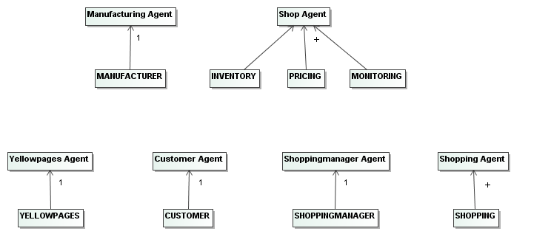

|  |  |  |  |  |  |
| --- | --- | --- | --- | --- | --- |
| Agent | Service | Inputs | Outputs | Pre-condition | Post-condition |
| Manufacturing Agent | Product creation | null | Product | True | Product ≠null |
| Manufacturing Agent | Provide products list | Avilability request | Products List | Avilability request ≠ null | Products List ≠ null ∧ Product ∈ Products List |
| Shop Agent | Price calculation | Product Availability | Product Price | Product Availability≠null ∧  Product availability>0 | Product Price≠null |
| Shop Agent | Check of product availability | Product Name | Product Availabiliy | Product Name≠null | Product Availabiliy ≠null |
| Shop Agent | ICNPResponce | Proposed Price | Response to proposed price | Product availability>0 | Response to proposed price≠null |
| Shop Agent | Update Products List | null | Products List | True | Products List ≠ null |

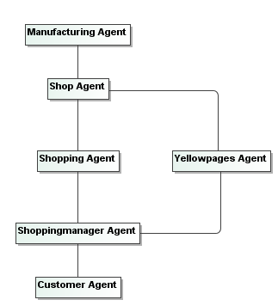

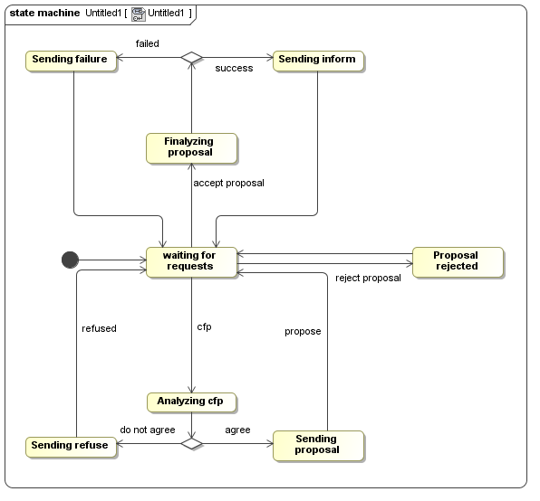

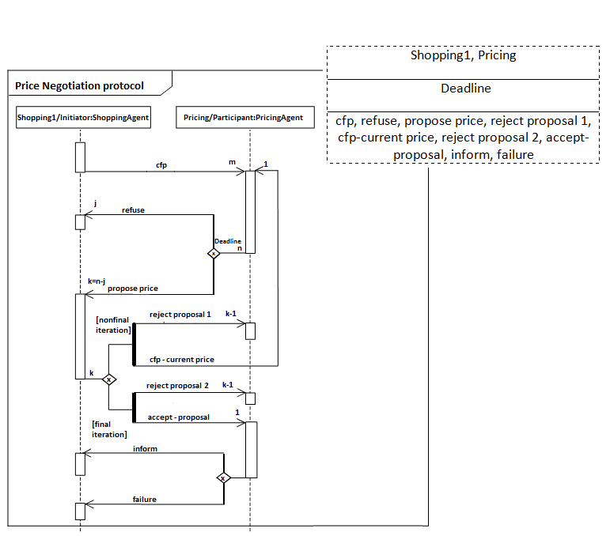

|  |
| --- |
| Shopping1, Pricing |
| Deadline |
| cfp, refuse, propose price, reject proposal 1, cfp-current price, reject proposal 2, accept-proposal, inform, failure |

