Utiliser le langage naturel pour controler l’Internet des Objets

Mycroft, une Intelligence Artificielle pour tout le monde
Note: La campagne originale a été financée à hauteur de 127% (127 500 $) avec 1.120 bailleurs sur la plateforme Kickstarter. C’est avec un tel support solide que nous avons décidé de poursuivre la campagne afin que nous puissions développer et envoyer notre module d’extension caméra. Ce module donnera à Mycroft la capacité de voir son environnement et mieux interagir avec les utilisateurs.
L’intelligence artificielle est ici. Voitures autonomes, traitement du langage naturel et un nouveau champion de Jeopardy - le tout vous étant apporté par les miracles de l’Intelligence Artificielle. Mais aussi importante qu’est l’I.A. pour notre avenir, il est du domaine privé de grandes entreprises. Plus maintenant.
Voici Mycroft
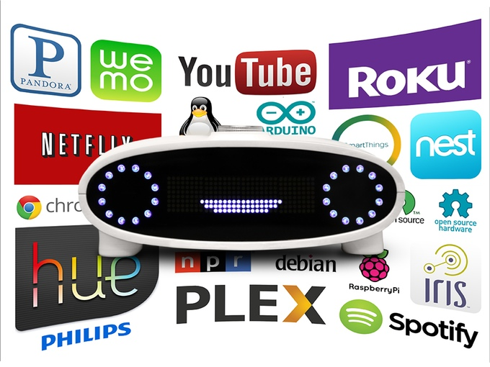
Mycroft est la première plateforme d’AI domestique open source et open Hardware du monde. Il est l’état de l’art de l’I.A. basé sur Raspberry Pi 2 et Arduino - deux des plateformes de développement ouvertes les plus populaires au monde.
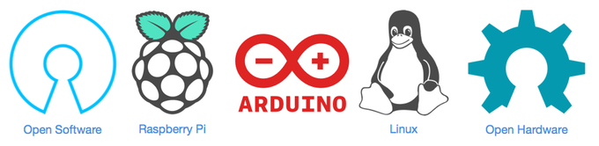
Mycroft utilise le traitement du langage naturel pour répondre à votre voix. Il rend les services en ligne comme YouTube, Netflix, Pandora, Spotify et autres disponibles instantanément. Pas besoin de sortir son smartphone, de se connecter, de sélectionner un réseau, de charger une application et de traquer une fonctionnalité. Vous voulez entendre de la bonne musique ? Dites « Mycroft, joue ‘Uptown Funk’ à partir de YouTube sur mon Chromecast » et quelques secondes plus tard, votre vidéo commence.
Ce n’est pas seulement pour les appareils de streaming. Mycroft a un haut-parleur intégré de haute qualité. Il peut jouer directement la musique. Il suffit de demander à Mycroft de jouer votre playlist préférée Pandora, de se détendre et de profiter de vos morceaux.
Mycroft s’intègre également avec vos appareils intelligents et vous permet de contrôler l’Internet des Objets. Connectez Mycroft à votre concentrateur SmartThings, aux dispositifs WeMo ou aux lampes Phillips Hue et commandez vos appareils avec le son de votre voix. Allumer les lumières, verrouiller les portes, faire du café, arroser les plantes aquatiques et nourrir les animaux domestiques. Quoi que ce soit - Si il est connecté à Internet - Mycroft peut le contrôler.
Mycroft est une plateforme matérielle en open source et open hardware. Elle permet aux développeurs, makers et bricoleurs d’explorer leurs propres idées. Vous voulez que Mycroft puisse poster sur votre compte Facebook ? Contrôler un Roomba ? Démarrer votre imprimante 3D ? Vous pouvez le faire. La communauté incluera une documentation complète sur le matériel à l’intérieur Mycroft et sur le logiciel qui le fait tourner. Et puisque le noyau de Mycroft est un Raspberry Pi 2 et que son affichage est alimenté par Arduino, il ya déjà des milliers de tutoriels, Instructions et kits de projets disponibles de sorte que vous pouvez le personnaliser pour répondre à vos besoins.

Vu sur
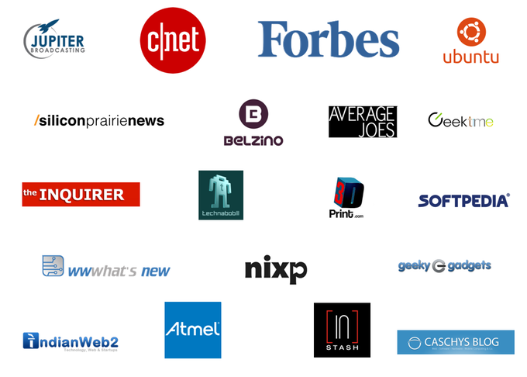

Le but
L’équipe de Mycroft est composé d’entrepreneurs expérimentés comprennant les besoins capitaux significatifs d’une société de technologie. Notre demande de financement ne concerne pas tout ce qui est nécessaire pour fabriquer des moules, acheter des composants, assembler les unités, développer complètement les logiciels et déployer notre infrastructure cloud. L’objectif lors de cette campagne Indiegogo n’est de ne pas financer entièrement leurs efforts.
A la place, l’équipe de Mycroft demande de prouver qu’il ya une communauté qui veut voir une solution d’intelligence artificielle open source. Son équipe de professionnels chevronnés a déjà fait un investissement financier non négligeable dans la technologie de Mycroft. Avec du soutien, ils prévoient de continuer à investir pour faire de Mycroft une alternative open source viable aux IAs propriétaires.

Perturber l’Intelligence Artificielle
Mycroft is poised to shake up the AI market in three ways.
Affordable - Mycroft is priced at only $129 per unit, which makes it affordable enough to install 100% coverage in your home or office.
Open source- Our disruptive pricing is possible because we are using open hardware. Mycroft's core components are a Raspberry Pi 2 and an Arduino compatible micro-controller. This provides our project with economies of scale right out of the box.
Open API - Mycroft uses a variety of open APIs to process language, determine intent and obtain results. Since much of Mycroft's processing is performed in the cloud by open APIs, we don't have to develop our own deep learning neural network. This dramatically reduces our cost and simultaneously improves accuracy and usability.
Mycroft has a lot of native skills and abilities baked in and, since it is open source, it allows outside developers to add more features over time.
Play Media. Play from a variety of sources on a variety of players.

Internet of Things Support. Supported Platforms

If This Then That. User can select Mycroft as a source/destination to manipulate Facebook, Twitter, etc.

Internet of Things Scene. Mycroft can manipulate a group of IoT devices at one time, or what we call "creating a scene." For example, the "Lock up" scene might turn off all of the lights, lock the door and shut off any music or media.
Create Voice Channel. Mycroft can create a voice channel between two units. This creates an on demand intercom link between two rooms.
Announce. If there are several Mycroft units in an installation, one unit can create an announcement that is played on all of the units.
Record. Mycroft can record audio. Recordings are uploaded to your preferred cloud storage for later retrieval. To let folks know it is recording Mycroft periodically beeps softly.
Calendar. Mycroft can read either Google Calendar or iCal.
Twitter. Mycroft can tweet for you.
Alarm Clock. Mycroft can act as an alarm clock and perform behaviors such as scenes, news, weather, etc. at certain times.
Reminders. Mycroft can repeat a reminder phrase to at a specified date, time.
Weather. Mycroft can give the current or future weather for a specified location.
Time. Mycroft can give the current time.
News. When asked for the news, Mycroft can play the top of the hour news from NPR or the BBC.
Stock Quotes. Mycroft can return the current price of a specified ticker symbol or company name.
Spelling. Mycroft can spell words out.
Math. Mycroft can perform simple arithmetic.
Parrot Mode. Upon entering this mode, Mycroft can repeat back whatever you say. Useful for entertaining a parrot or small child.
Exact match. Uses regular expressions to perform a shell command when an exact phrase or sub-phrase is spoken. Say the key phrase and perform any task.
Novelty. Performs search using Google, Wolfram Alpha, etc and tells knock-knock jokes.
We are happy to announce that we are partnering with Ubuntu and will be shipping with Snappy Core Ubuntu as the operating system powering Mycroft. Snappy Core Ubuntu will allow us to ship secure devices that utilize the latest and greatest containerization and app delivery technologies. Ubuntu’s parent company is changing the landscape of IoT and the cloud, and we are ecstatic to be a part of this revolution.
We will be utilizing Snappy in order to manage app installation through “Snappy Apps”, this new way of developing, distributing, and installing applications makes these processes simple and easy for both developers and end-users.
How does Mycroft compare with other voice systems? Here is a breakdown of where Mycroft stands.
Keep in mind that though the process below looks complex, it all takes place in just a few seconds.
1.) Mycroft listens for its name. When an end user says “Mycroft,” it listens for a command or question. If it doesn’t get one, it beeps softly to prompt you.
2.) Once it has received a command Mycroft connects to your home router through WiFi or Ethernet.
3.) Mycroft sends the command or question to the cloud.
4.) The cloud sends the audio to two or more online application interfaces (APIs) that translate speech to text (STT).
5.) The STT APIs respond with a text translation of the audio phrase.
6.) The Mycroft cloud compares the results and selects the best one based on past performance, response time and other factors.
7.) The text translation is sent to at least two artificial intelligence APIs.
8.) The artificial intelligence APIs respond with a data structure that translates the text into intents, objects, entities, contexts and other categories.
9.) The Mycroft cloud combines the data structure with the user’s profile information and sends the information back to the Mycroft unit.
10.) The Mycroft unit uses the data structure to select the appropriate action.
11.) Mycroft performs the action.
Ryan Sipes - CTO A long time open source software developer Ryan has contributed to the Solus Project, GtK, DuckDuckGo and many others. He is a former systems administrator for the Northeast Kansas Library System. Ryan has extensive experience with data center management including the construction and maintenance of high availability virtualization systems.
Joshua Montgomery - CEO One of the few entrepreneurs in the United States to build a gigabit fiber network from scratch, Joshua brings more than 15 years of entrepreneurial experience to the Mycroft project. Joshua’s previous project, Wicked Broadband, has been featured in Wired, ArsTechnica and Forbes. He is a firm supporter of the open source movement committed to an open future for AI.
Kristie Adair - CFO With more than 10 years of experience as a financial controller, Kris brings the Mycroft project expertise in financial planning, budgeting and accounting. In addition to her duties at Mycroft, Kris serves on the USD497 school board and is the director of the Lawrence Center for Entrepreneurship, a facility dedicated to helping entrepreneurs achieve success.
Derick Schweppe - Design Lead Derick is an industrial design instructor at the University of Kansas Department of Design where he shares his passion for design with talented students. Derick’s portfolio is filled with projects that help people develop emotional connections to the products they use every day. His talents are responsible for giving Mycroft both form and functionality.
Alejandro Seoane - Web Presence Lead Mycroft’s web presence is as important as its voice. Alejandro is responsible for making Mycroft’s online tools attractive and customer friendly. Alejandro takes great pride in developing unique concepts that are both visually appealing and easy for visitors to navigate.
Terry Manies - Communications Lead With over 15 years experience as a professional communicator, Terry is responsible for ensuring that Mycroft’s communications make sense. Terry is a communications professional who has worked in a variety of corporations and colleges including the University of Minnesota, University of Kansas, Northwest Missouri State and Baker University.
Zachary Spears - Video Production Lead Zachary Spears is an up and coming young film maker. Among his many projects is his work on the film Jayhawkers by Kevin Wilmott. His enthusiasm for all things film is both contagious and endearing. Zach’s job is to help the team communicate the creativity and utility of the Mycroft platform by producing high quality videos and stills.
We ship Mycroft units anywhere in the world. Any costs associated with international shipments over $20 will be billed to the supporter before shipment.
Shipment within the US and Canada will be billed at a flat rate of $10.
Risks and challenges
No one has built a stable, useful, home AI platform before. Until recently an AI for your home was science fiction. We believe strongly that the best approach to solving this problem is to leverage the power of the open source community.
Our team of engineers, designers and developers have already spent months working on Mycroft. We’ve come a long way from our original voice recognition loop and are getting very accurate results from the cloud. Our AI integration is top notch and 95% of the commands Mycroft is processing are coming back with match probabilities in excess of 90%. We have gone through dozens of software and hardware Revisions and multiple 3D printed enclosures. We’ve done our best to mitigate any risk to putting Mycroft in your hands and are working to deliver exceptional hardware and software.
That said, there are no guarantees in this life. Though we’ve got the skills, experience and drive to make Mycroft happen, we may not have anticipated all of the future roadblocks. We can’t promise that the system will ship on time or that all of the planned features will be available on day one. The software is in alpha and it is working well, but we expect some challenges as we scale it up.
What we can promise is that we’ll be transparent, honest and above all: open. At the end of this project the open source world will have Mycroft’s source code and access to modify, fix, tweek, hack and re-distribute Mycroft. On the hardware side anyone will be able to 3D print an enclosure, order one from Shapeways or make one from scratch. The display board uses COTS components and can be assembled using parts from Mouser.
We are committed to the open source philosophy and are excited to bring this project to you.

