**Part 2.(b) Analyzing Your Own Code**

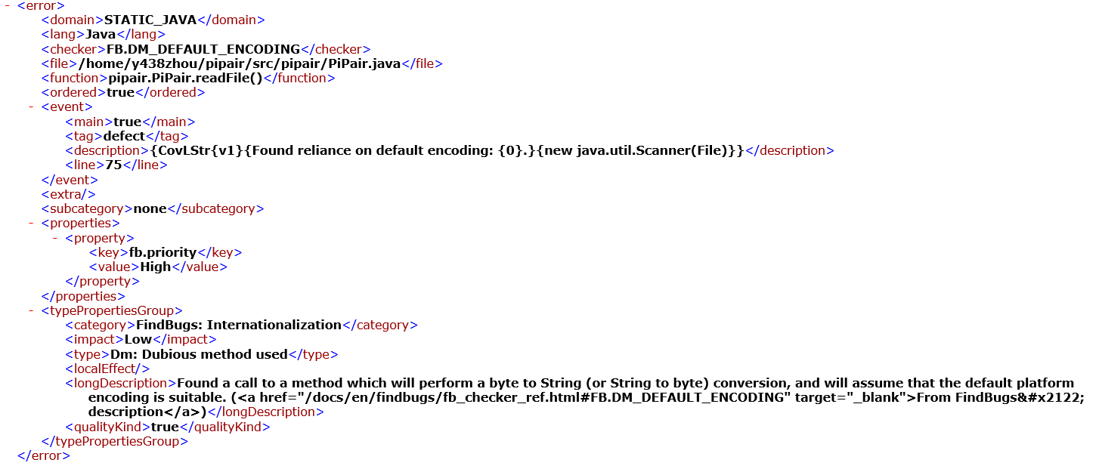

Fig

Fig shows the error outputs of our analysis with Findbugs. One bug was found in the type of Dubious method used occurring in line 75, referring to the findbugs.errors.xml file in the output folder:

75 Scanner scanner = new Scanner(file);

The description states finding a call to a method which will perform a byte to String (or String to byte) conversion, and will assume that the default platform encoding is suitable. When constructing a new Scanner for a specified file source and generates values by scanning, bytes from this file will converts into characters through the underlying platform's default character set. So it is taking risk with underlying messy code.