BALUYOT Winchester C.

2- ECE -D

Problem 1

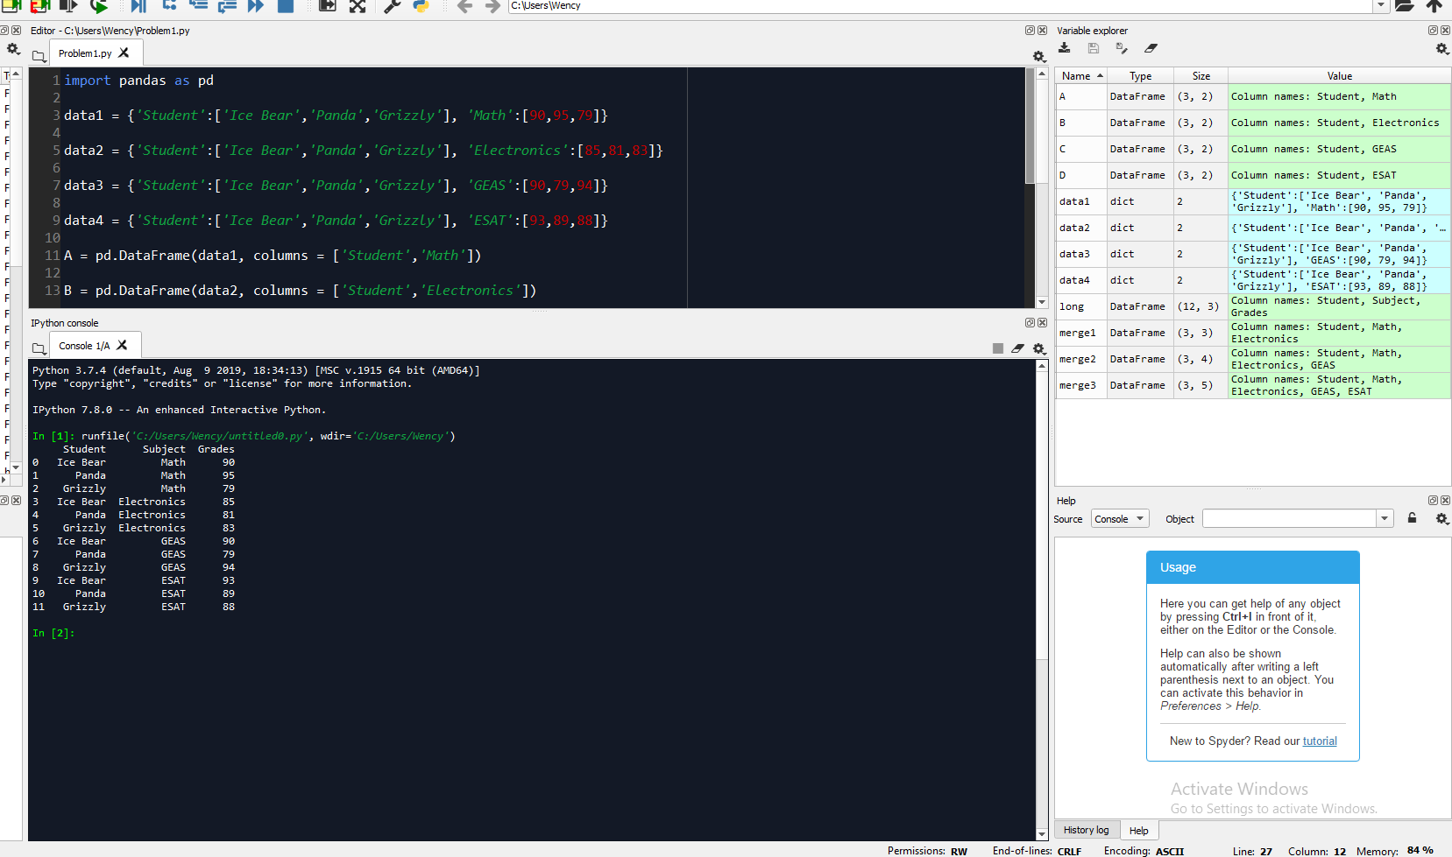

Problem 2

