BALUYOT WINCHESTER C.

2-ECE-D

PROBLEM 1

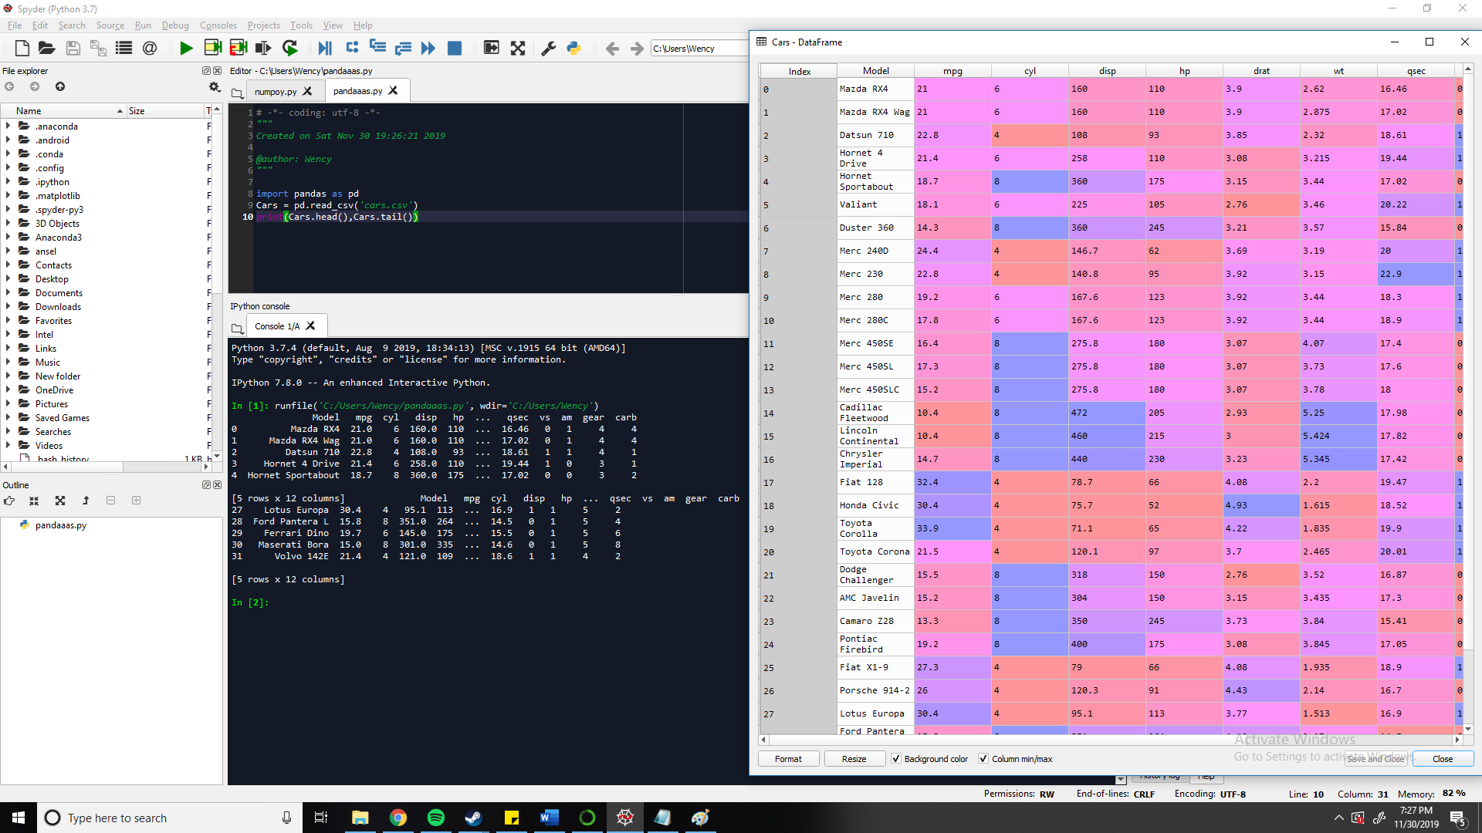

PROBLEM 2

