* Differentiate between the 6 discrete phases of mineral resource development

Geoscience, Exploration, Discovery, Development, Production and Reclamation

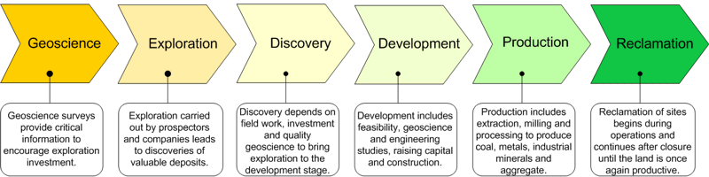

A mineral occurrence or mineral showing is a concentration of a mineral commodity (such as gold, silver, or diamond) that is considered valuable by someone, somewhere, or that is of scientific or technical interest.

A mineral deposit is a mineral occurrence or showing of sufficient size and grade (concentration) that is worthy of further exploration in order to define its true extent.

An ore deposit is a mineral deposit that has been tested and is known to be of sufficient size, grade, and accessibility to be mined at a profit. Testing commonly consists of surface mapping and sampling, as well as drilling through the deposit

* Define tonnage and grade, and how to use them to determine the total metal content of a deposit

- tonnage, or total number of tons

-The grade, or concentration, of the deposit describes the richness of the ore and is often reported as a weight of commodity "per ton of rock"

* Differentiate between a mineral resource and a mineral reserve

 -If there are enough results to roughly quantify the amount of ore in the ground (the 'resource'), the system acquires the classification of 'inferred mineral resource'.

- indicated mineral resource (we are confident there is 'this much', looks good so let's plan a mine)

- measured mineral resource (we know how much is here, there and there, looks good so let's design the mine workings)

- Resources of the measured and indicated status contribute to the overall 'probable' mineral reserve, while only the measured resources can be tabulated within the 'proven' mineral reserve.

* Differentiate between open pit, underground and placer mining activity

-In open pit mining, a large hole is mined and the material extracted. Easy to remove overburden and waste rock

- cheaper than underground, can get lower grade ores

- Bingham, Utah - one of the deepest (1.2km)

- Crush ores into smaller pieces (onsite or off), then  leaching, flotation, dewatering, and drying circuits before being sent to a smelter.

- Underground mining is more appropriate for ore deposits that are not close to surface, have complex geological geometries, and typically of higher grade.

- remove less waste rock by creating a network of underground ramps (called declines) and tunnels (called adits and drifts) to reach the ore bodies.

- crushing done underground mostly

- TauTona located in South Africa, reaches almost 4 km from the surface! Its network of tunnels stretch more than 800 km!

- Diavik Diamond mine - combined underground and open

* Differentiate between primary and secondary mineral deposits

- alluvial deposits involve river action,colluvial deposits involve movement only by gravity (such as on a hillside), and eluvial deposits involve primarily *in situ* weathering

- In the case of diamonds, the kimberlite would be the primary source rock and the alluvial river gravels that contain the concentrated diamonds would host the secondary placer deposit

- A typical sluice box has one or more metal troughs, or runs, with cross bars on the bottom, called riffles. As the water passes over these riffles, little whirlpools are created behind each riffle, and the denser gold particles fall to the bottom.

* Describe mining activity at the Diavik Diamond Mine in the Northwest Territories

- Diamond

* Locate major mining activity in Canada and British Columbia

Coal

* Be able to navigate a news release from a Canadian mining or exploration company