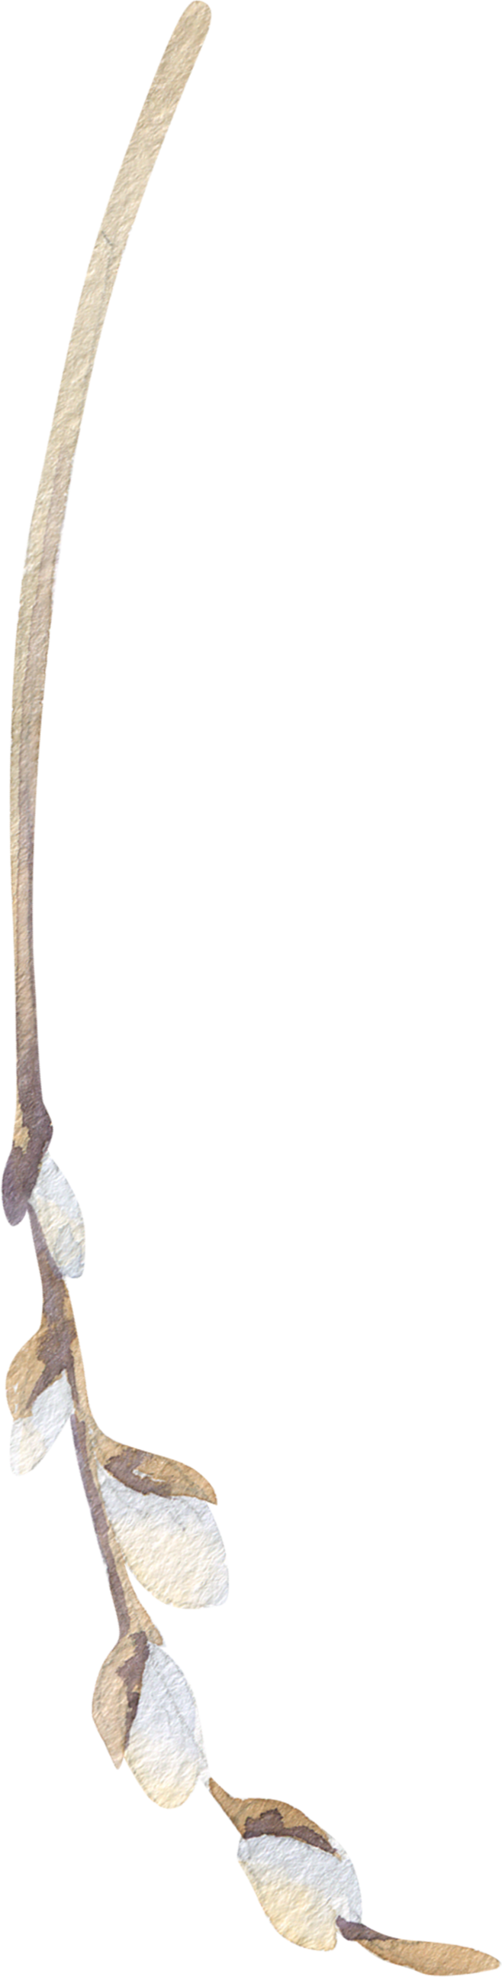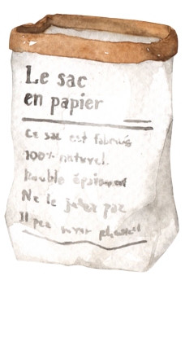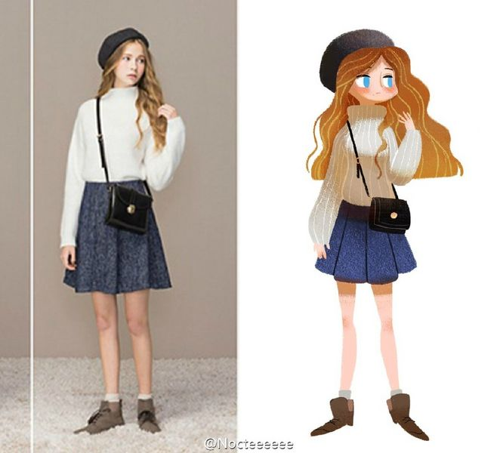

02

01

香樟は日を遮って、薄い緑のセミの翼の下にある。単車の裏座から近づいてくる。

香樟は日を遮って、薄い緑のセミの翼の下にある。単車の裏座から近づいてくる。

What is the probability of high school girls living together with those who have just confessed to being rejected? What is the probability of high school girls living together with those who have just confessed to being rejected? What is the probability of high school girls living together with those who have just confessed to being rejected? What is the probability of high school girls living together with those who have just confessed to being rejected?

**「旅行的意义」**

如果我去旅行；我要去哪里旅行？我为什么要旅行？我旅行的意义是什么？

旅行的地点，如果我去园林，我真的喜欢吗？如果去博物馆，旅行过后，我得到了什么？如果我去海边，我更愿意一个人感受大海。如果我去草原，我也想一个人享受辽阔。或许，我更愿意一个人背上行囊，去自己想去的地方。