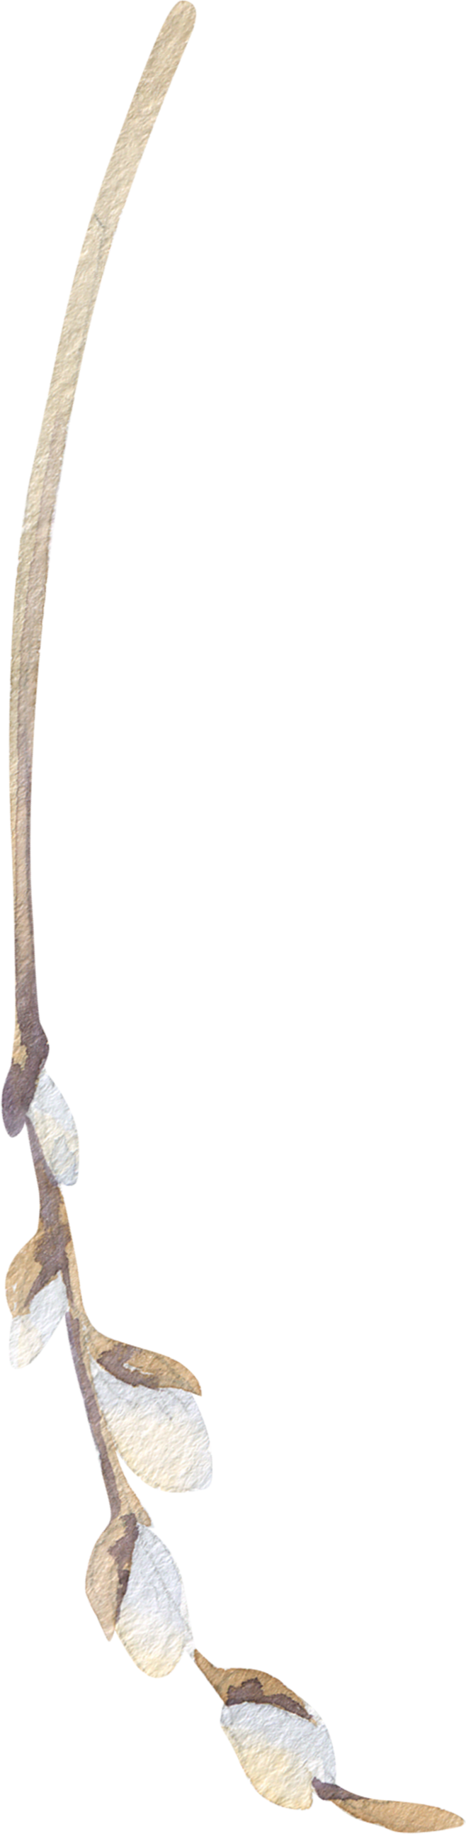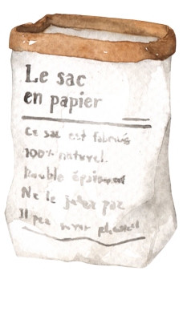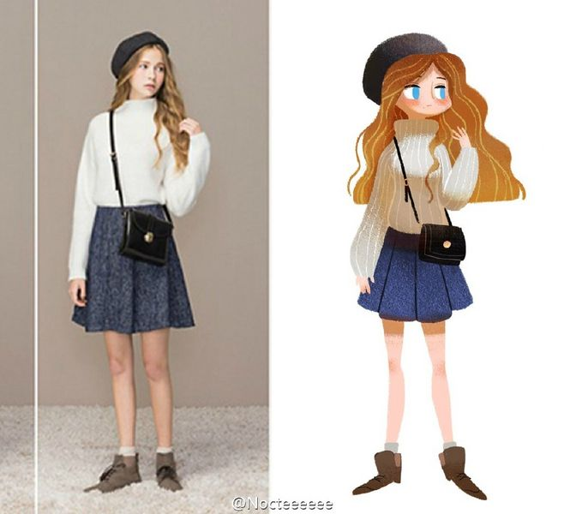

02

01

香樟は日を遮って、薄い緑のセミの翼の下にある。単車の裏座から近づいてくる。

香樟は日を遮って、薄い緑のセミの翼の下にある。単車の裏座から近づいてくる。

What is the probability of high school girls living together with those who have just confessed to being rejected? What is the probability of high school girls living together with those who have just confessed to being rejected? What is the probability of high school girls living together with those who have just confessed to being rejected? What is the probability of high school girls living together with those who have just confessed to being rejected?

**「联系与表达」**

现在我们，已经是25岁的成年人。如果想和某位女性建立联系，应该以成年人的相处方式。关于联系的建立，我不习惯说“我喜欢你”，要我去说的话我只想说“我想和你建立联系”。但说完之后呢？便是相处，应该如何相处呢？可能我喜欢的是一起读书、一起跑步、一起爬山。或许熟了之后再一起喝酒、还有我希望有一些距离和个人空间。