Lecture05作业

1.For the z-direction wind velocity time history calculate:

【matlab程序代码】

simData=load("zDirData.mat");

U = simData.U;

V = simData.V;

W = simData.W;

X = simData.X;

Y = simData.Y;

Z = simData.Z;

dt = simData.dt;

clear simData;

(1)Mean velocity profile (calculate the U-components u,v, and w)

U_mean=[mean(U(1,:));mean(U(2,:));mean(U(3,:));mean(U(4,:));mean(U(5,:))];

V_mean=[mean(V(1,:));mean(V(2,:));mean(V(3,:));mean(V(4,:));mean(V(5,:))];

W_mean=[mean(W(1,:));mean(W(2,:));mean(W(3,:));mean(W(4,:));mean(W(5,:))];

输出结果（1-5号点u-v-w）：

26.9719 34.3335 38.4046 41.3394 43.6724

-0.1761 -0.1875 -0.1811 -0.1668 -0.1562

-0.0436 -0.0414 -0.0337 -0.0200 -0.0051

【Target turbulence characteristic】

【程序代码】

Uavgr=50*(Z(1,:)./160).^0.22

【输出结果】

Ans=

27.1684 34.5964 38.7112 41.6855 44.0552

1. Turbulence intensity profiles (calculate the fluctuating velocity components u,V, and w)

【matlab程序代码】

%标准差计算

sigma_U=[std(U(1,:));std(U(2,:));std(U(3,:));std(U(4,:));std(U(5,:))];

sigma_V=[std(V(1,:));std(V(2,:));std(V(3,:));std(V(4,:));std(V(5,:))];

sigma_W=[std(W(1,:));std(W(2,:));std(W(3,:));std(W(4,:));std(W(5,:))];

%湍流强度计算

Iu=sigma_U./U_mean;

Iv=sigma_V./V_mean;

Iw=sigma_W./W_mean;

输出结果（1-5号点u-v-w方向湍流强度）：

0.2313 0.1855 0.1649 0.1500 0.1405

-27.2954 -26.3194 -26.8667 -28.7917 -30.2487

-76.9103 -80.6938 -99.1559 -169.5059 -680.0640

【Target turbulence characteristic】

【程序代码】

Iuz=0.23*(Z(1,:)./10).^(-0.22);

Ivz=0.78*Iuz;

Iwz=0.22*Iuz;

Iuvw_z=[Iuz;Ivz;Iwz]

【输出结果】

0.2300 0.1806 0.1614 0.1499 0.1418

0.1794 0.1409 0.1259 0.1169 0.1106

0.1265 0.0993 0.0888 0.0824 0.0780

(3)Wind power spectral density(select one point and calculate the fluctuating velocity

(components u, v, and w)

【matlab程序代码】

%功率谱计算

N=length(U(1,:));

U_magnitude=abs(fft(U(1,:)));

E_spectrumU=U_magnitude.^2;

V_magnitude=abs(fft(V(1,:)));

E_spectrumV=V_magnitude.^2;

W_magnitude=abs(fft(W(1,:)));

E_spectrumW=W_magnitude.^2;

(4)Probability density curve(select one point,calculate the fluctuating velocity

【matlab程序代码】

%概率密度计算

pdf_value=normpdf(U(1,:),U_mean(1),sigma_U(1));%选择（0,0,10）处U方向计算概率密度

plot(U(1,:),pdf_value);%画概率密度曲线

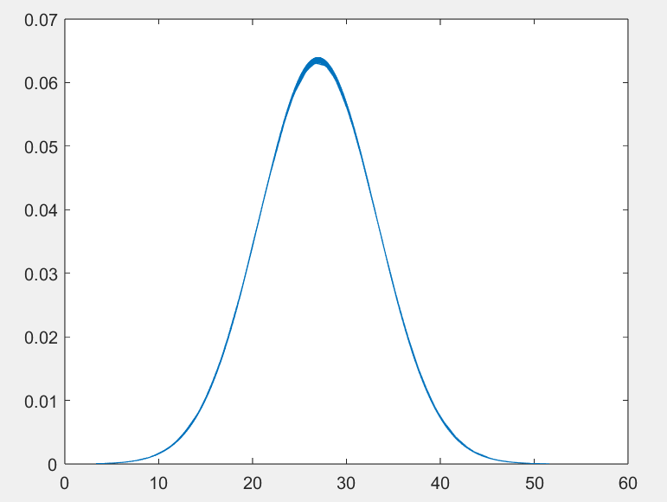

图1 1号点U方向概率密度曲线

For they-direction wind velocity time history. calculate:

(1) Spatial correlation coefficient in the y-direction (using the first point as the reference

point, calculate the fluctuating velocity components u, v, and w)

【matlab程序代码】

simData=load("yDirData.mat");

U = simData.U;

V = simData.V;

W = simData.W;

X = simData.X;

Y = simData.Y;

Z = simData.Z;

dt = simData.dt;

clear simData;

%计算标准差

sigma_U=[std(U(1,:));std(U(2,:));std(U(3,:));std(U(4,:));std(U(5,:))];

sigma_V=[std(V(1,:));std(V(2,:));std(V(3,:));std(V(4,:));std(V(5,:))];

sigma_W=[std(W(1,:));std(W(2,:));std(W(3,:));std(W(4,:));std(W(5,:))];

%计算（0,0,50)和（0,20,50）即1号点和2号点的相关性

cov_12=cov(U(1,:),U(2,:));

disp(cov_12)

输出结果：

40.0961 28.1982

28.1982 39.0200