**Father-Son Fishing Adventure**

Game Design Document

Thalia Godbout 215 406 689

Griffin Dickie 215 591 050

Index

1. Index
2. Intro
3. Gameplay Description
4. Systematic Breakdown of Components
5. Artistic Style Outline
6. Asset Breakdown
   1. Art Assets
   2. Text Assets
   3. Sound Assets
7. Development
8. Additional Ideas and Possibilities

Intro

Father-son bonding can be tough, and what better way to spend time with your son than going on a fishing trip? In Father-Son Fishing Adventure, you’re a cat dad taking your cat son fishing to try and regain the valuable bonding time you’ve lost. By catching fish and traversing through dialogue to interact with your son, the main goal of the player is to fill up the son love meter for the purr-fect fishing experience.

Gameplay Description

The core gameplay involves **conversing with your son to strengthen your bond** while on a fishing trip. The main goal of the player is to fill the *son love meter* as much as possible by interacting with your son and selecting actions in response to events. The end game occurs when the player has accumulated 10 fish (and in turn, has experienced 10 unique events). Depending on the amount of love the player has in the *son love meter* after catching 10 fish, the player may get a good or bad ending.

The player must first click on the *fish* button to catch a fish, after which an event will be triggered where the player can interact with the son. A scenario will be presented to the player, and the player can choose from a selection of actions to respond with by clicking a button.

The *son love meter* is a meter that measures how much you’ve bonded with your son, with 100% being the most love that the player can acquire. While some actions increase the *son love meter* by a certain amount of points, some actions decrease the meter, so the player must choose wisely to get the good ending of the game.

Note: The game should be played at a screen resolution of 1280 x 600 for optimal results

Systematic Breakdown of Components

Two systems in the game include the fishing system and the son interaction system. The **fishing system** simply involves pressing the fishing button to trigger an event. When the button is clicked, a random index is selected from an array of integers, with each integer corresponding to a different possible event. The corresponding event of the randomly selected integer is executed, allowing the player to choose an action which will either increase or decrease the *son love meter*. In order to ensure that every event is unique (no event will be called more than once), every time an index is selected from the array, a new array is created excluding the previously chosen element. The fishing system is a simple button click for the player but allows a new event to be triggered to bring the player to the next scene.

The **son interaction system** involves the player choosing an action in response to an event that they are presented with. When an event is triggered, text appears on the user interface to describe the event. The player can select one of the given actions by clicking the button of the action. Each action can either increase or decrease the *son love meter* depending on the nature of the effect on the son and player’s bond. This is the primary system that the player interacts with.

Artistic Style Outline

The artistic style and feel are meant to be wholesome, calming, and cute, just like father-son bonding time is in real life. The style chosen for the in-game art was a simple colourful pixel art style, with a simple UI and main menu.

The music chosen was also meant to go along with this style. The background music in the menu is meant to fit with the calming, father-son bonding mood, so we selected a fitting track. We also added background ocean sounds to the main scene of the game to add atmosphere, as well as a bell sound at the end of the game to indicate the boat has docked. Below is a mockup of the main scene of the game, with the single fish button in the bottom right corner and the *son love meter* in the top left corner.

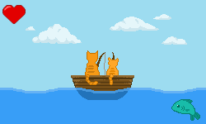

Asset Breakdown

Below is a list of the assets included in the game:

**Art assets:**

* Animated main menu background
* Good ending
* Bad ending
* Neutral ending
* Fish button sprite
* Heart sprite
* Scrolling background
* Animated boat + waves sprite
* Textbox background

**Text assets:**

* Scripted dialogue
* Options presented to the player

**Sound assets:**

* Main menu background music
* Background wave music
* Bell sound

Art Assets

The visual assets consist of a main menu which include *start game* and *quit game* buttons, and a main game scene which includes the *fish* button and the *son love meter* which each has its own sprite. The background of the main scene in the game consists of a scrolling cloud background, as well as a simple animated 2-frame sprite of two cats fishing on a boat. This sprite is always present in the main game, to act as a sort of background for the dialogue and events. A red exclamation sprite is also used to indicate a fish being caught whenever it appears. A simple blue textbox was also created to frame any text. All the art and animations in the game are kept simple. The individual frames of the sprites are made in Photoshop, and animations are assembled in the Unity animator.

We also included an animated sprite for the main menu, which involved the father and son cats standing on the beach fishing, staring out into the ocean. There is a slight breeze indicated by the fishing line and the movement in the cats’ ears. We also drew background art for the good ending, the bad ending, and the neutral ending. The sprite sheet of the animated main menu background, as well as the art for the three different possible endings, are included below:

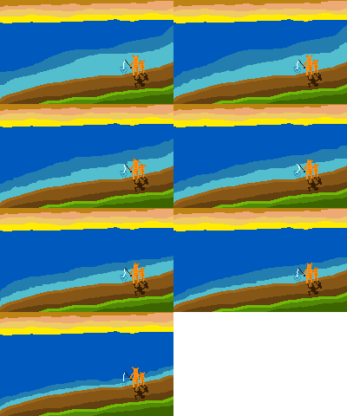 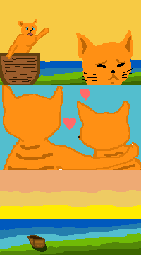

Text Assets

The main game scene includes text boxes to describe events and dialogue between the player and the son, as well as buttons containing various actions that the player can choose. All scripted dialogue is presented in the text box, which was created using Fungus. There are 20 different possible events that the player can get which all have their own text descriptions / dialogue, actions for the player to choose, and different effects on the *son love meter* level. The player will not get the same event twice during one playthrough of the game.

The dialogue and descriptions make up the majority of the gameplay and will take the most time to build during the creation of the game. The implementation of the dialogue will involve creating scripts to make each obtained event unique, as well as the writing of the narration itself.

Sound Assets

The main menu of the game has a calm instrumental background music to capture the feeling of the scene, involving the father and son looking out into the ocean. This background music is “Dream on Me” by Stefan Kartenberg, found on the following site: <http://dig.ccmixter.org/games>

The main scene of the game has ocean sounds as the background music to simulate the feeling of being on a boat and add atmosphere. The looping ocean sound effect was found on the following site: <http://soundbible.com/tags-ocean.html>

Additionally, we added a bell sound at the end of the game once the player has been through 10 events and has gotten an ending scene. The bell sound effect was found on the same site as the ocean sound effects: <http://soundbible.com/tags-ocean.html>

Development

We initially wanted to make something fun and light-hearted. After some brainstorming and going through other ideas, we decided on creating a sort of visual novel style game that would involve interactions between a father and a son going fishing. Additionally, making the characters cats would give us an excuse to throw in cat puns. We wanted to find a way to incorporate additional gameplay mechanics in a visual novel other than simply choosing actions in response to events. Due to time constraints, we decided to stick with something simple and include a small fishing mechanic where the player would have to press a button to catch the fish. Having a *son love meter* for the player to fill as a goal also added another mechanic to the game, instead of simply having dialogue to traverse through.

Our initial game idea was more ambitious than what we were able to create in the time limits we were presented with. We ended up having to exclude a fishing mini-game, and the fishing mechanic evolved into a simple button press that also determined the event that would be triggered.

We also add problems with the spacing of the text in the textboxes. When the game was played at a large resolution, the text was not centered properly and ran outside of the textboxes. We could not figure out how to solve this, so to avoid this problem, the game should be played with the following settings:

Screen Resolution: 1280 x 600

Graphics Quality: Ultra

[Checked]: Windowed

During the playtest of our game, the players thought the game was cute and entertaining. They liked the dialogue choices and the artwork as well as our fishing puns, and thought our concept was unique. The actual gameplay was very easy for the players to understand, and no prior instruction was needed for them to play the game. This feature was intentional on our part, since we wanted to ensure the gameplay was simple and the majority of the game consisted of the scripted dialogue. The outcome that the players got at the end of the game depended on how they wanted to answer the questions. The possible options for the player were written so that it was obvious whether they were positive or negative outcomes, so the ending that the player received depended on what the player wanted rather than any actual skill level. Overall, the playtesting results were positive, however the players thought that a less obvious selection of responses to events would make the game more dynamic and exciting.

Additional Ideas and Possibilities

If we had had more time to develop the game, we would have liked to create additional fishing mechanics. The fishing would act as a mini-game that would need to be played before interacting with your son, and to progress through the story you would have to talk with your son. However, we decided this would make things too complex with the limits we had and stuck to a simple single button press to catch a fish. To further reduce the complexity of the game, we had each event trigger once a fish is caught. We would have also liked to add more scenarios that could lead to an end game (such as the son falling out of the boat, etc.), but we decided to have only one way to reach the end game, which is catching 10 fish (and in turn triggering 10 unique events).

Initially if we had added a mechanic for the player to catch the fish, we wanted to have a multiplier value for the final points acquired by the player. The final amount of the *son love meter* would have been determined by multiplying the sum of the points given by the player’s selected actions by the number of questions answered. By multiplying the base points by the number of questions answered, there is a hidden scale that ensures that that the player must catch fish and interact with the son to gain points and get a good ending. However, since we did not implement a fishing mechanism, we did not add this multiplier.