Exporting ONNX from Matlab to Python
In Matlab install the add-on “Deep Learning Toolbox Converter for ONNX Model Format”.

Export the DAGNetwork from Matlab to ONNX

%% Exporting the neural network using the ONNX format
arturnet = load ('arturnet11.mat');
net = arturnet.arturnet11;
filename = "arturnet.onnx";
exportONNXNetwork(net,filename)
Note: Export to D: if not running matlab as admin.

Removing initializer errrors from the ONNX model
In Python 3.8 enviroment install the onnx library:

pip install onnx

Before creating an inference session in onnxruntime, the exported .onnx file should be rebuilt to remove initializer errors while running the python code. Error example:

2022-03-24 11:36:51.1441133 [W:onnxruntime:, graph.cc:1237 onnxruntime::Graph::Graph] Initializer input_1_Mean appears in graph inputs and will not be treated as constant value/weight. This may prevent some of the graph optimizations, like const folding. Move it out of graph inputs if there is no need to override it, by either re-generating the model with latest exporter/converter or with the tool onnxruntime/tools/python/remove_initializer_from_input.py.

Run “remove_initializer_from_input.py”

Delete the old .onnx model file and use the new one that was created.

1. ONNX inference with onnxruntime (running the neural network on the Jetson Nano)
- Set up an environment with Python 3.8
- In Python install the onnxruntime library:
pip install onnxruntime
- Open “ONNXJetson.py” and install all libraries needed.
- Run the program and obtain the WindowData parameters.

2. ONNX inference on the OAK-D camera (running the neural network on the camera)

On a Python 3.8 environment, install the onnx-simplifier library:

pip install onnx-simplifier

Run “simplifyONNX.py” with adjusted Path to obtain the simplified ONNX model.
Original Simplified
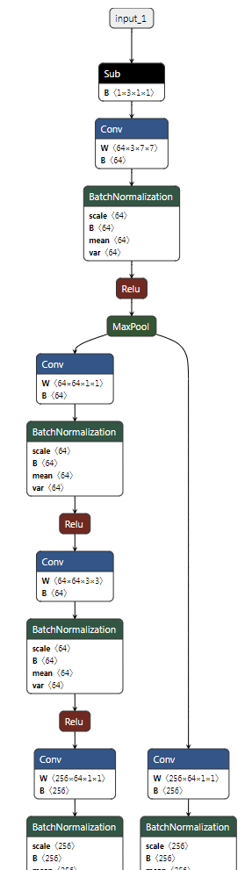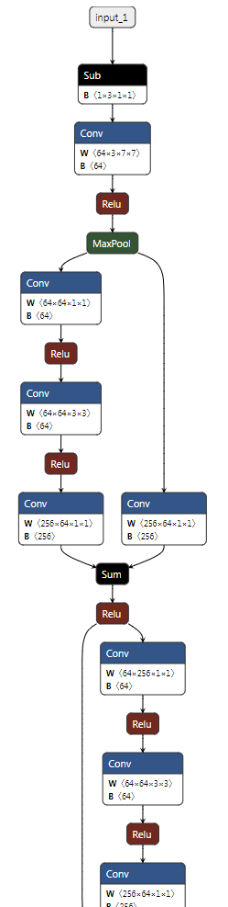

Install the 2021.4.2 version of OpenVINO:

pip install openvino-dev[onnx]==2021.4.2

Note: An older version of OpenVINO was installed for the blobconverter to work since the recent 2022 version would convert to Intermediate Representation (IR) without problems, but when it came to use the Luxonis MyriadX Blob Converter, the latest OpenVINO version option was 2021.4 and the conversion would fail. Unlike the 2022 version, when using 2021.4.2 version’s Model Optimizer, it doesn’t recognize the input shape of the original model, so it must be defined with no space between “,” and numbers.

To convert to OpenVINO using model optimizer, in the environment terminal, navigate to the folder where the simplified model is located and then execute:

mo --input_model arturnetsimp.onnx --input_shape [1,3,224,224]

This will give the Intermediate Representation (IR) of the model, and result in a pair of files describing the model: “.xml “ describes the network topology and “.bin” contains the weights and biases binary data.



The next step is to convert the IR into .blob

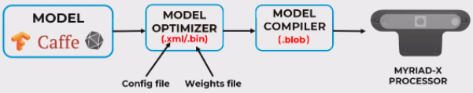

Install the Blob Converter:

pip install blobconverter

Convert to .blob using one of the following options

1.Using terminal:
blobconverter --openvino-xml C:\Users\artur\Desktop\Blob\arturnetsimp.xml --openvino-bin C:\Users\artur\Desktop\Blob\arturnetsimp.bin --shaves 4
2.Python code:
Run “blobconverterONNX.py”
3.Website: http://blobconverter.luxonis.com/

Note: After it finishes, get the blob from the default path: %UserProfile%\.cache\blobconverter

Converting from ONNX to .blob directly fails on that version of OpenVINO.

Had some problems with the internet connection, but after trying it at another time the error no longer appears.

