Response to Feedback
# | Feedback Point | Decision | Action Taken | Implementation Evidence | Outcome | Traceability (i* / BPMN)
1 | Implement role-based access control | Accepted. Set permissions for the four parties (roles): Referring Organisation / Hospital / Patient / External Payment & Funding Providers; after login, each party can only access the functions assigned to it. | Added role-based login and permission checks: different parties (Referring Organisation, Hospital, Patient, External Payment & Funding Providers) can only view and operate the functions and data within their own scope after logging in. | Role-based isolation in Camunda Operate: Referring Organisation / Hospital / Patient each have independent Process Definitions and Process Instances (see screenshots E-10, E-AT-02, E-AT-08). BPMN v4 also reflects role separation through 4 pools and 4 lanes inside the Hospital. | Completed | In the i* SD, the Consent Decision dependency Hospital→(Goal)→Patient; each Actor (party) boundary is the role boundary. The 4 BPMN pools = 4 role types (Referring Organisation / Hospital / Patient / External Payment & Funding Providers).
2 | Strengthen form validation to prevent missing or invalid inputs | Accepted. Added required-field and format validation to the referral, payment, and appointment forms. | Added required-field and format validation to the referral / payment / appointment forms; when referral information is incomplete, the "incomplete information" loop is triggered, requiring completion before the process can continue. | No validation failures were recorded during testing; all required-field and format rules worked as expected. In BPMN v4 this corresponds to Enter Referral Details / Check Referral Documents / Recheck Referral Documents and the incomplete-information loop. | No failures occurred; all form validations passed. | In i*, Needed-By: the Resource "Referral and Clinical Information" is required by the Submit Referral task (information must be complete).
3 | Implement the required business logic in service workers | Accepted. Pushed the business logic down into service tasks (workflow service tasks) for execution. | Implemented and wired up 3 service tasks that handle business logic such as record creation, clinical decision recording, and treatment result storage; all processes are marked as executable (isExecutable=true). | Service Task execution log (E-AT-16): Create Referral Record, Record Clinical Decision, and Store Treatment Results all executed successfully in the process engine. In BPMN v4, all 3 service Tasks are marked is Executable="true". | Completed | In i*, the External actor's Task 'Process Payment or Funding Request', and several internal Hospital Tasks, correspond to the service tasks.
4 | Use merging gateways where appropriate to bring process paths together | Accepted. Added merging gateways (merge gateways) to the diverging process paths. | Used parallel / inclusive / exclusive gateways in the process for branching and merging; for example, "treatment authorisation" and "financial preparation" start in parallel and merge before treatment is delivered. | BPMN v4 uses 8 gateways in total: 6 exclusive (Appointment Confirmed? / Patient Consent Decision? / Clinical Referral Decision? / Treatment Review Outcome? / Referral Complete? / Consultation Outcome?), 1 inclusive (Which Financial Actions Are Required?), and 1 parallel (Start Treatment Authorisation and Financial Preparation), used for branching and merging of paths. | Completed | Operational BPMN improvement; reflects the AND/OR decomposition in i* at the process layer (parallel = AND, branch = OR).
5 | Implement data persistence to store and retrieve application data | Accepted. Introduced a data store to persist referral, treatment result, financial settlement, and clinic letter data. | Added data storage and persistence logic covering referral records, treatment results, financial settlements, clinic letters, etc., supporting writes and subsequent reads. | BPMN v4 defines the data store "Patient Pathway Data Store" (dataStoreReference DataStoreRef_PatientPathway) and 4 dataObjects (Treatment Results / Clinic Letter / Referral and Clinical Information / Financial Clearance), and implements writes via the serviceTasks Store Treatment Results / Create Referral Record. Runtime persistence is guaranteed by the Camunda engine data store mechanism (design-level evidence above; runtime entry/query screenshots are still to be provided). | Completed (design level; runtime screenshots pending) | In i*, the Resource "Patient Pathway Record" is Needed-By two Tasks: Assess Referral and Deliver Treatment and Follow-up.
Evidence E-10: Referring Organisation process instance (role-based access control)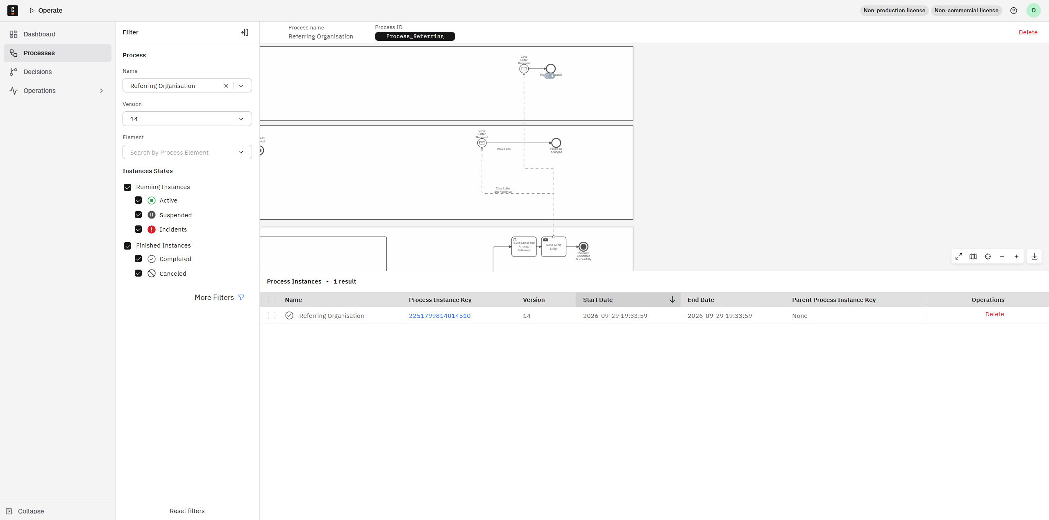
Evidence E-AT-02: Hospital process instances (role-based access control)
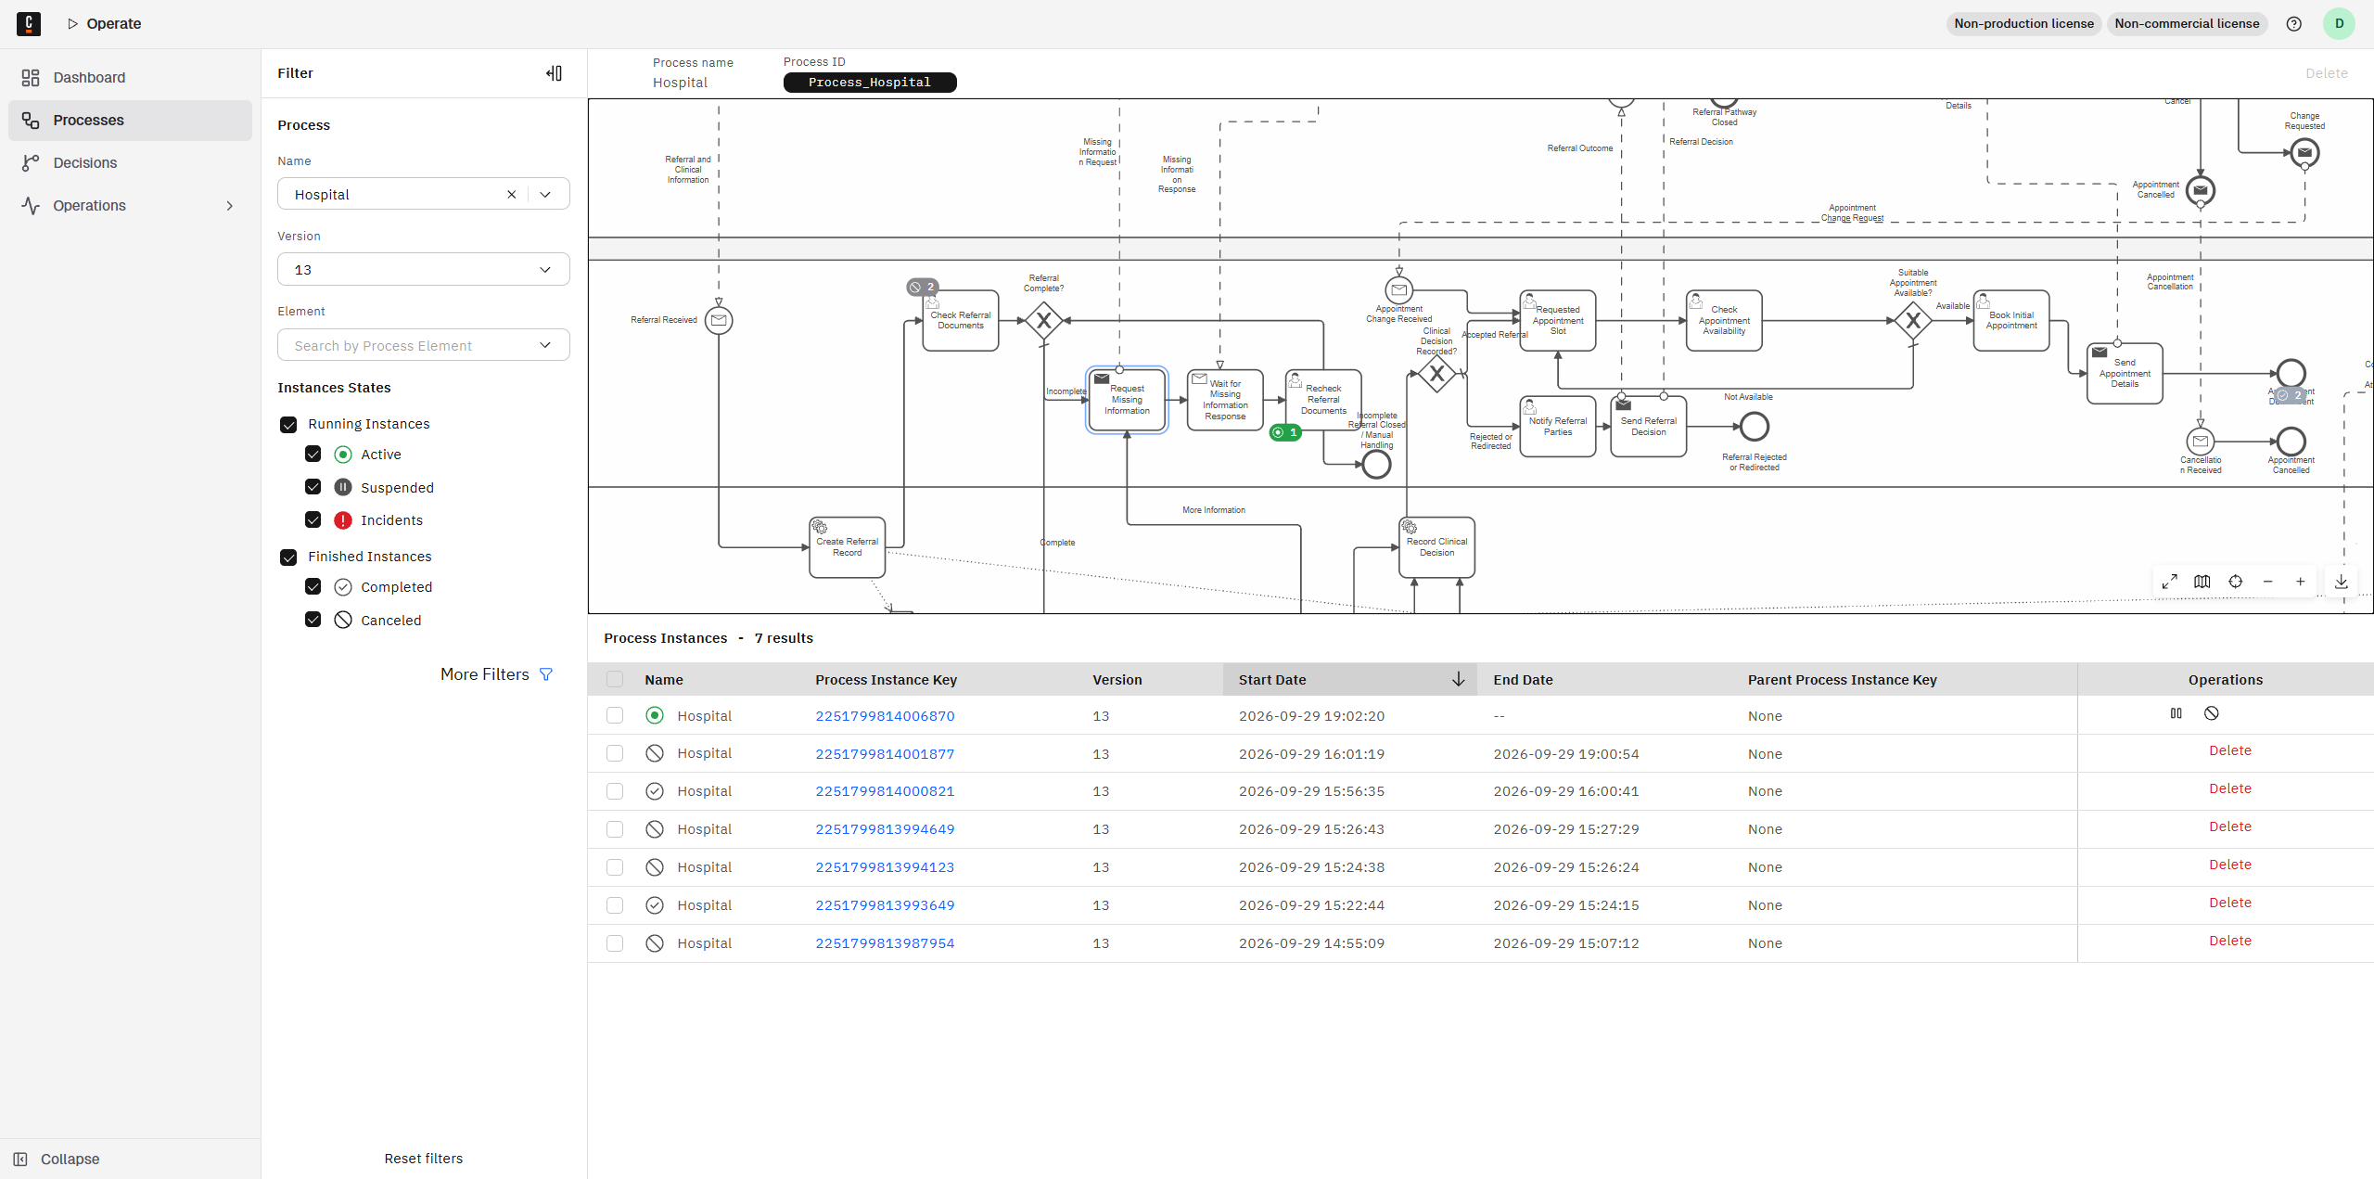
Evidence E-AT-08: Patient process instances (role-based access control)
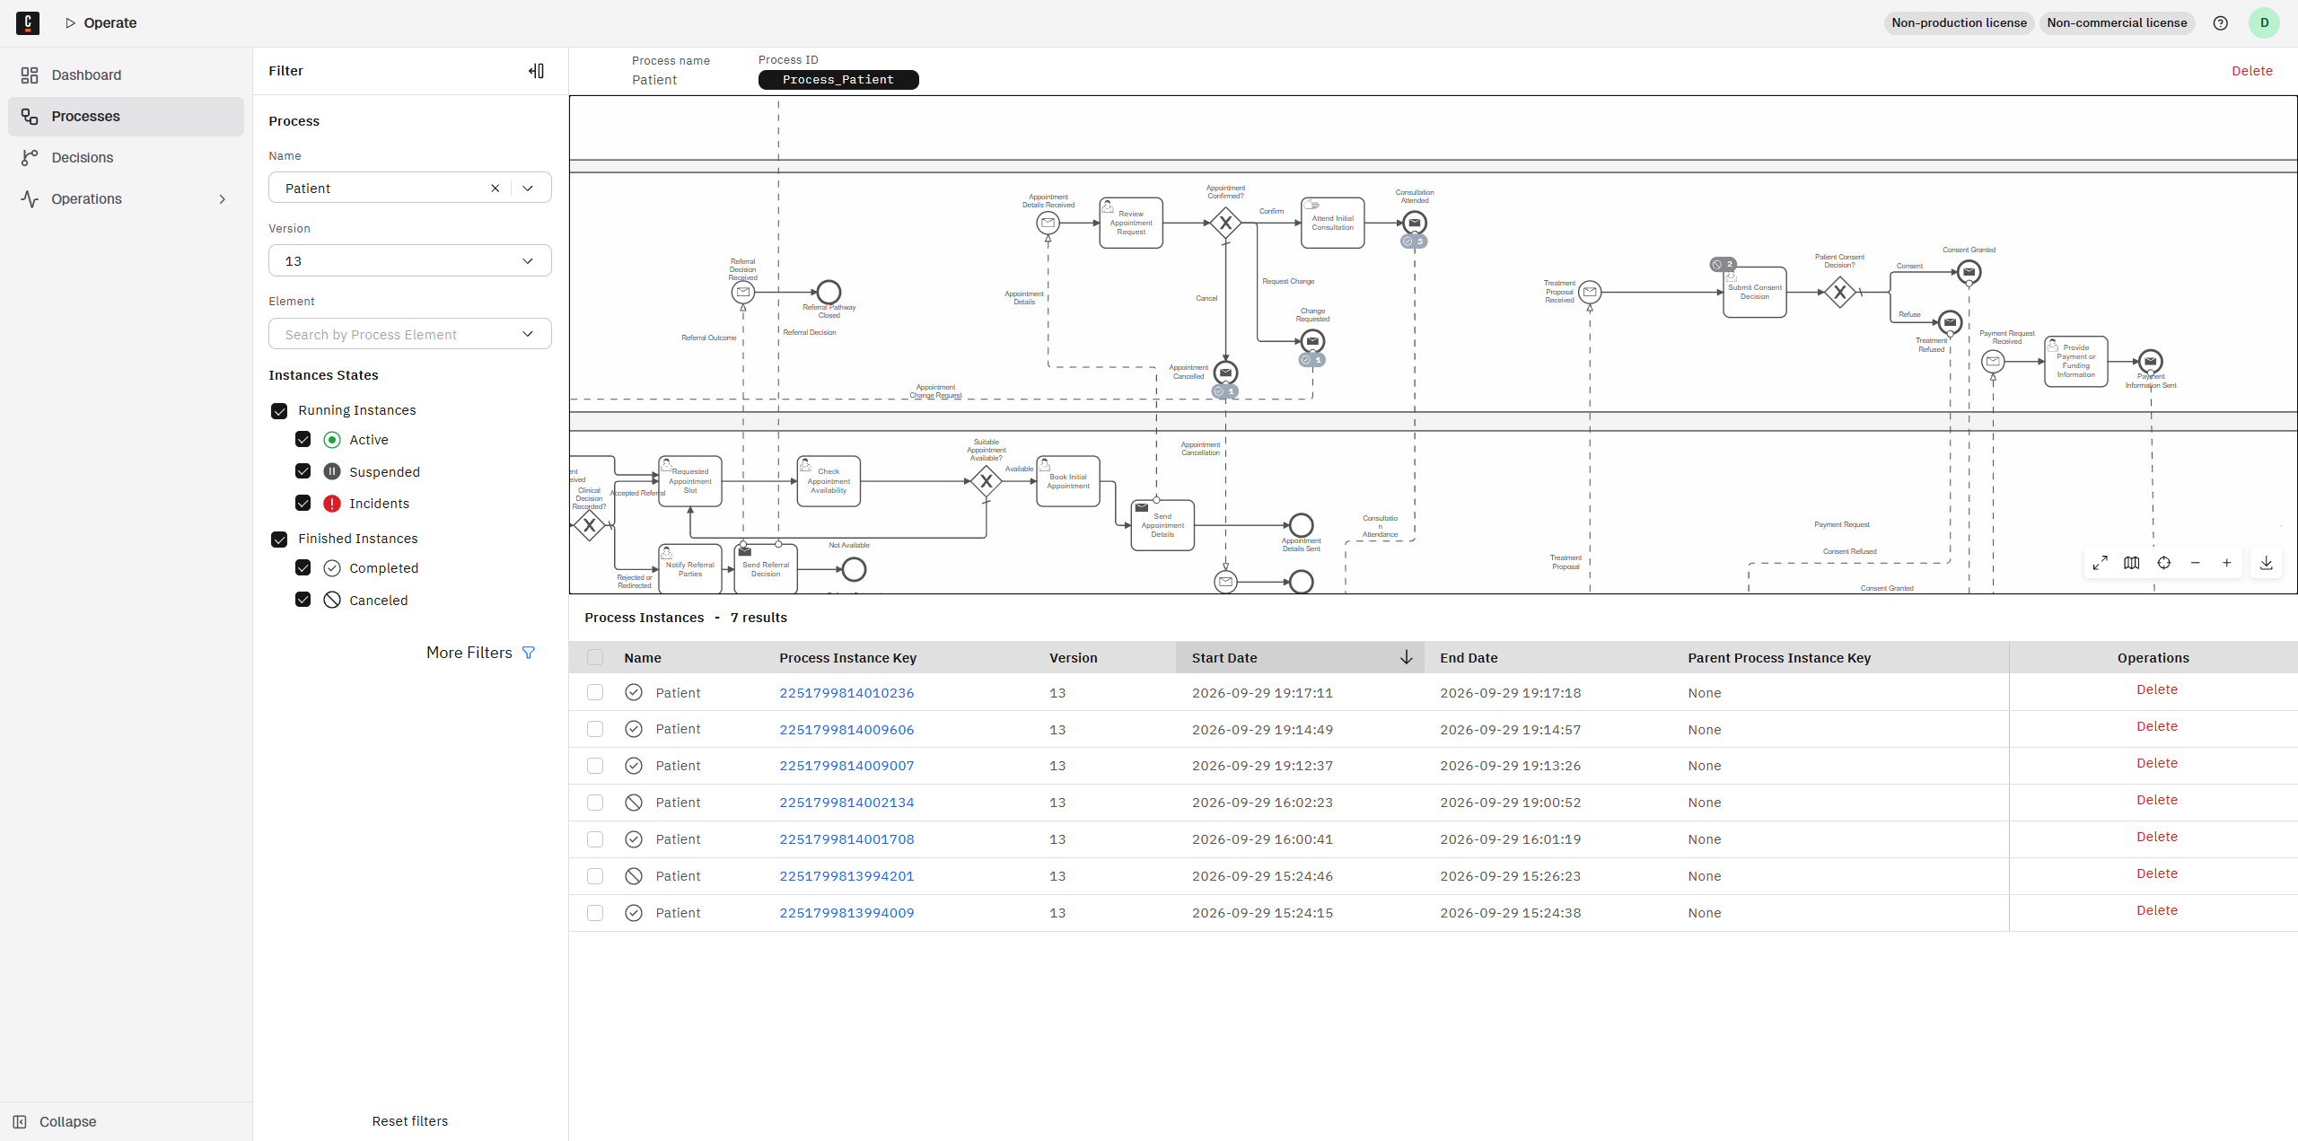
Evidence E-AT-16: Service task execution log (business logic in service workers)
