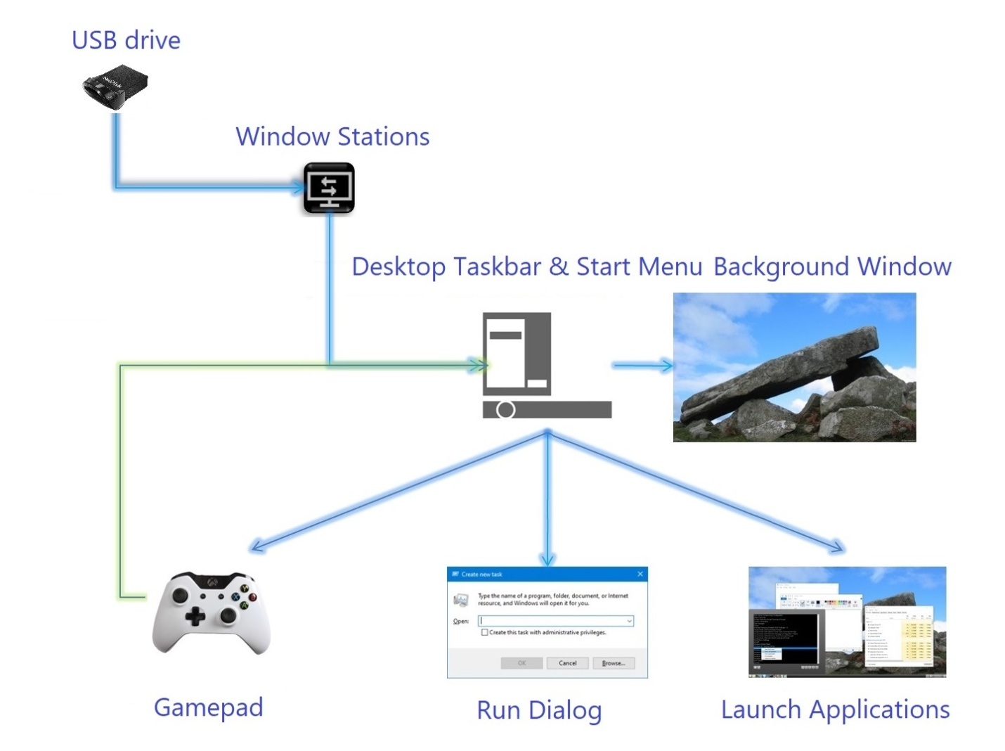

*Window Stations is a secure environment for decentralized computing.*

*Desktop programs run securely in parallel with the default desktop.*

*\* Alternatively, boot as an alternate shell instead of Windows 10.*

Features

**USB 3.1 paired to software activation**

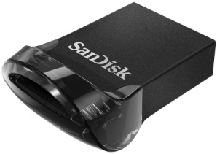

The alternate software Shell is directly integrated with a physical USB device. This makes it secure and portable to any PC. The software's product activation is linked directly to the hardware.

**Alternative desktop shell**

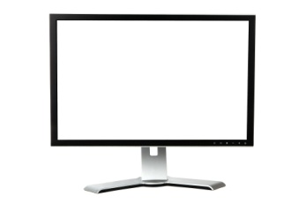

Programs are run on a secure desktop, started from an associated Window Station process Shell. The suite of applications is designed to operate inside of this controlled environment. Execution of the operating system is handled by the calling process associated with this Window Station.

**Cleaner Windows hierarchy**

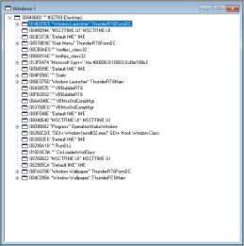

The secure desktop has a Window hierarchy that is filled with less clutter and uses less memory than the default desktop environment. The secure desktop can be switched back to the default desktop at any time.

**Zero installation signature**

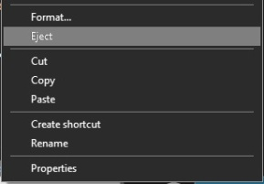

Everything needed to run the programs is included on the USB. Nothing is installed onto the host computer. Simply eject the USB when finished use.

**Protected keyboard input**



The secured desktop is separated from any malicious software that may be running on the default desktop. The default desktop is suspended, while the secured desktop is being operated.

**2D & 3D User Interface support**

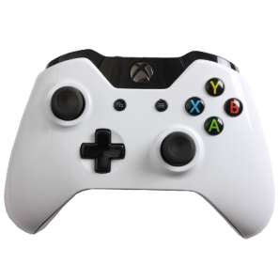

Gamepad controllers (xbox one w/keypad) simulate mouse and keyboard events. Windows can be manipulated with the thumb sticks and buttons. You can move, resize, maximize, restore, and close Windows without having to click the buttons on the title-bar of the application.

Preview

Alternate Window Station Desktop Shell

https://www.youtube.com/watch?v=C2wktiPy_SY

Window Stations w/USB Flash device

* Optionally, Window Stations can be launched at boot time as an alternate shell, instead of the default shell included with Windows 10 Enterprise edition or Windows 10 Education edition. These OS editions are licensed separately, for this kind of hybrid of setup. Samsung T5-T7 SSD drives work well for this type of boot shell. XBOX one game-pads are also sold separately.

About

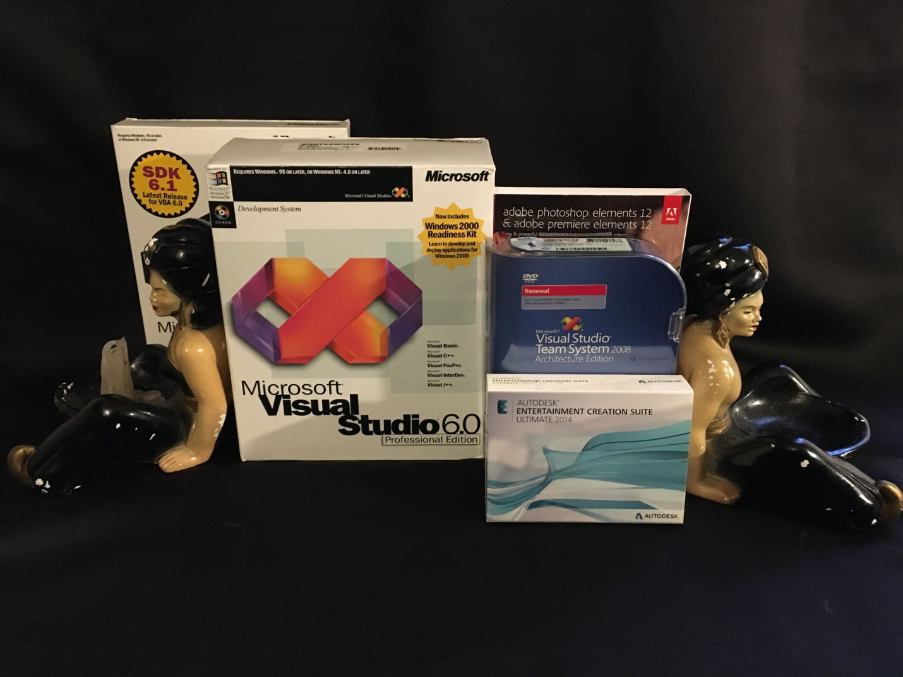Window Stations is being developed and licensed with Visual Studio 6.0 Professional & Visual Studio Team System 2008 Architecture Edition. The 3D assets have been retopologized with Autodesk Entertainment Creation Suite Ultimate 2014.