2. Interstellar

3. Complete “missions” on all planets

4. Spaceshuttle (pc), planets, blackhole (npc)

5. 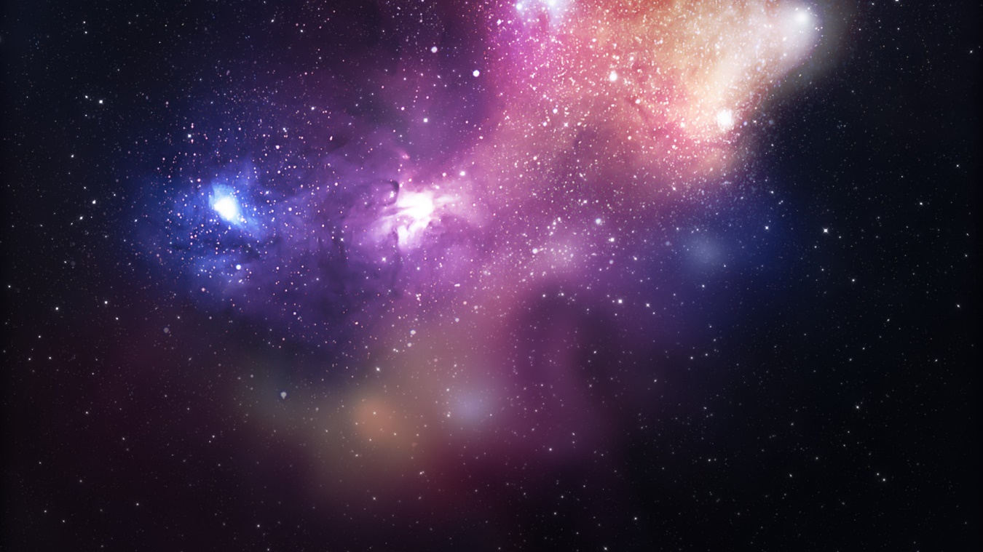

6. Computer

7. VS Code

8. p5, matter