# 句子分析步骤

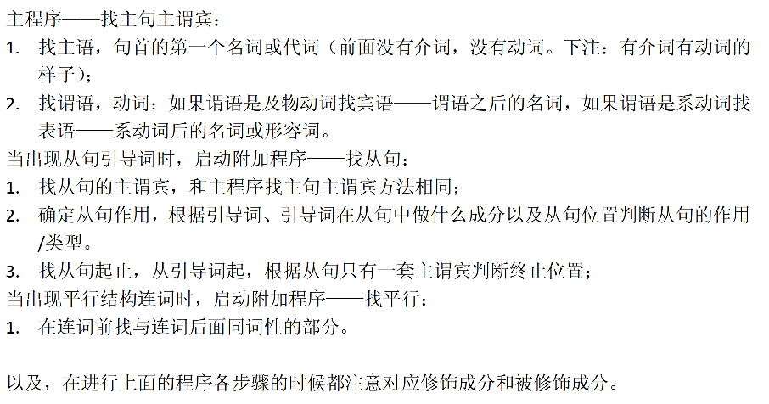

补充：

1. 介词后面要找名词构成介宾短语

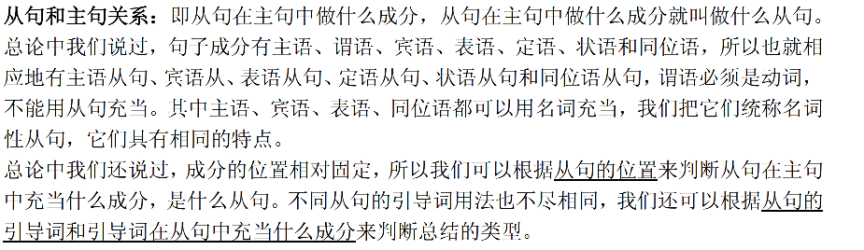

# 从句

## 定语从句

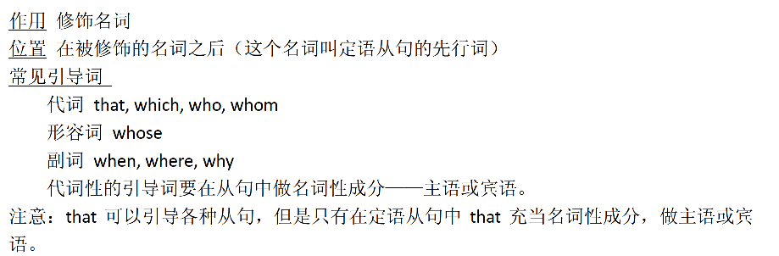

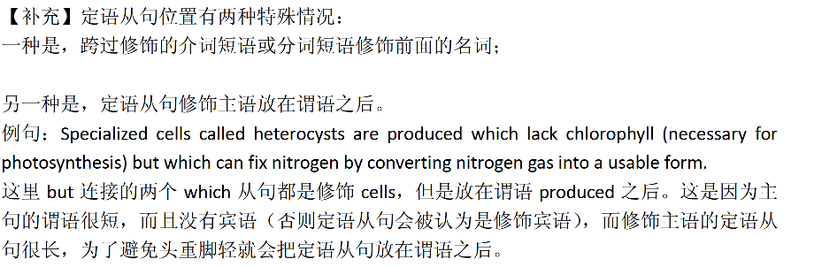

## 状语从句

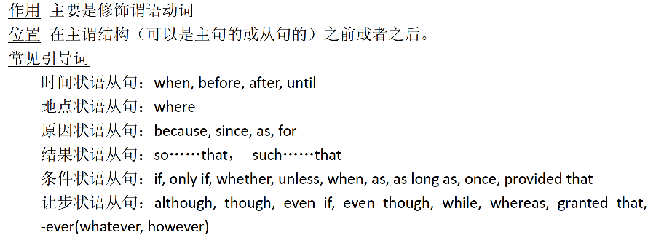

## 名词性从句

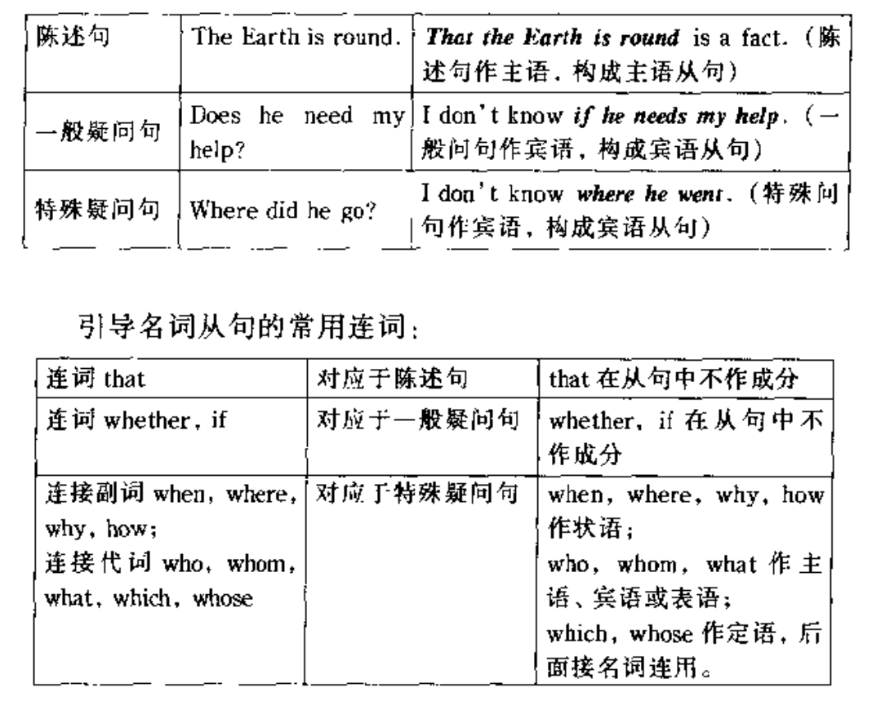

### 名词性从句VS定语从句







### 宾语从句



### 同位语从句



#### 同位语从句VS定语从句





# 平行结构



如何找



## 并列



## special case

有可能会省略谓语

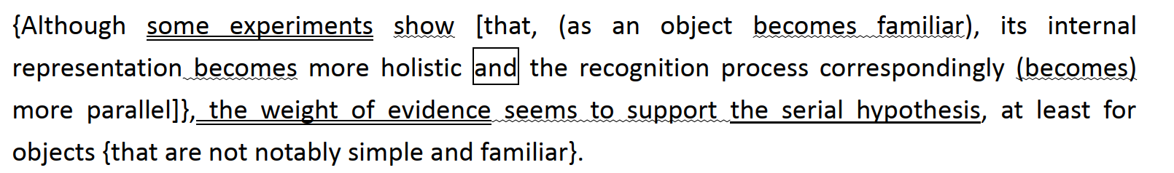

疑问句可以先改语序再看平行结构



## 对比



## 比较

注意使用do来指代以及倒装的情况

### e.g.

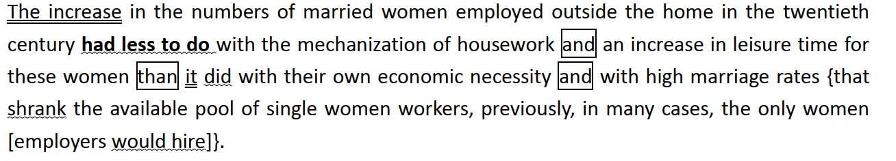

## as同级比较

**后一个as后面的部分去前一个as前找**

# 辨识过去分词

## 虚拟语气省略should

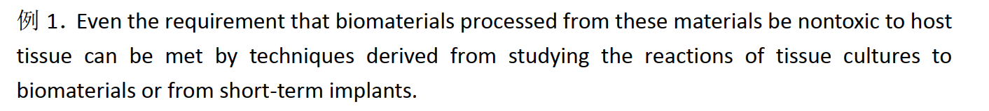

**these meterials (should) be nontoxic to host tissue**

# 短语修饰

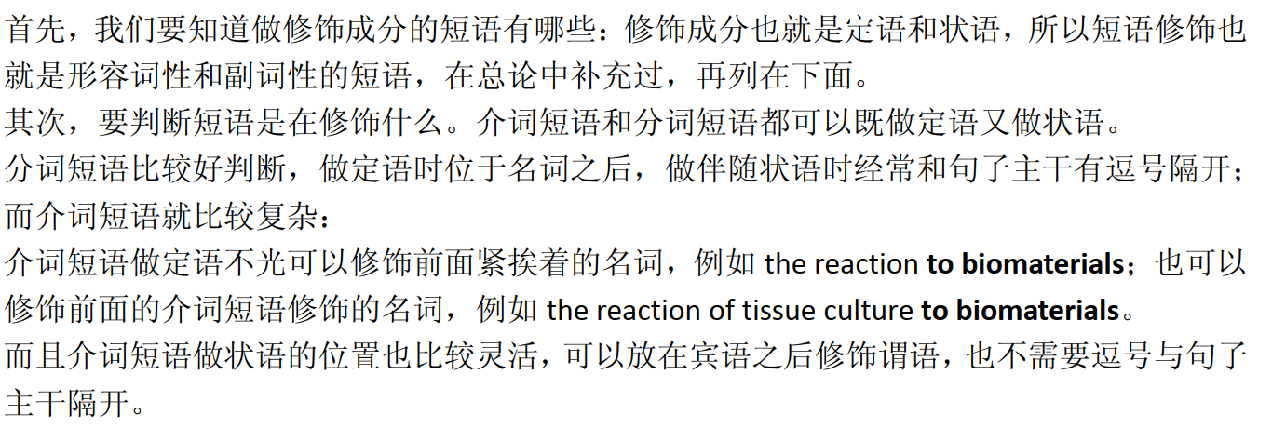

1. 做定语和状语

2. 分词短语 and 介词短语

## 如何判断修饰的是什么

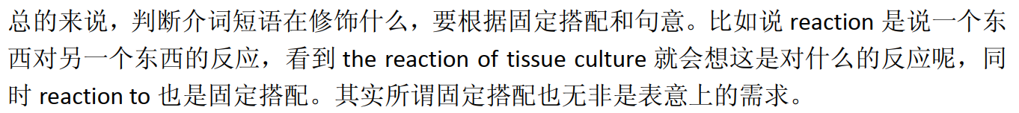

## 动名词短语

﻿focused a great deal of attention in recent years on "determining more accurately the status of women in various periods"



# That用法

主要有**三种**：









material fundamentally different from that(指material) of the midocean ridge

# 做题遇到的长难句

Between the late 1800s and early 1900s, various institutional structures emerged that set researchers in scientific fields apart as a professional class and moderated disputes by _____ some kinds of knowledge as real science.

1. 定语从句后置

2. 并列

83-6

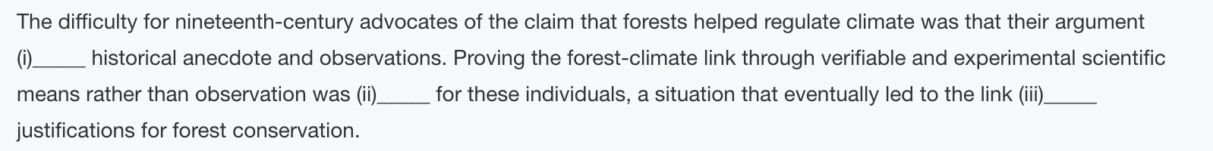

重点理解一下第二句：

Proving …… through {veriable and …… means}（rather than）{observation} [was] problematic for these individuals, a situation……（整句话做前面那句话的同位语）

101-4

状语前置：主语（hypothesis that ……）太长所以放到后面去了，把状语at the heart of……提前

# 一些插入语

## as it did

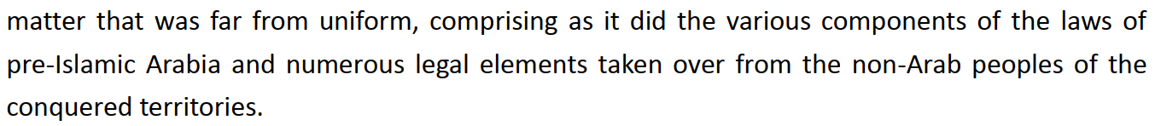

comprising as it did the various ……

﻿as it did 表示“就像它所做的那样” 是插入语加强语气