# 课程安排

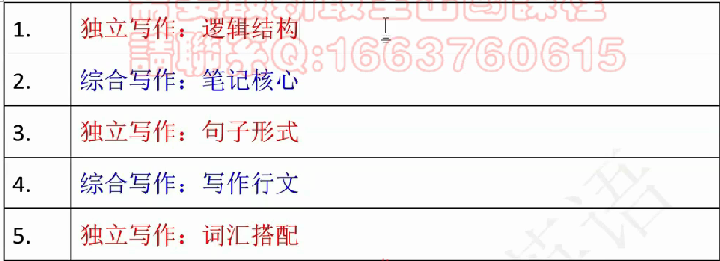

时间紧张：保证直播课跟下来

# 独立写作

为什么FAIR？

看不懂？

1. 逻辑：偏题，hard to follow

2. 语言：错误，hard to understand

语言重复——语言变化：大good 27+

文章的目的：看懂

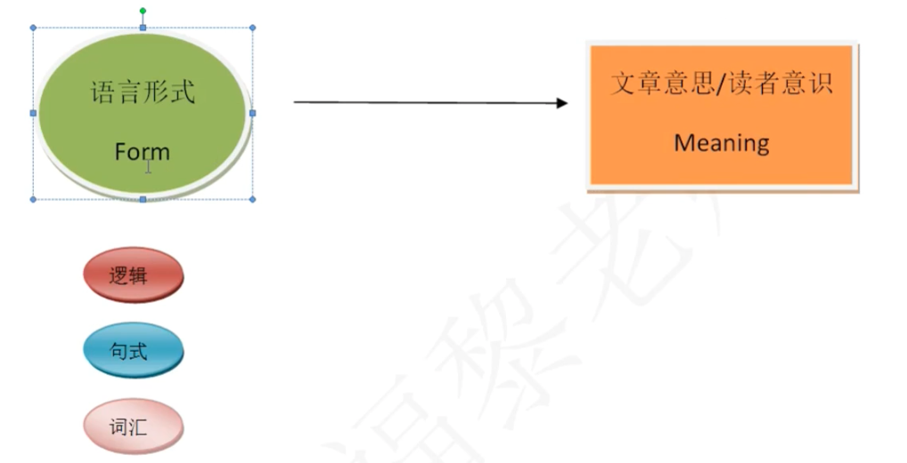

第一次课逻辑，第三次课句式，第三次课词汇

## 逻辑/结构

### 段间逻辑

开头段： 中间段1 + 中间段2 => 结尾段——总分平行

3+5+5+3 = 16句话

### 句间逻辑

### 开头段

话题引入 -> 对方观点 vs 自己观点——句间逻辑

### 句内逻辑

A - B B' - C C' - D——句内逻辑

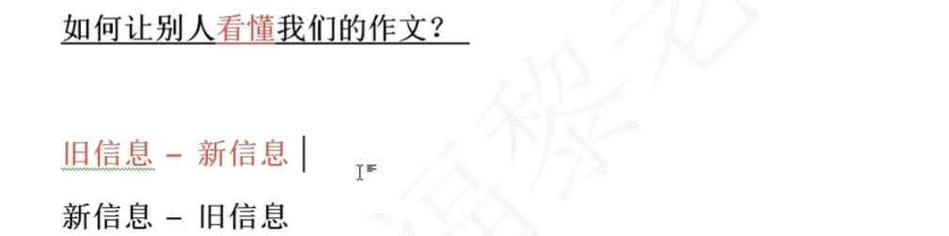

变化：同义词，近义词，下义词，上义词【句子相关词】

e.g.



N：名词引入

1. 直接写话题（一共有九大话题）：这道题属于教育，可以用话题词（education）

2. 从题目中选择一个非选项词的中性词，这道题问要不要strict rules，选一个其他的，比如Success

同位语解释

1. the foundation of xx

2. the objective everyone strives for

3. an essential element in xx

disscussion over a. 抄题目 whether 句子b. （recommend）把题目变成一个名词 the necessity of xx

对方观点

Loose regulations, in some people's views, should proposed.

自己的观点

倒转

Contrary to these people's opinions is my perspective that setting rigid requirements to children is beneficial.

总结：

Education, the foundation of success, has been valued and even triggers a heated discussion over the necessity of strict rules for children. Loose regulations, in some people's views, should proposed. Contrary to these people's opinions is my perspective that setting rigid requirements to children is beneficial, due to the contribution to （下面的两个观点）their school performance and personal development.

**托福不看思维，严密，甚至合理性**

因为考试大部分是用e-rater改（除了特别高或特别低人会改）

## 中间段

五句话

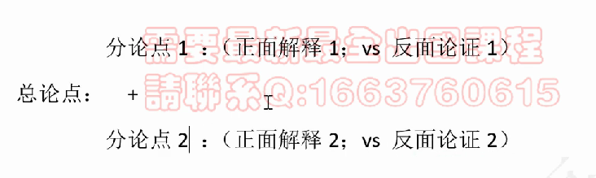

题目读完两遍开始破题：

逻辑起点

5.1 5.2 and 两分钟破题

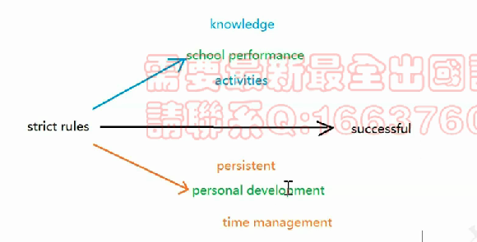

What must be prioritized is that [strict rules -> school performance] strict requirements, instead of / rather than / not giving them freedom, are conductive to children's school performance, by helping them acquire much knowledge and participate in numerous activities.（+ 对比 + 分论点）

rules到success还是knowledge到success——rules推知识，逻辑起点很重要

Initially, [strict rules->knowledge] it is under exacting rules that children can obtain a large quantity of knowledge.（短句子）

解释是一句长句子，大概25-35词

窄逻辑终点（比如节约钱）文章至少50%提到（分论点中提到or解释中提到）

要解释什么：strict rules —— knowledge

两种方法：

1. 加中间环节

rules —— knowledge

严格规则话，家长会让孩子（背唐诗，做数学题，做作业），就会获得知识

2. knowledge下切

knowledge：数学领域的知识，艺术领域的知识

3. 也可以切逻辑起点（不多）

也可以结合起来，比如背唐诗学会语文知识，做数学题学会数学知识

To be more specific, under the requirement of stringent regulations from parents, children will devote more time to learning, such as particing a musical instrument and reciting poems, thus gaining a wide range of knowledge;

想不到？

1. **思路简单，具体，落地**

2. 信手捏词，近五年真题

3. 带入自己（我小的时候，我的爸妈会让我干什么什么事情）

However,【x knowledge -> freedom】

however, children will allocate their time to entertainment and thus are distracted from getting such expertise if parents do not regulate them strictly.

反面 + 理由（锦上添花，不加也行）

Moreover, [strict rules -> activities] exacting rules urge children to participate in various after-school activities.（短句子）

strict rules -> activities

下切activities

In detail, children are demanded by their parents to take part in assorted activities, including social clubs, field work, and experiment research, so as to boost their competitiveness; Children will be reluctant to do various activities, which can be exhausting, when parents do not set strict rules for them.

### 例子

*不是30的必要条件，高分率不好，并不推荐*

a. 相关比较难（细枝末节比较多）

b. 口语

c. 具体：一个人、数字

d. 省去对比

（扣总论点）Take a child from Beijing No.1 Primary School as an example, who is under strict regulations from his parents

（扣分论点1）He was required to recite 300 Chinese poems, so he mastered a wide range of Chinese words and phrases.

（扣分论点2）Moreover, due to his high performance in literacy, he usually attended competitions of poems, which prepared him for future learning.

e.g.

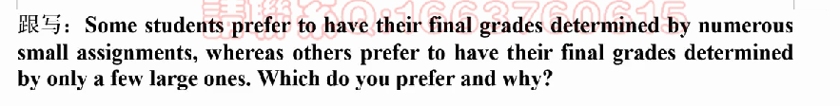

虽然是问你的观点，但不要用第一第二人称，要用第三人称

逻辑起点，题目中的选项，两个选项，AB

逻辑终点，哪个更好

many small assignments——good

可以把good下切

learning和personal development

learning下切

（knowledge）

（interest）

personal development

（time management）

（persistent）

Education, an essential element in life, has been valued and even triggers a heated discussion over the number of assignments. A few large tasks, in some people's views, should be advisable. Contrary to these people's opinions is my perspective that assigning a large amount of homework places students as beneficiaries, due to the contribution to their learning and personal development.

What must be prioritized is that [small tasks -> learning] when doing numerous assignments, rather than a few ones, students will boost their academic performance, by / via / through acquiring much knowledge and cultivating their interest. Initially, [多assignments -> knowledge]never can we ignore that small tasks are **conducive** to knowledge. In detail, [small tasks ——> knowledge] under the requirement of assorted assignments, students will frequently receive their notes, search for information and inquire others, during which they will expand their expertise; on the contrary, [B->C 题目的另一个选项][x knowledge -> large ones] students are unlikely to accumulate such a large quantity of proficiency when they deal with only a few assignments, since they tend to finish their homework on their own without referring to others. In addition, [small tasks -> interest] doing smalll tasks also triggers interest in learning. To be more specific, [small tasks ——> interest]when dealing with small tasks, students will make a progress step by step, build their confidence and bury themselves in exploring, so they will become interested in the subject; however, [x interest ——> big ones]students are more relectuant to develop their enthusiasm in learning when they are handling some big tasks.

中间环节

make a progress

build their confidence

bury themselves in exploring

也可以切逻辑起点，比如数学，化学等等，但是由于四个小点逻辑起点一样，所以只能用一遍

What should be equally worth discussing is that small tasks, instead of larger ones, can enhance / boost / faciltate students' personal development by honing / practicing / cultivating their time management skills and making them more persistent.

when coping with small tasks, students would prioritize core tasks, label them according to importance and deal with the most urgent ones; on the other hand,

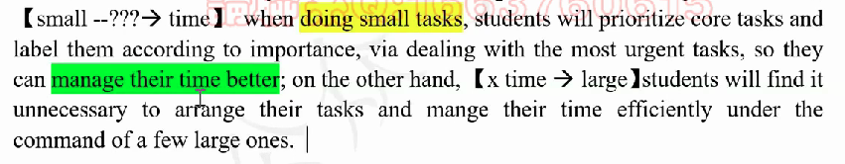

## 结尾段



Learning, being important to students(或者一个同位语), will be improved when students are assigned with many tasks. Personal development, being esssential in one's life, will be facilitated under the requirement of numerous assignments. To conclude, only by dealing with much homework can students reap and harvest benefits.