# 综合写作

## 笔记概述

*录播2.0*

### 专有名词

笔记要记什么：专有名词（很难找到同义词的名词）

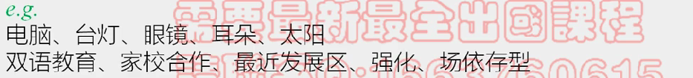

### 逻辑

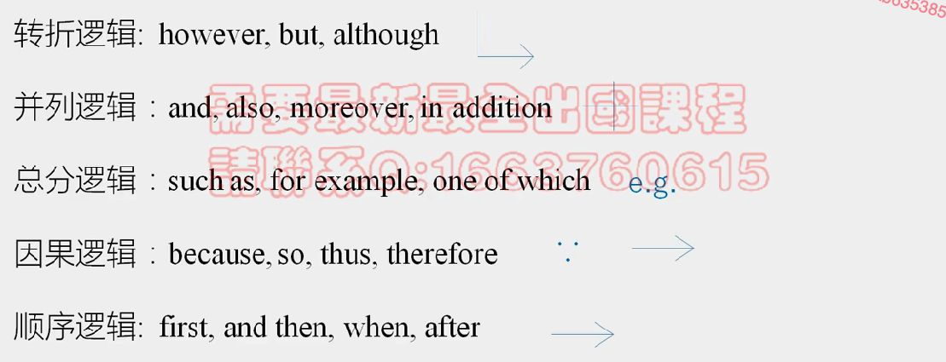

何谓改写：固定说法保留下来，逻辑意思可以用自己的话表述

## 笔记核心

多听：100%听懂

1. 听力能力：单词反应速度——精听

2. 减少笔记：

少记

1. 对比（反驳阅读信息）名词（能代表句子核心的意思，信息量最大）e-rater会根据名词来判断

2. 偶尔逻辑（逻辑强调不多）= 意思

一些记号：

+：并列

多听少记：意思+名词/笔记

## TPO45

阅读永远都是4个段落，3分钟阅读时间

每段读完再记笔记

开头段：重点内容：倒数1，2句

但前面的信息也要看

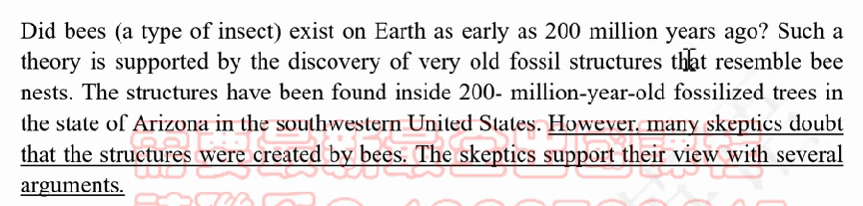

对象，（3）

bees, x 200

每段的结构

TS（中心名词）：细节名词（0~3个）【why；下切】

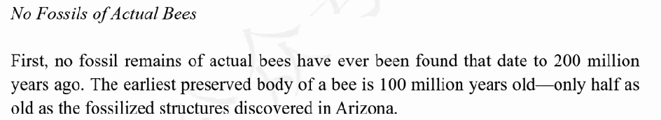

x bees fossils：-100

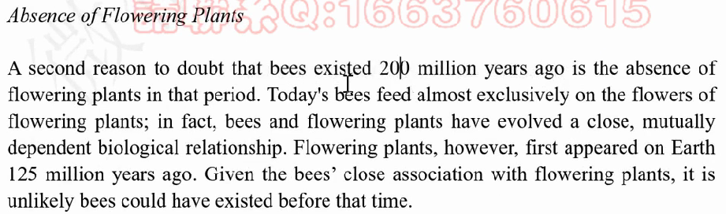

x flowering plants：-125，close relationship

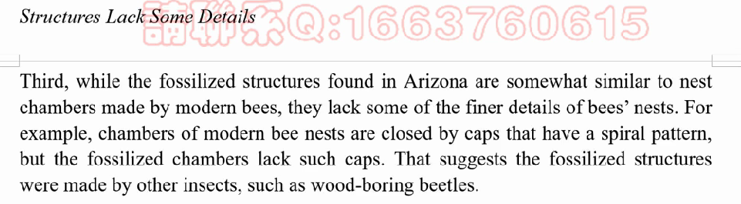

structures x details：x caps - chambers

听 *听力如何反驳阅读*

200前，没有tree resin to preserve bees，不能形成fossils

tree resin（占一分）会有小黑板：余光瞟一眼屏幕看有没有变化

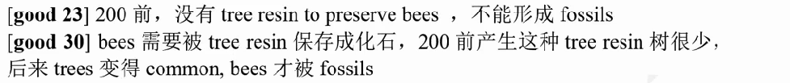

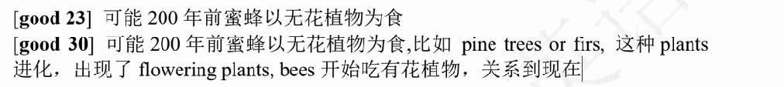

听力good 30 ~ professor说的内容

*把听力文章copy下来*

## TPO53

听力开头段记一下he/she

First，~~（not 阅读，although 阅读，about阅读）~~，**一句一名词**

quality（不用记low，如果有时间写一个减号）

> e-rater名词必须是原词，但是动词形容词都可以变化

substances

health risks

similarily——并列逻辑“+”

这句话没有名词，记录一下意思（汉字也可以）：continue

money -

health x

第二段

it might seem fair to …… 在尽管阅读，不做笔记，要记如何反驳的

incomes

earning people

pack / 人

expense

+ food

burden

第三段

谓语出来，听到中间偏后的位置就可以做笔记了

写单词的时候就会一心二用，还要听下一句

不用听完了再去筛选名词，名词敏感度

million $

没有名词：依赖，depen

policy law

measures, park

x smoking 公私

x income

### 听不懂

万一听不懂：根据语法：所有的名词都记录下来

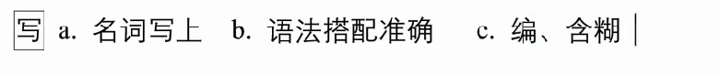

综合写作不要求语言的丰富性，只需要用最直白的话表达清楚意思就行了。

## 真题

**数字就是名词，就是1分**

**小黑板的词要抄下来，就是1分**

听完之后先补笔记：

a 划听力的TS

b 串汉语：补单词，从第三段开始补

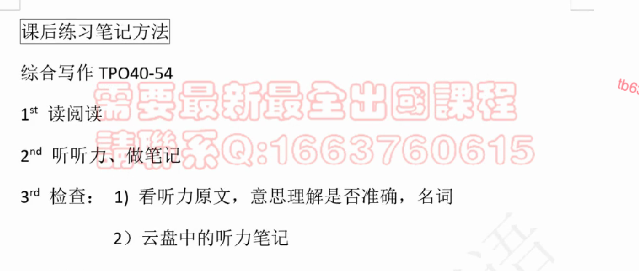

# 行文

逻辑：模板搞定

综合写作5个段落



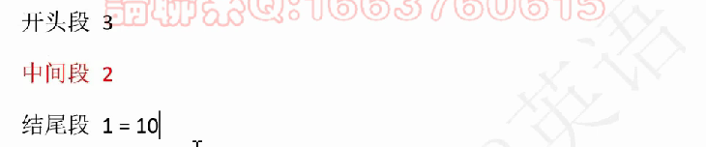

一共十句话

阅读论点 vs 听力论点 ：听力细节

句内逻辑：旧-新

## 模板

### 开头段

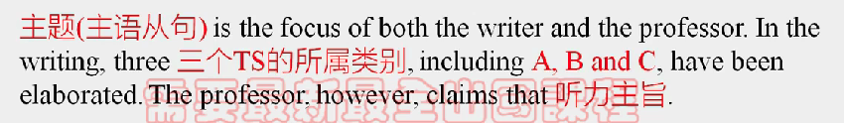

A, B and C（都是名词或者都是doing）

### 理由段一

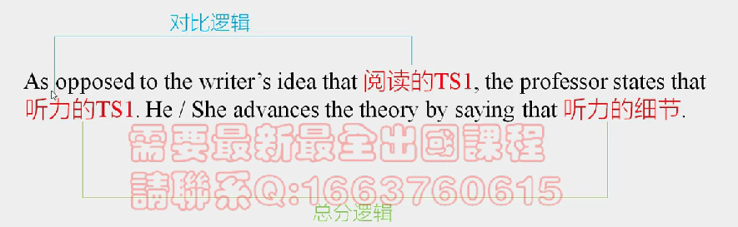

### 理由段二

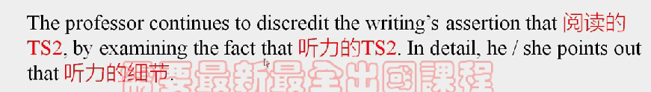

### 理由段三

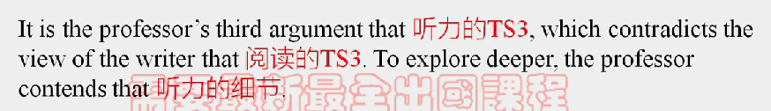

### 结尾段



没有时间可以省略

### 省略

a. 开头段 including

b. 结尾段 4段

### 时间安排

3min 补笔记 + 17min 写作：3-5min一个段落

## 句式

多样性：特殊句式不要用（容易让句子意思产生变化）

复合句 = 主干 + 连词 + 修饰



### 三大

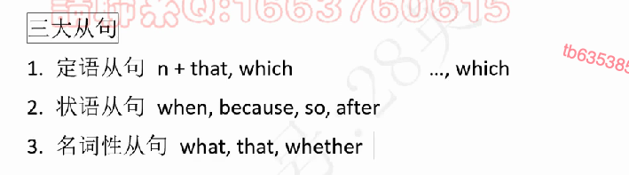

### 四小

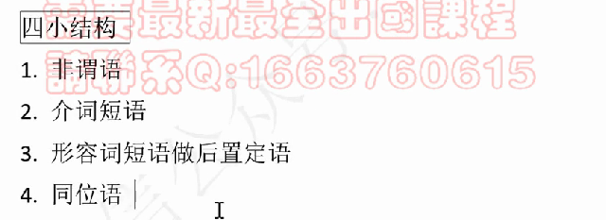

非谓语

1. 修饰名词 n + doing/done

2. ……，doing表示句子的结果

介词短语

prep + n

形容词短语

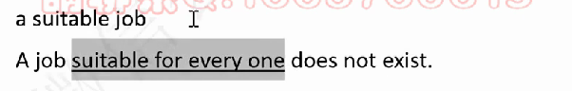

同位语

名词1，名词2

### 关系与区别

非谓语和定语从句很接近。也可以修饰名词，表达句子结果等

介词短语充当状语，和状语从句互换

形容词短语和定语从句也可以互换

Q：如何选择？

A：信息比较多可以用从句，信息比较少可以用四小结构

## 搭配

搭配意识：屏幕上打的每一个单词，都要和它前面的单词和后面的单词形成正确的搭配关系（何谓正确：外国人会不会这么说）



my：Earthquakes often occur in the region of the lake.

Miss. Li: The earthquake often happens in this region where the lake lays.

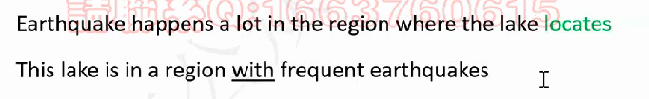

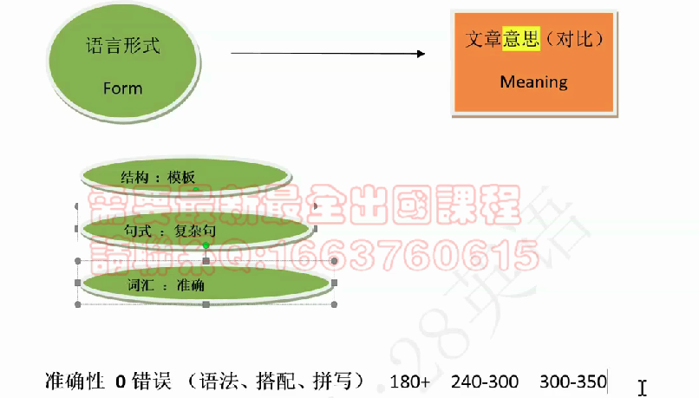

准确性 0错误（语法，拼写，搭配（不需要高级搭配，简单的方式表达准确就行了））

**简单也要保证准确**

## TPO51

### 中心段结构

补笔记 3min——把汉语理顺

1. 划听力TS 波浪线

2. 补单词

听力TS：在补笔记的时候确定

（一句话反驳阅读）（概述性，反驳性）——根据意思来找

第一段：

大象去水边是为了找吃的并不是因为自己快g了。

if没听懂：反说阅读，也是可以上28的

阅读TS

可以抄但不能连续5个单词一样



是否要加细节：判断标准：增加对比感：如果听力说到了这个细节，就写上（不加细节也可以到27，28）

e.g.

Elephants know that they are dying, by going to bodies of water and die there.

听力TS

e.g.

The reasons why they go to near water is that they need look for soft vegetation.

听力细节

按照professor的顺序从上往下写出来就可以了

1句话复杂句

if信息多：几句句子中间用分号分隔

The teeth of old elephants become wore down / do not work well(正确比高级更重要), which makes / making it difficult for them to chew, so they leave herds to seek soft vegetation; such vegetation usually grows near water, where elephants graze and eventually die, forming elephants gravyyards.

第二段

阅读TS：

Elephants know how to paint things such as flowers and animals.

听力TS：

Elephants only paint lines and patterns without knowing they're animals or flowers.

听力细节：

TS中提到了听力要不要再提到：一般不用再提，如果觉得没有这个名词说不通，再提：

Trainers will touch elephants' sensitive ears to control / order / lead them to move painbrushes in certain ways and do tricks; they will move the brush strokes to draw lines but do not know what they are painting.

第三段

阅读TS

elephants do not fear mice.

听力TS

elephants do not fear mice.

听力细节

### 没听懂

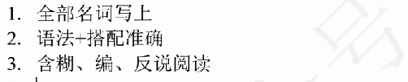

elephants are afraid of mice because they are unfamiliar with the animals and fearing mice is a instinct; in environments such as zoos, they show fear to mice, recognizing / considering / regarding mice as a threat.

## 真题

除了模板（都是一般现在时）以外的时态和阅读一样

What caused the Eocene warming（参考阅读）, an increase of global temperatures, is the focus of both the writer and the professor. In the writing, three reasons, including changes in ocean currents, comet collisions and the release of methane, have been

第一段：

As opposed to the writer's idea that Eocene warming was caused by ocean currents, the professor states that the amount of heat was too little to cause the warming. She advances the theory by saying that oceam currents brought / transported / transmitted only a small amount of heat, which was less than the heat used by Eocene warming / Eocene warming needed.

第二段：

The professor continues to discredit the opinion of the writing that Eocene warming(提到了磁性物质，所以写一下) was caused by comet collisions, proved by / supported by magnetic particles, by examing the fact that magnetic particles, the only evidence, has / came from other sources.

第三段：

To explore deeper, the professor contends that it would take thousands of years for the escaped methane to cause a greenhouse effect, but（逗号后面是but，分号后面是however）the leak of the methane and the Eocene warming happened at the same time, so the warming was not caused by the slow accumulation of the methane.

结尾：

An apparent divide exists between the writer and professor on the reasons / causes of Eocene warming.

考试技巧：cut paste undo redo

把重复的单词cut