ETS想要多样，丰富的句式

两个方法

## 3+3

opening变化

### 调整主语本身

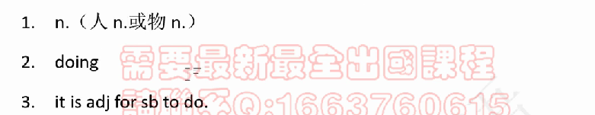

going somewhere is good

[it]形式主语 is adj for sb [to do]真正主语

It is well-known [that……]真正主语

### 给主语前面带一个帽子

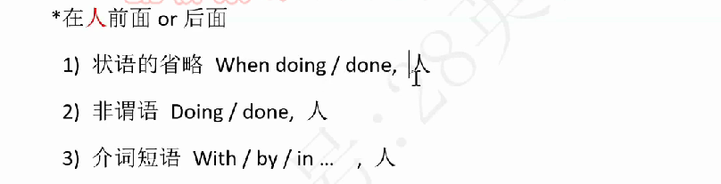

状语省略：后面必须是人（逻辑主语），比如When doing homework, student will learn more knowledge不能说academic performance gets improved.

e.g.做运动帮助学生提高身体健康。

Doing sports help students improve physical health.

Sports help students improve physical health.

It is beneficial for students' physical health to do sports.

Students' physical health will get improved if they do sports.

When doing sports, students' physical health get improved.

By doing sports, students' physical health will get improved.

With sports done, ……

## 特殊句式——强倒更多

### 强调句



把it is和that去掉，这个句子是不是正确的

It is doing sports that improves students' physica health.

It is doing exercise that students students can improve their health.

去掉it is that之后强调的是非谓语

### 倒装

1. Never can sb do

Never can we ignore that

Never can we ignore the significance of A to B（AB同为n，同doing）

Never can we ignore the significance of sports to students' physical health.

Never can we ignore the significance of doing sports to improving students' physical health.

2. only



Only by doing sports can students improve their physical health.



逻辑主语，人才能发出做运动的动作。后面的主语要是动作的发出者。

### 更多



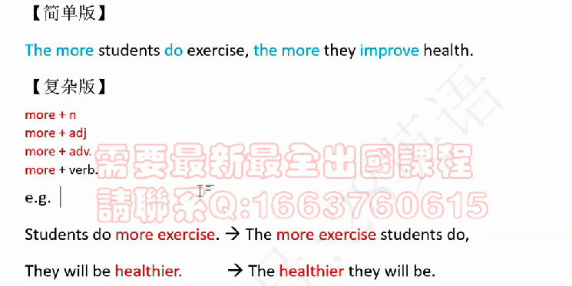

建议写简单版

more修饰n/adj/adv时，more和被修饰的部分一起提前。

修饰v时，单独一个more提前。

e.g. 作业多，成绩高。

复杂版：The more homework students do, the higher grade they will have.

简单版：The more students do homework, the more they get grades.

### 并列反问

并列



Not only can students acquire theoretical knowledge, but also they can obtain practical knowledge.

反问



How can they get promoted in the future if……？

3+3‘：特殊句式 大概1：1 XXY YYX



选项3，已经分好了两个小点：less expensive food & cook at home

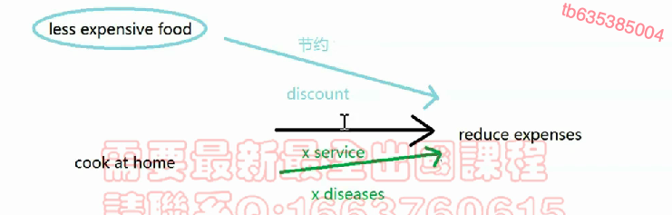

逻辑终点比较小，都要落到**节约钱上**

## In practice

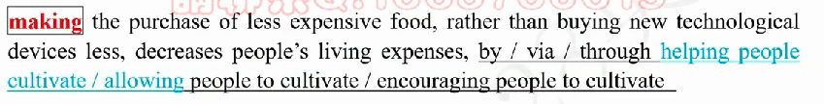

主语是物的话，by / via后面要注意逻辑主语还得是物，所以不能直接cultivate而是help people cultivate

Notices

0. what must be prioritized is that 因为句式本身比较复杂，所以建议用3+3'

1. the more和not only（但这样就要写两点）用在解释上比较好

2. 反对方：[never(under no circumstances); how; it is impossible for sb to do; people find it impossible to do(形式宾语)]

People find it impossible to develop the habit of saving in life, if they only decrease the frequency of buying technological devices, which can be expensive individually.

3. Moreover, [not only可以承上启下]写not only时前面尽量加上一个帽子，这样可以让人做主语



4. 表示句子结果[, which（后面跟三单）; , doing; so ..., and ...]，常用在解释的后面

5. 看到by，when省略等，要注意到逻辑主语

6. by vs via vs through

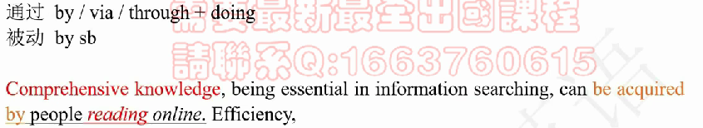

上面这句话用by reading online不够好，因为主语是knowledge而不是人

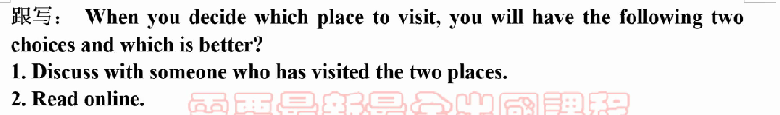

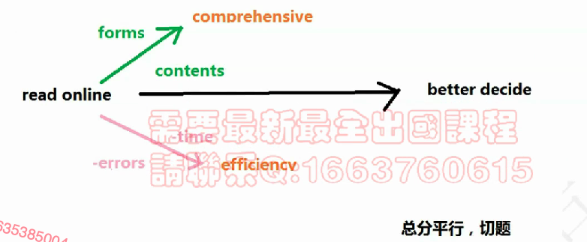

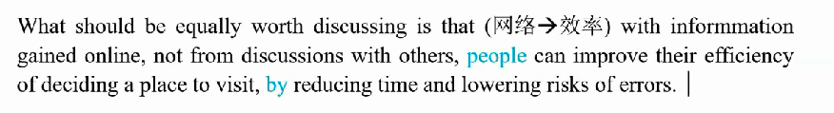

看到by，注意这句话的主语是谁

# 词汇

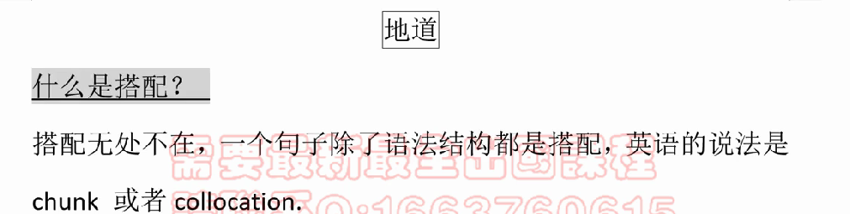

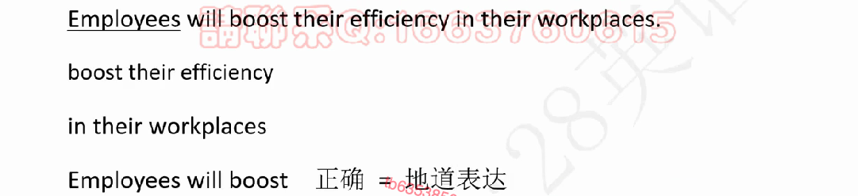

1. 动宾搭配

2. 介词

3. 主谓搭配

**搭配 = 地道 > 丰富**

How to improve:

1. 多背诵多积累

200核心表达

2. 提高搭配意识

表达重复不是ETS最看重的，ETS着重强调的是句式的多样。

成功：success / achievement

个人发展：personal development / growth / advancement

难：hard / difficult / laborious

现在：now / nowadays / in modern time / days

更会：be more likely(inclined) to / tend to

因为：due to / thanks to / owing to

advanced / high-quality / well-designed system

access: have the access to sth.; access本身也是及物; the access to sth. is denied

无法获得的：hard to reach / achieve //// inaccessible / inapproachable

确保：ensure / secure / guarantee

重要的：important / essential / crucial / critical

## 加戏

(easy) access to education and (professional) teachers

## 双拼



两个近义词放在一起，表强调

# timeline

破题 2' no more than 5'

开头段3'（快，不会对成绩造成很大影响）

15' very crucial, you must begin the next explanation paragraph

两个理由段长度差很多结构上会扣很多分

结尾段3'

2'检查：中间段——检查、语法、拼写

