

Beach Notification Data

Flow Configuration Document and Submission Guide
Version: 2.1
Revision Date: 08/25/2008

This page intentionally left blank.
Table of Contents
Table of Contents i
List of Exhibits iii
Acknowledgements 1
1 Introduction 1-1
1.1 Background 1-1
1.2 Document Scope 1-1
1.3 How to Use This FCD 1-2
2 Notification Data Exchange Overview 2-1
3 Configuring the Data Exchange 3-1
3.1 Preparing for the Data Exchange 3-1
3.2 Composing the Notification Data Submission 3-1
3.2.1 Annual Reporting Components 3-3
3.2.2 Periodic Reporting Components 3-3
3.3 Configuring the Data Exchange 3-4
3.4 Submission Processing and Feedback 3-6
Appendix A – Beach Notification Submission Guide 1
A.1 Preparing for Beach Notification Reporting 1
A.1.1 Step 1: Consolidate Beach Data 1
A.1.2 Step 2: Establish CDX Account 2
A.1.3 Step 3: Sync Beaches List with EPA 2
A.1.4 Step 4: Update Required STORET and WQX Data 2
A.2 Preparing the Beach Notification XML file 2
A.2.1 Generating the Beach Notification XML File 3
A.2.2 Reviewing the XML Data before Submitting 4
A.3 Submitting Data and Obtaining Feedback 7
A.3.1 Submitting Beach Notification Data 7
A.3.2 Querying PrAWN 7
Appendix B – Additional Resources 1
B.1 The EPA Beach Program Data User’s Corner 1
B.2 2004 National Beaches Conference Proceedings and Transcripts 1
B.3 EPA STORET Web Interface Module (WebSIM) 1
B.4 EPA Web Reach Indexing Tool (WebRIT) 1
B.5 EPA WQX 1
B.6 EPA CDX 1
B.7 EPA BEACON Web Site 1
B.8 The National Environmental Information Exchange Network 1
B.9 Earth 911 2
B.10 Altova XML Spy 2
B.11 Microsoft’s XML Notepad 2007 2

List of Exhibits
Exhibit 2-1 - Manual Upload of Notification Data to CDX Web 2-1
Exhibit 2-2 - Exchange of Beach Notification Data via the Exchange Network 2-2
Exhibit 3-1 – High-Level Structure of the Beach Notification XML Schema 3-2
Exhibit 3-2 – Data Elements to Include in a Periodic Submission 3-3

This Page Intentionally Left Blank

Acknowledgements

This document is based on an older FCD compiled by Bill Rensmith at Windsor Solutions, and used with the author’s permission. The original document has been modified and updated by CGI Federal. CGI Federal would like to acknowledge the input and support of the following individuals in creating this document:

Erik Richards | CGI Federal
Andrew Hampton | CGI Federal
Bill Rensmith | Windsor Solutions
Charles Kovatch | US EPA
Michael Klos | CGI-AMS
Dennis Murphy | Delaware DNREC
David Edgington | North Carolina DENR/ITS
Jessica Archer | Washington DOE
Deb Soule | New Hampshire DES
Andrew Cornwell | New Hampshire DES
Bob Peeples | Earth911.org
Mike Matsko | New Jersey DEP
Richard Hyjack | New Jersey DEP

This Page Intentionally Left Blank

Introduction

Background
In January of 2000, Congress passed the Beaches Environmental Assessment and Coastal Health Act (BEACH Act). The Act amended the Federal Water Pollution Control Act with the purpose of improving the quality of coastal recreation waters. Each year following the passage of the Act, EPA has awarded grants to coastal states for the purpose of increasing monitoring and notification activities at coastal beaches and recreational use waterways.
Under BEACH Act grant criteria, grantees must report monitoring and notification data to EPA on an annual basis. Monitoring data consists of the results of laboratory analysis of water samples collected at beaches. Notification data consists of information about beach swimming advisories and beach closures which result from either high bacteria levels, rain events, or other causes.
To store the data, EPA built processes and systems to allow states to submit both monitoring and notification data electronically via the EPA Central Data Exchange (CDX) Web portal. For monitoring data, an XML schema was produced which contained data elements needed to transport measurement result data to EPA’s WQX database. A STORET configuration can be used as well. For notification data, EPA developed a separate XML schema and a new EPA database named the Program Tracking, Beach Advisories, Water Quality Standards, and Nutrients (PrAWN) database. Software was developed to allow CDX to parse the incoming XML data into either the STORET or PrAWN database, depending on the submission type.
While the BEACH Act grant guidance only requires annual submission of monitoring data for the previous year, Exchange Network participants soon realized that the submission of data to EPA could be automated using Web services and the Exchange Network. This would allow EPA to receive beach notification data in near “real time” and would alleviate the burden of manually preparing and submitting data annually. Furthermore, this effort lays the groundwork for building a network infrastructure which allows beach notification data to be aggregated, manipulated and displayed from a variety of sources.

Document Scope
A Flow Configuration Document (FCD) defines the supported data services and the approaches and processes that are used to exchange information over the Exchange Network using Web services technology. In addition, the FCD serves as a guide for trading partners to the details and challenges associated with a specific data exchange.
The CDX node supports transmittal of beach notification data. As such, this document focuses on the technical aspects of transmitting notification data to the CDX node via the Exchange Network.
This document captures the exchange of beach notification data over the Exchange Network. This exchange developed as a natural evolution of what can be considered a traditional, regulatory flow where data travels in one direction from state agencies to EPA. Because of this, this exchange serves to replicate this traditional data exchange scenario, however in a more frequent, automated process.
While the current exchange configuration is limited to submitting notification data to the EPA CDX node, expanded capabilities are envisioned for this exchange which would allow authorized external parties to query an exchange partner’s node for data such as current or historical beach closures.
Appendix A – Beach Notification Data Submission Guide is provided to assist beach program managers and BEACH Act grant recipients with all aspects of collecting, preparing and submitting beach notification data to EPA. This guide is intended to supplement the documentation which has previously been made available to BEACH Act grant recipients on the topic of data reporting.
Information in Appendix A will be valuable to both beach program managers and technical staff interested in broadening their understanding of BEACH Act grant reporting. This guide is intended for users who either submit beach notification data using the traditional method via the CDX Web portal or those which automate submission using the Exchange Network.

How to Use This FCD
This FCD does not supersede or replace previous information which has been published for BEACH Act reporting. Rather, this FCD focuses specifically on the exchange of data via Web Services and the Exchange Network. This data exchange mechanism operates in parallel with the existing process of submitting BEACH Act data via the CDX Web interface. This guide is intended to instruct technical staff who wish to implement the automated exchange of beach notification data to EPA.

Notification Data Exchange Overview
As stated, the beach notification data flow is an augmentation of the existing manual process. Typically, this process is performed annually to eliminate the burden of composing a submission file more often than necessary. The following high-level diagrams illustrate the relationship of the Network exchange with the manual process of submitting beach notification data to EPA.

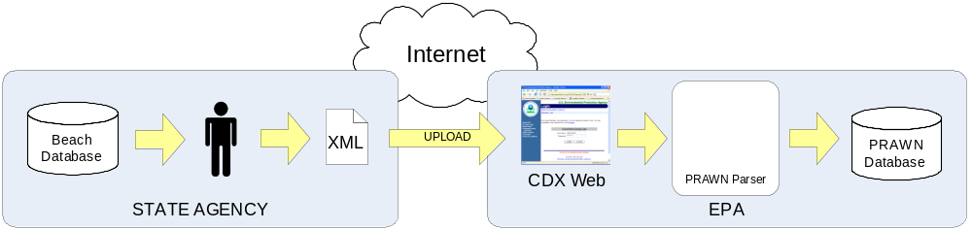

Exhibit 2-1 - Manual Upload of Notification Data to CDX Web

The manual process for submitting notification data to EPA is performed as follows:
- Beach notification data is collected into a database by the state agency
- A staff person composes a XML submission file containing beach advisory and closure data for all records which have not previously been submitted to EPA
- Staff person logs into the CDX Web site and uploads the XML file
- The EPA CDX archives a copy of the submission and performs basic file validity checks.
- EPA CDX passes the XML file to the PrAWN parser, which performs comprehensive validation checks against a set of rules specific to the beach notification data exchange.
- Upon successful validation, the XML data is parsed and stored in the EPA PrAWN database.
- CDX sends an email to the submitter indicating success or failure
The following diagram illustrates how the beach notification data exchange via the Network provides a parallel route for submitting beach notification data to EPA.

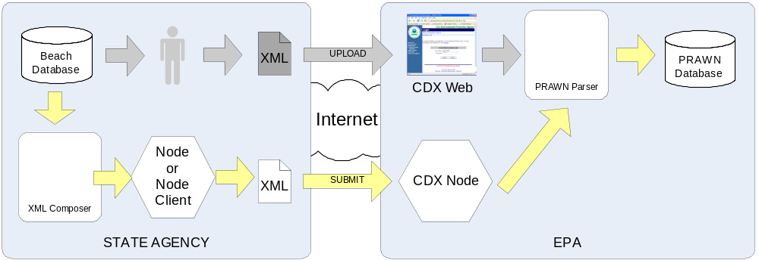

Exhibit 2-2 - Exchange of Beach Notification Data via the Exchange Network

Using the Network to transfer notification data to EPA is performed in these steps:
1. An XML composer utility creates an XML file of all the new beach advisories/closures since the previous successful submission.
2. The XML file is either passed to the state’s Exchange Network node or a node client utility
3. The state’s node or node client utility submits the XML file to the EPA CDX Node.
4. The EPA CDX Node performs file archiving and basic file validation.
5. The EPA CDX Node passes the payload to the PrAWN parser, which performs comprehensive validation checks against a set of rules specific to the beach notification data exchange.
6. Upon successful validation, the XML data is parsed and stored in the EPA PrAWN database.

Configuring the Data Exchange
Once the prerequisites have been satisfied, it is possible to begin transmitting beach notification data over the Exchange Network. This section contains the detailed information needed to configure an Exchange Network node or node client to begin submitting beach notification data to EPA.

Preparing for the Data Exchange
A number of events must take place before beach notification data can be submitted to EPA. These include seeding the PrAWN database with beaches (since beaches can not be added via XML), establishment of CDX Web accounts, and adding of monitoring stations to EPA STORET. Please see the Beach Notification Submission Guide for information on meeting these preconditions.
A total of four user accounts will be needed at EPA CDX; two for the test environment and two for the production environment. Within each environment, one account is needed to access the CDX Web site and one account is needed to access the CDX Node.
Contact the CDX Help desk to obtain user accounts to the CDX Web environment. Before seeking to obtain accounts for the CDX Node, ensure that your agency does not already have an account established. If your agency has one or more data exchanges in production, it is likely that you will not need to obtain a new account.
When you establish accounts with CDX for either the CDX Web or CDX Node, you will be asked which “flow” or data exchange to which you are requesting permission. Be sure that your account is tied to the “beaches” or “e-beaches” data exchange.

Composing the Notification Data Submission
While the BEACH Act grant reporting conditions require only one annual submission of notification data, the submission of this data via the Exchange Network enables reporting of data on a much more frequent basis. Indeed, one of the stated goals of the Network is to promote the timely exchange of data . Reporting beach advisories when they occur (as opposed to a single annual submission) certainly conforms to this goal. As such, this discussion is based on this operating scenario.
The beach notification XML schema was initially designed for the purpose of annual submissions. Due to this, there are special considerations when using the schema for more frequent data reporting. Before these specific considerations are discussed, it is necessary to provide an overview of the beach notification schema structure. The following diagram depicts a high-level view of the schema.
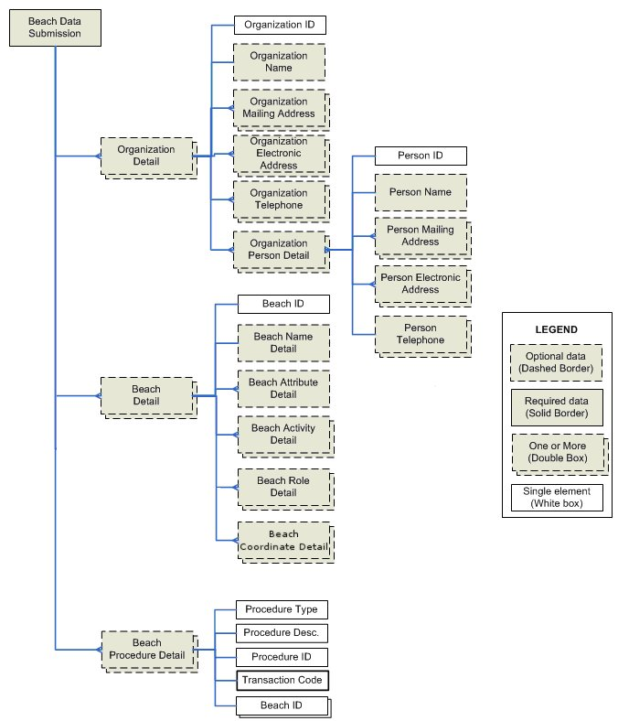
Exhibit 3-3 – High-Level Structure of the Beach Notification XML Schema
Detailed schema information can also be found in the Beach Notification Data User’s Guide (see Appendix B - Additional Resources). Additional information about the schema structure can be found in Appendix A – Notification Data Submission Guide in the section labeled Preparing the Beach Notification XML File. Review these documents and the schema to gain an understanding of the structure and usage of schema components such as transaction codes and unique identifiers.

Annual Reporting Components
It is recommended that each reporter perform a single annual submission which contains Organization Detail and Procedure Detail data. It is only necessary to update this data annually since this information is not likely to change frequently. Furthermore, submitting this data more frequently would create more of a burden on the reporter to track reported and unreported Organizations and Procedures.
The Beach Attribute Detail element contains information about the beach length, swim season length, sampling frequency, pollution sources, beach tier ranking, and an indicator whether or not the beach falls under the beach act for a given year. In the new schema, this information can be submitted multiple times per year. The information in the most recent submission will always be considered authoritative for that year.

Periodic Reporting Components
For more frequent submissions, only certain elements within the Beach Detail should be sent to EPA. Specifically, the submission file should contain elements relating to advisories and closures which have occurred since the last submission. The following diagram illustrates the schema elements which should be transmitted in a periodic update.

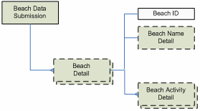

Exhibit 3-4 – Data Elements to Include in a Periodic Submission

The Beach Data Submission Element is the root element of the XML instance file. This element may contain one or more Beach Detail elements. Include one Beach Detail block for each beach which has one or more advisories or closures to report.
The Beach Name Detail element may be omitted from the submission file if the beach has already been added to PrAWN and the beach information has not changed since it was last updated at EPA. Please see Appendix A of this document for more information.
The Beach Activity Detail element contains data about the advisory or beach closure. This element contains data for each of the notifications being reported. Per the schema, most elements within the Beach Activity Detail element are required.
It is important to note is that for each beach notification, the last date of the beach closure (stored in the ActualStopDate element) must be known in advance. For this reason, notification data can not be sent to EPA until the advisory or closure end date is known.
Additionally, due to the potential for overlap of activities on portions of the same beach (activities do not have to encompass an entire beach); it is not possible to determine if duplicate activities have been submitted. For this reason, it is critically important that states maintain tracking on all activities submitted so that they are not submitted more than once. In the event that an activity has been submitted more than once, the only recourse is to work directly with the EPA Beach program manager to correct the mistake.

Configuring the Data Exchange
The workflow described will employ only the simple Submit Network primitive method, with the State or local agency using this method for submission of the XML document. The following table contains the configuration parameters needed to execute the submission.

Business Process |  | Simple Submit
Parameters |  | securityToken: | The authentication ticket issued by the Network Authentication and Authorization Service (NAAS), enabling the data provider to invoke the submit method.
 |  | transactionId: | N/A
 |  | dataflow: | set to “BEACHES”
 |  | documents: | Single nodeDocument structure containing the beach notification XML data.
Timing/Initiation |  | Initiated at the frequency of the submitter’s choosing. Ideally, the exchange will be initiated whenever a new beach advisory/closure is recorded by the state agency. All of prior year’s data must be submitted by January 31st, per BEACH Act reporting requirements.
Payload
 | Schema | BEACHES_Notification_v2.1.xsd
 | Schema Location | http://www.exchangenetwork.net/registry/notificationdata_schema.xsd
 | Naming Convention | *xml - Note It is recommended that the file name contain an identifier for the submitter (such as state abbreviation) and a time stamp. The file name does not affect any aspect of the data exchange.
 | Transport | The file may be sent as XML or compressed in ZIP format in the nodeDocument element.
Header Document |  | N/A
Flow Status/Fault Conditions |  | See following section for a discussion of error feedback processing
Security |  | 1.Submitting operation NAAS account must have authority to invoke the submit and getStatus methods for the BEACHES data exchange.
 |  | 2.Submitting NAAS account must be associated with a corresponding Web CDX account for the purposes of email notifications from CDX about processing status.

Submission Processing and Feedback
The error processing and feedback mechanism for this exchange inherits all of the functionality which is present in the manual upload. A discussion of error handling can be found in section 2.1 of the Beach Notification Data User’s Guide.
Exchange Network (NAAS) user accounts will be linked to legacy CDX accounts for the Beach notification data exchange. This allows the CDX Node to pass a received file into the CDX Web processing chain under the guise of an existing CDX web account. After the submission payload is passed to CDX Web, all processing from that point forward is carried out in the same manner as if the file originated via the CDX Web upload screen.
Please see the EPA Beach Notification Data User’s Guide and the Submitting Data and Obtaining Feedback section in Appendix A of this document for more information.

Appendix A – Beach Notification Submission Guide

A.1 Preparing for Beach Notification Reporting
The beach notification data exchange requires a fair amount of preparatory work before the exchange of data can begin. This section discusses each of the steps which must be taken to prepare for the submission of beach notification data to EPA.

A.1.1 Step 1: Consolidate Beach Data
Develop a Data Collection Strategy
The first and most important step is to implement data collection procedures which simplify the collection, transportation and aggregation of data. Double data entry should be avoided if possible. Consistent data collection and recording is vital. Coordinating data collection becomes more challenging when multiple labs are used, each utilizing different analyses and reporting methods. Many states now perform field data collection using PDA devices. Others have implemented Web-based data entry systems. A wealth of experience and information is now available to those who wish to streamline data collection and processing of beach data.
The 2004 National Beaches Conference provided a forum for data management. Three states and EPA each presented how each agency collects, stores, and shares beach data. The transcripts from these presentations can provide useful information about how to build a suitable data management strategy. Links to the transcripts are found in the Additional Resources appendix.
Develop a Data Repository
Data collection procedures must be coordinated with the development of a data repository. Ideally, a relational database such as Microsoft Access or a more robust platform such as Oracle or SQL Server would be used for this purpose. The Notification Access database provided by EPA may be used if a custom database can not be obtained.
The appendix of this document contains the relational data models of three systems, the EPA PrAWN database and the EPA Access Notification Database (used to create XML files). These models are provided here to assist an agency in determining the requirements for building a local database to store beach notification data.
Obtaining Geographic Datum
Obtaining accurate geospatial data is an important part of collecting beach data. The EPA STORET database relies on latitude and longitude data to plot beaches using EPA’s EnviroMapper and other GIS (Geographic Information System) applications. Three latitude/longitude pairs should be collected for each beach; begin, mid and endpoint.
There are many ways to obtain coordinates for beaches, the most common being to outfit a collector with a GPS unit to record the coordinates when conducting a site visit. A number of computer tools also can provide this information. Desktop applications such as ESRI’s ArcView and Google Earth (http://earth.google.com) both allow for very accurate determination of location coordinates. Web-based tools such as TopoZone (http://www.topozone.com) and EPA Enviromapper (http://www.epa.gov/enviro/emef/) also allow latitude and longitude coordinates to be determined using a combination of aerial photographs, satellite imagery, topographic maps and other means.
A topic of much discussion is the location of beach endpoints. Many coastal beaches do not have a clear beginning and endpoint, as the beach extends for miles along the shoreline without a clear delimiter. In these cases, no precedent for determining beach endpoints has been established at this time.

A.1.2 Step 2: Establish CDX Account
The EPA Central Data Exchange (CDX) is a Web-based application which allows authorized users to submit and retrieve data from EPA systems. A CDX user account must be created in order to submit beach notification data. CDX passwords expire on a regular basis, so be sure to check frequently and update account information as necessary. To obtain a CDX account, contact the CDX helpdesk via phone or email.

A.1.3 Step 3: Sync Beaches List with EPA
The beach notification XML schema does not enable you to create or delete beaches within the EPA PrAWN database. Because of this, it is important to reconcile your list of beaches with those which are stored in the EPA PrAWN database prior to submitting beach notification data to CDX. This can be challenging since it is common for a state’s list of beaches to change over time. For example, new beaches are added to the state database, duplicate beaches are identified and merged, beaches are split into two, and so on.
Coordinate with the EPA beach program manager and EPA contractors to reconcile the state beach list with the EPA list stored in the PrAWN database. For new beaches, EPA Beach ID numbers will be generated and provided to you. It will be necessary to add this identifier to the state beach database since each record in the beach notification XML file must be identified using a prescribed EPA Beach ID.

A.1.4 Step 4: Update Required STORET and WQX Data
All beaches must be defined in the STORET or WQX database. This is required since each beach advisory/closure must also include the station identifier. If the station identifier can not be found by the PrAWN submission parser, an error message will be generated and the submission will be rejected.
Each station must have a minimum of two projects associated with it; one project named “EPABEACH” and one project with the name of the EPA Beach ID, described in the previous section. This allows EPA to query for beach data using either the PrAWN EPA Beach ID or the generic umbrella project “EPABEACH”.
There are two ways in which data can be updated. If the state operates a local version of the STORET Oracle database, then the stations and projects can be added to the local database, a Oracle export file can be created and sent (via FTP) to EPA to be merged with the EPA STORET data. This method will be available through calendar year 2008. The new method for updating beach data is to use a WQX submission. See Appendix B – Additional Resources for links to information about WQX submission.

A.2 Preparing the Beach Notification XML file
This section describes the beach notification XML schema in detail and provides instruction on creating an XML submission file.

Required and Optional Data
Most of the data elements defined by the schema are optional. This enables the creator of a notification data XML instance file to have flexibility in the breadth of data included in a submission file. For example, it is not necessary to define any organizations or procedures in a submission file for the file to be successfully accepted and processed by EPA. This is useful since the schema supports detailed information which may not be collected by states that are required to submit notification data.
Unique Identifiers
Unique identifiers are required for each beach, organization, person, and procedure.
Beach identifiers are provided by EPA for all beaches. Please see the Sync Beaches List with EPA section for more information about this process.
Organization identifiers must be unique within PrAWN. Prefix organization identifiers with your two-character state abbreviation to ensure that ID collisions will not occur with other state’s organizations within PrAWN. Person IDs and Procedure IDs only need to be unique within a given organization.

A.2.1 Generating the Beach Notification XML File
This section discusses methods which can be used to generate the beach notification XML file.
The Beach Notification Access Database
The best option for creating a beach notification XML submission file is to use the Microsoft Access database provided by EPA. EPA has also produced a Quick Reference Guide to assist users in using the Access database. The Quick Reference Guide should serve as a primary reference. Additional helpful information about the database is included in this section. Please see the Additional Resources appendix for information on obtaining the database and documentation.
Before the XML file can be generated using the Access database, the data must be populated into the Access database tables. There are three methods which can be used to populate the tables; direct data entry, copy and paste from other data sources, and SQL queries. Of these, direct data entry is the least preferred method and should be avoided if possible.
The copy and paste method may save time, but it is very easy to introduce serious errors in the data if rows and columns do match up exactly between the data source and the destination table. The paste operation may fail if data does not match the table data type (i.e. pasting text into a numeric field) or if blank (null) data is being written to a required field.
The most preferred method is to use SQL queries. Using this method, data is read from a source table, transformed and/or manipulated, and finally written to a destination table. Each query can be saved and run again at a future time, making the data population process reproducible. This is crucial if you need to recompose a submission file, reuse last years SQL queries for the current year submission, or audit how certain data got into your submission file in the first place. If you choose to use the query method, enlist the assistance of an experienced database programmer or Microsoft Access expert to help with this task.
The order in which tables are populated is important. The following table lists the order in which tables must be populated in the beach notification Access database. Within each step, the order of tables is not important; however the order of steps must be followed.

Step | Tables to Populate
BEACH
ORGANIZATION
PROCEDURE
PERSON
BEACH_ACTIVITY
BEACH_ATTRIBUTE
BEACH_PROCEDURE_ASSIGN
BEACH_ORGANIZATION_ROLE_ASSIGN
BEACH_LATITUDE_LONGITUDE_COORDINATE
MAILING_ADDRESS
TELEPHONE
ELECTRONIC_ADDRESS
BEACH_PERSON_ROLE_ASSIGN
BEACH_ACTIVITY REASON
BEACH_ACTIVITY_STATION

After the tables are populated, follow the directions in the Quick Reference Guide provided by EPA to generate the XML file from the Access database.
Other Methods of Generating XML Data
For the non-technical staff person, the notification Access database provided by EPA is the most viable option for preparing the XML submission file. All other options require the skills of a programmer with experience working with XML data.
The non-profit organization Earth911 also provides services to states which are required to report data under the BEACH Act. Earth911’s Web site enables states to enter beach monitoring data directly. Advisories and closures are posted on the public Web site. Additionally, Earth911 also provides services to prepare and submit beach monitoring data to EPA on behalf of a state agency. Contact Earth911 for more information.

A.2.2 Reviewing the XML Data before Submitting
It is useful to examine the contents of the XML file before submitting to EPA. If there are mistakes, it is best to catch these prior to submitting the data since corrections will require coordination with EPA.
First, examine the data in the Access database closely for inconsistencies or mistakes. This is the easiest way to identify problems since data is easily viewed in tabular format.
After the file is generated, there are several ways to examine the contents of the submission file. The XML file can be opened using your web browser, such as Microsoft Internet Explorer. It is possible to expand and collapse each section of the file using the plus (+) and minus (-) signs next to each node.

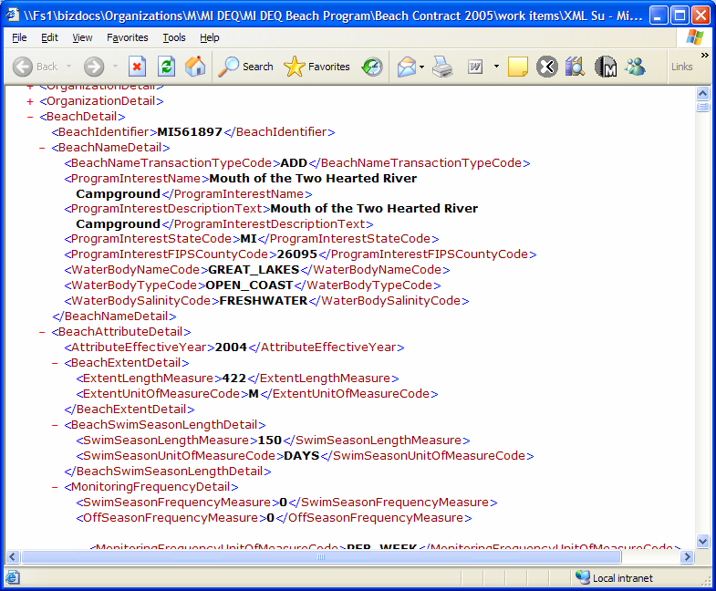

Exhibit A-1 - Viewing XML Data Using Internet Explorer

Other utilities provide a much better look at the contents of an XML file. The most common utility is Altova XMLSpy which can be downloaded from the Altova Web site. This tool allows a user to see a summary of the data in the XML file (such as the count of records in each section) as well as view and edit data.

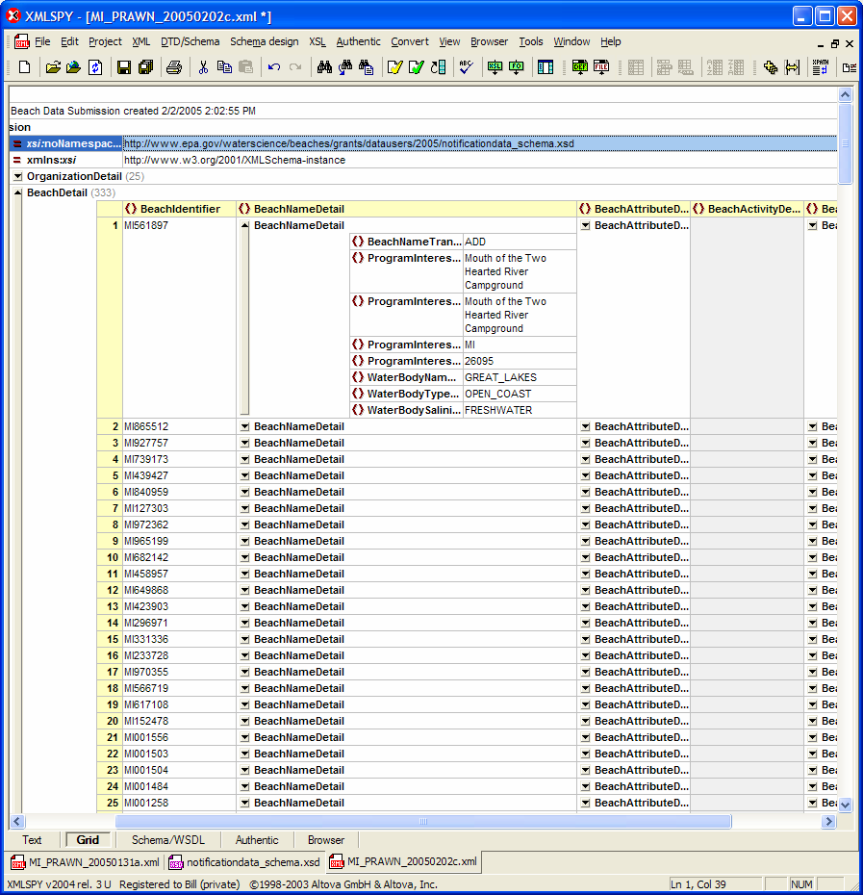

Exhibit A-2 – Viewing XML Data Using Altova XML Spy

Lastly, it is possible to validate the XML file prior to submission. Validation is the process by which the XML file is checked against the rules in the schema. If the file is not valid, an error message will indicate the data which violates the schema rules. XMLSpy is capable of validating an XML file against the schema.

A.3 Submitting Data and Obtaining Feedback
This section contains information on uploading the beach notification XML file to CDX, obtaining feedback and other useful information.

A.3.1 Submitting Beach Notification Data
Once the submission file has been created, it is important to keep a copy of the submission file for future reference. Saving the file to a network location that is regularly backed up will help ensure that the file will not be lost.
Beach notification XML files should be uploaded to EPA via the CDX Web site. Instructions are provided in the Beach Notification Data User’s Guide provided by EPA. The uncompressed file size may not exceed 5 MB in size.
The CDX system archives the submission and passes a copy to the PrAWN processor. It is the PrAWN processor that examines the data in the submission file and checks against a series of rules. If data within the submission file violates any of the rules defined in the PrAWN processor, an error report is generated. The errors are sent via email to the CDX account holder. A copy of the error report is also sent to the user’s CDX Inbox, which is available once logged into the CDX Web site. Upon successful processing of the submission file, an email is also returned to the submitter indicating that the file was processed successfully.

A.3.2 Querying PrAWN
The PrAWN database is internal to EPA. Data from PrAWN is replicated into a database which is accessible via the Internet through the EPA BEACON application. Beach notification data is not regularly replicated to the BEACON web site, so do not expect a submission made recently to be reflected in the data available using BEACON.

Appendix B – Additional Resources

B.1 The EPA Beach Program Data User’s Corner
Contains links to relevant information about BEACH Act data reporting including XML schema, the Notification Access database and user’s guides. This is the first place to check for information related to BEACH Act grant reporting.
http://www.epa.gov/waterscience/beaches/grants/datausers/

B.2 2004 National Beaches Conference Proceedings and Transcripts
The document named “Part 3” contains presentations from EPA and three other states describing how each entity collects, stores, and shares beach data
http://www.epa.gov/waterscience/beaches/meetings/2004/

B.3 EPA STORET Web Interface Module (WebSIM)
Information about registering for and accessing STORET via the Internet
http://www.epa.gov/waterscience/beaches/grants/datausers/2005/UserGuideSTORETWebReg.pdf
http://www.epa.gov/waterscience/beaches/grants/datausers/2005/UserGuideSTORETWebSIMv2004Nov.pdf

B.4 EPA Web Reach Indexing Tool (WebRIT)
A Web-based utility which allows users to derive latitude and longitude coordinates for beaches.
http://www.epa.gov/waterscience/beaches/grants/datausers/2005/UserGuideWebRITBeachTips.pdf
http://www.epa.gov/waterscience/beaches/grants/datausers/2005/UserGuideWebRITTutorial.pdf

B.5 EPA WQX
General information about WQX
http://www.epa.gov/storet/wqx.html

B.6 EPA CDX
EPA’s Web portal for uploading beach notification XML files
http://www.epa.gov/cdx (helpdesk: 1-888-890-1995 or email epacdx@csc.com)

B.7 EPA BEACON Web Site
EPA’s Web-based system for retrieving data from the PrAWN database
http://oaspub.epa.gov/beacon/beacon_national_page.main

B.8 The National Environmental Information Exchange Network
This web site contains information about the NEIEN including the Beaches data exchange using the Exchange Network.
http://www.exchangenetwork.net

B.9 Earth 911
Earth 911 is a non-profit organization which provides beach notification data collection and display services via the Internet, among many other services.
http://www.earth911.org and http://www.beaches911.org

B.10 Altova XML Spy
A utility to help compose, view and validate XML files
http://www.altova.com/en/

B.11 Microsoft’s XML Notepad 2007
A free utility to help compose, view and validate XML files
https://www.microsoft.com/downloads/details.aspx?familyid=72D6AA49-787D-4118-BA5F-4F30FE913628&displaylang=en

BEACH Act reporters may add monitoring results to a local copy of the STORET database, create an export file, and transfer the file to EPA to be merged with the EPA database. This topic is convered in detail in Appendix A under the section labeled Step 4: Update Required STORET data.
Please see section 4.2 of the NPAT Exchange Network Business Plan available at http://www.epa.gov/oeiinter/imwg/pdf/business_plan.pdf for more information.
SQL, or Structured Query Language, is a standard language used to retrieve and manipulate data in a database.
Please see Appendix B – Additional Resources for contact information.
Please see the Additional Resources Appendix for more information on downloading this utility.
For best results, place a copy of the notification data schema files in the same directory as your XML instance file. This will ensure that XMLSpy can find the schema in order to perform validation.

