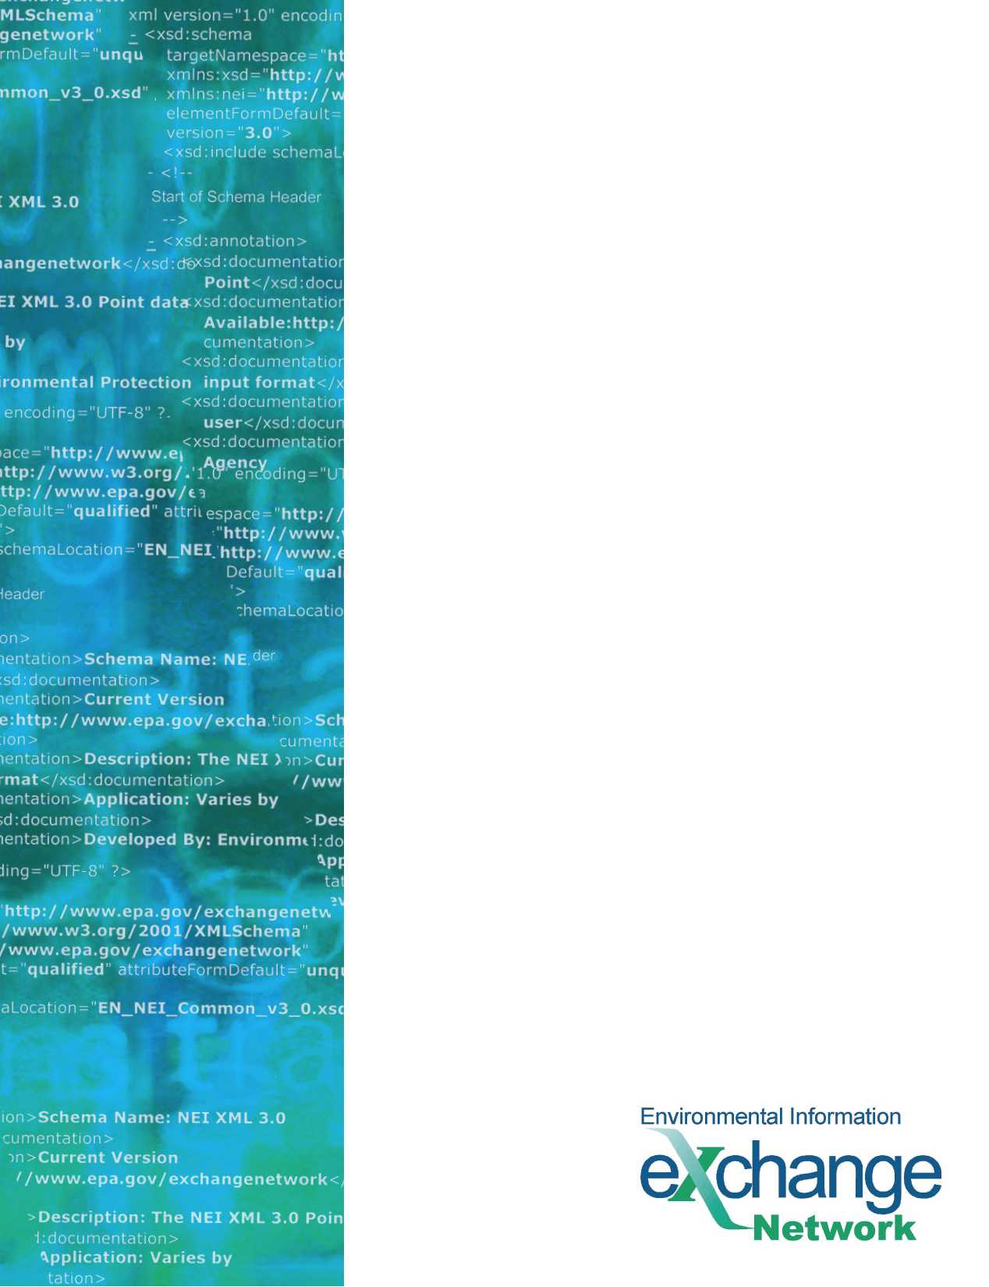
Node 2.0 Compatibility
Guidelines for the
Water Quality Exchange v2.0 (WQX)
Flow Configuration Document Addendum

Version: 2.0b
Revision Date: 2/3/2009

Prepared for: Environmental Council of States (ECOS)
Prepared by: Windsor Solutions, Inc.

Version and Component Alignment
This is the original release of this document. The version number has been set to 2.0 to align with the version of the WQX FCD to which this document relates.
The following table indicates the versions of related documents and components to which this document applies.
Component | Version(s) Supported | Explanation (optional)
FCD | v1.0, v2.0
Schema | v1.0, v2.0

Web Service Methods
This addendum to the Water Quality Exchange (WQX) v2.0 Flow Configuration Document (FCD) describes how the WQX services must be implemented on a Specification v2.0-compliant node. A separate document available on the Exchange Network website describes the approach and methodology used to develop these flow compatibility guidelines.
To obtain the endpoint URL for the Node v2.0 implementation of the WQX v2.0 exchange, please visit this link on the Exchange Network wiki: http://www.exchangenetworkwiki.com/wiki/index.php/Node_Endpoints_at_U.S._EPA%27s_Central_Data_Exchange.

Authenticate
As with all Node 2.0 interactions, credentials must be authenticated and tokens validated against NAAS v3.0.

Submit
Specification v2.0 introduces three new parameters to the Submit operation: flowOperation (required), recipients (optional), and notificationURI (optional). How each new parameter should be implemented for WQX v2.0 Submit operations is described below.

dataflow Parameter
Data requestors must include the text “WQX” as the dataflow name for all requests.

flowOperation Parameter
Submitters must pass the value “default” in the flowOperation parameter. The submitter must provide a value as it is required by the Specification v2.0 WSDL. This value will be ignored by CDX.

recipients Parameter
Submitters should not specify any recipient information in the request. If any recipient information is included, it will be ignored by the CDX node.

notificationURI Parameter
Submitters should not specify any notificationURI information in the request. If any notification URI information is included, it will be ignored by the CDX node.

Exchange Network Header Usage
The WQX v2.0 exchange will continue to use Header v0.9 for both Node v1.1 and v2.0 implementations.

Submit Response
CDX must return a status and status text as required by the Specification v2.0. How the status is determined shall be a decision for CDX. It is anticipated that CDX will simply return a status of “received” in the synchronous Submit response.

Download
As specified in the FCD, implementers must include the text “WQX” in the dataflow parameter for Download operations.

Query/Solicit
Specification v2.0 introduces two major changes to the Query operation: the introduction of a required dataflow parameter and the introduction of a strongly typed parameter list. The implication of each change is discussed below.

Dataflow Parameter
As with the WQX v1.0 implementation, data requestors must include the text “WQX” in the dataflow parameter.

Parameters Parameter
WQX implementers shall use the parameter names exactly as specified in the WQX v2.0 FCD. The datatype parameter may be safely omitted from the request since the name is adequate for the receiving node to process the parameter values correctly.

The NAAS v3.0 test endpoint is https://naas.epacdxnode.net/xml/auth_v30.wsdl. The production endpoint is https://cdxnodenaas.epa.gov/xml/auth_v30.wsdl

