

Development Plan

Virtual Reality Training Tool



January 25, 2023

Jeremy Cavallo, Luka Cvetko, Slav Ivaskiv, Robert Tedeschi

Table of contents

Project Overview 1

Scope, Purpose, and Objectives 2

Team Organization 2

Problem Resolution Policy 3

Project Plan 3

Configuration Management Plan 4

Technology 4

# Project Overview

Currently, CPR and basic medical training is only accessible through online instruction and physical classes. These methods present two problems: online classes lack hands-on experience in medical training, while in-person classes often cost money and are inconvenient to attend. Our solution to this problem is to create a virtual reality training tool that will be widely accessible to anyone with a VR headset. This tool will supply hands-on experience in the comfort of the user’s own home, and will teach various medical tools everyone should know, such as CPR, the Heimlich Maneuver, and more.

# Scope, Purpose, and Objectives

This project provides a virtual reality tool that will make basic medical training accessible to anyone with a VR headset. This tool will be a cheap alternative to in-person classes and will be more convenient for the user. Also, in comparison to online video lessons on the given topics, our tool will provide the user with more hands-on experience through a virtual reality setting. This means our users will be more prepared for real-world scenarios than those who only use online resources to learn these topics.

The scope of the project is to cover the basic medical tools and procedures everyone should know. These include CPR and resuscitation, the Heimlich maneuver, bandaging wounds, dealing with head trauma, and applying a tourniquet. For each of these tools, we will supply basic training within the virtual setting, then ask the users to carry out a test. The user’s performance will be tracked, and feedback will be given to them at the end of the test. The goal is that, after the user has received a passing test score on each scenario, they will be able to recognize when to use the tool and how to apply the tool to save someone’s life in the real world. Our scope does not include car accident first aid, motorcycle accident first aid, shrapnel wounds, or heat stroke.

Our objective with this project is to deliver a VR simulation tool that has four different scenarios. Each scenario will teach the user useful and correct medical first aid for common encounters that everyone should know. The scenarios are bandaging a wound and applying tourniquet, CPR and resuscitation, the Heimlich maneuver, and handling head trauma. Each scenario will start with a brief but detailed explanation (with visual aid) of the equipment being used, when to use it, and how to use it properly. The user will then be walked through using said equipment step by step. Any misuse will cause an alert to pop up informing the user of the proper way to use that equipment. After the user successfully completes the walk-through, the user will be prompted to do the simulation again, without any help. Upon completion of the scenario, the user will be shown the report with each step being evaluated as pass or fail.

# Team Organization

For this project, Jeremy will be the team lead. He has leadership experience from his job and athletic career as a captain of the Cross-Country team. He knows what it takes to lead a group and will ensure everyone is doing their part and staying on track. He is also the UI/Frontend lead since he has experience developing user interfaces from his app development endeavors. He will also serve as the backup documentation lead.

Robert will be the documentation lead for this project and will handle proofreading documents prior to submission and ensuring the formatting is correct and consistent. He will also serve as the backup quality assurance lead and the backup UI/Frontend lead.

Slav will be the presentation lead this project and will handle completing our presentations. This includes ensuring text is readable and minimal, images and graphics are of high quality, and all slides are numbered properly. He will also be the quality assurance lead, which means he will oversee the overall quality of the project in terms of visual quality, performance quality, and general code quality.

Finally, Luka will be the backend lead for this project and will oversee the organization of files and data within the project. If our project ends up requiring a database, he will handle keeping it organized and functional. He will also serve as the backup presentation lead.

For each of the above leadership roles, the section leader will have the final say in their given area of leadership. That is, the documentation lead will have the final say in what is included in a document, the formatting, and the submission of the document. The same goes for all other leadership roles. If the leader needs a second opinion or for some reason cannot fulfill their duty, the backup will step in and aid the leader. Any of the section leaders can also turn to the team lead, Jeremy, if they need help as well.

# Problem Resolution Policy

For this project, we will follow a three-strike policy. The first time a group member misses a meeting unexcused or does not deliver a piece of code without reason, we will discuss the issue within the group and attempt to solve it ourselves. The second time a team member misses or does not deliver, we will turn to the Graduate Teaching Assistant for aid in dealing with the situation, and if that does not solve the issue, we will ask the professor for assistance on the third strike.

When a team member makes a pull request on GitHub, we have a discord bot set up in our server to alert everyone that a pull request was made. Before being merged, at least one other group member will need to review the code and resolve any conflicts. This helps to ensure that no code with issues is merged with our main branch.

If there are disputes on technology, we will simply take a team vote between the different options at hand, and the technology that the majority chooses will be used. Since our group has 4 people, if it is split 2 and 2, we will ask the TA to break the tie and select the technology or propose a different one that they think is more suited for the task.

# Project Plan

During this project, we plan to meet as a group 3 times per week. Of those 3 meetings, one will be with the Graduate Teaching Assistant. This will ensure that we are all on the same page, and if someone is stuck, they can get help quickly. Jim is our client this semester, and we plan to meet with him one day a week for at least an hour.

Weekly Schedule:

* Team meetings: Monday before/after class, Tuesday 2:30pm, Thursday 3:00pm, Sundays as needed
* Meeting with TA: Not determined yet, will be decided based on TA’s schedule
* Meeting with Client: Thursdays at 3:00pm

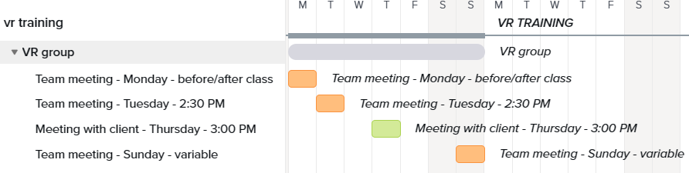

*Figure 1. Gantt chart representing the weekly meeting schedule of the team*

Schedule:

* 2/3 First Prototype: Basic menus will be functional, each training scenario will take the user to a different room, with some interactable 3D objects.
* 2/12 Requirements: SRS document, including all functional and non-functional requirements
* 2/26 Design Specification
* 3/3 Second Prototype: Information about how to carry out the scenarios will be displayed, as well as most of the 3D assets being present and functional.
* 3/24 Third Prototype: All critical functionality tested and working, only some UI updates, polishing, and minor tests remain.
* 4/2 Test Plan
* 4/16 Final Prototype: Project should be finished, including all UI updates and testing of all features

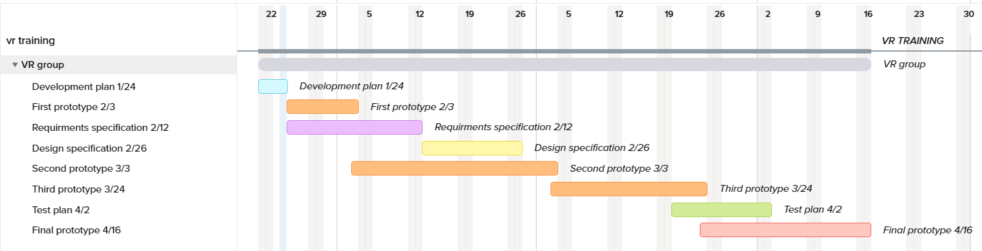*Figure 2. Gantt chart representing the flow of the project with assigned due dates.*

# Configuration Management Plan

The team will use GitHub Project with Kanban board configuration. Issues will be linked to it, so the team and Graduate Teaching Assistant can easily see the visual representation of the current progress of the project.

GitHub was also selected to host the codebase and any changes made to the code will be pushed to the remote repository. Our repository will have a separate development branch for each group member. Members are to commit their changes to their branch. Once team members complete feature development, they will create a pull request to have it reviewed by other team members. Once a pull request is created, it must be reviewed by at least one team member before it can be merged into the main branch. This will ensure our main branch remains intact and limited in bugs. Once the review is finished, code will be merged into the main branch. On the GitHub repository, the main branch will be protected to not allow direct commits.

Documentation and supplemental materials (assets) required for feature functionality that cannot be hosted on GitHub will be shared amongst group members in a shared OneDrive folder, so each team member can easily get features running on their system.

# Technology

Our project will utilize the Unity engine for development (editor version 2021.3.17f1). This relies on the C# programming language. Unity comes with a built-in API which will be used heavily to implement the features selected for implementation. Project will mainly target Oculus VR platform with Rift and Quest 2 headsets used for testing. Blender (V3.4.1) will be used for 3D modelling.