EVIDENCE TEMPLATE

Name:

91878v1 and 91880v1

Develop a design for a digital outcome.

Develop a digital media outcome.

Develop a design for a digital outcome.

# Key requirements for the design ( For Achieve)

|  |
| --- |
| Who is the site for? Who are the end users? |
|  |

|  |
| --- |
| What is the site supposed to do? What are the specifications. What is the purpose of the website? |
|  |

## Elements of good design (Based on Research) ( For Achieve)

Based on the designs you’ve looked (researched at) write down a list of things you think make a good design and things that are bad in a design. You should include the good things in your design and make sure you have NONE of the bad things! Do reference the website if you are especially telling thing about that website or include a snapshot.

|  |  |
| --- | --- |
| Good design elements | Bad design elements |
|  |  |
|  |  |
|  |  |
|  |  |
|  |  |

|  |  |  |
| --- | --- | --- |
| **Colour** | **Hex code** | **Why did you choose this colour? What do your stakeholders think about it?** |
|  |  |  |
|  |  |  |
|  |  |  |
|  |  |  |
|  |  |  |

|  |  |  |  |
| --- | --- | --- | --- |
| **Font** | **Purpose** | **Decoration** | **Reason for choosing** |
| **E.g.**  **Comic sans** | H1 | Burgundy, Underlined left align | Comic sans projects a immature, informal and childish mood which is perfect for my site. |
|  |  |  |  |
|  |  |  |  |
|  |  |  |  |

3). Generating design Ideas: At least three wireframes of the Index page (Main page and other pages) of the website. (For Achieve)

4). Choose one wireframe of index page and other pages out of three and describe why you choose that one, and then include colour, text, images and font in the chosen wireframes) and call it a Design or Mock-up. Show feedbacks (For Achieve)

|  |
| --- |
| 5) Improvements in the Design (before and after screenshots with explanation) based on stakeholder feedback and self-evaluation. (For Merit) |

6) Explain how the most relevant implications (at least 3) applies to you. Describe the Relevant Implication. Explain how the implication applies to the outcome. Explain what the outcome needs to do or to include to meet the implication.

7). Fitness for purpose (For Excellence)

Justifying, with evidence, that the chosen design is suitable for the purpose and end users. There may also be annotations on the finished design showing suitability.

Show the below using screenshots annotations and explanations on the finished design:

|  |  |
| --- | --- |
| The brief said I had to produce according to | |
|  | My design meet this because it has this and that… |
| End user Requirements |  |
| Research: |  |
| Feedback: |  |
| The brief said the design had to: | |
|  | My design meet this because it has this and that… |
| Purpose |  |
| Relevant Implications |  |
| Aesthetic elements |  |

Develop a digital media outcome

1). Development and Test Digital Media outcome (For Achieve)

Evidence of Development and testing your Digital media outcome. Include the following evidence:

* 1. Organise a site folder (HTML and image files) and screenshot this

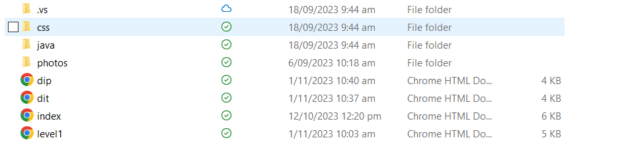

* 1. Edit Images: cropping / image resizing using a graphics application, show before and after images



Changed color from black to white in photoshop.

2). TESTING LOGS

|  |  |  |
| --- | --- | --- |
| TESTING LOGS / JOURNAL – RECORD DAILY LOGS OF TESTING WITH SCREENSHOOTS AND ANNOTATIONS AND EXPLANATIONS. WHAT PROBLEM YOU FACED AND HOW DID YOU FIXED IT TO IMPROVE THE WEBSITE | | |
| DATE AND PROBLEM FACED, HOW DID YOU FIXED IT. | BEFORE SCRENSHOT WITH EXPLANATION | AFTER SCREENTSHOTS WITH EXPLANATION. HOW DID IT IMPROVED THE QUALITY OF OUTCOME. SHOW REFINEMENTS (EXCELLENCE) |
|  |  |  |
|  |  |  |
|  |  |  |
|  |  |  |
|  |  |  |
|  |  |  |
|  |  |  |
|  |  |  |
|  |  |  |
|  |  |  |
|  |  |  |
|  |  |  |
|  |  |  |

|  |  |  |
| --- | --- | --- |
| **ASPECT TESTED** | **HOW DID YOU TEST IT? Show it with SCREENSHOTS with annotation and explanations** | **How well is this implication addressed? Show it with SCREENSHOTS with annotation and explanations** |
| **Social / Cultural / Ethical** |  |  |
| Are text and images appropriate for all users? |  |  |
| Could anything here be offensive? |  |  |
| Is it culturally appropriate? Is Te Reo used? Used correctly? |  |  |
| **Legal / Intellectual Property** |  |  |
| Are all images and text copyright free? | Yes, I got all my photos from either the bdsc website or checked the copywrit. |  |
| Have I declared my own copyright? |  |  |
| **Usability / Functionality** |  |  |
| Test site in different web browsers  (e.g. Chrome, Firefox, IE) |  |  |
| Test links and menus all work |  |  |
| Check fonts and images display properly |  |  |
| **Accessibility** |  |  |
| Is site readable? |  |  |
| Test site on different screen sizes and devices |  |  |
| Is it readable to colour blind users? |  |  |
| **Aesthetics** |  |  |
| Check text is accurate (spelling and grammar) |  |  |
| Does it look good? |  |  |
| **Future-proofing** |  |  |
| [Validate](https://validator.w3.org/) your HTML code |  |  |
| Check code for good layout and commenting |  |  |
| **End User Considerations** |  |  |
| What specific needs do your end users have? Age? Sex? Disabilities? |  |  |

**(Optional: You can also create a screen cast as an evidence of testing)**