# Hbase升级后有大量RIT

# 1、背景

HDP2.6升级->HDP3.1

对应

Hbase1.x->Hbase2.1.6

* 启动后，有大量RIT超时
* Procedure中卡住了很多AssignRegion Procedure
* 部分表scan limit10 查询结果为0 row
* 部分表scan limit10 查询结果RS不在线

# 2、查询RS日志

2020-10-24 20:07:53,316 WARN [RS_OPEN_REGION-regionserver/xxxxxx:60020-14] regionserver.HRegion: Failed initialize of region= xxx_CUSTOMER_GROUP_20201021,,1603044003394.18e8a61d5e580c0c8f767b6dd710a40a., starting to roll back memstore  
  
java.io.IOException: java.lang.IllegalArgumentException: No enum constant org.apache.hadoop.hbase.io.encoding.DataBlockEncoding.PREFIX_TREE  
 at org.apache.hadoop.hbase.regionserver.HRegion.initializeStores(HRegion.java:1096)  
 at org.apache.hadoop.hbase.regionserver.HRegion.initializeRegionInternals(HRegion.java:944)  
 at org.apache.hadoop.hbase.regionserver.HRegion.initialize(HRegion.java:900)  
 at org.apache.hadoop.hbase.regionserver.HRegion.openHRegion(HRegion.java:7274)  
 at org.apache.hadoop.hbase.regionserver.HRegion.openHRegion(HRegion.java:7232)  
 at org.apache.hadoop.hbase.regionserver.HRegion.openHRegion(HRegion.java:7204)  
 at org.apache.hadoop.hbase.regionserver.HRegion.openHRegion(HRegion.java:7162)  
 at org.apache.hadoop.hbase.regionserver.HRegion.openHRegion(HRegion.java:7113)  
 at org.apache.hadoop.hbase.regionserver.handler.OpenRegionHandler.openRegion(OpenRegionHandler.java:283)  
 at org.apache.hadoop.hbase.regionserver.handler.OpenRegionHandler.process(OpenRegionHandler.java:107)  
 at org.apache.hadoop.hbase.executor.EventHandler.run(EventHandler.java:104)  
 at java.util.concurrent.ThreadPoolExecutor.runWorker(ThreadPoolExecutor.java:1142)  
 at java.util.concurrent.ThreadPoolExecutor$Worker.run(ThreadPoolExecutor.java:617)  
 at java.lang.Thread.run(Thread.java:745)  
Caused by: java.lang.IllegalArgumentException: No enum constant org.apache.hadoop.hbase.io.encoding.DataBlockEncoding.PREFIX_TREE  
 at java.lang.Enum.valueOf(Enum.java:238)  
 at org.apache.hadoop.hbase.io.encoding.DataBlockEncoding.valueOf(DataBlockEncoding.java:31)  
 at org.apache.hadoop.hbase.client.ColumnFamilyDescriptorBuilder$ModifyableColumnFamilyDescriptor.lambda$getDataBlockEncoding$2(ColumnFamilyDescriptorBuilder.java:801)  
 at org.apache.hadoop.hbase.client.ColumnFamilyDescriptorBuilder$ModifyableColumnFamilyDescriptor.lambda$getStringOrDefault$0(ColumnFamilyDescriptorBuilder.java:703)  
 at org.apache.hadoop.hbase.client.ColumnFamilyDescriptorBuilder$ModifyableColumnFamilyDescriptor.getOrDefault(ColumnFamilyDescriptorBuilder.java:711)  
 at org.apache.hadoop.hbase.client.ColumnFamilyDescriptorBuilder$ModifyableColumnFamilyDescriptor.getStringOrDefault(ColumnFamilyDescriptorBuilder.java:703)  
 at org.apache.hadoop.hbase.client.ColumnFamilyDescriptorBuilder$ModifyableColumnFamilyDescriptor.getDataBlockEncoding(ColumnFamilyDescriptorBuilder.java:800)  
 at org.apache.hadoop.hbase.regionserver.HStore.<init>(HStore.java:269)  
 at org.apache.hadoop.hbase.regionserver.HRegion.instantiateHStore(HRegion.java:5746)  
 at org.apache.hadoop.hbase.regionserver.HRegion$1.call(HRegion.java:1060)  
 at org.apache.hadoop.hbase.regionserver.HRegion$1.call(HRegion.java:1057)  
at org.apache.hadoop.hbase.regionserver.HRegion$1.call(HRegion.java:1057)  
 at java.util.concurrent.FutureTask.run(FutureTask.java:266)  
 at java.util.concurrent.Executors$RunnableAdapter.call(Executors.java:511)  
 at java.util.concurrent.FutureTask.run(FutureTask.java:266)  
 ... 3 more  
2020-10-24 20:08:28,637 ERROR [RS_OPEN_REGION-regionserver/xxxxxx-0614:60020-12] handler.OpenRegionHandler: Failed open of region=xxx_CUSTOMER_GROUP_20201026,,1603476004706.fde73d133e593736716715de39cef600.  
java.io.IOException: The new max sequence id 1 is less than the old max sequence id 5  
 at org.apache.hadoop.hbase.wal.WALSplitter.writeRegionSequenceIdFile(WALSplitter.java:697)  
 at org.apache.hadoop.hbase.regionserver.HRegion.writeRegionCloseMarker(HRegion.java:1167)  
 at org.apache.hadoop.hbase.regionserver.HRegion.doClose(HRegion.java:1702)  
 at org.apache.hadoop.hbase.regionserver.HRegion.close(HRegion.java:1516)  
 at org.apache.hadoop.hbase.regionserver.HRegion.close(HRegion.java:1466)  
 at org.apache.hadoop.hbase.regionserver.HRegion.openHRegion(HRegion.java:7287)  
 at org.apache.hadoop.hbase.regionserver.HRegion.openHRegion(HRegion.java:7232)  
 at org.apache.hadoop.hbase.regionserver.HRegion.openHRegion(HRegion.java:7204)  
 at org.apache.hadoop.hbase.regionserver.HRegion.openHRegion(HRegion.java:7162)  
 at org.apache.hadoop.hbase.regionserver.HRegion.openHRegion(HRegion.java:7113)  
 at org.apache.hadoop.hbase.regionserver.handler.OpenRegionHandler.openRegion(OpenRegionHandler.java:283)  
 at org.apache.hadoop.hbase.regionserver.handler.OpenRegionHandler.process(OpenRegionHandler.java:107)  
 at org.apache.hadoop.hbase.executor.EventHandler.run(EventHandler.java:104)  
 at java.util.concurrent.ThreadPoolExecutor.runWorker(ThreadPoolExecutor.java:1142)  
 at java.util.concurrent.ThreadPoolExecutor$Worker.run(ThreadPoolExecutor.java:617)  
 at java.lang.Thread.run(Thread.java:745)  
2020-10-24 20:08:29,176 INFO [RpcServer.priority.FPBQ.Fifo.handler=18,queue=0,port=60020] regionserver.RSRpcServices: Open xxx_CUSTOMER_GROUP_20201023,,1603216803826.b1ddf4aeec528550fb45d39713d2980d.

# 3、解决办法

#升级前检查所有表的DataBlockEncoding是否合适.验证所有列族并打印出任何不兼容性。：  
./bin/hbase pre-upgrade validate-dbe

存在不合适的表：  
2018-07-13 09:58:32,028 WARN [main] tool.DataBlockEncodingValidator: Incompatible DataBlockEncoding for table: t, cf: f, encoding: PREFIX_TREE   
  
这意味着表t，列族f的数据块编码不兼容。要修复，请在 HBase shell 中使用alter命令  
alter 't', { NAME => 'f', DATA_BLOCK_ENCODING => 'FAST_DIFF' }   
或者  
alter 't', { NAME => 'f', DATA_BLOCK_ENCODING => 'NONE' }

所有表都合适
  
2020-10-25 04:17:22,153 INFO [main] tool.DataBlockEncodingValidator: The used Data Block Encodings are compatible with HBase 2.0.

DataBlockEncoding是表的属性，value值可以为如下图

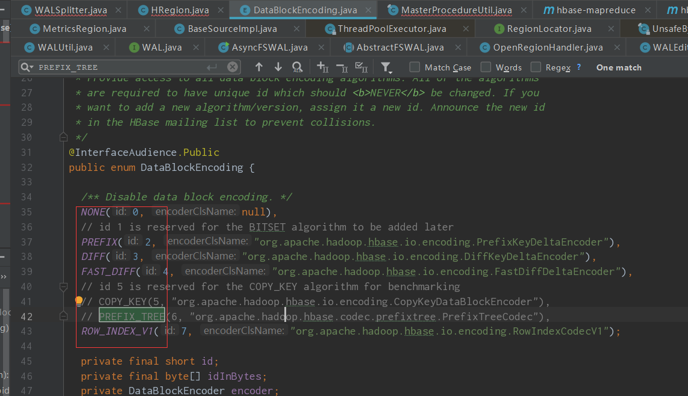

上图是Hbase2.1.6版本中DataBlockEncoding属性对应的代码，在2.x中，因为DataBlockEncoding的value值为PREFIX*TREE时在1.x中表现的不稳定性。移除注释了PREFIX*TREE。

所以**如果Hbase升级没有注意到有表的DataBlockEncoding属性为PREFIX_TREE**

**则在升级后可以选择去alter这个属性（最好是升级前做检查，进行修改比较稳妥）**