## Your deliverables are as follows:

* Completed Data Model – 25 pts.
* Table creation script – 5 pts.
* Created tables in schema – 25 pts.

Since the Data model and the SQL script are the only 2 files you have, you will submit them with the assignment.

Data Model

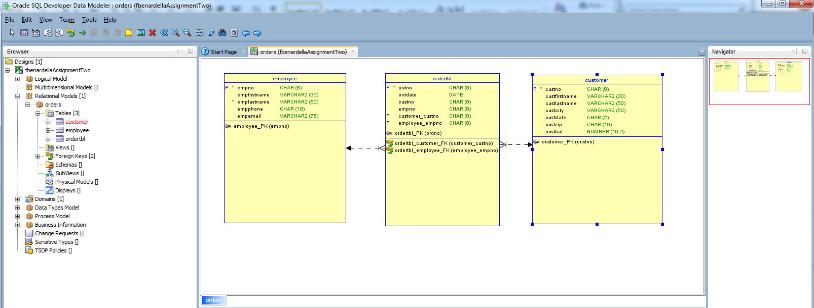

Table Create Script:

-- Generated by Oracle SQL Developer Data Modeler 4.1.1.888

-- at: 2015-09-19 19:56:10 MST

-- site: Oracle Database 11g

-- type: Oracle Database 11g

CREATE TABLE customer

(

custno CHAR (8) NOT NULL ,

custfirstname VARCHAR2 (30) ,

custlastname VARCHAR2 (50) ,

custcity VARCHAR2 (50) ,

custstate CHAR (2) ,

custzip CHAR (10) ,

custbal NUMBER (10,4)

) ;

ALTER TABLE customer ADD CONSTRAINT customer_PK PRIMARY KEY ( custno ) ;

CREATE TABLE employee

(

empno CHAR (8) NOT NULL ,

empfirstname VARCHAR2 (30) ,

emplastname VARCHAR2 (50) NOT NULL ,

empphone CHAR (10) ,

empemail VARCHAR2 (75)

) ;

ALTER TABLE employee ADD CONSTRAINT employee_PK PRIMARY KEY ( empno ) ;

CREATE TABLE ordertbl

(

ordno CHAR (8) NOT NULL ,

orddate DATE ,

custno CHAR (8) ,

empno CHAR (8) ,

customer_custno CHAR (8) ,

employee_empno CHAR (8)

) ;

ALTER TABLE ordertbl ADD CONSTRAINT ordertbl_PK PRIMARY KEY ( ordno ) ;

ALTER TABLE ordertbl ADD CONSTRAINT ordertbl_customer_FK FOREIGN KEY ( customer_custno ) REFERENCES customer ( custno ) ;

ALTER TABLE ordertbl ADD CONSTRAINT ordertbl_employee_FK FOREIGN KEY ( employee_empno ) REFERENCES employee ( empno ) ;

-- Oracle SQL Developer Data Modeler Summary Report:

Created tables in scheme

