**FinTech Homework 3**

1. **Sharpe Ratio**

Sharpe Ratio: 1.40

風險等級 : 高風險

1. **Screen shot the output of your Sharpe ratio from your monitor**

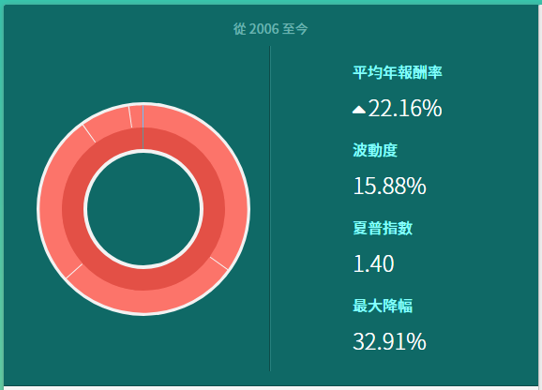

1. **List assets of your portfolio**

|  |  |  |
| --- | --- | --- |
| **投資組合列表** | | |
| **US Equity** | | **100.00%** |
| GOOG | Alphabet Inc. | 35.00% |
| FB | Facebook Inc. | 28.44% |
| MSFT | Microsoft Corporation | 26.70% |
| SQ | Square Inc. | 7.66% |
| QCOM | QUALCOMM Inc. | 2.19% |
| QQQ | PowerShares QQQ Trust, Series 1 (ETF) | 0.00% |
| NVDA | NVIDIA Corporation | 0.00% |
| AMZN | Amazon.com Inc. | 0.00% |
| VOO | Vanguard標普500指數ETF | 0.00% |
| VB | Vanguard小型股ETF | 0.00% |
| SHE | SPDR Series Trust SPDR SSGA Geber Diversity Index ETF | 0.00% |
| JNJ | Johnson & Johnson | 0.00% |
| AVGO | BroadCom Ltd | 0.00% |
| PFE | Pfizer Inc. | 0.00% |
| VNQ | Vanguard不動產投資信託ETF | 0.00% |
| VZ | Verizon Communications Inc. | 0.00% |
| T | AT&T Inc. | 0.00% |
| **Fixed Income** | | **0.00%** |
| LQD | iShares iBoxx投資等級公司債券ETF | 0.00% |
| MUB | iShares國市政債券ETF | 0.00% |
| BIV | Vanguard美國中期債券ETF | 0.00% |
| TLT | iShares 20年期以上美國公債ETF | 0.00% |
| **Commodities** | | **0.00%** |
| IAU | iShares黃金信託ETF | 0.00% |

