Results

Daniel Reyes

6/3/2021

Table of Contents

# Results

# Univariate analysis: trait ~ group + year

## Model 1: Mainland/Island

### Mericarp

We found that mericarps in island populations are larger but less spiny than mericarps in mainland populations. Mericarps on islands are 7% longer, 5% wider, 12% deeper than mainland populations ( $X^{2}$ = 14.10, p = <0.001; $X^{2}$ = 12.43, p = <0.001; $X^{2}$ = 52.33, p = <0.001). Their upper spines are 6% more separated between them on island populations than on mainland ( $X^{2}$ = 5.85, p = 0.015). However, lower spines are more common on mainland populations than on island populations ( $X^{2}$ = 76.74, p = 0.001). The effect of year was significant on all traits ( $X^{2}$ = 8.61, p = <0.001; $X^{2}$ = 8.16, p = <0.001; $X^{2}$ = 19.54, p = <0.001; $X^{2}$ = 0.091, p = <0.001).

## Warning in grid.Call(C_stringMetric, as.graphicsAnnot(x$label)): font metrics  
## unknown for character 0x4d

## Warning in grid.Call(C_stringMetric, as.graphicsAnnot(x$label)): font width  
## unknown for character 0x67

## Warning in grid.Call(C_stringMetric, as.graphicsAnnot(x$label)): font width  
## unknown for character 0x6a

## Warning in grid.Call(C_stringMetric, as.graphicsAnnot(x$label)): font width  
## unknown for character 0x70

## Warning in grid.Call(C_stringMetric, as.graphicsAnnot(x$label)): font width  
## unknown for character 0x71

## Warning in grid.Call(C_stringMetric, as.graphicsAnnot(x$label)): font width  
## unknown for character 0x79

## Warning in grid.Call(C_stringMetric, as.graphicsAnnot(x$label)): font width  
## unknown for character 0x51

## Warning in grid.Call(C_stringMetric, as.graphicsAnnot(x$label)): font metrics  
## unknown for character 0x4d

## Warning in grid.Call(C_stringMetric, as.graphicsAnnot(x$label)): font width  
## unknown for character 0x67

## Warning in grid.Call(C_stringMetric, as.graphicsAnnot(x$label)): font width  
## unknown for character 0x6a

## Warning in grid.Call(C_stringMetric, as.graphicsAnnot(x$label)): font width  
## unknown for character 0x70

## Warning in grid.Call(C_stringMetric, as.graphicsAnnot(x$label)): font width  
## unknown for character 0x71

## Warning in grid.Call(C_stringMetric, as.graphicsAnnot(x$label)): font width  
## unknown for character 0x79

## Warning in grid.Call(C_stringMetric, as.graphicsAnnot(x$label)): font width  
## unknown for character 0x51

## Warning in grid.Call(C_stringMetric, as.graphicsAnnot(x$label)): font metrics  
## unknown for character 0x4d

## Warning in grid.Call(C_stringMetric, as.graphicsAnnot(x$label)): font width  
## unknown for character 0x67

## Warning in grid.Call(C_stringMetric, as.graphicsAnnot(x$label)): font width  
## unknown for character 0x6a

## Warning in grid.Call(C_stringMetric, as.graphicsAnnot(x$label)): font width  
## unknown for character 0x70

## Warning in grid.Call(C_stringMetric, as.graphicsAnnot(x$label)): font width  
## unknown for character 0x71

## Warning in grid.Call(C_stringMetric, as.graphicsAnnot(x$label)): font width  
## unknown for character 0x79

## Warning in grid.Call(C_stringMetric, as.graphicsAnnot(x$label)): font width  
## unknown for character 0x51

## Warning in grid.Call(C_stringMetric, as.graphicsAnnot(x$label)): font metrics  
## unknown for character 0x4d

## Warning in grid.Call(C_stringMetric, as.graphicsAnnot(x$label)): font width  
## unknown for character 0x67

## Warning in grid.Call(C_stringMetric, as.graphicsAnnot(x$label)): font width  
## unknown for character 0x6a

## Warning in grid.Call(C_stringMetric, as.graphicsAnnot(x$label)): font width  
## unknown for character 0x70

## Warning in grid.Call(C_stringMetric, as.graphicsAnnot(x$label)): font width  
## unknown for character 0x71

## Warning in grid.Call(C_stringMetric, as.graphicsAnnot(x$label)): font width  
## unknown for character 0x79

## Warning in grid.Call(C_stringMetric, as.graphicsAnnot(x$label)): font width  
## unknown for character 0x51

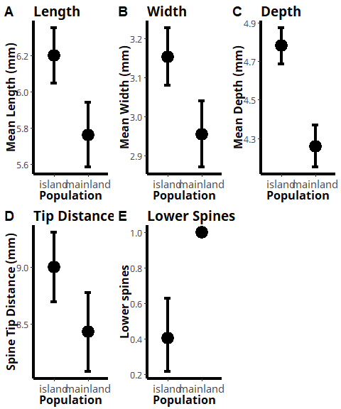

Figure : Estimated means of mericarp traits between island and mainland populations.

### Flower

We found no significant differences between mainland and island populations on petal length (p = 0.299). However, there was a significant result for year ( $X^{2}$ = 15.89, p = <0.001) between mainland and island populations.

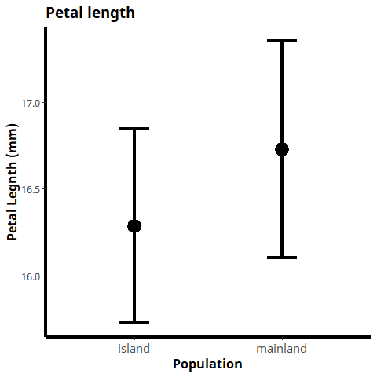

Figure : Estimated means of petal length between island and mainland populations.

### Leaf

We found that leaves in island populations are longer, and have more leaflets than leaves in mainland populations. Leaves on islands are 20% longer, their leaflets are 7.5% larger and they have approximately 11% more leaflets than mainland populations ( $X^{2}$ = 21.86, p = <0.001; $X^{2}$ = 4.86, p = 0.027; $X^{2}$ = 39.61, p = <0.001). The effects of year were also significant for all three traits. ( $X^{2}$ = 6.50 p = <0.001; $X^{2}$ = 4.86, p = <0.001).

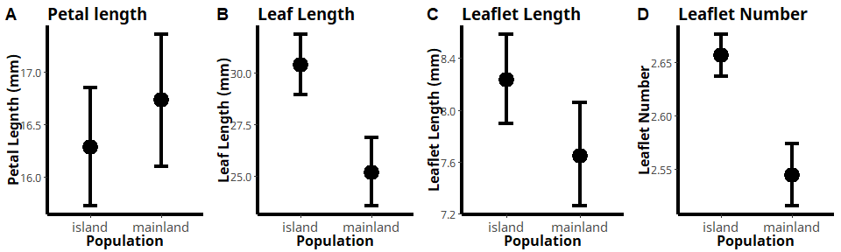

Figure : Estimated means of leaf traits between island and mainland populations.

## Model 2: Galapagos/Other Islands

### Flower

We found that *Tribulus* flowers in the Galapagos are smaller than flowers of populations from other islands. Petal length of *Tribulus* on the Galapagos is 46% shorter than petals from other islands ( $X^{2}$ = 156.39, p = <0.001). The effect of year has also significant between the two groups ( $X^{2}$ = 10.13, p = 0.0014)

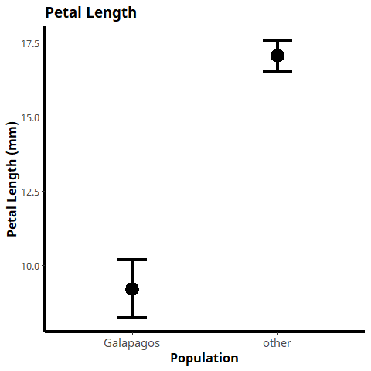

Figure : Estimated means of petal length between the Galapagos and other islands populations.

### Leaf

We found that leaf length of population from the Galapagos are smaller than populations from other islands. Leaves are 22% shorter and leaflets are 18.5% shorter compared to other island populations ( $X^{2}$ = 20.39, p = <0.001; $X^{2}$ = 17.20, p = <0.001). However there were not significant differences for the number of leaflets between Galapagos and other island populations (p = 0.17). The effect of year was not significant for both leaf and leaflet length (p = 0.44, p = 0.347).

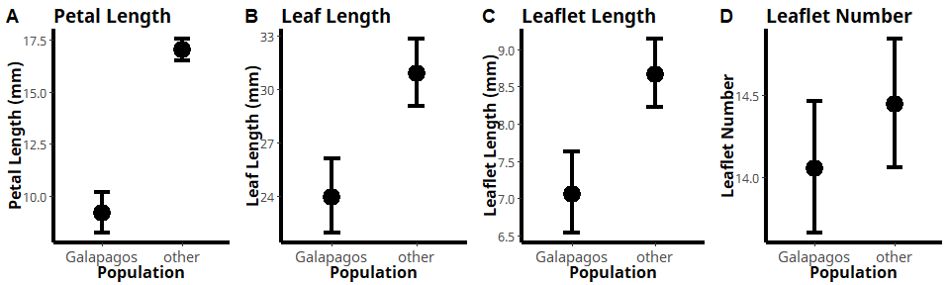

Figure : Estimated means of leaf traits between the Galapagos and other island populations.

## Model 3: Finch Beak

### Mericarp

The presence of large beak finch species, *Geospiza magnirrostris* and *Geospiza cornirostris* was significantly associated with the presence of lower spines ( $X^{2}$ = 125.47, p = <0.001). However, mericarp length, width, depth and spine tip distance were not significant (p = 0.08, p = 0.58, p = 0.37, p = 0.25). The effect of year was significant for lower spines ( $X^{2}$ = 17.414, p = <0.001) but not significant for the other traits (p = 0.69; p = 0.32; p = 0.11; p = 0.94).

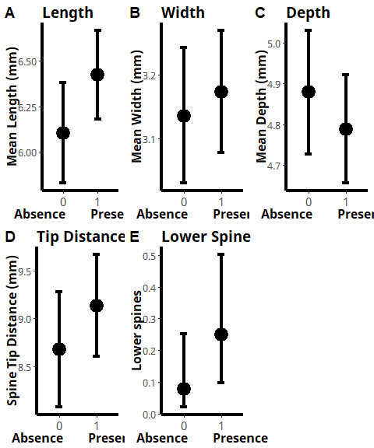

Figure : Estimated means of mericarp traits between finch beak communities. 1 = Presence of large finch species, *Geospiza magnirrostris* and *Geospiza cornirostris*. 0 = Absence of large finch species.

### Flower

There was no statistically significant difference for petal length and year between islands with large beak finches present and absent (p = 0.55; p = 0.009)

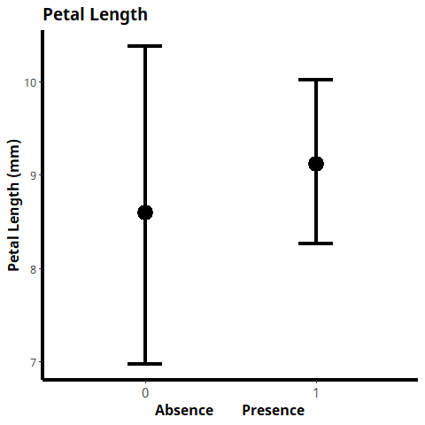

Figure : Estimated means of petal length between finch beak communities. 1 = Presence of large finch species, *Geospiza magnirrostris* and *Geospiza cornirostris*. 0 = Absence of large finch species.

### Leaf

There is not statistically significant difference between islands with large finch beak species present and absent for all three leaf traits, leaf length, leaflet length and leaf number (p = 0.17; p = p = 0.15; p = 0.73). However there was a significant effect of year for leaf length and leaflet number ( $X^{2}$ = 12.85, p = <0.001; $X^{2}$ = 11.98, p = <0.001). The effect of year for leaflet length was barely significant ( $X^{2}$ = 3.7091, p = <0.0542).

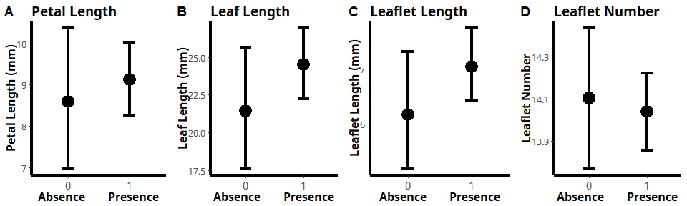

Figure : Estimated means of leaf traits between finch beak communities. 1 = Presence of large finch species, *Geospiza magnirrostris* and *Geospiza cornirostris*. 0 = Absence of large finch species.

# Univariate ANOVA table summary

Model

Dataset

Trait

Chisq

P

Model 1: Mainland/Island

Mericarp

Length

14.101

0.000

Year Length

8.619

0.003

Width

12.438

0.000

Year Width

8.160

0.004

Depth

52.334

0.000

Year Depth

19.542

0.000

Tip Distance

6.090

0.014

Year Tip Distance

0.028

0.868

Lower Spines

76.744

0.000

Model 1: Mainland/Island

Flower

Petal Length

1.077

0.299

Year Petal Length

15.899

0.000

Model 1: Mainland/Island

Leaf

Leaf Length

21.862

0.000

Year Leaf Length

6.502

0.011

Leaflet Length

4.865

0.027

Year Leaflet Length

8.693

0.003

Leaf Number

39.619

0.000

Model 2: Galapagos/Other Islands

Flower

Petal Length

156.398

0.000

Year Petal Length

10.133

0.001

Model 2: Galapagos/Other Islands

Leaf

Leaf Length

20.397

0.000

Year Leaf Length

0.573

0.449

Leaflet Length

17.206

0.000

Year Leaflet Length

0.882

0.348

Leaf Number

1.864

0.172

Model 3: Finch Beak Presence/Absence

Mericarp

Length

3.018

0.082

Year Length

0.157

0.692

Width

0.277

0.599

Year Width

0.963

0.326

Depth

0.795

0.373

Year Depth

2.468

0.116

Tip Distance

1.313

0.252

Year Tip Distance

0.005

0.944

Lower Spines

2.487

0.115

Model 3: Finch Beak Presence/Absence

Flower

Petal Length

0.346

0.556

Year Petal Length

6.720

0.010

Model 3: Finch Beak: Presence/Absence

Leaf

Leaf Length

1.879

0.170

Year Leaf Length

12.856

0.000

Leaflet Length

2.028

0.154

Year Leaflet Length

3.709

0.054

Leaf Number

0.113

0.737

Year Leaf Number

11.986

0.001

# Multivariate analysis: trait ~ group + condition(year)

## Model 1: Mainland/Island

### Mericarp

We observed that mericarps from islands and mainlands populations differed in size and number of spines. Mericarps on islands are larger than mericarps on the mainland with depth being the variable that contributes more to the variation of mericarp size. For spines, the presence of lower spines was more related to mainland populations than to island populations and was the variable that contribute to most of the variation between the two groups.

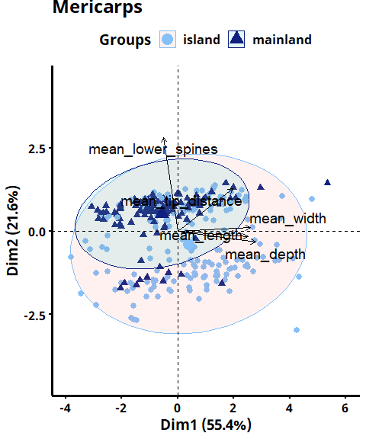

Permutation test for rda under reduced model Terms added sequentially (first to last) Permutation: free Number of permutations: 999

Model: rda(formula = scale(mericarp_traits) ~ mainland_island + Condition(year_collected), data = mericarp) Df Variance F Pr(>F)  
mainland_island 1 0.2607 255.79 0.001 *** Residual 4626 4.7145  
— Signif. codes: 0 ‘***’ 0.001 ’****’ 0.01 ’*’ 0.05 ‘.’ 0.1 ’ ’ 1

### Leaf

Leaves are larger on islands than in the mainland. This size difference also contributes to the number of leaflets present, with island populations habving more. This trait is the main difference between the two groups.

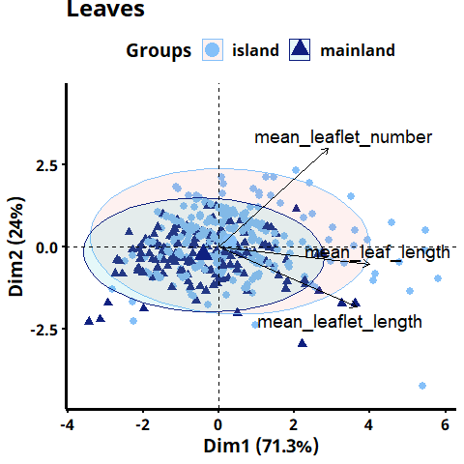

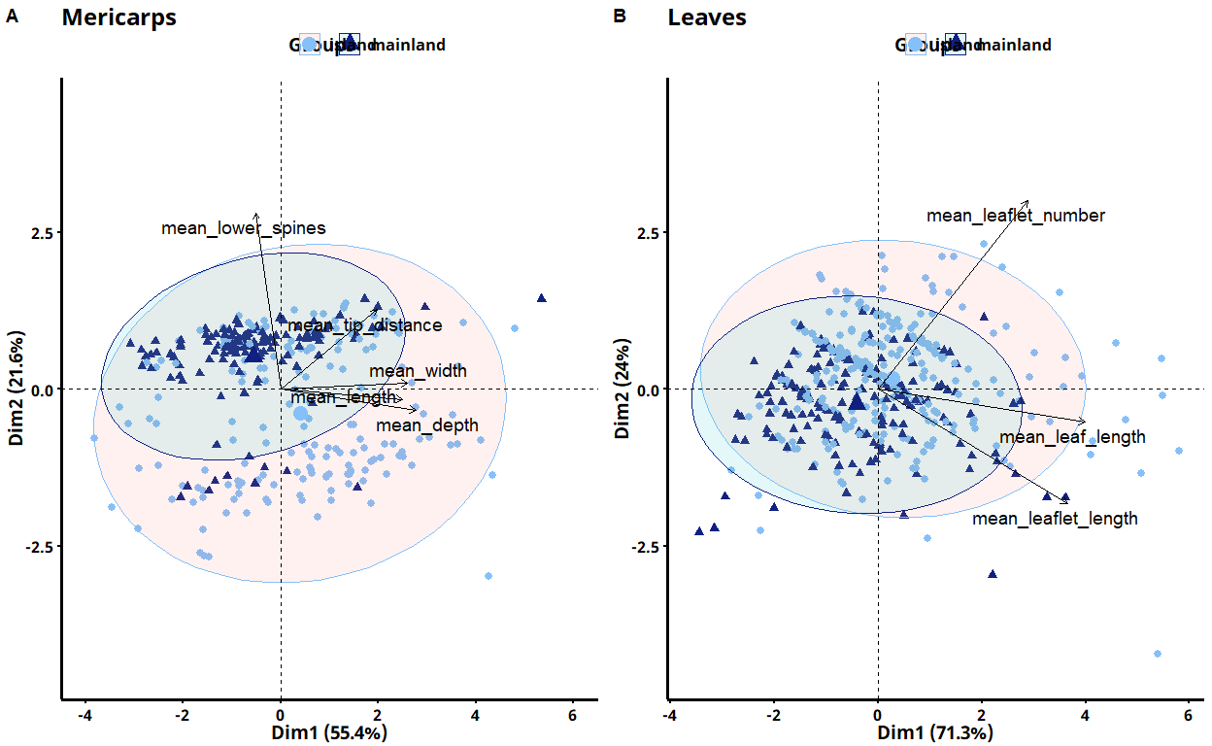

## Model 2: Galapagos/Other

### Leaf

Leaves from the Galapagos Islands are smaller than other island populations. *Tribulus* leaves in the Galapagos are smaller and have less leaflets than other Islands.

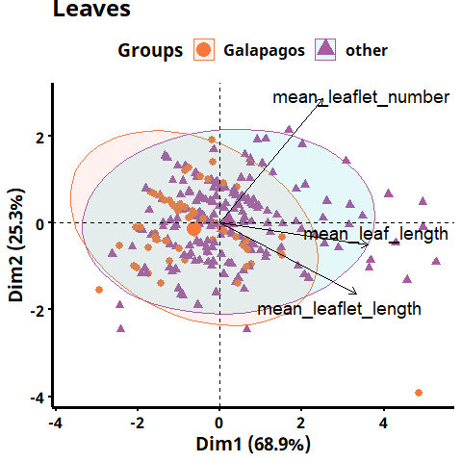

## Model 3: Finch Beak

### Mericarp

The presence of lower spines is by far the trait that contributes most to the differences between groups. This means that the presence of lower spines are associated with large beak finches. Mericarp size contributes 54% of the variation but is not particularly associated with any group.

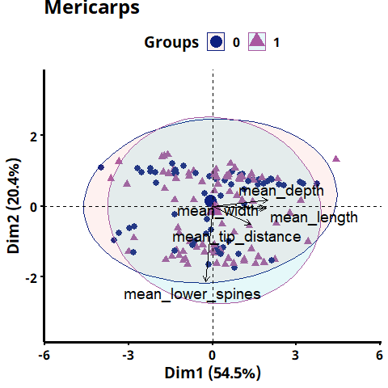

### Leaf

Leaf size and leaflet number is not particularly associated with any group of finches.

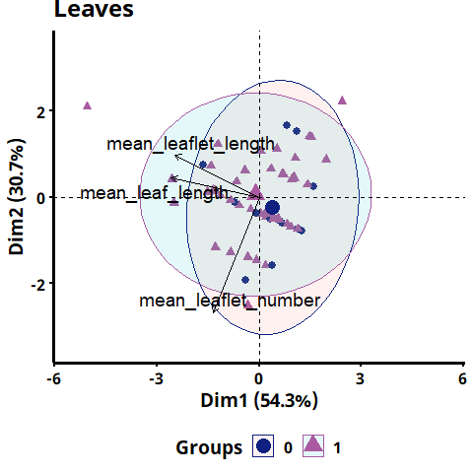

## Warning in grid.Call(C_textBounds, as.graphicsAnnot(x$label), x$x, x$y, : font  
## width unknown for character 0x47

## Warning in grid.Call(C_textBounds, as.graphicsAnnot(x$label), x$x, x$y, : font  
## width unknown for character 0x72

## Warning in grid.Call(C_textBounds, as.graphicsAnnot(x$label), x$x, x$y, : font  
## width unknown for character 0x6f

## Warning in grid.Call(C_textBounds, as.graphicsAnnot(x$label), x$x, x$y, : font  
## width unknown for character 0x75

## Warning in grid.Call(C_textBounds, as.graphicsAnnot(x$label), x$x, x$y, : font  
## width unknown for character 0x70

## Warning in grid.Call(C_textBounds, as.graphicsAnnot(x$label), x$x, x$y, : font  
## width unknown for character 0x73

## Warning in grid.Call(C_textBounds, as.graphicsAnnot(x$label), x$x, x$y, : font  
## metrics unknown for character 0x4d

## Warning in grid.Call(C_textBounds, as.graphicsAnnot(x$label), x$x, x$y, : font  
## width unknown for character 0x47

## Warning in grid.Call(C_textBounds, as.graphicsAnnot(x$label), x$x, x$y, : font  
## width unknown for character 0x72

## Warning in grid.Call(C_textBounds, as.graphicsAnnot(x$label), x$x, x$y, : font  
## width unknown for character 0x6f

## Warning in grid.Call(C_textBounds, as.graphicsAnnot(x$label), x$x, x$y, : font  
## width unknown for character 0x75

## Warning in grid.Call(C_textBounds, as.graphicsAnnot(x$label), x$x, x$y, : font  
## width unknown for character 0x70

## Warning in grid.Call(C_textBounds, as.graphicsAnnot(x$label), x$x, x$y, : font  
## width unknown for character 0x73

## Warning in grid.Call(C_textBounds, as.graphicsAnnot(x$label), x$x, x$y, : font  
## width unknown for character 0x47

## Warning in grid.Call(C_textBounds, as.graphicsAnnot(x$label), x$x, x$y, : font  
## width unknown for character 0x72

## Warning in grid.Call(C_textBounds, as.graphicsAnnot(x$label), x$x, x$y, : font  
## width unknown for character 0x6f

## Warning in grid.Call(C_textBounds, as.graphicsAnnot(x$label), x$x, x$y, : font  
## width unknown for character 0x75

## Warning in grid.Call(C_textBounds, as.graphicsAnnot(x$label), x$x, x$y, : font  
## width unknown for character 0x70

## Warning in grid.Call(C_textBounds, as.graphicsAnnot(x$label), x$x, x$y, : font  
## width unknown for character 0x73

## Warning in grid.Call(C_textBounds, as.graphicsAnnot(x$label), x$x, x$y, : font  
## width unknown for character 0x47

## Warning in grid.Call(C_textBounds, as.graphicsAnnot(x$label), x$x, x$y, : font  
## width unknown for character 0x72

## Warning in grid.Call(C_textBounds, as.graphicsAnnot(x$label), x$x, x$y, : font  
## width unknown for character 0x6f

## Warning in grid.Call(C_textBounds, as.graphicsAnnot(x$label), x$x, x$y, : font  
## width unknown for character 0x75

## Warning in grid.Call(C_textBounds, as.graphicsAnnot(x$label), x$x, x$y, : font  
## width unknown for character 0x70

## Warning in grid.Call(C_textBounds, as.graphicsAnnot(x$label), x$x, x$y, : font  
## width unknown for character 0x73

## Warning in grid.Call(C_textBounds, as.graphicsAnnot(x$label), x$x, x$y, : font  
## width unknown for character 0x47

## Warning in grid.Call(C_textBounds, as.graphicsAnnot(x$label), x$x, x$y, : font  
## width unknown for character 0x72

## Warning in grid.Call(C_textBounds, as.graphicsAnnot(x$label), x$x, x$y, : font  
## width unknown for character 0x6f

## Warning in grid.Call(C_textBounds, as.graphicsAnnot(x$label), x$x, x$y, : font  
## width unknown for character 0x75

## Warning in grid.Call(C_textBounds, as.graphicsAnnot(x$label), x$x, x$y, : font  
## width unknown for character 0x70

## Warning in grid.Call(C_textBounds, as.graphicsAnnot(x$label), x$x, x$y, : font  
## width unknown for character 0x73

## Warning in grid.Call(C_textBounds, as.graphicsAnnot(x$label), x$x, x$y, : font  
## width unknown for character 0x47

## Warning in grid.Call(C_textBounds, as.graphicsAnnot(x$label), x$x, x$y, : font  
## width unknown for character 0x72

## Warning in grid.Call(C_textBounds, as.graphicsAnnot(x$label), x$x, x$y, : font  
## width unknown for character 0x6f

## Warning in grid.Call(C_textBounds, as.graphicsAnnot(x$label), x$x, x$y, : font  
## width unknown for character 0x75

## Warning in grid.Call(C_textBounds, as.graphicsAnnot(x$label), x$x, x$y, : font  
## width unknown for character 0x70

## Warning in grid.Call(C_textBounds, as.graphicsAnnot(x$label), x$x, x$y, : font  
## width unknown for character 0x73

## Warning in grid.Call(C_textBounds, as.graphicsAnnot(x$label), x$x, x$y, : font  
## width unknown for character 0x47

## Warning in grid.Call(C_textBounds, as.graphicsAnnot(x$label), x$x, x$y, : font  
## width unknown for character 0x72

## Warning in grid.Call(C_textBounds, as.graphicsAnnot(x$label), x$x, x$y, : font  
## width unknown for character 0x6f

## Warning in grid.Call(C_textBounds, as.graphicsAnnot(x$label), x$x, x$y, : font  
## width unknown for character 0x75

## Warning in grid.Call(C_textBounds, as.graphicsAnnot(x$label), x$x, x$y, : font  
## width unknown for character 0x70

## Warning in grid.Call(C_textBounds, as.graphicsAnnot(x$label), x$x, x$y, : font  
## width unknown for character 0x73

## Warning in grid.Call(C_textBounds, as.graphicsAnnot(x$label), x$x, x$y, : font  
## width unknown for character 0x47

## Warning in grid.Call(C_textBounds, as.graphicsAnnot(x$label), x$x, x$y, : font  
## width unknown for character 0x72

## Warning in grid.Call(C_textBounds, as.graphicsAnnot(x$label), x$x, x$y, : font  
## width unknown for character 0x6f

## Warning in grid.Call(C_textBounds, as.graphicsAnnot(x$label), x$x, x$y, : font  
## width unknown for character 0x75

## Warning in grid.Call(C_textBounds, as.graphicsAnnot(x$label), x$x, x$y, : font  
## width unknown for character 0x70

## Warning in grid.Call(C_textBounds, as.graphicsAnnot(x$label), x$x, x$y, : font  
## width unknown for character 0x73

## Warning in grid.Call(C_textBounds, as.graphicsAnnot(x$label), x$x, x$y, : font  
## width unknown for character 0x47

## Warning in grid.Call(C_textBounds, as.graphicsAnnot(x$label), x$x, x$y, : font  
## width unknown for character 0x72

## Warning in grid.Call(C_textBounds, as.graphicsAnnot(x$label), x$x, x$y, : font  
## width unknown for character 0x6f

## Warning in grid.Call(C_textBounds, as.graphicsAnnot(x$label), x$x, x$y, : font  
## width unknown for character 0x75

## Warning in grid.Call(C_textBounds, as.graphicsAnnot(x$label), x$x, x$y, : font  
## width unknown for character 0x70

## Warning in grid.Call(C_textBounds, as.graphicsAnnot(x$label), x$x, x$y, : font  
## width unknown for character 0x73

## Warning in grid.Call(C_textBounds, as.graphicsAnnot(x$label), x$x, x$y, : font  
## width unknown for character 0x47

## Warning in grid.Call(C_textBounds, as.graphicsAnnot(x$label), x$x, x$y, : font  
## width unknown for character 0x72

## Warning in grid.Call(C_textBounds, as.graphicsAnnot(x$label), x$x, x$y, : font  
## width unknown for character 0x6f

## Warning in grid.Call(C_textBounds, as.graphicsAnnot(x$label), x$x, x$y, : font  
## width unknown for character 0x75

## Warning in grid.Call(C_textBounds, as.graphicsAnnot(x$label), x$x, x$y, : font  
## width unknown for character 0x70

## Warning in grid.Call(C_textBounds, as.graphicsAnnot(x$label), x$x, x$y, : font  
## width unknown for character 0x73

## Warning in grid.Call(C_textBounds, as.graphicsAnnot(x$label), x$x, x$y, : font  
## width unknown for character 0x30

## Warning in grid.Call(C_textBounds, as.graphicsAnnot(x$label), x$x, x$y, : font  
## metrics unknown for character 0x4d

## Warning in grid.Call(C_textBounds, as.graphicsAnnot(x$label), x$x, x$y, : font  
## width unknown for character 0x30  
  
## Warning in grid.Call(C_textBounds, as.graphicsAnnot(x$label), x$x, x$y, : font  
## width unknown for character 0x30  
  
## Warning in grid.Call(C_textBounds, as.graphicsAnnot(x$label), x$x, x$y, : font  
## width unknown for character 0x30  
  
## Warning in grid.Call(C_textBounds, as.graphicsAnnot(x$label), x$x, x$y, : font  
## width unknown for character 0x30

## Warning in grid.Call(C_textBounds, as.graphicsAnnot(x$label), x$x, x$y, : font  
## width unknown for character 0x31  
  
## Warning in grid.Call(C_textBounds, as.graphicsAnnot(x$label), x$x, x$y, : font  
## width unknown for character 0x31  
  
## Warning in grid.Call(C_textBounds, as.graphicsAnnot(x$label), x$x, x$y, : font  
## width unknown for character 0x31  
  
## Warning in grid.Call(C_textBounds, as.graphicsAnnot(x$label), x$x, x$y, : font  
## width unknown for character 0x31  
  
## Warning in grid.Call(C_textBounds, as.graphicsAnnot(x$label), x$x, x$y, : font  
## width unknown for character 0x31

## Warning in grid.Call(C_textBounds, as.graphicsAnnot(x$label), x$x, x$y, : font  
## width unknown for character 0x30  
  
## Warning in grid.Call(C_textBounds, as.graphicsAnnot(x$label), x$x, x$y, : font  
## width unknown for character 0x30  
  
## Warning in grid.Call(C_textBounds, as.graphicsAnnot(x$label), x$x, x$y, : font  
## width unknown for character 0x30  
  
## Warning in grid.Call(C_textBounds, as.graphicsAnnot(x$label), x$x, x$y, : font  
## width unknown for character 0x30  
  
## Warning in grid.Call(C_textBounds, as.graphicsAnnot(x$label), x$x, x$y, : font  
## width unknown for character 0x30

## Warning in grid.Call(C_textBounds, as.graphicsAnnot(x$label), x$x, x$y, : font  
## width unknown for character 0x31  
  
## Warning in grid.Call(C_textBounds, as.graphicsAnnot(x$label), x$x, x$y, : font  
## width unknown for character 0x31  
  
## Warning in grid.Call(C_textBounds, as.graphicsAnnot(x$label), x$x, x$y, : font  
## width unknown for character 0x31  
  
## Warning in grid.Call(C_textBounds, as.graphicsAnnot(x$label), x$x, x$y, : font  
## width unknown for character 0x31  
  
## Warning in grid.Call(C_textBounds, as.graphicsAnnot(x$label), x$x, x$y, : font  
## width unknown for character 0x31

## Warning in grid.Call(C_textBounds, as.graphicsAnnot(x$label), x$x, x$y, : font  
## width unknown for character 0x47

## Warning in grid.Call(C_textBounds, as.graphicsAnnot(x$label), x$x, x$y, : font  
## width unknown for character 0x72

## Warning in grid.Call(C_textBounds, as.graphicsAnnot(x$label), x$x, x$y, : font  
## width unknown for character 0x6f

## Warning in grid.Call(C_textBounds, as.graphicsAnnot(x$label), x$x, x$y, : font  
## width unknown for character 0x75

## Warning in grid.Call(C_textBounds, as.graphicsAnnot(x$label), x$x, x$y, : font  
## width unknown for character 0x70

## Warning in grid.Call(C_textBounds, as.graphicsAnnot(x$label), x$x, x$y, : font  
## width unknown for character 0x73

## Warning in grid.Call(C_textBounds, as.graphicsAnnot(x$label), x$x, x$y, : font  
## metrics unknown for character 0x4d

## Warning in grid.Call(C_textBounds, as.graphicsAnnot(x$label), x$x, x$y, : font  
## width unknown for character 0x47

## Warning in grid.Call(C_textBounds, as.graphicsAnnot(x$label), x$x, x$y, : font  
## width unknown for character 0x72

## Warning in grid.Call(C_textBounds, as.graphicsAnnot(x$label), x$x, x$y, : font  
## width unknown for character 0x6f

## Warning in grid.Call(C_textBounds, as.graphicsAnnot(x$label), x$x, x$y, : font  
## width unknown for character 0x75

## Warning in grid.Call(C_textBounds, as.graphicsAnnot(x$label), x$x, x$y, : font  
## width unknown for character 0x70

## Warning in grid.Call(C_textBounds, as.graphicsAnnot(x$label), x$x, x$y, : font  
## width unknown for character 0x73

## Warning in grid.Call(C_textBounds, as.graphicsAnnot(x$label), x$x, x$y, : font  
## width unknown for character 0x47

## Warning in grid.Call(C_textBounds, as.graphicsAnnot(x$label), x$x, x$y, : font  
## width unknown for character 0x72

## Warning in grid.Call(C_textBounds, as.graphicsAnnot(x$label), x$x, x$y, : font  
## width unknown for character 0x6f

## Warning in grid.Call(C_textBounds, as.graphicsAnnot(x$label), x$x, x$y, : font  
## width unknown for character 0x75

## Warning in grid.Call(C_textBounds, as.graphicsAnnot(x$label), x$x, x$y, : font  
## width unknown for character 0x70

## Warning in grid.Call(C_textBounds, as.graphicsAnnot(x$label), x$x, x$y, : font  
## width unknown for character 0x73

## Warning in grid.Call(C_textBounds, as.graphicsAnnot(x$label), x$x, x$y, : font  
## width unknown for character 0x47

## Warning in grid.Call(C_textBounds, as.graphicsAnnot(x$label), x$x, x$y, : font  
## width unknown for character 0x72

## Warning in grid.Call(C_textBounds, as.graphicsAnnot(x$label), x$x, x$y, : font  
## width unknown for character 0x6f

## Warning in grid.Call(C_textBounds, as.graphicsAnnot(x$label), x$x, x$y, : font  
## width unknown for character 0x75

## Warning in grid.Call(C_textBounds, as.graphicsAnnot(x$label), x$x, x$y, : font  
## width unknown for character 0x70

## Warning in grid.Call(C_textBounds, as.graphicsAnnot(x$label), x$x, x$y, : font  
## width unknown for character 0x73

## Warning in grid.Call(C_textBounds, as.graphicsAnnot(x$label), x$x, x$y, : font  
## width unknown for character 0x47

## Warning in grid.Call(C_textBounds, as.graphicsAnnot(x$label), x$x, x$y, : font  
## width unknown for character 0x72

## Warning in grid.Call(C_textBounds, as.graphicsAnnot(x$label), x$x, x$y, : font  
## width unknown for character 0x6f

## Warning in grid.Call(C_textBounds, as.graphicsAnnot(x$label), x$x, x$y, : font  
## width unknown for character 0x75

## Warning in grid.Call(C_textBounds, as.graphicsAnnot(x$label), x$x, x$y, : font  
## width unknown for character 0x70

## Warning in grid.Call(C_textBounds, as.graphicsAnnot(x$label), x$x, x$y, : font  
## width unknown for character 0x73

## Warning in grid.Call(C_textBounds, as.graphicsAnnot(x$label), x$x, x$y, : font  
## width unknown for character 0x47

## Warning in grid.Call(C_textBounds, as.graphicsAnnot(x$label), x$x, x$y, : font  
## width unknown for character 0x72

## Warning in grid.Call(C_textBounds, as.graphicsAnnot(x$label), x$x, x$y, : font  
## width unknown for character 0x6f

## Warning in grid.Call(C_textBounds, as.graphicsAnnot(x$label), x$x, x$y, : font  
## width unknown for character 0x75

## Warning in grid.Call(C_textBounds, as.graphicsAnnot(x$label), x$x, x$y, : font  
## width unknown for character 0x70

## Warning in grid.Call(C_textBounds, as.graphicsAnnot(x$label), x$x, x$y, : font  
## width unknown for character 0x73

## Warning in grid.Call(C_textBounds, as.graphicsAnnot(x$label), x$x, x$y, : font  
## width unknown for character 0x47

## Warning in grid.Call(C_textBounds, as.graphicsAnnot(x$label), x$x, x$y, : font  
## width unknown for character 0x72

## Warning in grid.Call(C_textBounds, as.graphicsAnnot(x$label), x$x, x$y, : font  
## width unknown for character 0x6f

## Warning in grid.Call(C_textBounds, as.graphicsAnnot(x$label), x$x, x$y, : font  
## width unknown for character 0x75

## Warning in grid.Call(C_textBounds, as.graphicsAnnot(x$label), x$x, x$y, : font  
## width unknown for character 0x70

## Warning in grid.Call(C_textBounds, as.graphicsAnnot(x$label), x$x, x$y, : font  
## width unknown for character 0x73

## Warning in grid.Call(C_textBounds, as.graphicsAnnot(x$label), x$x, x$y, : font  
## width unknown for character 0x47

## Warning in grid.Call(C_textBounds, as.graphicsAnnot(x$label), x$x, x$y, : font  
## width unknown for character 0x72

## Warning in grid.Call(C_textBounds, as.graphicsAnnot(x$label), x$x, x$y, : font  
## width unknown for character 0x6f

## Warning in grid.Call(C_textBounds, as.graphicsAnnot(x$label), x$x, x$y, : font  
## width unknown for character 0x75

## Warning in grid.Call(C_textBounds, as.graphicsAnnot(x$label), x$x, x$y, : font  
## width unknown for character 0x70

## Warning in grid.Call(C_textBounds, as.graphicsAnnot(x$label), x$x, x$y, : font  
## width unknown for character 0x73

## Warning in grid.Call(C_textBounds, as.graphicsAnnot(x$label), x$x, x$y, : font  
## width unknown for character 0x47

## Warning in grid.Call(C_textBounds, as.graphicsAnnot(x$label), x$x, x$y, : font  
## width unknown for character 0x72

## Warning in grid.Call(C_textBounds, as.graphicsAnnot(x$label), x$x, x$y, : font  
## width unknown for character 0x6f

## Warning in grid.Call(C_textBounds, as.graphicsAnnot(x$label), x$x, x$y, : font  
## width unknown for character 0x75

## Warning in grid.Call(C_textBounds, as.graphicsAnnot(x$label), x$x, x$y, : font  
## width unknown for character 0x70

## Warning in grid.Call(C_textBounds, as.graphicsAnnot(x$label), x$x, x$y, : font  
## width unknown for character 0x73

## Warning in grid.Call(C_textBounds, as.graphicsAnnot(x$label), x$x, x$y, : font  
## width unknown for character 0x47

## Warning in grid.Call(C_textBounds, as.graphicsAnnot(x$label), x$x, x$y, : font  
## width unknown for character 0x72

## Warning in grid.Call(C_textBounds, as.graphicsAnnot(x$label), x$x, x$y, : font  
## width unknown for character 0x6f

## Warning in grid.Call(C_textBounds, as.graphicsAnnot(x$label), x$x, x$y, : font  
## width unknown for character 0x75

## Warning in grid.Call(C_textBounds, as.graphicsAnnot(x$label), x$x, x$y, : font  
## width unknown for character 0x70

## Warning in grid.Call(C_textBounds, as.graphicsAnnot(x$label), x$x, x$y, : font  
## width unknown for character 0x73

## Warning in grid.Call(C_textBounds, as.graphicsAnnot(x$label), x$x, x$y, : font  
## width unknown for character 0x30

## Warning in grid.Call(C_textBounds, as.graphicsAnnot(x$label), x$x, x$y, : font  
## metrics unknown for character 0x4d

## Warning in grid.Call(C_textBounds, as.graphicsAnnot(x$label), x$x, x$y, : font  
## width unknown for character 0x30  
  
## Warning in grid.Call(C_textBounds, as.graphicsAnnot(x$label), x$x, x$y, : font  
## width unknown for character 0x30  
  
## Warning in grid.Call(C_textBounds, as.graphicsAnnot(x$label), x$x, x$y, : font  
## width unknown for character 0x30  
  
## Warning in grid.Call(C_textBounds, as.graphicsAnnot(x$label), x$x, x$y, : font  
## width unknown for character 0x30

## Warning in grid.Call(C_textBounds, as.graphicsAnnot(x$label), x$x, x$y, : font  
## width unknown for character 0x31  
  
## Warning in grid.Call(C_textBounds, as.graphicsAnnot(x$label), x$x, x$y, : font  
## width unknown for character 0x31  
  
## Warning in grid.Call(C_textBounds, as.graphicsAnnot(x$label), x$x, x$y, : font  
## width unknown for character 0x31  
  
## Warning in grid.Call(C_textBounds, as.graphicsAnnot(x$label), x$x, x$y, : font  
## width unknown for character 0x31  
  
## Warning in grid.Call(C_textBounds, as.graphicsAnnot(x$label), x$x, x$y, : font  
## width unknown for character 0x31

## Warning in grid.Call(C_textBounds, as.graphicsAnnot(x$label), x$x, x$y, : font  
## width unknown for character 0x30  
  
## Warning in grid.Call(C_textBounds, as.graphicsAnnot(x$label), x$x, x$y, : font  
## width unknown for character 0x30  
  
## Warning in grid.Call(C_textBounds, as.graphicsAnnot(x$label), x$x, x$y, : font  
## width unknown for character 0x30  
  
## Warning in grid.Call(C_textBounds, as.graphicsAnnot(x$label), x$x, x$y, : font  
## width unknown for character 0x30  
  
## Warning in grid.Call(C_textBounds, as.graphicsAnnot(x$label), x$x, x$y, : font  
## width unknown for character 0x30

## Warning in grid.Call(C_textBounds, as.graphicsAnnot(x$label), x$x, x$y, : font  
## width unknown for character 0x31  
  
## Warning in grid.Call(C_textBounds, as.graphicsAnnot(x$label), x$x, x$y, : font  
## width unknown for character 0x31  
  
## Warning in grid.Call(C_textBounds, as.graphicsAnnot(x$label), x$x, x$y, : font  
## width unknown for character 0x31  
  
## Warning in grid.Call(C_textBounds, as.graphicsAnnot(x$label), x$x, x$y, : font  
## width unknown for character 0x31  
  
## Warning in grid.Call(C_textBounds, as.graphicsAnnot(x$label), x$x, x$y, : font  
## width unknown for character 0x31

